A natural strategy against climate change

R.D.Schuiling,

Institute of Geosciences, Utrecht University, Utrecht., 3508 TA, The Netherlands

Abstract

This paper presents a short description of the quantitatively most important applications of enhanced weathering of olivine to counter climate change and ocean acidification. CO2 is captured by the weathering of basic silicates, in particular olivine or its hydrated equivalent serpentine. During the whole history of the Earth, weathering has played the major role in the capture and storage of the CO2 that was emitted by volcanoes. If all that CO2 had remained in the atmosphere there would be no life on our planet. It is logical, therefore, to stimulate this process to counteract climate change, caused by the rapidly rising CO2 levels in the atmosphere. Enhanced weathering covers applications on land, along the coast and in shallow marine environments. In addition some topics are mentioned that have no geographic restriction. An attempt is made to quantitatively estimate the carbon capture potential of each topic.

Keywords: enhanced weathering; olivine spreading; CO2 capture; ocean acidification; quantification of effects.

Introduction

Fact sheet. Most people are neither earth scientists nor employed in the mining industry. To remove some stubborn misunderstandings, first the following information is provided.

* *Olivine is a silicate, and is the most common mineral in the Earth. Its composition in major olivine massifs is close to (Mg0.92Fe0.08)2SiO4.*
* *It is the fastest weathering common silicate.*
* *Experiments in sterile laboratories show rather low rates of weathering. In the real world, however, the rates of weathering are several orders of magnitude higher due to biotic factors (a.o. lichens, soil bacteria, mycorrhizal fungi* [1]*, ants* [2]*, termites, lugworms).*
* *By far the most common weathering reaction is the reaction by which water + CO2 convert olivine to a magnesium bicarbonate and silica solution. For olivine that means Mg2SiO4 + 4 CO2 + 4 H2O🡪 2 Mg2+ + 4 HCO3- + H4SiO4. This means that the weathering of 1 ton of olivine captures 1.25 tons of CO2.*
* *In the long run such solutions reach the sea, where corals, shellfish and plankton convert them to solid carbonate rocks, the ultimate sustainable storage of CO2.*
* *This natural process of weathering has throughout geological time removed excess quantities of CO2 from the atmosphere. If all that CO2 had remained in the atmosphere there would be no life on Earth.*
* *Many large olivine massifs are close to the surface, where they can be mined in open pit mines, at low cost and at a low CO2 penalty of 3.5 to 4 % of the CO2 that is ultimately captured by the olivine.*
* *The olivine concept is based on the natural process of weathering that has always kept a tight lid on the CO2 levels of the atmosphere, so its application in enhanced weathering is unlikely to cause environmental problems.*

Presently humankind is burning in a few hundred years the fossil fuels that have taken hundreds of millions of years to form. The regular weathering process cannot cope with the ensuing fiftyfold rise in emission. It is expected that enhanced weathering of olivine can provide the answer, although it will involve a number of large-scale operations to be carried out in the whole world.

**LAND**

**Agriculture**

1. Much of the agricultural land is characterized by low soil pH. To remedy it, such farmland is often limed. Liming, however, is CO2 –positive, because the CO2 is already combined with the CaO, so all the CO2 emitted by mining, milling and transport of limestone increases the amount of CO2 in the atmosphere. When one replaces liming by spreading a quantity of olivine with an equal neutralizing effect, it can also raise the soil pH to an acceptable level, while at the same time CO2 is captured. By comparing the effect of olivine spreading with the effects of liming, it can be determined whether olivine spreading is an acceptable alternative both as effects and cost are concerned. It is expected that both treatments will not differ significantly as far as direct costs are concerned. One ton of olivine can neutralize more acid than one ton of lime, but lime acts faster. An olivine treatment lasts longer and permits longer intervals between spreading. Agricultural land occupies about 1.95 billion hectares on Earth. A significant part of this is regularly limed, or would benefit from liming, so an olivine treatment will have similar positive results. If one ton of olivine per hectare would be spread each year on half of this area, it would amount to an annual carbon dioxide capture of 1.2 x 109 tons.
2. Rice culture on irrigated fields offers an easy way to measure the effect of olivine spreading. One just needs to compare the composition of the incoming irrigation water with the composition of the drainage water after it has passed a rice paddy on which olivine was spread.

Rice, but also other “wet” grasses (bamboo, sugar cane, reed) need silica, which is delivered by the weathering of the olivine. The rice production can be compared with similar plots where no olivine was spread. The total area of rice fields in the world amounts to 146 million hectares. With an olivine gift of 6 tons/ha this is equivalent to a capture of 1.1 billion tons of CO2

[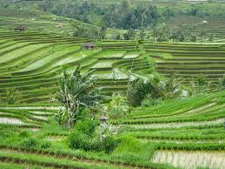](http://www.google.nl/url?sa=i&rct=j&q=&esrc=s&frm=1&source=images&cd=&cad=rja&uact=8&docid=pTyCWZHK_iVJiM&tbnid=vY_KvreL5wAmuM:&ved=0CAUQjRw&url=http://www.flickr.com/photos/ameland1732/1396398922/&ei=c2w5U938LOX30gX774HoCA&bvm=bv.63808443,d.bGQ&psig=AFQjCNG_0fekQ7R_k3hIEtG2iQ8Uk8JPjA&ust=1396358613175231)

Fig.1: Rice needs silica

1. Plantations of coffee, tea, cocoa and bananas occupy roughly 20 million hectares. With an annual olivine gift of 6 ton/ha this means a capture of 150 million tons of CO2 for these products. The use of olivine on plantations has the advantage that it can be combined with the spreading of fertilizer, by which the cost of the operation is decreased.

**Forestry**

1. Forests occupy approximately 40 million km2 on Earth. It is not clear which parts are to be considered as exploitable, but governments that provide concessions for commercial forestry should add a mandatory obligation of reforestation to the logging companies of any cut plots, and to spread olivine sand on the new plots. Many forests are on acid soils, and these would profit from an olivine gift. Moreover the magnesium from the olivine is the main component of chlorophyll.
2. Forest fires. Forest fires cause the largest CO2 emissions (around 6 Gt), after the burning of fossil fuels [3]. Such fires are treated with water, both from the ground as well as from fire-fighting planes. We found that quenching with a suspension of fine-grained serpentine in water is much faster and more effective. After a successful demonstration at the training site of the Dutch Fire Brigades at Wijster, the Dutch Fire Brigades have started a study on the most practical way to apply these suspensions. The most important property of serpentine is that it immediately forms a thin baked crust on the burning material that prevents the access of oxygen to it.

A second advantage of this quenching method is the fact that the baked serpentine quickly reacts with rainwater and CO2 after the fire. This compensates for part of the CO2 emitted by the fire. When forest fires on the whole world could be reduced by 10 percent by applying this new quenching method, it would cause an emission reduction combined with the compensation after the fire of an estimated 0.5 to 1.0 Gt CO2 annually. In addition it would save lives.

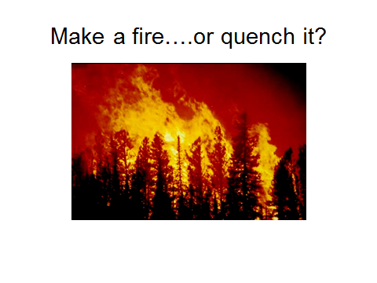 Fig.2:Forest fires are the second largest emitters of CO2 after fossil fuels

**COAST**

1. Sandy coasts lose sand by surf and currents. Beach replenishment is used to compensate these losses. The sand is sucked from the seafloor and brought to the beach. This operation can also be carried out when the sand is replaced by olivine

sand. There are a number of olivine beaches in the world, and many more beaches at the base of olivine cliffs that contain olivine, We have observed that tourists feel quite well on such beaches, although most of the time they don’t realize that their beach sand has an unusual composition. In the Netherlands annually some 15 million m3 of sand is added to the beach (~ 25 million ton) to replace the sand lost by erosion. When this replenishment would be carried out by olivine sand, it would amount to a CO2 compensation of 30 million tons, a sizable part of the Dutch CO2 emission. An advantage of this method is that ships, bringing the olivine, can discharge their load directly on the coast, saving time and harbor duties. Another advantage is environmental, because the sucking of sand from the sea bottom causes a serious disturbance of benthic life. This and similar approaches to spread olivine in or along the marine environment also help to fight ocean acidification and restore the pH of the oceans.

1. One can also construct artificial olivine reefs at strategic locations to protect the coast from surf and waves. The reefs must be constructed in such a way that the seawater in the pores is only slowly refreshed. In such a case the pH of the pore waters will rise, and calcite will precipitate as a consequence, making the reefs self-cementing. Next to coastal protection, these reefs will also serve as a place for mussels and oysters to settle, and for fish to breed. This makes them tourist attractions.

1. Tidal flats. Tidal flats are densely populated by lugworms. These eat on average 3 times a year through the top few cm, searching for food. Experiments have been run to feed the lugworms small pieces of basalt. Within a year most of the basalt piece had turned into clay! [4]. Olivine weathers faster than basalt, so for small pieces of olivine a rapid digestion is also expected. This means that some spreading of olivine over tidal flats will result in additional CO2 capture.
2. Olivine grit spread on beaches will be milled by the surf. Experiments in a flume and on a shaking table have been carried out to prove this [5]. In the flume it was found that the large olivine grains did not sink in the finer sand, but kept rolling and jumping over it. Both here and in the shaking experiments the grains are rapidly worn down by mutual collisions or by scraping along each other. This produces myriads of tiny slivers that weather fast in the seawater and make the pH rise. Expensive (both in terms of energy and other costs) milling to extremely fine grain size is not required, because the surf will handle that free of charge.
3. Diatom cultivation for biodiesel production. The production of biofuels from land-based plants meets with strong criticism, because it occupies large areas that are withdrawn from food production, or were a habitat of threatened animals. The production of biofuels from land-based plants also consumes large volumes of fertilizer and irrigation water. Biodiesel production from marine organisms that contain sufficient lipids to serve as a raw material does not have these disadvantages. This proposal is aimed as a short survey of the possibilities of diatom culture. Diatoms are a major component of marine biomass. They are rich in lipids, and multiply rapidly under favorable conditions. They require silica, because they have a silica skeleton. This can be provided by the weathering of olivine. A first test could be set up as follows. Starting at the high-tide line a sloping hill must be constructed that extends 50 meter into the sea. On this hill one or more gutters are constructed that are filled with olivine sand. At the top of the hill seawater enters the olivine and slowly trickles through it. Just before the exit point the water will be sampled to see the changes in composition by the reaction with the olivine. The water is then fed into a small circular pond, that is separated from the open sea by a ring dike. At the start this pond was filled with normal seawater, but its composition will slowly change as more and more of it is replaced by water that has reacted with olivine. It is assumed that the pond’s initial ecology was similar to that of the open sea. As the supply of silica-rich water creates favorable conditions for diatoms, the new ecology will approach a monoculture of diatoms.

When this hypothesis is confirmed, one can discuss the set-up of a diatom farm. In its simplest form this can be visualized as an artificial lagoon, separated from the sea by a dam, and a beach covered with olivine. The dam must be constructed in such a way that the tidal currents can pass through it. The olivine beach will wet at high tide, and drains during ebb tide. The drainage water will be rich in silica, and mix with the lagoon. When this first study produces a positive result, one can start to think how to apply this concept at such a scale, that biofuel production on land can be significantly reduced, thereby safeguarding the world’s food supply.

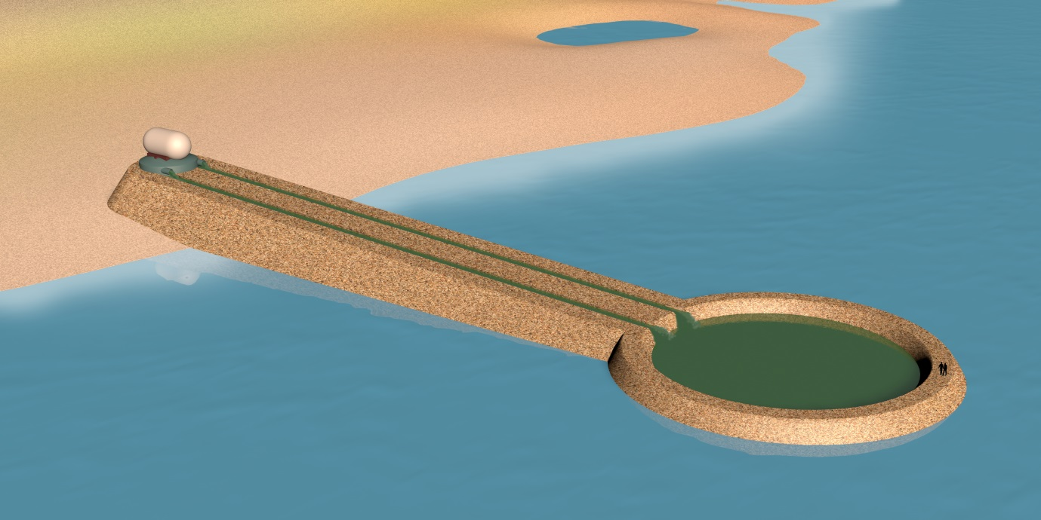

Fig.3: Olivine reactor and diatom pond

**SHALLOW SEAS**

11.Related to proposal 9 is a way to dump mixtures of olivine grit directly on the sea bed, at places where bottom currents are so fast that the sea floor is covered with pebbles. In Western Europa large areas are found in the Southern Bight of the North Sea, in the Channel and in the Irish Sea [6]. When a part of this area with fast bottom currents is covered with a 1 cm thick layer of olivine grit, the total CO2 emission of the adjacent countries (UK, Ireland, France, Belgium and the Netherlands) can be compensated. Experiments have shown that mixtures of different grain sizes are more effective than a homogenous grain size. This megascale approach, in which the rolling olivine grains mill each other along the sea floor is the most direct way in which olivine weathering can act against ocean acidification, and restore the ocean pH to its former value. The addition of biotic elements like iron and silica will help to increase the ocean biomass, in particular diatoms, which play an important role in the food chain of fishes. The bicarbonate trapped by the olivine weathering will serve the CO2-need of photosynthesizers. This approach can be extended to other areas of shallow seas with high current velocities. *It could potentially remove all the CO2 that must be removed in order to avert climate change*

**OTHER PROPOSALS**

1. Improving air quality in buildings. Many offices and schools suffer from the sick- building syndrome. In the course of the day people become drowsy, they lose their concentration, and their productivity goes down. At the beginning of the day the internal atmosphere has a normal CO2 content (around 400 ppm), but at the end of the day this has gone up to 1500 to 1600 ppm. Theoretically one could suggest to open all doors and windows, but that is very unfavorable for the energy balance, and brings noise and dust nuisance. A solution could be to circulate the internal atmosphere through a so-called CATO-reactor (Clean Air Through Olivine), a trough filled with a watery suspension of minute olivine particles. The air with a slight overpressure passes through a perforated tube along the bottom of the trough. When the bubbles rise through the olivine suspension, the CO2 is transformed to bicarbonate. Another advantage is that pollen and allergenic particles are also caught in the reactor, which makes the stay in the building more tolerable for people suffering from asthma or hay fever. During this operation the bicarbonate and silica levels in the trough will increase, so the suspension in the reactor must regularly be refreshed to prevent scaling. The old suspension can best be discharged in a larger basin (a pond can serve this purpose). When several buildings close together have a CATO reactor, they can all discharge their old suspensions in the same pond. It is also possible that they would share one large reactor. The silica serves the growth of diatoms, and the bicarbonate can be used for photosynthesis. The silica that was set free by the olivine reaction can also be used for wet grasses (reed, bamboo, rushes) along the borders of the pond. To give an idea of the capacity of this proposal to catch CO2 the following approximation can serve. Suppose that in the temperate zone there will be one million school buildings or offices equipped with a CATO reactor, and that these buildings serve on average 250 people during 8 hours a day. In 8 hours an average adult exhales about 300 gram of CO2 . This is equivalent to an annual capture of CO2 of 22 million tons. Additionally more will be captured by the increased biomass in the ponds.

13. More green biogas. Biodigesters begin to play an increasingly important role in the energy mix. In a normal digester a biogas is formed which consists for approximately 2/3 of methane and 1/3 of CO2 with traces of H2S. To bring this to natural gas quality which permits it to be mixed with normal gas, the CO2- content must be drastically lowered, and it should not smell. Tests at the Agricultural University at Wageningen and at the Technical University of Delft have shown that the addition of fine olivine powder to the digesters has the following effects:

a: part of the CO2 in the biogas shifts to bicarbonate dissolved in the digestate liquid,

so the biogas becomes richer in methane. If the biodigester is operated under a . moderate pressure, the biogas becomes almost pure methane [7].

b: The digester does not smell any more.

c: The absolute quantity of produced methane increases.

These positive effects can be explained as follows. The change of CO2 into a bicarbonate solution was the aim of the addition of olivine, so this effect of CO2 removal was expected. The loss of smell of the digester (a real boon for the surroundings) is caused by the reaction of the iron part of the olivine with the H2S of the biogas to form an iron sulfide. The increase of methane production is more difficult to understand. This is similar to the reaction that in nature sometimes leads to spectacular results. When CO2 and water react with olivine in an anoxic, reducing environment, the FeO that was liberated from the olivine must find some oxygen, because it cannot exist as such, and must oxidize to magnetite (Fe3O4). It grabs the required oxygen from water and CO2. This leaves C en H2 which combine to form methane (C + 2H2🡪 CH4). Experiments have shown that this reaction is catalyzed by the presence of fine-grained magnetite. When this reaction takes place under natural conditions, it may lead to long-lived methane flames, like the Yanartasi (the rock that always burns) in Turkey, or the Fuegos Eternos (the eternal fires) in the Philippines.

In view of the important role played by the iron content of the olivine, it would be an advantage to dispose of an olivine source that is richer in iron than normally. The commercially available olivine deposits all have closely the same composition (Mg0.92Fe0.08)2SiO4. I know that in Guinea, W.Africa, there is a large olivine deposit (not in exploitation) where the olivine has approximately double the iron content. For this application it could be worthwhile to start a modest exploitation in that country.

14. CO2 saving by phytomining of nickel [8]. Mining and ore processing have not only a large impact on the environment, but they are also energy-intensive, leading to a large CO2 emission. For nickel production there is the following (partial) alternative [9]. Many plant species from several plant families are known to possess the remarkable property that they can extract nickel very effectively from nickel-rich soils and store it in their tissues (nickel hyperaccumulators, fig.4). These plants can be harvested at the end of their growing season, dried and burnt. The ash of these plants often contains up to 10% of nickel, more than the richest nickel ores. By sowing such plants on soils with olivine or serpentine, or on mine tailings that contain these minerals, their nickel content can be recovered. The biomass grown on 1 hectare amounts to 10 tons, which is equivalent to 1 ton of plant ash. At 10% of nickel in the ash, that means that one can recover100 kg of nickel per hectare. The nickel price on the LME is rather variable, but is mostly between 13.000 en 20.000 Euro per ton of metal. This would imply that the proceeds per hectare would be between 1.300 and 2.000 euro, from which the (low) costs of modest fertilizing and harvesting must be subtracted, and the cost of extraction of the nickel from the ash..

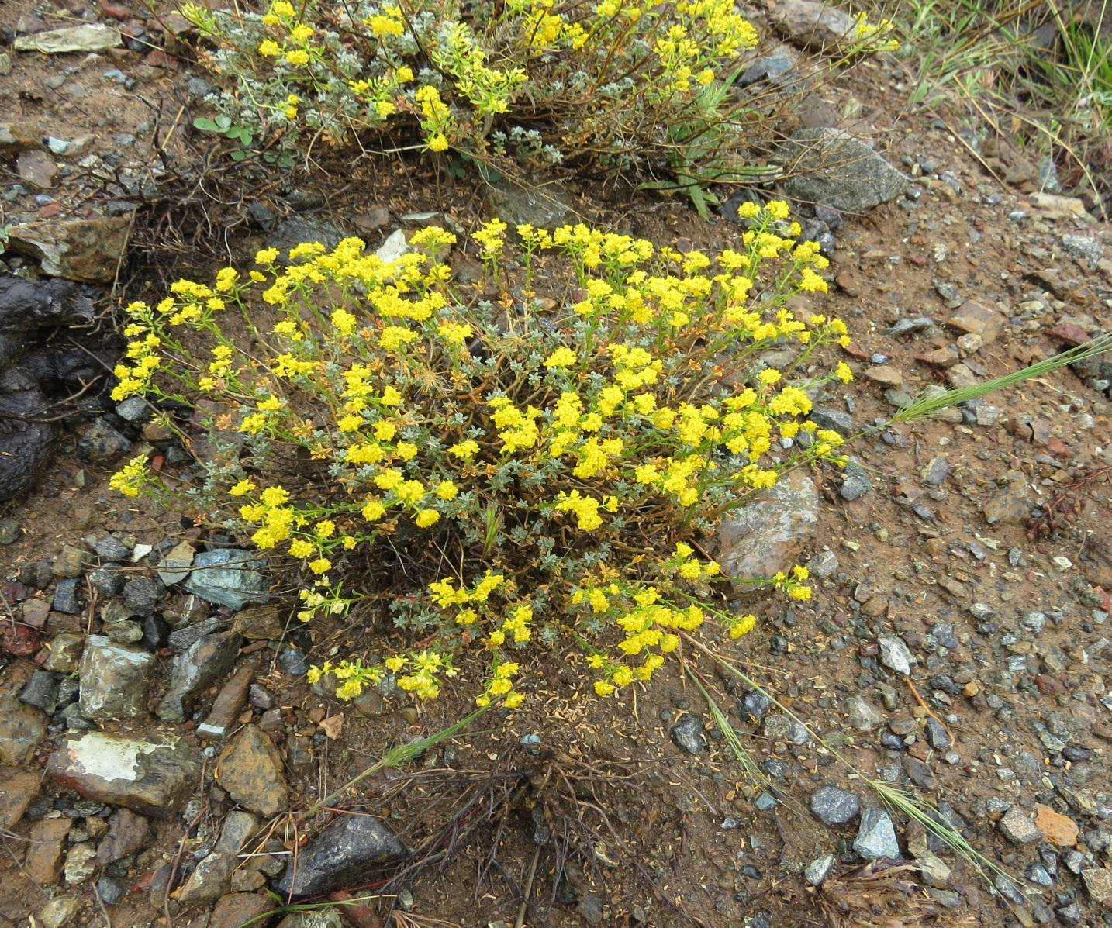

Fig.4: *Alyssum cypriacum,* a nickel hyperaccumulator plant.

Picture made available by Christodoulou Hadjigeorgios

For land that brings no other proceeds, like the top layer of mine tailings, phytomining can be economically interesting. Nickel is contained in the crystal lattice of olivine (about 0.2 to 0.3%). For the plants to extract this nickel, the olivine must weather, so for every ton of nickel 350 to 500 ton of olivine must weather. This is equivalent to a CO2 capture of 400 to 550 ton. Annual world production of nickel is 1.5 million tons. Even if only 1% of the required mining would be replaced by phytomining, this would already represent an annual decrease of 7.5 million ton CO2 emission. To calculate the total reduction of CO2 , the savings in emission from the normal mining and ore processing must be added.

15.Olivine transport and spreading by rivers. A very low-cost, but rather unusual way of spreading olivine is the following. Weathering is fastest in the wet tropics. New olivine mines should preferentially be started in these areas, to keep transport costs down. The word wet tropics implies the presence of large rivers, which burst their banks in the wet season. Downstream they will inundate the low land in the delta. The rivers transport not only large volumes of water, but also silt, around 7 kg/m3. When an olivine mine would discharge its fine olivine fraction also in the river, e.g. at a rate of 0.2 kg/m3, then this olivine fraction will also be transported by the river and settle on the flooded land. Part of the finest fraction will even end up in the sea where it will quickly weather. This will be a modest contribution to the recovery of the ocean acidification. When a tropical river in spate transports 10.000 m3 water per second, and assuming that the wet season will last 3 months, then each mine can spread 14 million tons of fine-grained olivine silt practically for free, thereby catching 17 million tons of CO2. With this simple approach it is likely that several tropical countries can compensate their entire CO2 emission.

References

[1] Van Schöll, L., Kuyper, Th.W., Smits, M.M., Landeweert, R., Hoffland, E. and Van Bremen, N**.** (2008) Rock-eating mycorrhizas: their role in plant nutrition and biogeochemical cycles. Plant Soil **303**:35–47.

[2] Dom, R.I. (2014) Ants as a powerful biotic agent of olivine and plagioclase dissolution. Geology, doi 10.1130/G35825.1

[3] Van der Werf, G.R., Morton, D.C., DeFries, R.C., Olivier,J.G.J., Kasibhatla,P.S., Jackson,R.B., Collatz,G.J. and Randerson, J.T. (2009) CO2 emissions from forest loss. Nature geoscience, Vol.2, November 2009.

[4] Needham, S.J. Worden, S.H. and Cuadros, J**.** (2006) Sediment ingestion by worms and the production of bio-clays: a study of macrobiologically enhanced weathering and early diagenetic processes. Sedimentology, **53**, 567–579.

[5] Schuiling, R.D. and de Boer, P.L. (2011) Rolling stones; fast weathering of olivine in shallow seas for cost-effective CO2 capture and mitigation of global warming and ocean acidification, Earth Syst. Dynam. Discuss., 2, 551-568, doi:10.5194/esdd-2-551-2011.

[6] Belderson, R.H., Wilson, J.B., Holme, N.A. (1988) Direct observations of longitudinal furrows and their transition with sand ribbons of strongly tidal seas. *in* P.L.de Boer et al. (eds) Tide-influenced sedimentary environments and facies, 79-91. Reidel Publ. Company.

[7] Lindeboom, R. (2014) Autogenerative High Pressure Digestion. Biogas production and upgrading in a single step. PhD thesis. Wageningen Agricultural University

[8] Baker, A.J.M., and Brooks, R.R. (1989) Terrestrial higher plants which hyperaccumulate chemical elements – a review of their distribution, ecology and phytochemistry. Biorecovery 1, 81-126

[9] Schuiling, R.D. (2013) Farming nickel from non-ore deposits, combined with CO2 sequestration. Natural Science **5**, no 4.