For the last month, I have been exploring using bamboo as a material for low-cost structures.

The traditional paradigm for bamboo construction is to use 3- or 4-years old bamboo poles that have been treated with a solution of boric acid/borax.

The raw bamboo pole of 5-meter length costs about Rs 60 /70 per pole or Rs 3 or 4 per running foot.
This treatment costs about Rs 25 to Rs 30 per running foot, which makes the treated pole cost at par with MS poles and with a life of 10 years at most. To protect the poles under use, they have to have a hat and a boot; meaning they have to have a roof over them and a concrete base. This adds to the high cost already. Transportation costs of bamboo poles is also very high making the viability of a bamboo house further questionable.

Traditional geodesic domes can be built using bamboo poles, as I have already done. However, for large structures, the geodesic domes require maths knowledge, precision tools, and hubs whose costs are not suitable one-of-a-type implementation.

Complex/expensive hubs for geodesic domes

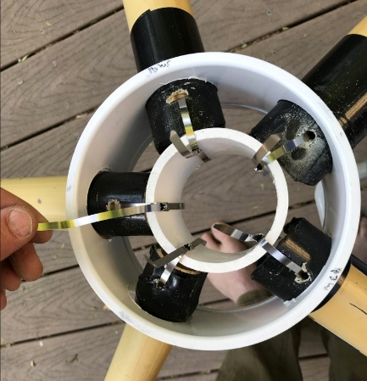 | 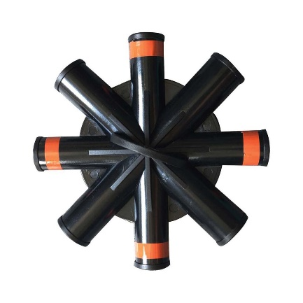 | 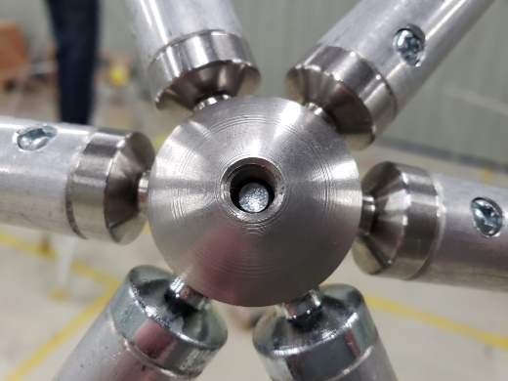 | 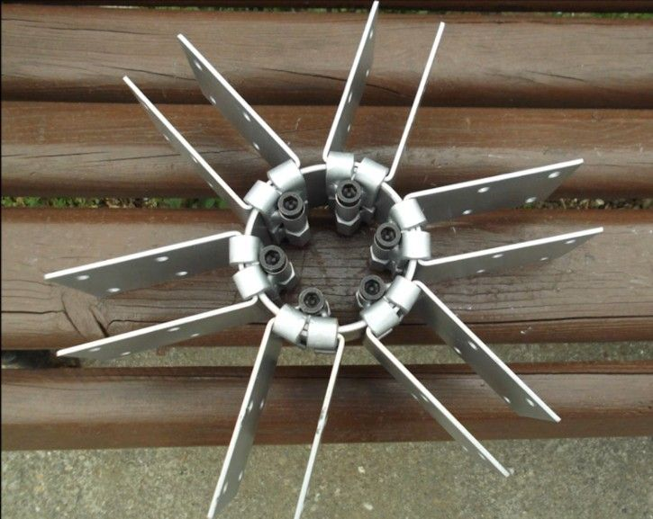

I have also been exploring another form of geodesic domes called nexorade. A nexorade with 33 feet radius covers 3,500 sq. ft of space and can be built with bamboo poles of 16 feet in length (as a simplification, the radius is just double the bamboo pole length.) There is a demand for such large structures, as meeting halls, a marketplace, a large dining hall/recreational area, etc. But nobody wants the structure to come crashing down their head after 10 years.

Nexorade Images
Bamboo pole nexorade | Nexorade with slats | Nexorade with Slats
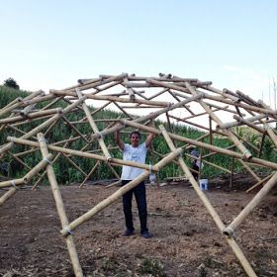 | 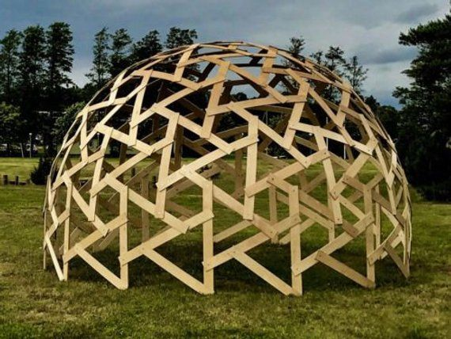 | 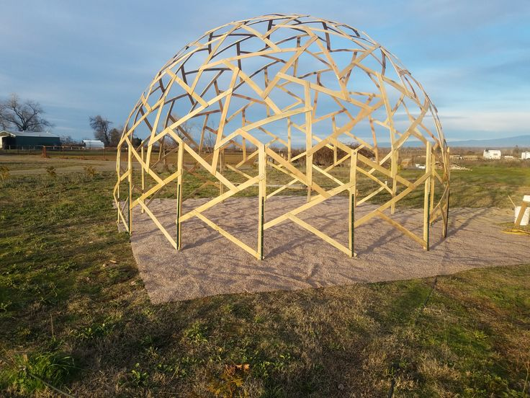

I was intensely searching for a solution that reduces the cost of the treatment and prolongs the life of the bamboo for 20 years or 30 years. In addition, redundancy is built into the structure so that the failure of a part does not lead to even a local sag.

About 15 days ago I had an insight that instead of using bamboo poles that might break at a later stage, why not break the pole before the use?
TRIZ teaches this as an engineering innovation principle called segmentation. Long bamboo splits, also called slats are one way to split bamboo before use. I was able to get 135 such splits of one-meter length each and started to build a nexorade in our garden. About 20% has been built. Till yesterday I was thinking that the next time around, I will place two splits, one over the other, tie them together with wire and treat them as one for strength and redundancy in making the nexorade.

Bamboo Poles | Bamboo splits connector
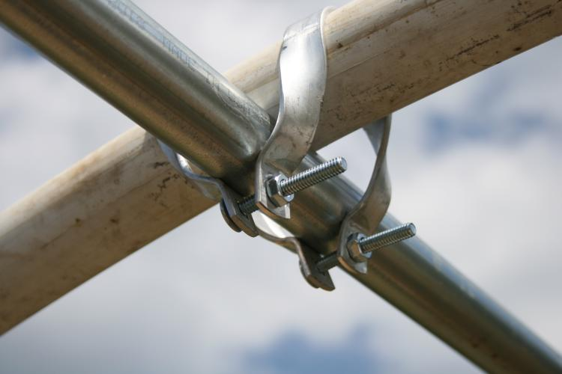 | 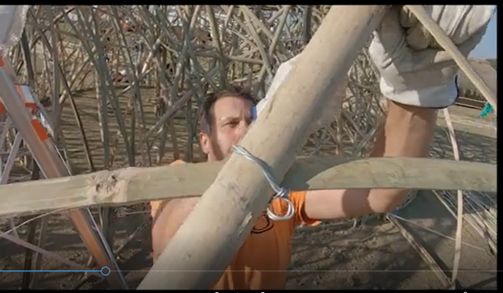

I have learnt from experience that to make drastic cost changes, it’s necessary to throw away the existing paradigm of manufacturing.

Construction paradigm changes thus undergone two changes.
Firstly, Dome are replaced by nexorades.
Secondly, bamboo poles are replaced by bamboo splits.

Small domes (say less than 24 feet diameter) can be built with simple hubs.
Large domes need expensive hubs whose number rapidly increases with diameter.
Struts have holes drilled into them so that they can join to the hubs.
Bamboo poles lose some strength when holes are drilled into them.
They also develop a tendency to split along the line aligning the two holes.

Nexorades, large or small, are inter-woven and need no hubs at all.
All interweaving points represent the same thing; just two nexorades crossing over each other.
Interweaving points can be fixed with a mechanism with holes or without any holes.
In particular, bamboo splits can be fixed with a simple thin GI wire cross-over without making any holes that weaken the bamboo.

I was also searching for paradigm changes in the treatment costs.
The first thing I wanted to do was to replace the boric salts with almost zero-cost chemicals that just drive out the sugars from the bamboo poles and give some protection.
I decided that common salt as obtained from the sea, would do the purpose.
To treat one ton of bamboo, which is about 100 poles, twenty kgs of common salt may be needed.
Make a super saturated solution of common salt and push the sugar out with it.
Some suggest adding another low-cost element, alum, to this mixture.

As common salt attracts moisture, it too will leech out and therefore will not give a life beyond 10 years.
It needs to be supplemented with a method that is not water-based but is based on oil, gas or is an emulsion etc or uses some other paradigm like a slow release drug.

Smouldering car/scooter tyres emit poisonous gases and char particles that can be blown into an underground chamber where bamboos are kept. A slight draft would ensure that the gases and char particles are evenly and thoroughly spread over the bamboo. Say a week of treatment like this would give a non-leeching treatment to the bamboo.

Yesterday I saw a video from Manipur which validates my thinking and lead me to a good solution.
The video is over 3 hours long but you can watch just the first 20 minutes. The link is given below:
How To make a Mud Bamboo House in Just 5 Hours ? Learn from experts @ Worldbamboo manipur - YouTube

Proposed Solution Steps:
- Treat bamboo with ordinary salt, dry it, and split it into 5 parts for thick bamboo or 4 parts for thinner bamboo.
- Boil splits in spent engine oil heated to its boiling point. Remove from fire and let them cool in the oil for a day. Drain excess oil from the splits in a big drum. Wipe the splits which are then ready to use.
- Where the structure calls a single-pole, replace that with two/three splits parallel to each other and weave the splits from the other side between them. Tie with a single strand of gauge 20-gauge galvanized wire that is cheap and commonly available. You need pliers that cost about Rs 200 to do a good job.
- For large carpet area demands like a glass house, a large meeting hall, etc. nexorades of woven splits would be the right solution.
- For houses for common persons, nexorades may not work. Geodesic domes may not sell.
- For a house of 400 sq ft area, I propose a half capsule shape bamboo split structure, with a breadth of 13 feet and length of 32 feet with rounded ends, and near straight walls that merge into a roof of say 12 ft height. All these parameters can easily be varied.
- The strength of the geodesic dome partly comes from its triangulation. Weaving bamboo into a triangular weave or a hexagon weave is a well-known art. Using either weave, use two/three parallel bamboo splits to weave the walls and roof such that the weave holes are about one foot wide.

Triangular Weave | Hexagonal Weave
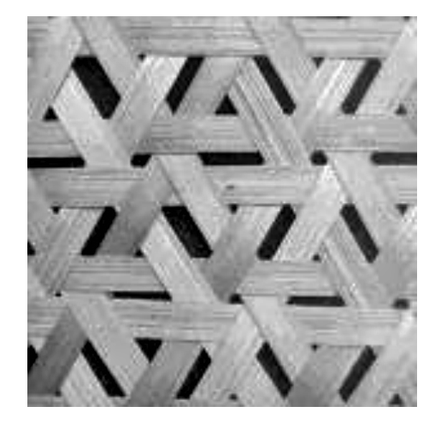 | 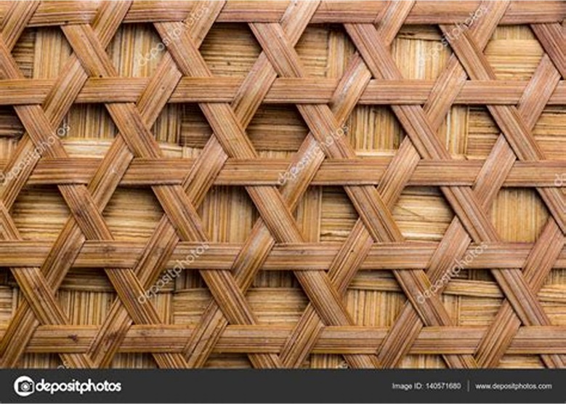

- Apply Ferro-cement to the structure for a home and bury the bamboo inside the Ferro-cement.
- A stone rubble foundation, or better, is essential.
- Costing is not possible at this moment till the first experimental structure is built.

Comments and questions as well as suggestions for improvement are all welcome.
Regards
Ashok

