Observations from the OuiShare 2015 Conference on the Collaborative Economy

The Collaborative Economy represents a broad set of emergent trends, but is most well-known for the new and disruptive business models of companies such as Airbnb and UBER. Both of these companies have created young billionaires in a depressed global economy and in doing so have attracted a lot of attention from the media, entrepreneurs as well as traditional businesses.

PWC estimates that the collaborative economy is growing faster than Facebook, Yahoo and Google combined. It is currently a 15 billion dollar market, but PWC speculates that it could be worth 335 billion by 2030. There are currently over 7500 sharing platforms.

But business success represents only one side of the story, and the bigger picture includes a broad range of actors working for social and political change.

The OuiShareFest 2015 was the 3rd annual conference of the global collaborative economy, and brought together over 1000 people from a diverse range of backgrounds and interests. Participants ranged from entrepreneurs, to social, political and environmental activists, all dedicated and optimistic about the creation of a new and different future.

The theme of the conference was Lost in Transition. Many of the speakers referred to this theme, as it reflects some of the current challenges, tensions and dilemmas of the collaborative economy. Transition is change, and the actors feel stuck between things moving too fast, and other things (like regulatory frameworks) moving too slow.

“We are in the space between certainties”

DRR is a collaborative enterprise by nature and I attended to understand both the successes, and learn from those dedicated to the collaborative economy.

Motivations and Drivers:

The collaborative economy, also called the sharing economy was partly borne from the economic downturn, the resulting austerity and lack of confidence in banks and institutions, partly borne from the newly discovered ability to re-purpose an abundance of underused assets and partly a reaction to the modern throwaway society.

Entrepreneurs like Airbnb and BlaBlaCar have developed clever ways to monetise excess capacity, such as spare bedrooms and empty car seats. Ecological and social applications such as tool or car sharing sites change the unsustainable throw away economy, and improve society through sharing.
Political applications such as DemocracyOS hope increase direct democracy and provide better stewardship of the commons.

Regular businesses and local politics see the sharing economy as a way to engage younger people, and the 25-34 year old millennials are driving the sharing economy.

Opportunities and Advantages of the Collaborative Economy:

Internet platforms enable instant connections between diverse and geographically distributed supply and demand, and empower both sides of the by dramatically lowering transaction costs. Platforms are massively and rapidly scalable, and lessons and improvements can be transferred instantly.

It took Intercontinental hotel group over 60 years to grow to an enterprise with 650,000 rooms. Airbnb grew to this size in just 4 years.

Trust is a fundamental element of all transactions, can be mediated through reputation engines which provide third party valuation.

Ebay was the first to prove this, but almost all collaborative economy applications are based on reputation.

Gifting economy applications may start with the idea of saving money, but the real value and appreciation lie in how they help people to re-learn social behavior, and change the way we perceive society.

Couch surfing now has over 10 million members who stay for free at other members houses. The major draw has turned out to be the social interaction, rather than the cost saving.

Local solutions help build community fabric and take many people from social isolation to promoters of community values. They help us meet unexpected but relevant people

The Repair Café movement which started in the Netherlands offers free community repair services and has now been replicated in 18 countries “What’s interesting for us is that it creates new places for people to meet, not just live next to each other like strangers. That it’s linked to sustainability makes it even more interesting”

“Every meetup is the strengthening of a web of social fabric - not just transactional but networking”
The use of collaborative applications by local governments has successfully lowered the average age of participation.

The Jemengage site in Paris is a participatory budgeting platform with an average participant age of 32 - much lower than traditional demographic for city participation - which is old, socialist and retired.

The maker community is bringing production (and customization) back to the individual. 3D printing can reduce the need to stock a supply of spare parts, and also allow individuals to design and create their own objects

Hasbro allows people to print toys on 3D

Products and brands are evolving to services.

Car makers such as BMW now allow you to rent an electric car.

Local currencies can reverse the economic trends of globalization, which often return little to the local economy.

The mayor of Brighton U.K. takes his full salary in local currency, and many communities are considering paying a portion of their procurement budget in local currency.

Well-designed communication can create massive social change.

The Story of Stuff - 9 short movies have been viewed over 45 million times. “People are overwhelmed by the problems, want to do something, and feel that they can make a better world. The challenge for citizen engagement is different than we thought”

Putting a face on a transaction changes the way people behave. No one cares about hotel rooms, but they do care about your home.

HomeExcange has brokered over 1 million exchanges, with almost no problems

Platforms learn from the crowd and add value.

Duolingo platform has turned 150 hours of regular language study into 34 hours.

Large central platforms have the power to change laws and change the regulatory framework.

Social support for Airbnb has changed the regulatory framework in many cities.

New business models create new challenges, but also help solve them with new creative solutions

Keepdriving is a simple car loaning system that helps drivers in ride programs such as Lyft and UBER maintain their income when their car is having repair.

Emerging Issues and Challenges:

In spite of the general optimism of a new, more social, more collaborative future that the actors envisage, the OuiShare conference also had open and direct discussions on the challenges and issues that are rapidly emerging.

The conference theme “Lost in Transition” was highly appropriate.

Successful platforms such as Airbnb, UBER and BlaBlaCar and essentially trying to scale globally and are creating new monopolies. These monopolies are not owned by the collaborators, but rather by venture capitalists (the 1%) that inject hundreds of millions of dollars into their rapid expansion. 37% of sharing economy startups are venture capitalist funded.

While the sharing economy has been shown to have a greater impact on low income communities, the monetization of excess capacity favours those with existing wealth, such as those with spare rooms, spare houses and spare cars, and may increase global inequality.

Employment in a distributed service economy such as TaskRabbit can re-employ, but is also seen as creating precarious jobs with low wages and no benefits. 52 million people, or 1 in 3 in the U.S. work independently. Freelancers want to work that way, as they enjoy the flexibility, but are also very afraid and the number one issue is anxiety. How do you measure the economy (or GDP) when you can't count jobs?

Social welfare and tax systems are currently unable to cope with informal nature of the sharing economy and may become unsustainable. The digital economy is global but tax systems are national - and effective tax systems are based on willingness to pay.

There is a potential for criminal abuse of reputation based online systems by those wishing to gain money, visas or other social assets.

Reputation and social recommendation can permit covert racism. Studies have shown that Airbnb hosts can easily discriminate, where the traditional hotel sector does not.
If reputation is largely defined online, what about people who are not in social networks = no trust?

Sharing has increased significantly in the economic recession, but might not survive an economic recovery. Pressure from cheap goods and strong marketing will eliminate part of this new market.

The collaborative or sharing economy can strengthen civic participation and improve democracy, but there is currently a lack of knowledge on how to manage the common assets. Direct democracy can be manipulated by fear or xenophobia.

Global platforms (and technology) can drain money from local and national economies. Using an iPhone to take an UBER ride to your Airbnb creates some local wealth, but corporate profits are all made in California.

Platforms like Google and Facebook has found ways to capitalize of normal activity like shopping or social interaction by selling ads or collecting and selling data, in exchange for free services. At what point will they also charge for the services, and what then is the return to the participants?

Some new ideas can be successfully supported through crowd funding, but can then be sold for high profit to predatory capitalists with no return to the initial supporters. Oculus virtual reality glasses – was originally crowd-funded through Kickstarter and raised 2 million - sold later for 2.5 billion to Facebook.

Established interests that are opposed to and fearful of disruption and will fight to block change using significant resources, potentially slowing or stopping progressive social change. Bitcoin and the blockchain are considered revolutionary by some and serious threats by others.

New political parties can fake participation through the Internet, and regain power. False share washing can be used to maintain current power structures. Key elements of accountability and responsibility need to be developed .

Implications for DRR:

Resilient cities are sustainable cities and can learn from successful efforts in Sharing cities See: http://www.shareable.net/sharing-cities

Bottom up DRR citizen movement can learn from Story of Stuff - what about the story of RISK? UNISDR should create a video. See: http://storyofstuff.org/

Crowd sourcing of translation of DRR documents can get help from makesense or crowdsourcingweek

Application design of marketplace platform can learn from reputation engines, and comparing sites which provide insight on motivations built into platforms. See presentations by Traity.

General use of collaborative economy principles and online applications can increase the participation of younger actors in DRR

Craig Duncan – May 27, 2015

Notes and references:

Report March 2015 – What we know about the Sharing Economy

http://www.compareandshare.com

Quiz about what type of Change Maker you are:

Resister, Networker, Nurturer, Investigator, Builder, Communicator
http://storyofstuff.org/changemaker/

Citizen muscle boot camp:

4 week MOOC
Connecting with your purpose
Talking skills
Growing your network
Plans into action

Peer review of social entrepreneur ideas
Makesense.org

Proving that business are not green washing
Businessimpactassessment.net -

Sharing cities

Instead of the corporate narrative as a marketplace - see the city as a commons
http://www.shareable.net/sharing-cities

How to spot open washing
http://readwrite.com/2011/02/03/how_to_spot_openwashing

Ind.ie manifesto
I love the Internet. I love modern technology. I love to share, to learn, to grow, to connect.
I don’t love being your product.
I am not a thing to be mined and farmed and sold.
I am not your lab rat.
POC21 Hacking the COP with open source. Innovation camp - 12 projects - 5 Weeks >> Paris during COP21 Poc.cc

Egosystem vs. Ecosystem diagram:

Egosystems are based on control - Ecosystems call on what is needed

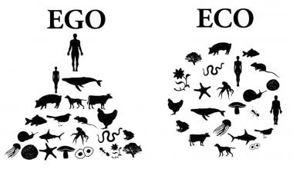

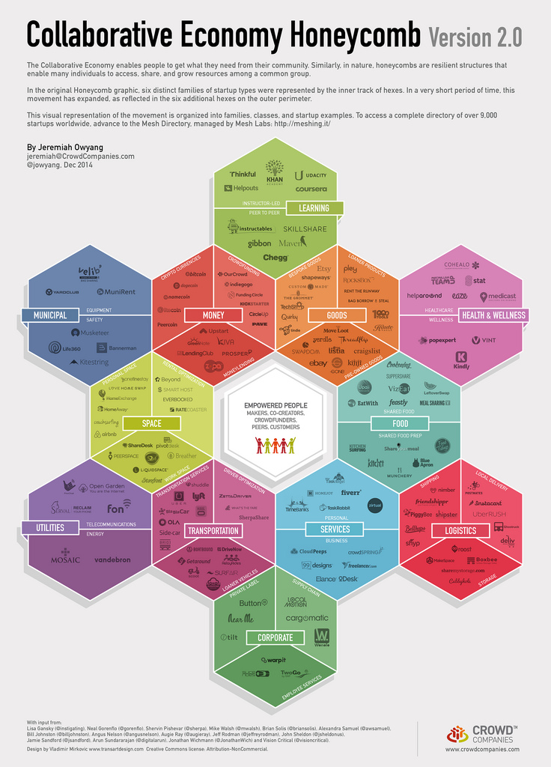

Kacklay's level of citizen science:
At the most basic level, participation is limited to the provision of resources, and the cognitive engagement is minimal. This can be termed ‘crowdsourcing’. In participatory sensing, the implementation of a similar level of engagement will have participants asked to carry sensors around and bring them back to the experiment organiser.
The second level is ‘distributed intelligence’ in which the cognitive ability of the participants is the resource that is being used. Galaxy Zoo and many of the ‘classic’ citizen science projects are working at this level. The participants are asked to take some basic training, and then collect data or carry out a simple interpretation activity
The next level, which is especially relevant in ‘community science’ is a level of participation in which the problem definition is set by the participants and, in consultation with scientists and experts, a data collection method is devised. The participants are then engaged in data collection, but require the assistance of the experts in analysing and interpreting the results. This method is common in environmental justice cases.
Finally, collaborative science is a completely integrated activity, as it is in parts of astronomy where professional and non-professional scientists are involved in deciding on which scientific problems to work and the nature of the data.

14 parts of the crowdsourcing economy – from Crowdsourcingweek

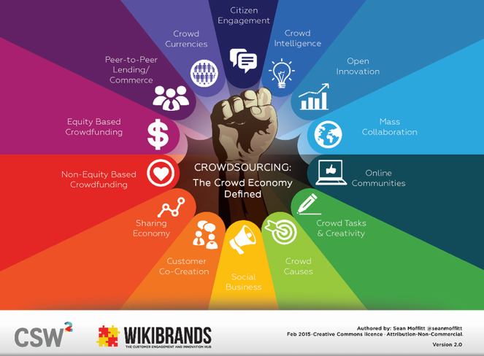

#1 Crowd Currencies – alternative currencies moderated and balanced by the crowd in a distributed, decentralized and publicly-known manner e.g. Bitcoin
#2 Peer-to-Peer Lending/Commerce – direct social lending and socialized commerce between people without a financial or retail intermediary e.g. Lending Club, Etsy.
#3 Equity Based Crowdfunding – members of the crowd become part-owners of the company which is raising funds in the form of shares and dividends e.g. Crowdcube.
#4 Non-Equity Based Crowdfunding – members of the crowd give money to support a worthy cause or as an exchange for a “reward,” typically the product or service that the crowdfunding company produces or provides e.g Kickstarter.
#5 Sharing Economy – a collaborative economic model built around the sharing of human and physical resources incl. shared creation, production, distribution, trade and consumption of goods, space, travel and services by different people and organizations e.g. Airbnb .
#6 Customer Co-Creation – a partnership between an organization and group of customers, to jointly produce a mutually valued outcome while encouraging a more active involvement from the customer to create a value rich experience e.g. Lego Mindstorms, Threadless.
#7 Social Business – companies who encourage genuine listening, sharing, engagement and commerce through open, social channels to create value across the corporation or within various functions e.g. Dell, Betabrand.
#8 Crowd Causes – individuals, not-for-profits or purpose-driven organizations, who engage collectively with passionate and interested stakeholders to raise the profile, impact and fundraising potential of their causes e.g. Charity Water.
#9 Crowd Tasks and Creativity – the effort of obtaining requested labour, services, solutions, ideas, or content by soliciting contributions from groups of people, typically online and geographically dispersed, rather than via traditional employees or suppliers e.g. Amazon Mechanical Turk, Crowdspring, Freelancer
#10 Online Communities – groups of individuals gathering and participating on web-based platform(s) and interacting with one another on an ongoing basis driven by a common, tribal attraction for a belief, idea, product, brand, idea, cause or business e.g. Reddit.
#11 Mass Collaboration – a form of collective action that occurs when large numbers of people work independently on a single project, often modular in nature, that produce shared understandings and outputs e.g. Wikipedia.
#12 Open Innovation – use of inflows and outflows of knowledge to accelerate innovation inside organizations, and expand markets for external applications, through more permeable, open organizational boundaries and combining the organization’s resources with external co-operators e. Nine Sigma, OpenIDEO.
#13 Crowd Intelligence – the shared or group intelligence and insight that emerges from the collaboration, collective efforts, and/or competition of many individuals e.g. Netflix, Quora.
#14 Civic Engagement – digitally-connected platforms and activities to help inform, organize, empower and mobilize citizens, communities, national, regional and global movements e.g. Code for America, Challenge.gov.
END

