UPDATE ON THE SCHOOL BUILDING PROJECT AT MAKOROMBO
On the 4th of February, 2023, the school foundation was laid, and thereafter, the women in the two communities filled the foundation with top soil. The same women also transported all the blocks from the block construction site to the building construction site. Thereafter the technical team for the construction work commenced the work. Water fetching was also done by the women and they were so happy for this exercise. Below are photos of some of the work we have carried out so far.
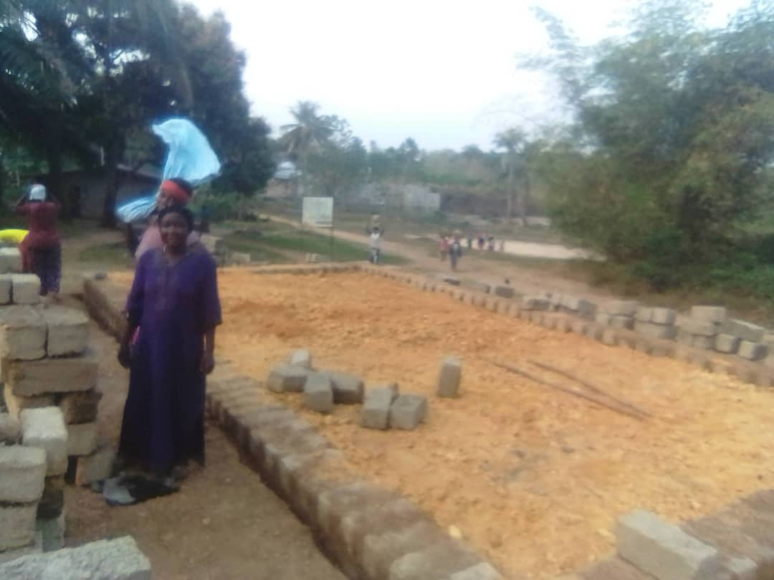
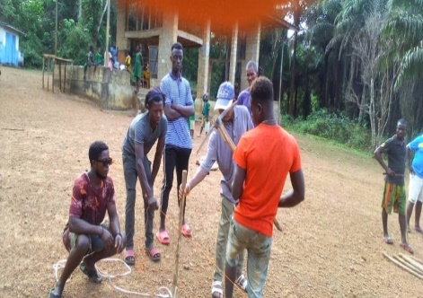
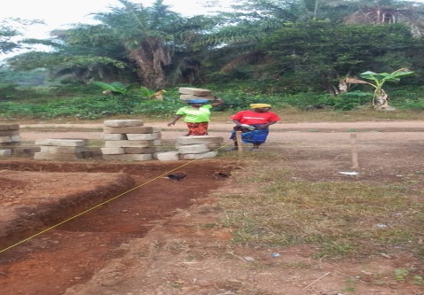
Laying out of school foundation digging of foundation constructed foundation
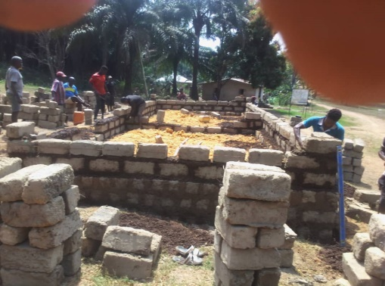
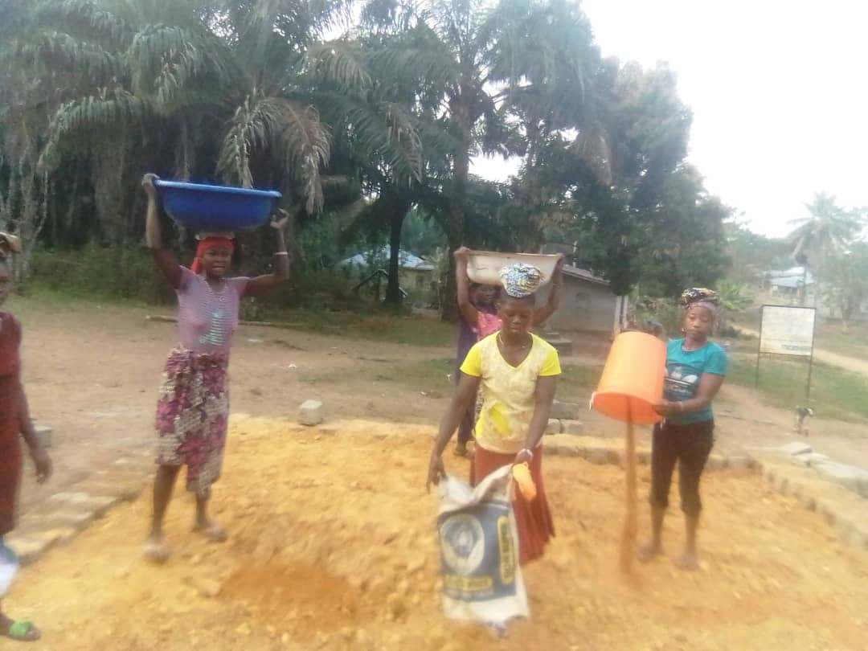
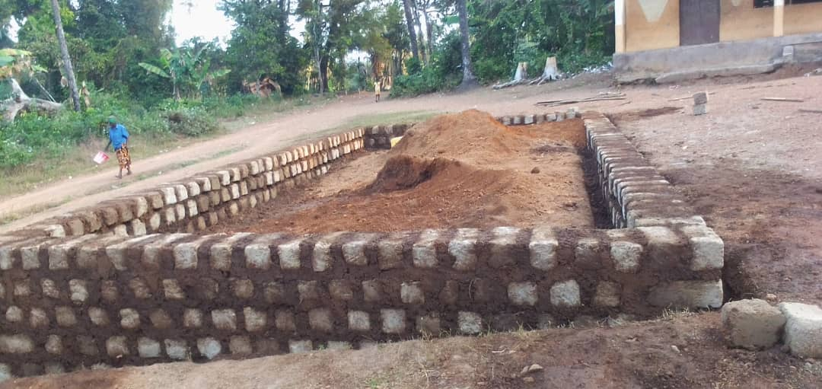
Filling of foundation by women
Foundation fully constructed Construction of walls

Construction of wall height in progress current construction level
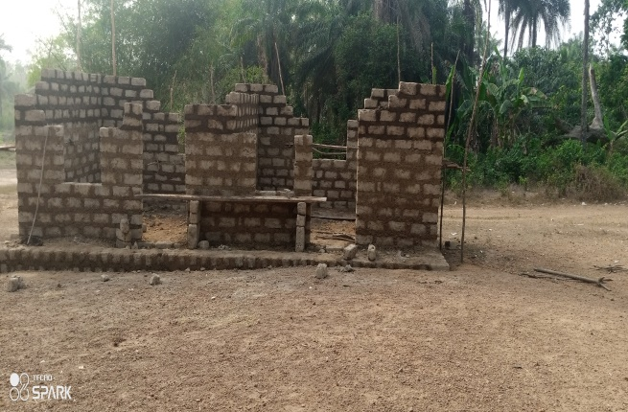
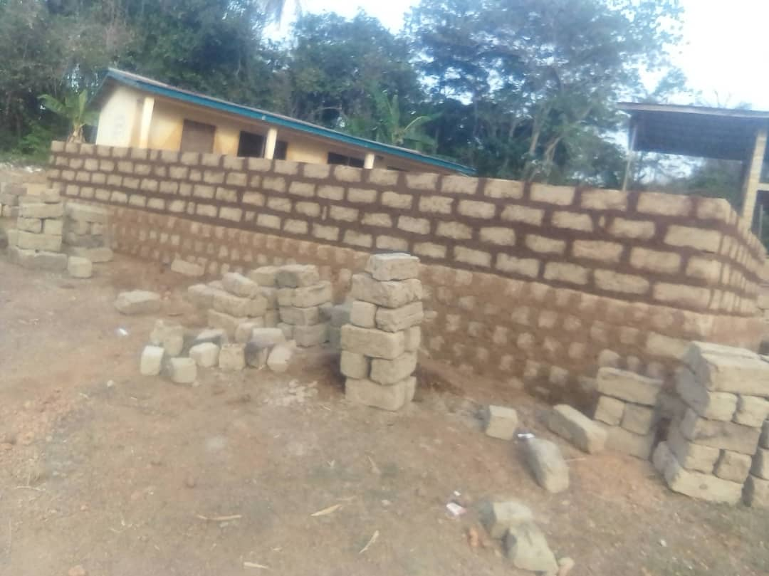
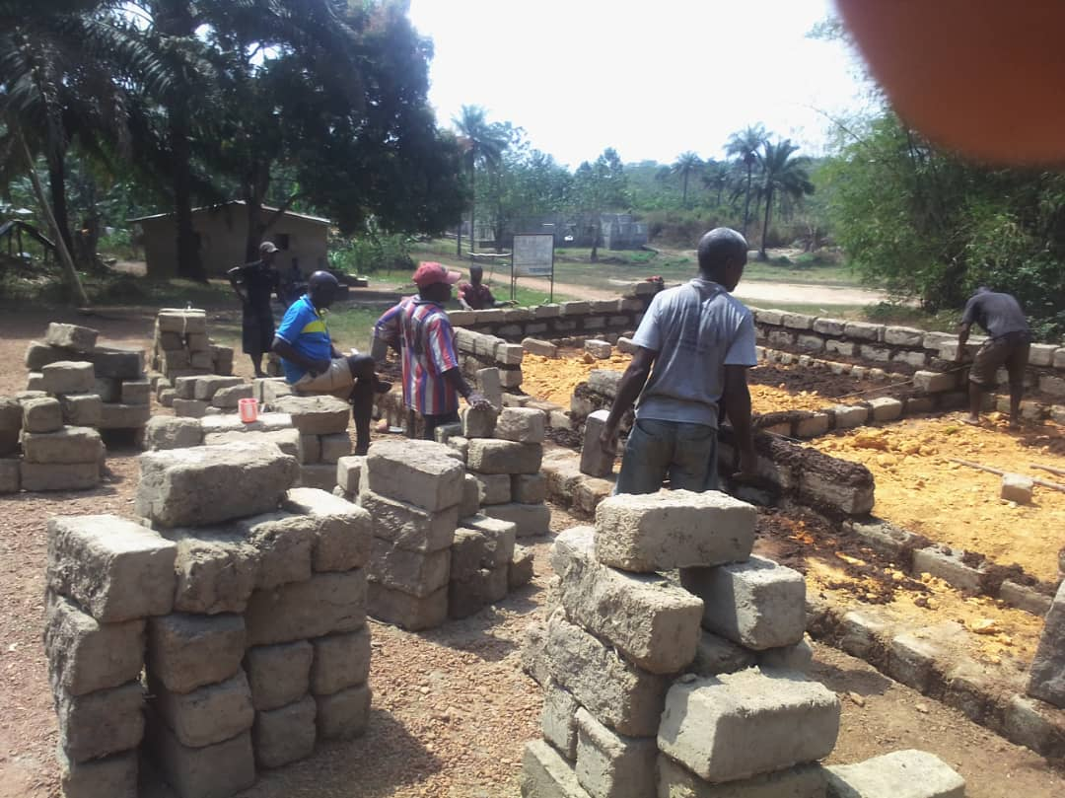
Demarcation of classrooms

