PEOPLE’S ACTION AGAINST HUNGER-SL
PROGRESS REPORT FOR WELL CONSTRUTION IN MBUNDORBU COMMUNITY BAOMA CHIEFDOM
Funds received from friends for Sierra Leone for the well construction in Mbundorbu community Baoma chiefdom is still ongoing, After completion a comprehensive and final report will be made after the fixing of everything and water is running .building a water well for a community can save lives, keep families healthy and promote health among the most vulnerable.. a water well is a simple but robust mechanism that can extract water from a greater depth of over 100 feet from the ground. due their capacity in the volume of water they can extract and their durability, they can support entire communities (consisting of many households) with access to clean water, every single day, any time of the day.
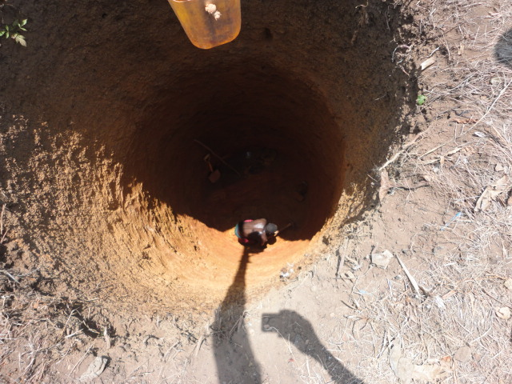
Current pictures of the installation of water well
