Previous emails in Google forms separated by a comma
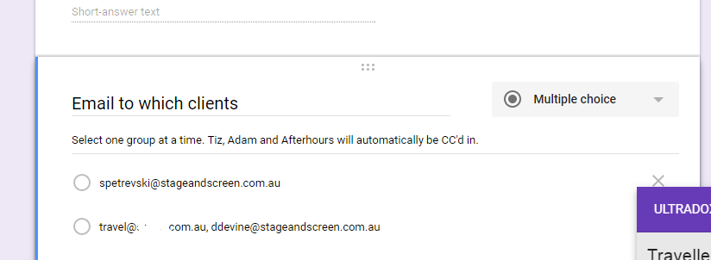
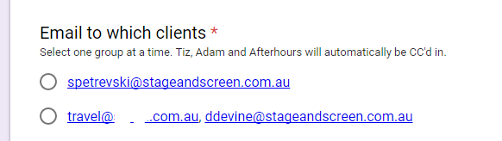
Now using Ultradox Form and the comma lists each email as new answer.
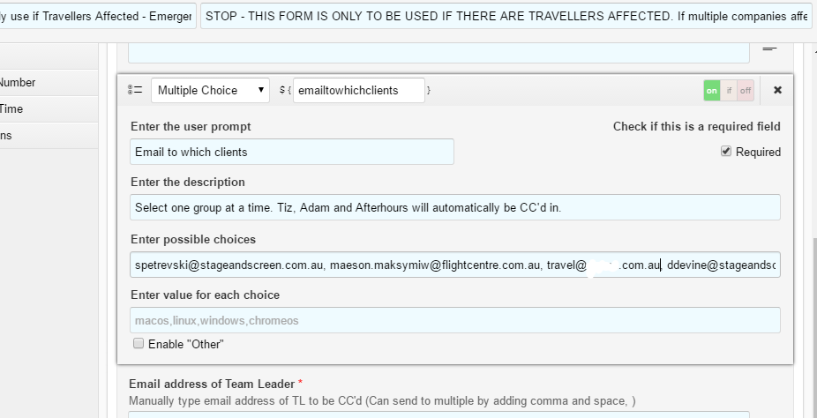

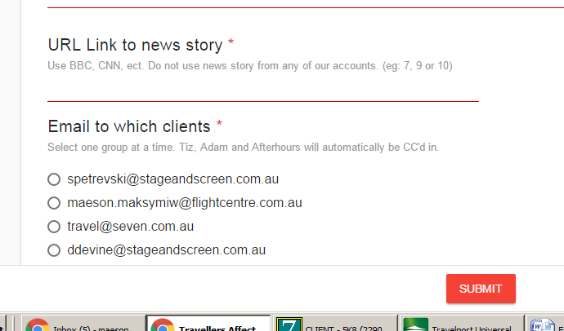

I notice there was a \ before the comma which did group the emails together in the form setup, however when loading the actual form it still separates the email addresses.
