PRACTICAL NO:-7
AIM: IDENTIFY AND SPECIFY DIFFERENT TYPES OF WIRES, CABLES, CABLE JOINTS USED FOR DIFFERENT CURRENT AND VOLTAGE RATINGS.
THEORY:
Wires are used for passage of electric current in many ways from generating power plant to various distribution levels like (1) In overhead Transmission and distribution lines,(2) In giving service connection to various consumers,(3) In winding coils of electrical machines,(4) In house and industrial wiring,(5) In underground cables etc.
For conduction of small current, single standard insulated copper conductors are used. As per the current rating, the conductors have specific diameter or cross-sectional area and level of insulation depends upon voltage rating. Following various types of wires and cables are used in domestic and industrial wiring:
- V.I.R.( Vulcanized India Rubber) wire
- C.T.S. or T.R.S. (Cab tyre Sheathed or Tough Rubber Sheathed) wire
- Weather proof wire
- L.C.(Lead Covered) wire
- MICC (Mineral insulated copper covered) wire
- PVC (Poly Vinyl Chloride) wire
- Flexible wire
1) VIR (Vulcanized India rubber) wire:
In this type of wires conductors are made up of aluminum or copper. A layer of vulcanized rubber is provided over it. There may one or two layers. Over this a cotton tape is wound and braiding of impregnated cotton is wound over it.
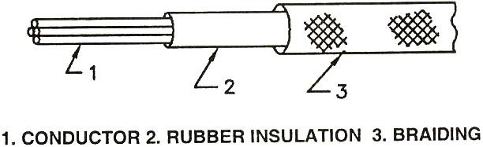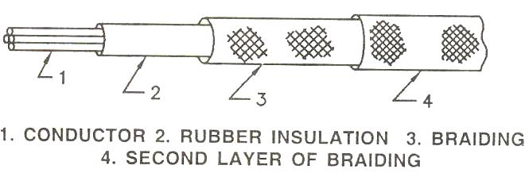
Figure 1 Single Braided VIR Wire FIGURE 2 Double Braided VIR Wire
Single braided wire and double braided wire is shown in figure. These types of wires can bear little mechanical stress. Due to the effect of water, moisture etc. its insulation properties are reduced. Chemicals also effect the insulation and it may be cut due to the sharp tools etc. Due to excessive heat the rubber may melt.

2) CTS or TRS (Cab tire Sheath or tough rubber sheath) wire:
In this type of wire layer of strong and durable rubber is provided over the conductor. Its mechanical strength is more than that of the VIR wire. Effect of heat, moisture and water is less in it. This type of wire is available in varieties of single core, twin cores and three cores. It is used in house wiring and industrial wiring. Single core and twin core wire is shown in figure.
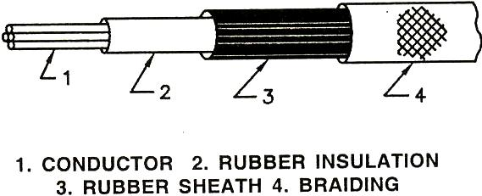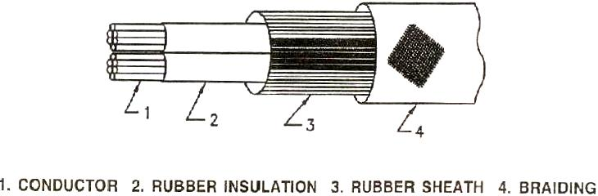
FIGURE 3 Single Core TRS Wire FIGURE 4 Twin Core TRS Wire

(3) Weather proof wire:
On this type of wire there is no effect of atmosphere. A layer of rubber is provided on copper conductor. Braiding of cotton is provided on this. It is made waterproof by dipping it into waterproof compound. This type of wire is available in single core or double core types. Outer sheath is inflammable so it is ot used in casing-capping type wiring and the places where there are inflammable materials. It is useful in service connections. Its use is nowadays has become limited.
(4) LC (Lead Covered) wire:
In this type of wire coating of insulated rubber is provided on the conductor. A tube made of lead is kept over it. Due to there is no effect of moisture on the rubber. So it is used in the place where there is presence of moisture. As Lead is soft. It is easily affected by mechanical stresses. So care has to be taken while using it. This wire can be used directly on wooden batten.
(5) MICC (Mineral insulated copper covered) wire:
In this type of wire coating of magnesium oxide is provided as insulation on the copper conductor. Over this copper sheath is provided. When this wire has to be used in moist atmosphere, a serving made of PVC is provided over this. This wire is less affected by temperature. This type of wire is used in wiring in mines, factories, refineries, furnace, boilers, rolling mills etc.
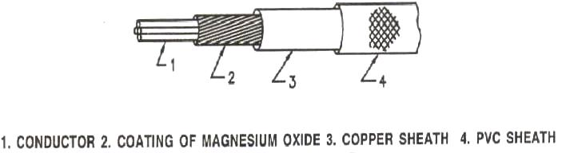
FIGURE 5 MICC Wire
(6)PVC (Poly Vinyl Chloride) Wire:
In this type of wire insulation made of poly vinyl chloride is provided over copper or aluminum conductor. PVC wires are widely used and use of paper and rubber insulated wires is reduced. This type of wire is manufactured for voltage rating of 11 KV. It is available in single PVC and double PVC Types. This type of wire is also available in twin core and three core circular and two core flat types.
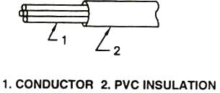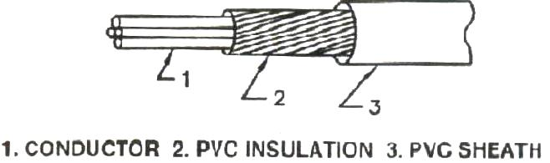
FIGURE 6 Single PVC Wire FIGURE 7 Double PVC Wire
(7)Flexible wire:
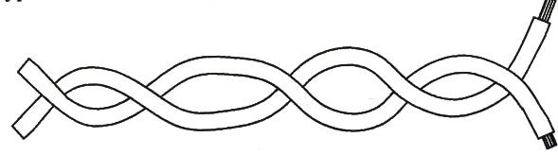
FIGURE 8 Flexible Wire
In this type of wire instead of using thick conductor many thin copper conductors of 36 gauges are used. This is called stranding. These wires are available in the size of 14/36, 23/36, 40/36 etc. These strands are twisted and PVC insulation is provided over it.
Such two wires of different colors of insulation are twisted together and coil is prepared. As the flexible wire is used instead of thick wire, the wire can be bent in any direction. This type of wire is used in giving connections to table lamp, fan, tube light etc.
CABLES: Cables are classified according to basis of construction.
(1)Low tension cable
(2) Belted cable
(3) Screened or H type cable
(4) SL type cable
(5) HSL type cable
(6)Super tension Cable
(1) Low Tension cable:
Vulcanized India rubber (VIR) cables are manufactured for the voltage ratings of 250/440V and 650/1100V. Aluminium or copper core is used. Insulation of VIR is provided on the core. Braiding of cotton, tough rubber sheath or metal sheath is used.
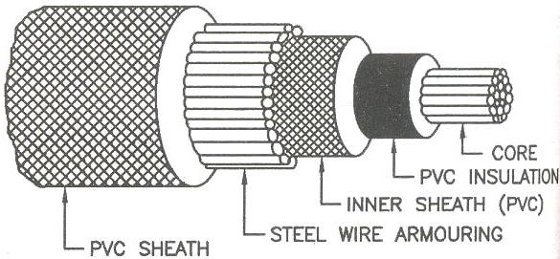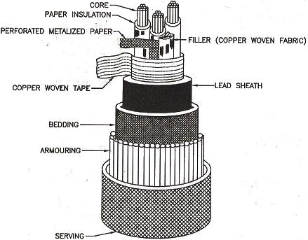
Figure 9 Construction of Single Core PVC Cable Figure 10 screened or H type cable

PVC cables are becoming popular. In this, there is insulation of PVC over the copper or aluminium core. Sheath of PVC is provided over the insulation. There is armoring of steel tape or steel wire over the sheath. There is covering of PVC over the armoring which works as the serving.
(2) Screened or H type Cable:
This type of cable was developed by M Hochstadter so this type of cable is known as the H type Cable. Figure shows the telescopic view of this type of cable. Each core is insulated and then a screen of metalized paper is wound round it. So this type of cable is called the screened type cable. Metalized screen is perforated so the process of impregnation can be done easily.
(3) Belted cables:
Belted cables are used for the medium voltages. Construction is similar to the LT Cables. There is paper insulation surrounding the core, which is called the belt. Figure (a) shows two-core shaped cable. Figure (b) shows three core shaped cable. Figure (c) shows the round core three-core cable while figure (d) shows four-core shaped cable.
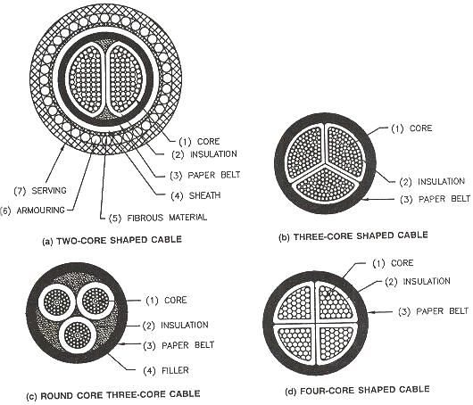
Figure 11 Belted Cables
(4) SL cable:
SL cable means separate lead sheathed cable. In this Type of cable, there is paper insulation surrounding the core. There is Separate lead sheath over each core. So all the three cores work as separate cable and the dielectric stress become radial. No overall lead sheath is used surrounding the three cores. Bedding, armoring and serving are provided like other cables.
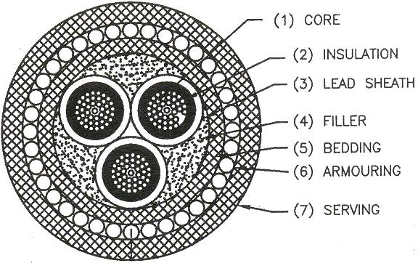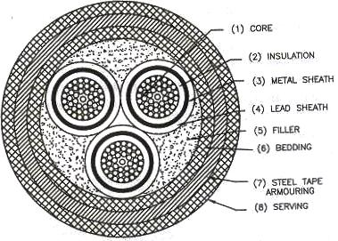
Figure 10 SL Cable Figure 11 HSL Cable
(5) HSL Cable:
This type of cable is the combination of H type and SL type cables. Paper insulation is provided over each core. Metalized paper is wound over the insulation and lead sheath is provided over this. Filler space is filled with copper woven fiber material. Bedding, armoring and serving are provided as usual.

(6) Super Tension Cable:
In this type of cable no additional arrangement is made to prevent the formation of voids. If the cables are to be used for 132 KV and 220 KV, arrangement has to be made to prevent formation of voids and to increase the dielectric strength. This can be achieved by two ways.
(1)By using the oil filled cables
(2) By using the gas filled cables.
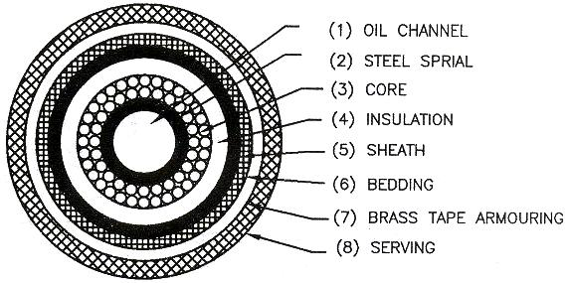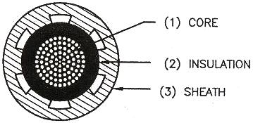
Figure 12 Single Core Cable with Oil Channel in Conductor Figure 13 single core oil filled cable with oil channel in the sheath

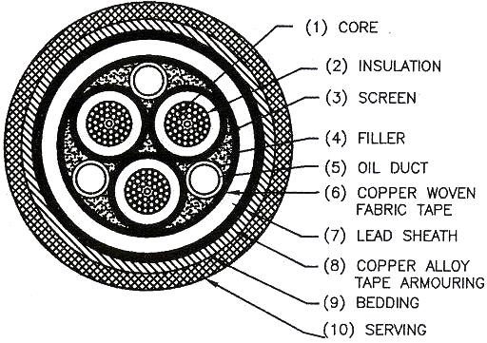
Figure 14 Three Core Cable with Oil Channel in the Filler Space

CONCLUSION:

