PRACTICAL:-6
AIM: TO IDENTIFY DIFFERENT TYPES OF DOMESTIC WIRING.
THEORY:
There are four types of wiring used in domestic wiring.
(1)Cleat wiring
(2) Batten Wiring
(3) Casing-Capping Wiring
(4) Conduit wiring
DOMESTIC WIRING:
(1)CLEAT WIRING:
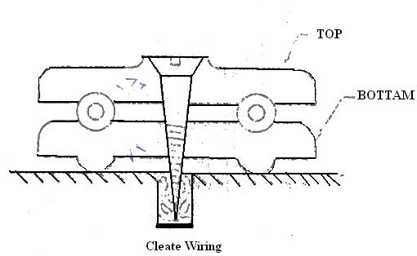
Cleat is in two parts. Two or three grooves are provided in the bottom part. Cleats are made from China Clay material. There is one hole in each part to allow the screw to pass through. Wires are placed in grooves and after putting the top cleat, it is fitted on wall. Distance of half a metre is kept between the adjacent cleats. Vulcanized India rubber (VIR) wire is used in cleat wiring. This type of wiring is used only for temporary use. It cannot be used for permanent use. Wires are in the open atmosphere so there is effect of dust, moisture, fumes etc.
(2)BATTEN WIRING:
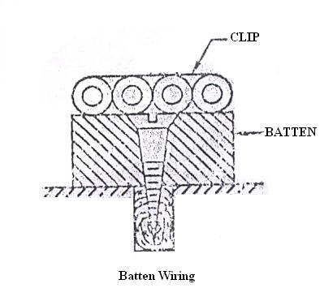
In this type of wiring a long wooden batten is fitted on the wall with the help of screws. Small clips are fitted on the batten with the help of small nails. Wires are fitted on the batten with the help of clips. The type of wiring depends upon the type of wire used.

(a)PVC Wiring:
In this type of wiring PVC wires are used. Single PVC or double PVC wires are used. PVC wires on batten wiring are popular for house wiring.
(b) TRS/CTS wiring:
In this type of wiring Tough Rubber Sheath (TRS) or Cab Tire Sheath (CTS) wires are employed. It is fitted on the batten with help of clips. As special type of rubber is used instead of ordinary rubber there is no effect of moisture. This type of wiring is costlier than PVC wiring.
(c) Lead Sheath wiring:
In this type of wiring lead sheath wire is used. So there is no effect of moisture, fumes etc. Moreover mechanical protection is available. It is necessary to earth the lead sheath.
(3) CASING-CAPPING WIRING:
There are two types of casing- capping wiring: (A)Wood casing-capping wiring and (B) PVC Casing-capping wiring
- Wood casing-capping wiring:
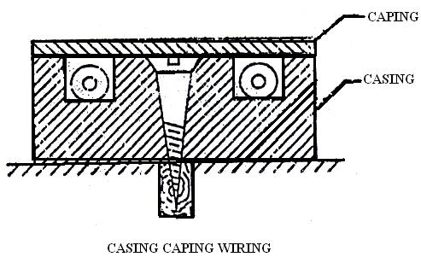
In this type of wiring there is long strip of wood with two grooves along the length. This is called casing. Casing is fitted on the wall with the help of screws. VIR wires are kept in the grooves. Casing is covered by thin strip of wood. It is known as capping. In this type wiring there is protection against moisture, dust, mechanical damage etc. but there is no protection against fire.

(b) PVC Casing-Capping wiring:
Recently PVC Casing-capping type wiring is becoming popular. It is called PVC Channel wiring also. PVC Channel is in two parts. One is the base and the other is the top. Base is of C section. Holes are drilled at regular intervals in the base for fixing. Channel is fixed on the wall or ceiling with the help of screws passing through these holes. There is snap on cover which is fixed on channel by pressing it. No nail or screw is needed for this. Channels are of two types: continuously slotted type and rigid type.
In Continuously slotted type channel, slots are given on both the side walls. Wires are taken in and out of the channel through these slots. In rigid type channel no slots are provided.
This type of wiring is light in weight and can be easily installed. Wires are not to be pulled as in conduit wiring. Its cost is less and fault can be detected easily, as the channel can be opened easily. In addition to this the appearance of wiring is also good.

(4) CONDUIT WIRING:
In this type of wiring long thin hollow tube of steel or PVC called Conduit is used. Conduit is fixed on wall with the help of saddle. Inspection boxes are provided at certain intervals.
PVC or VIR wire is kept in conduit. In conduit wiring there is protection against moisture, dust, mechanical damage, fire etc. however in PVC Conduit wiring there is no protection against fire.
Types of conduit wiring:
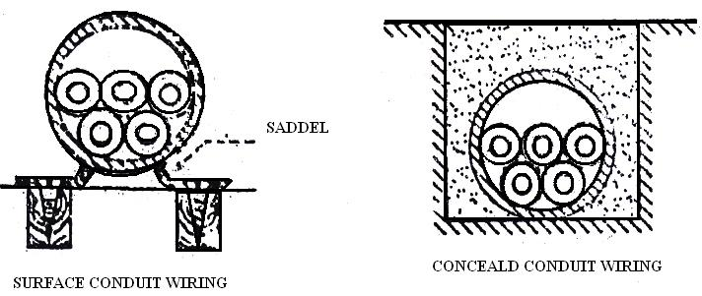
Conduit wiring can be done by two ways: (i) surface conduit wiring and (ii) concealed conduit wiring, in surface conduit wiring conduit is fixed on the surface of the wall or ceiling with the help of saddle. While in concealed conduit wiring Conduit is kept under the ceiling or wall. So conduit is not visible. So the appearance of the room is not spoiled due to the wiring. It is necessary first to decide precisely the locations of points because it is very difficult and costly to alter the locations afterwards. Surface conduit wiring are shown in figure.
TYPES OF CONDUIT:
For wiring the following type of conduits are used:
(1)Rigid steel conduit
(2) Rigid non-metallic conduit
(3) Flexible steel conduit
(4) Flexible non-metallic conduit

1) RIGID STEEL CONDUIT:
This type of conduit is made up of steel. There are two types:
(a)Heavy gauge screw type
Heavy gauge conduit is either solid drawn or welded type. Solid drawn conduit is costly. It is used only for gas proof or explosion proof wiring installations. While seam welded type heavy guage conduit is used for domestic, commercial and industrial wiring installations.
(b) Light gauge.
Light gauge conduit is manufactured by bending the thin sheet of steel. The vertical joint is sometime open. So it is not useful for weather proof wiring installations. This type of conduit cannot be used as earth conductor, but separate earth wire should be run.
2) NON-METALLIC CONDUIT:
Non-metallic conduit is made of fiber asbestos, PVC, high density polythene (HDP) or poly vinyl (PV). PVC conduits are widely used as it gives protection against moisture and chemical surroundings. Its weight is less and is less costly and can be installed easily. This type of conduit can be buried in wall or ceiling.
3) FLEXIBLE CONDUIT:
Where there are vibrations of the machine and where there is no possibility of installing rigid conduit. This type of conduit is used. Earthing wire has to be run.

CONCLUSION

