PRACTICAL-3
AIM: - IDENTIFY AND CONNECT VARIOUS ELECTRICAL MEASURING INSTRUMENTS AND MEASURE VARIOUS ELECTRICAL PARAMETERS LIKE CURRENT, VOLTAGE, POWER.
Voltmeter, Ammeter, Watt meter and Energy meter are four pillars of electrical energy and are most important devices used in electrical engineering field. You can't imagine any application in electrical engineering without voltage, current, energy and power measurement. Voltmeter, Ammeter, Watt meter and Energy meter connections and basics are discussed here.
If you are an electrical engineer than you must know how to connect various electrical instruments in a circuit, specially measuring instruments. The most common instruments or measuring apparatus you must know about are Voltmeter, Ammeter, Energy meter and Watt meter.
AMMETER: -
An ammeter is a measuring instrument used to measure the electric current in a circuit. Electric currents are measured in amperes (A), hence the name. Instruments used to measure smaller currents, in the milli ampere or microampere range, are designated as millimeters or micro ammeters. Early ammeters were laboratory instruments which relied on the Earth's magnetic field for operation. By the late 19th century, improved instruments were designed which could be mounted in any position and allowed accurate measurements in electric power systems.
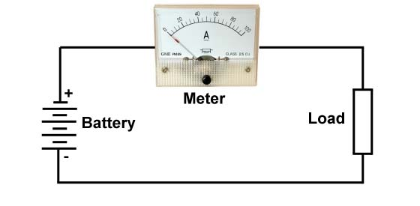
Connection of an ammeter is shown below with circuit diagram: -

TYPES OF AMMETER:-
(1)Moving-coil ammeters
The D'Arsonval galvanometer is a moving coil ammeter. A moving coil meter indicates the average (mean) of a varying current through it, which is zero for AC. For this reason moving-coil meters are only usable directly for DC, not AC.
This type of meter movement is extremely common for both ammeters and other meters derived from them, such as voltmeters and ohmmeters. Although their use has become less common in recent decades, this type of basic movement was once the standard indicator mechanism for any analogue displays involving electrical machinery.
(2) Moving-iron ammeters
Moving iron ammeters use a piece of iron which moves when acted upon by the electromagnetic force of a fixed coil of wire. This type of meter responds to both direct and alternating currents (as opposed to the moving-coil ammeter, which works on direct current only). Consequently such meters would normally have a non linear scale, but the iron parts are usually modified in shape to make the scale fairly linear over most of its range. Moving iron instruments indicate the RMS value of any AC waveform applied.
(3) Digital ammeters
Digital ammeter designs use a shunt resistor to produce a calibrated voltage proportional to the current flowing. This voltage is then measured by a digital voltmeter, through use of an analog to digital converter (ADC); the digital display is calibrated to display the current through the shunt. Such instruments are generally calibrated to indicate the RMS value for a sine wave only but some designs will indicate true RMS (sometimes with limitations as to wave shape).
An ammeter must always be connected in series, i.e. the measured
current must pass through the meter.
VOLTMETER: -
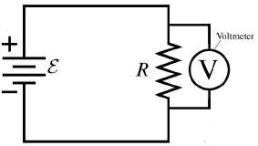
Voltmeter is a device that is used to measure voltage or potential difference across two given points. Essentially a voltmeter is nothing but a galvanometer with infinite resistance connected in series. This makes the resistance of an ideal voltmeter infinite. Voltmeter is connected in parallel, this is shown below: -

As shown in image a voltmeter is connected in parallel or in shunt configuration, due to voltage division in series. If we connect it in series high resistance of voltmeter will make the circuit insulating and no current will flow and the system will stop working.
A voltmeter is always connected in parallel, i.e., across the resistor that causes the voltage drop.
TYPES OF VOLTMETER:-
(1) Analog voltmeter
A moving coil galvanometer can be used as a voltmeter by inserting a resistor in series with the instrument. The sensitivity of such a meter can be expressed as "ohms per volt", the number of ohms resistance in the meter circuit divided by the full scale measured value.
Moving-coil instruments with a permanent-magnet field respond only to direct current. Measurement of AC voltage requires a rectifier in the circuit so that the coil deflects in only one direction. Moving-coil instruments are also made with the zero position in the middle of the scale instead of at one end; these are useful if the voltage reverses its polarity.
(2) Digital voltmeter
Digital voltmeters (DVMs) are usually designed around a special type of analog-to-digital converter called an integrating converter. Voltmeter accuracy is affected by many factors, including temperature and supply voltage variations. To ensure that a digital voltmeter's reading is within the manufacturer's specified tolerances, they should be periodically calibrated against a voltage standard such as the Weston cell.
WATT METER: -
A watt meter Measures power consumed by an apparatus in a given time. Normally watt meter gives reading in watt or kilowatt. A Wattmeter has two coils one is current coil and other is voltage coil. The power is product of Voltage across the load and current flowing through the load i.e.
P=V/*I
Connection of watt meter is shown below: -
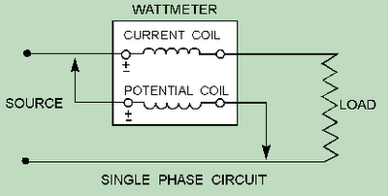

The Current coil is connected in series as current remains same in series (concept of Ammeter) and potential coil is connected in parallel as voltage remains same in parallel (concept of Voltmeter)
TYPES OF WATTMETER:-
(1)Electrodynamics
The traditional analog wattmeter is an electrodynamics instrument. The device consists of a pair of fixed coils, known as current coils, and a movable coil known as the potential coil.
The current coils connected in series with the circuit, while the potential coil is connected in parallel. The result of this arrangement is that on a dc circuit, the deflection of the needle is proportional to both the current and the voltage, thus conforming to the equation
W=VA or P=VI...
(2) Electrodynamometer
An early current meter was the electrodynamometer. Used in the early 20th century, the Siemens electrodynamometer, for example, is a form of an electrodynamics ammeter that has a fixed coil which is surrounded by another having its axis at right angles to that of the fixed coil.
(3)Electronic wattmeter
Electronic watt meters are used for direct, small power measurements or for power measurements at frequencies beyond the range of electrodynamometer-type instruments.
(4)Digital wattmeter
A modern digital electronic wattmeter/energy meter samples the voltage and current thousands of times a second. For each sample, the voltage is multiplied by the current at the same instant; the average over at least one cycle is the real power. The real power divided by the apparent volt-amperes (VA) is the power factor. A computer circuit uses the sampled values to calculate RMS voltage, RMS current, VA, power (watts), power factor, and kilowatt-hours. The readings may be displayed on the device, retained to provide a log and calculate averages, or transmitted to other equipment for further use. Wattmeter vary considerably in correctly calculating energy consumption,

CONCLUSION:-

