Project funded by the European Union | 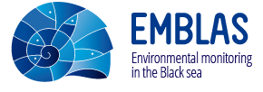 | 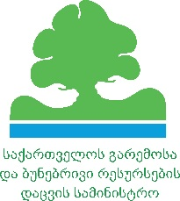 | 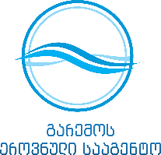 | 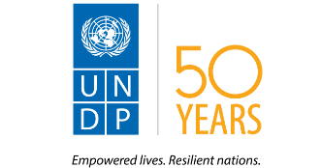

For immediate release

Press Release

Georgia-Ukraine Black Sea Surveys

BATUMI. 27 May 2016 – The biggest research vessel in the European Union «Mare Nigrum» arrived in Batumi marine port from Odessa on May 27 to finalise a joint Georgia-Ukraine environmental research of the Black Sea.

A team of researchers, which includes specialists from Georgia, Ukraine and five EU member states, was welcomed by representatives of the Georgian government, Ajara officials, media and citizens. This was followed by an outdoor concert in the port and press conference attended by Tamar Bagratia, Head of the National Environment Agency of Georgia; Giorgi Ermakov, Batumi Mayor; and representatives of the Ukrainian Scientific Centre of Ecology of the Sea and Institute of Marine Biology of National Academy of Sciences of Ukraine.

The Black Sea research is an initiative of the European Union and UNDP, carried out in cooperation with the government agencies and research institutions of Georgia and Ukraine. The Black Sea Surveys include territorial waters of Georgia and Ukraine and are being undertaken by a team of researchers from both countries and five EU member-states.

The surveys are the first deep open Black Sea research in the territorial waters of Georgia and Ukraine:
- For the first time the parameters for determination of the good environmental status of the Black Sea will be defined;
- For the first time the screening of emerging organic pollutants, large-scale study of marine litter, photographic identity catalogue of dolphins’ populations will be performed;
- For the first time marine microbes will be identified by their DNA;
- First in 21st century study of the life in hydrogen sulphide layers;
- First determination of the status of the sea by the algae species.

The surveys contribute to the implementation of EU-Georgia Association Agreement in the field of environment, addressing namely the EU Marine Strategy Framework Directive in part of the initial assessment of marine waters and the EU Water Framework Directive in part of the status assessment of the coastal zones.

The Joint Black Sea surveys are conducted within the framework of the project ‘Improving Environmental Monitoring in the Black Sea” (EMBLAS) co-financed by the European Commission (EC) and UNDP.

More information is available at http://emblasproject.org and Facebook: www.facebook.com/UNDPGeorgia and https://www.facebook.com/UNDPUkraine

Media contact:
Olena Marushevska, EMBLAS project, bluerivers.ukraine@gmail.com
Tea Shatirishvili, National Environment Agency (NEA), teashatirishvili1@gmail.com, +995 577 151541
Sophie Tchitchinadze, UNDP in Georgia, sophie.tchitchinadze@undp.org, +995 599 196907

