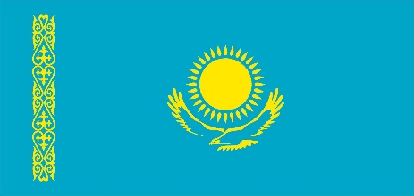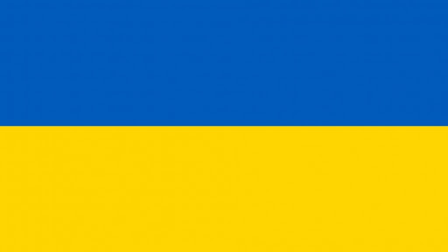

The First Climate Dialogue
"Kazakhstan-Ukraine"
May 25-26, 2021

The Embassy of the Republic of Kazakhstan in Ukraine and the Ministry of Ecology, Geology and Natural Resources of the Republic of Kazakhstan, with the support of the Ministry of Environmental Protection and Natural Resources of Ukraine, initiated the First Climate Dialogue in the Kazakhstan-Ukraine format in the EECCA region on May 25-26, 2021.
This event marks a qualitatively new stage in climate diplomacy at EECCA region (Eastern Europe, Caucasus and Central Asia) and demonstrates the orientation of the two extractive countries in the region to consolidate all Stakeholders interested in implementation of the Paris Climate Agreement.
The dialogue is supported by the World Bank, EU Delegation, UNDP, OECD in Kazakhstan and Ukraine, Green Academy, AUES, EECCA, CISC under Ministry of Information and Social Development of the Republic of Kazakhstan will bring together leading expert institutions, business and NGOs. The significance of this event is dictated by the need to establish sustainable communications between the main stakeholders of the climate process (governments, business, scientists, NGOs) in preparation for the 26th Conference of the Parties to the UNFCCC (COP-26), in Glasgow in November 2021.
The main topics of the dialogue will be the directions of decarbonization, the economic mechanisms of this process, including carbon tax, emissions trading, green finance and innovation, low-carbon urban development, etc.
The first dialogue will be held in a hybrid format (offline-online). The face-to-face dialogue will take place in Kyiv and Nur-Sultan, which will be joined by participants from EECCA region.
The result of the Dialogue should be the development of a resolution of participants to the Ministerial Conference in Bonn, in June 2021 and package of numbers of the Memorandums will be signed for strengthening cooperation between Kazakhstan and Ukraine in low carbon development areas.
The online event will be held using Zoom platform, registration for which is available to everyone at the following link: https://undp.zoom.us/meeting/register/tZUvd-qupjojEtyp8ef576Bs7o2Xao5C-8fi. After registration, a confirmation email containing login information with a link to connect will be sent.
To participate in the physical event (offline), you must register via the link https://forms.gle/FDkNrdttiAdUDXgJ9 before May 24, 2021 at 18.00 Nur-Sultan time, Kazakhstan. Only registered participants will be allowed to join the physical event.
If you have any questions regarding participation and registration for the event, please do not hesitate to get in touch via the following contacts:
Nur-Sultan, Kazakhstan: + 7 (701) 301 36 83, jakupova@cisc.kz – Dana Jakupova, Civil Initiatives Support Center;
Kyiv, Ukraine: +380 97 518 1548, Olhaboiko206@gmail.com – Olga Boyko, CAN EECCA.

_________________________________

