**Invasive pest alert**

Spotted Lanternfly
(Lycorma delicatula)

If seen, please report: https://massnrc.org/pests/slfreport.aspx

Take a photo, if possible

Look for the following life stages:

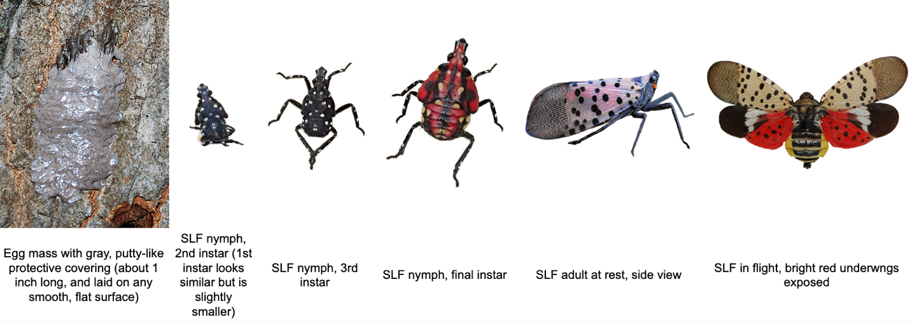

The Spotted Lanternfly (SLF) is a highly destructive, invasive insect pest. It can feed and lay eggs on 100+ plant species. This insect can significantly weaken trees.

It is important to monitor for the presence of SLF. As of September 2020, two dead adults were found in Massachusetts and a population has recently been detected in Worcester County. This pest is already established in neighboring states, including Connecticut, Delaware, New York, New Jersey, and Pennsylvania.

The preferred host for SLF is tree-of-heaven (an invasive) but it will use several native tree species during its life cycle, including oaks, maples, pines, white ash, and American beech. It is also damaging to agricultural crops, such as apple and grape.

SLF egg masses can be found on inanimate surfaces too: tires, trailers, lawn furniture, stone, fencing, etc., allowing it to be transported long distances. Inspect items before travelling. If traveling from a state that has SLF, please check your vehicle and other items before entering Massachusetts.

Learn more about the Spotted Lanternfly:
https://ag.umass.edu/landscape/fact-sheets/spotted-lanternfly
https://www.aphis.usda.gov/aphis/resources/pests-diseases

Image from Massachusetts Introduced Pest Outreach Project

