The T W G Report
18.6.15
2009 – A Victoria University Tax Working Group (TWG) Report could have been written by Henry George. It specifically affirms that a land tax reduces the selling price, (effectively, by the amount of the charge capitalised at the current rate of interest). It cites set-off as the way to make it politically acceptable. Tax set-off and similar provisions have long been in place to accommodate people in the change without compromising the principle. It dismisses a Capital Gains Tax because it fails to distinguish improvements influenced by inflation, and land value, that causes it.

A progressive Land Tax would revert current ‘freehold’ to leasehold in 5 years.
(Under the Public Bodies Leases Act the rentals are set at auction).

The Report was prepared by – The Policy Advice Division of the IRD and by the N.Z. Treasury.
_______________________________

When Govt. is funded from Socialised Rent instead of taxes, the savings of wages earn interest instead of paying interest on a mortgage. Labour becomes the Capitalist (see diagram).

Banks become Finance Companies accumulating the savings and making them available for working capital in the short and medium term, with balanced ledgers for borrowing / lending, terms/amounts, competing for funds and clients.
The Sharemarket has a role to play for larger amounts in the longer term for planes, ships and major construction, without the rogue factor of land price.
For intergenerational infrastructure Govt. and Local Body Stock is a Trustee Investment for Superannuation without the market place risk. New land subdivisions should be done by the local Council engaging private contractors. The Rent should be shared with Central Govt.
Q.E. or injected money other than the savings of Labour is unnecessary and wrong. It diminishes the value of money and the savings. With advancing productivity money and the savings would be
enhanced in value.

Money is essentially a measure of the relative labour content of goods and services permitting the exchange of consumables, perishables, or durables, now, progressively or later. It assesses the relative value of the Labour content, whether of brain or brawn, applied by the seller or avoided by the purchaser, for exchange purposes. Even gold has a dollar price, for these reasons.
When the capitalised value of a gratuitous licence which has no labour content, but does have an effective purchasing power and exchange value for the labour of others, is introduced to the labour exchange process, then the measure is thereby expanded but with no corresponding increase in the goods and services. That’s inflation. Too much money chasing too few goods; future money but only present production. Over time the goods and services diminish in value whereas the rights appreciate, compounding the effect.

It is not some separate, elusive quantum that has to be controlled, and that somehow has to service
countless transactions, from very small to very large. The technical term Money Supply of M1, 2, 3 is a
small liquidity sequence, not to be confused with the supply of money.
The valuable licences or tradeable rights become part of the indiscriminate exchange of goods, services and equities, all freely interchangeable, quantified in dollar terms, and convertible into cash, as maybe minimally required. Electronic transfers now replace cheques, paper notes and coins. Whilst it may be interesting to quantify M1, 2,3 and the velocity of circulation, it cannot influence the external rogue factor that drives them.

Underlying currency inflation is caused by rising land values. We now have a land values based currency (Refer “Land – Money Question, In Brief”).
The CPI (Consumers Price Index – wages / prices) monitors the effect of underlying currency inflation. The Reserve Bank has been directed to disregard reference (except obliquely) to underlying inflation, caused by non-tradeables (land). This official rort is designed to protect the sacrosanctity of private property in ‘land’.

- Land price privatised is the cause of the rich / poor divide, housing & unemployment problems : socialised it is the cure ! We would all be on the Property Ladder !
It is the basic Constitutional Human Rights issue.
The
“LAND” RENT FOR REVENUE & JUSTICE
Association (International) *

Pay for what we Hold or Take, not what we Do or Make

Private Enterprise must not include private ownership of the elements of life.
Free trade must not include the freedom to ‘invest’ in owning others’ natural resources
which should rightfully be their source of revenue

ECONOMICS IN ONE LESSON 25.9.12
P & P Bk III Chapter V
Wages
Earn it
Spend it
Save it
Invest it (interest)
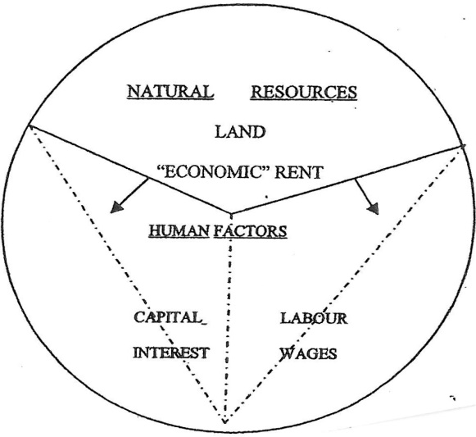
WAGES & INTEREST
SHOULD MOVE
IN TANDEM
(Tax)
(Tax)
THE DIAGRAM SHOWS:

1. The three factors of production – LAND, LABOUR and CAPITAL, and the returns therefrom viz –
“LAND” – being all natural resources and natural monopolies, the Rent for which is currently
capitalised into a purchase price. By definition the payment should be annualised in favour of the
owner, viz the Crown.

“LABOUR” – being all human economic endeavour whether of brawn or brain, for which Wages
are paid.

“CAPITAL” – essentially savings from wages used by Labour to make it more productive. Ideally,
Labour should supply Capital and reap the rewards, by way of Interest and better wages. In fact,
Capital is currently supplied by the recipients of (economic) Rent compounding their return. Some
“interest” is really Rent. The “Landowner” currently becomes the Capitalist as well. Rightfully
the“Labourer” should be the “Capitalist”.

2. That the price paid for LAND can only be at the expense of CAPITAL and LABOUR. Under the
speculative impetus of freehold tenure it incessantly bears upon them (arrows), with LABOUR in
the weaker position. All progress tends to be capitalised into Land Price.

3. Increasing the size of the ‘cake’ does not alter the proportions. If anything, the mere prospect
thereof reduces the proportion available to Labour, driving it even to subsistence level.

4. The portions taken by Labour and Capital are even further diminished by taxation.

UNDER RESOURCE RENTAL TENURE THESE PRESSURES WOULD BE REVERSED. LABOUR AND CAPITAL WOULD BE RELIEVED OF TAXATION – RENT IN LIEU, AND THE LEVEL OF RENT WOULD BE NEGOTIATED AFTER WAGES AND INTEREST HAD BEEN DETERMINED.

“Land”ie. Natural monopolies. Rights to land, water, airwaves, minerals, fisheries, hydro-power generation and supply, any public utility such as a port, airport, or the monopolistic rights to reticulate wires, pipes, rails, roads, and the like; even the right to pollute. Distinguishing ownership from the operation.
* Affiliate of The International Georgist Union, London, and Prosper Australia Inc., Melbourne
89A Ngaio Rd, Waikanae 5036, NZ, Tel (04) 904-0367, Fax (04) 904-0368
Email: resourcerentals@xtra.co.nz Website : www.resourcerentalsrevenue.org

