There Was a Dramatic Rewriting of the Rent Laws. What’s the Impact Been?

By City Limits | October 2, 2019
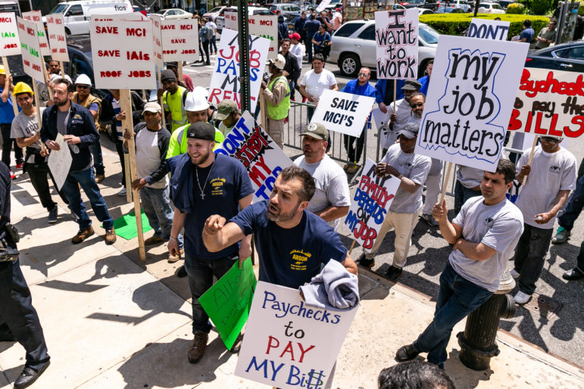
Adi Talwar
In the run up to the vote on the revised laws, contractors squared off with tenants and their allies outside a hearing about at Medgar Evers College in Brooklyn.
A little over three months ago the New York State legislature passed a sweeping overhaul of the rent-stabilization laws affecting nearly a million apartments in the city.
Vacancy decontrol was ended. Vacancy bonuses were eliminated. Landlords’ ability to raise rents after major capital improvements and individual apartment improvements was sharply curtailed. And those were just the changes that garnered headlines. Everything from the rules affecting coop conversions to the rights of mobile-home-park residents were reshaped by the new law.
Tenants declared victory. Landlords foretold a disaster.
Is reality matching those predictions? Is it too early to tell? Have government agencies caught up with the dramatic reorientation of rent policies that the legislature approved?
City Limits in partnership with the Henry George School of Social Science will discuss those questions and others on Thursday night in a panel discussion called “Rent Reform Meets Reality.” Carmen Vega-Rivera, tenant leader for Community Action for Safe Apartments; Denise Favorule, board member of the Henry George School of Social Science and broker for the Corcoran Group; Frank Ricci, director of government affairs for the Rent Stabilization Association; and Tom Waters, housing policy Analyst for the Community Service Society of New York will join moderator and City Limits executive editor Jarrett Murphy for a 90-minute discussion about the impact of the law so far, and the hopes and fears people carry into the next stage of implementation.
Tickets for the 6 p.m. event are still available here. You can also catch the live broadcast of the event on our Facebook page.

