Need to:

* Turn source links to attributions
* Format photos
* Format and color-code vignette boxes and research highlight boxes
* Consider where to insert reflection/application activities
* Add Bringing it all together summaries to final vignettes

**Planning for Health, Safety, and Nutrition**

One way to foster healthy lifestyles is to encourage the development of health-promoting habits during early childhood. Preschool education about health can begin a lifelong process of learning about oneself, relationships to others, and the world. Preschool children’s experiences with their health and ways to improve it, both at home and in the early childhood setting, enhance their desire and ability to make healthy decisions throughout their lives.

The preschool health foundations describe the health knowledge, attitudes, habits, and behaviors that set the groundwork for all preschool children to develop into healthy adults. They explain what children should know about health, and what health habits and practices should be part of their daily routines when they are provided with high-quality health education in preschool. These skills and behaviors set young children on the path toward health and healthy lifestyle choices.

Source: <https://www.cde.ca.gov/sp/cd/re/documents/psframeworkvol2.pdf> from page 226

Here are the preschool health foundations. These describe the health knowledge, skills, and behaviors that preschool children typically develop in a quality preschool environment. Through supportive communication and participation in everyday routines and activities, children begin to develop behaviors such as making food choices, engaging in physical activity, and maintaining personal safety and oral health. These skills and behaviors set young children on the path toward health and healthy lifestyle choices.

Source: <https://www.cde.ca.gov/sp/cd/re/documents/psframeworkvol2.pdf> from pages 231-232

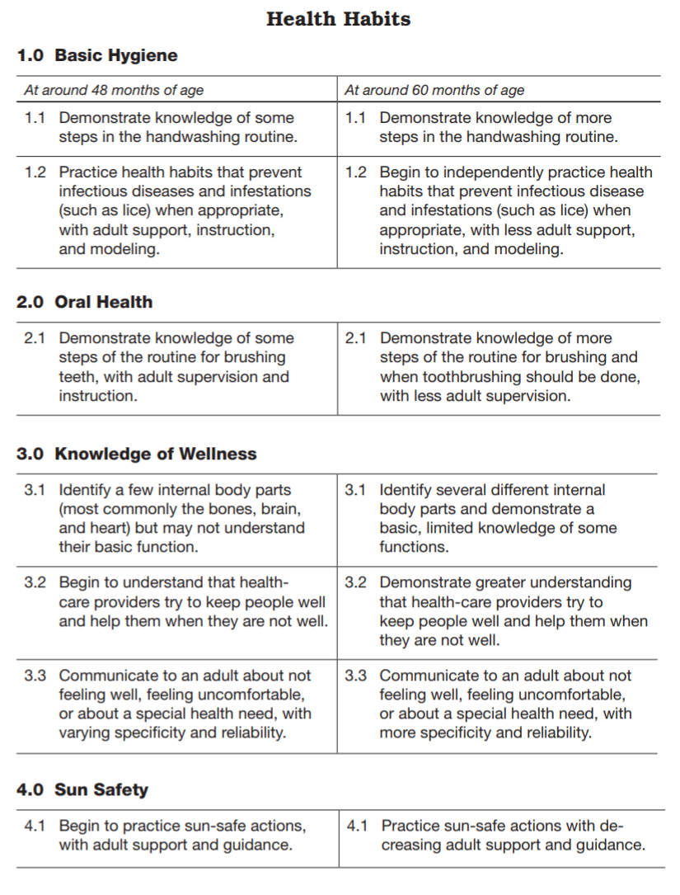

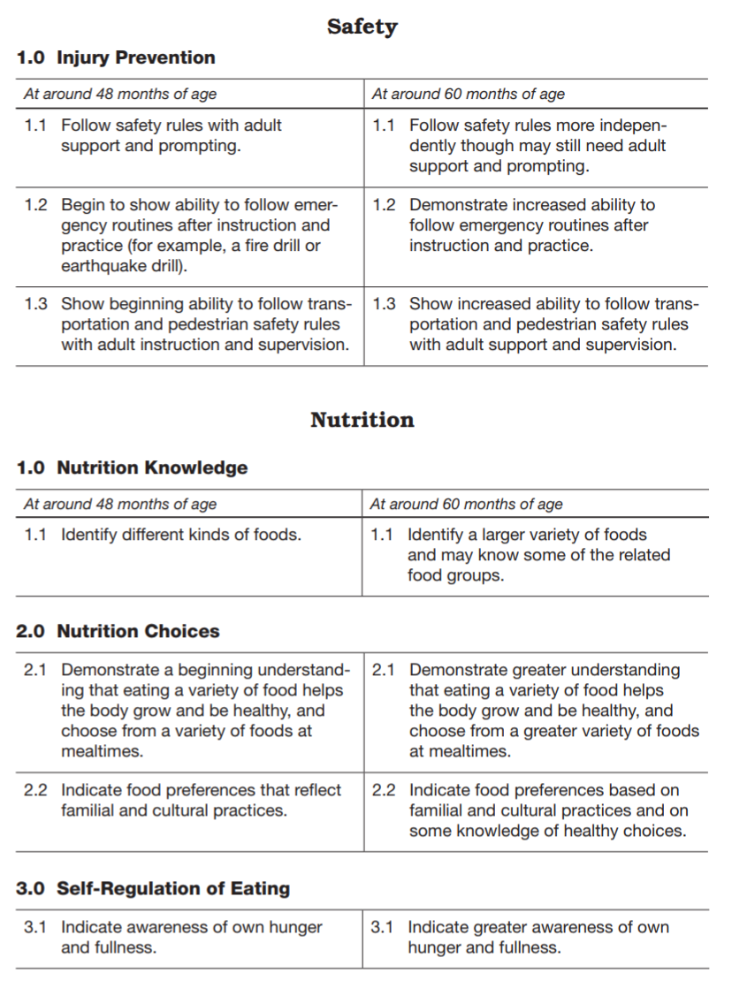

Source: <https://www.cde.ca.gov/sp/cd/re/documents/psfoundationsvol2.pdf> from pages 111-112

They represent a vision of young children’s developmental process, not an expectation. Each child enters preschool with a genetic back-ground, developmental characteristics, an individual level of knowledge and skills, and understanding of everyday routines. The differences are based not only on the child’s age, but also on the child’s developmental level, prior experiences, and special needs. It is the responsibility of adults to help each child to develop the knowledge, skills, and behavior that pro-mote healthy development.

An integrated and comprehensive approach is most effective when preschool children are taught about health. Health education does not stand alone in the preschool curriculum. It is integrated with the other eight domains: social–emotional development, language and literacy, English-language development, mathematics, visual and performing arts, physical development, history–social science, and science. Health is comprehensive. Health education involves ideas directly relevant to the child, such as “How do I grow?” Pre-school teachers work with children who are naturally curious and eager to learn about their bodies and how each part works. A developmentally appropriate curriculum promotes overall health (e.g., wellness, safety, **oral health**, nutrition) and integrates topic areas. For example, a discussion about safety rules might include nutrition and sanitation.

Source: <https://www.cde.ca.gov/sp/cd/re/documents/psframeworkvol2.pdf> from pages 226-227

**Guiding Principles**

Teachers address ideas and concepts that children can grasp at their developmental level and then progressively build on what children already know and understand. This approach applies to all children, including children with various abilities, disabilities, or other special needs (such as delays in language, cognition, or physical ability). c the integration of health with the eight domains and provide a basis for teacher guidance in the health domain strands and sub-strands.

* Health knowledge is individualized.
* Preschool children and their families possess diverse backgrounds and cultural practices.
* Learning about health practices has a language component.
* Children’s personal health status (i.e., physical, mental, emotional) affects their ability to learn and develop in all domains.
* The overall theme of health education for preschool is personal health.
* Children learn through their experiences, including play, routines and scripts, modeling, and developing and sustaining relationships at preschool. This learning is supported through adult scaffolding.
* Practicing scripts, or behavioral rules, can foster development of certain health-promoting behaviors or skills.
* The preschool program provides both indoor and outdoor environments that are safe and appropriate, challenging, and inviting for all children.
* Teachers help children feel secure by assuring them that there are adults who will take care of them (e.g., parents, family members, teachers, health care providers, special needs assistants).

Source: <https://www.cde.ca.gov/sp/cd/re/documents/psframeworkvol2.pdf> from pages 227-228

**Environments and Materials**

Children learn most effectively in a safe, inviting environment in which they can freely explore and challenge themselves. Health and safety in the preschool program, both indoors and outdoors, includes environment, supervision, and education. Environment is the first component of safety; a safe environment allows children to explore, play, and learn without unnecessary restriction. The environment should be set up and maintained to reduce the risk of injury and **disease transmission**.

Proper supervision of children is essential, and the required adult-to-child ratios must be met at all times, including periods when children play outdoors, are transported, and go on field trips.5 The most effective supervision includes active involvement with children’s learning: teachers move around the room with children, attend to children and their interactions, make eye contact, encourage children verbally, and model appropriate voice and actions.

Education is multifaceted. Teachers promote children’s learning through discussion, modeling, and daily routines through active participation. An accessible and supportive environment with appropriate facilities and items allows children to practice and demonstrate progress in learning.

The following recommendations apply to establishing the preschool environment as related to the three health domain strands: Health Habits, Safety, and Nutrition.

* Establish a physical learning environment designed for children’s initiative.
* Provide safe, inviting learning environments, and appropriate supervision of children.
* Maintain a clean, healthy, and sanitary environment. Incorporate cleaning and sanitizing into the daily routine.
* Have supplies available and accessible to promote routine health practices.
* Provide stimulating and developmentally appropriate materials in interest areas for children’s use during play.
* Provide furnishing and utensils appropriate for children’s size and abilities.
* Be creative and include a gardening space, either indoors or outdoors, where children can plant seeds, tend the garden, and watch the plants grow.

Source: [https://www.cde.ca.gov/sp/cd/re/documents/psframeworkvol2.pdf from pages 229-231](https://www.cde.ca.gov/sp/cd/re/documents/psframeworkvol2.pdf%20from%20pages%20229-231)

Research Highlight

Cleaning and **disinfecting** is essential. Studies have shown that some **germs,** including influenza virus, can survive on surfaces for two to eight hours; rotavirus can survive up to 10 days. Cleaning with soap and water removes visible soil. After cleaning, disinfection (sanitizing) kills bacteria, viruses, and fungi (i.e., “germs”). The **Centers for Disease Control and Prevention (CDC)** states that a bleach and water solution of one tablespoon household bleach to one quart water is effective. Wet the surface with the solution and allow to air dry. Mix fresh bleach solution each day to maintain effectiveness, and store in a clearly labeled spray bottle out of children’s reach. Research shows that other chemicals (e.g., ammonia, vinegar, baking soda, Borax) are not effective against some bacteria.

W. Rutala and D. Weber, *Guidelines for Disinfection and Sterilization of Healthcare Facilities, 2008.*

Source: <https://www.cde.ca.gov/sp/cd/re/documents/psframeworkvol2.pdf> from page 230

**Health Habits**

Teachers can help children establish positive health habits. This learning is progressive, and preschool teaching often focuses on scripts and routines for prevention of disease and injury. Later, as children grow and develop knowledge and skills, they begin to believe and understand that they are responsible for their own health.

Health Habits includes basic hygiene, oral health, knowledge of wellness, and sun safety. The following section introduces and recommends strategies to support learning to these. Teacher-guided activities on health habits may be used to introduce or focus attention on a specific topic or concept. However, learning is primarily achieved through children’s daily routines (e.g., washing hands at certain times, brushing teeth after meals) and verbal or nonverbal scripts that illustrate the desired lifelong behavior (e.g., using tissue when blowing the nose, coughing into elbows). Children demonstrate knowledge of body parts, disease prevention, and wellness as they practice routines and develop descriptive scripts (e.g., “We wash our hands, fingers, and wrists”; “I’m going to brush my teeth and tongue”); they begin to understand more difficult concepts through scaffolding.

Source: <https://www.cde.ca.gov/sp/cd/re/documents/psframeworkvol2.pdf> from pages 235-236

Create full page-width photo montage with these images:

|  |  |
| --- | --- |
| Source: <https://www.cde.ca.gov/sp/cd/re/documents/psframeworkvol2.pdf> from page 241 | Source: [https://www.cde.ca.gov/sp/cd/re/documents/psframeworkvol2.pdf from page 239](https://www.cde.ca.gov/sp/cd/re/documents/psframeworkvol2.pdf%20from%20page%20239) |
| Source: <https://www.cde.ca.gov/sp/cd/re/documents/psframeworkvol2.pdf> from page 235 | Source: <https://www.cde.ca.gov/sp/cd/re/documents/psframeworkvol2.pdf> from page 232 |

Vignette

*The children are playing indoors when Miss Marie reminds them that it is time to prepare for lunch. She begins to sing a handwashing song as children leave their interest areas. Some of the children begin singing as they wash their hands. The song follows the familiar “Row, Row, Row Your Boat” tune, and the children enjoy singing it in both English and Spanish.*

*English:*

*Wash, wash, wash my hands*

*Make them nice and clean*

*Rub the bottoms and the tops*

*And fingers in between*

*Spanish:*

*Lava, Lava, Lava mis manos*

*Lavalas muy limpias*

*Lavalas de arriba y abajo y*

*Entre mis dedos de las manos*

*The children have learned that if they sing the song two times while washing their hands, then their hands should be clean! Miss Marie sings along with the children as she observes the handwashing process. She helps Tonya, who has a hearing impairment, by clapping along with the song; Tonya can look in the mirror above the sink to see when the song (clapping) ends. The younger children sometimes need help in dispensing the soap and turning the water on and off; the older children enjoy helping the younger ones and like to model their handwashing skills.*

Source: <https://www.cde.ca.gov/sp/cd/re/documents/psframeworkvol2.pdf> from page 235

Teachers can support children’s development of the Health Habits foundations with the following:

* Teach children how to wash their hands.
* Practice toothbrushing skills.
* Model basic hygiene and disease prevention actions throughout the day (including issue tissue to blow nose, sneezing and coughing into their elbows, using napkins, brushing teeth, using utensils to serve foods, etc.).
* Remind children about health practices throughout the day. Include strategically placed visual reminders throughout the environment.
* Incorporate handwashing, toothbrushing, sun safety, and other health practices in the daily routine.
* Use visuals aids to demonstrate invisible germs.
* Reinforce learning with stories and music.
* Observe individual children attentively. Learn what experiences, knowledge, skills, and abilities each children has to determine where they are at in the learning process.
* Build communication and vocabulary skills. Use children’s home languages. Tell them stories and have them draw stories about health routines (such as visiting the dentist). Introduce words that apply to different topics of safety (such as protect).
* Encourage pretend play, especially to work through their fears. Provide special interest areas (doctor’s office, dentist office, eye doctor’s office, etc.) with props for role playing.
* Provide hats and look at how each might protect children from the sun. Encourage children to dramatize protecting baby dolls from the sun.
* Encourage children to explore and accept differences. Children recognize physical differences and the different health practices, meal setups and food choices, and safety considerations.
* Use correct terminology for body parts in both English and children’s home languages.
* Familiarize children with health helpers (lab technicians, nutritionists, dentists, eye doctors) and include others that may be utilized by their families (chiropractors, acupuncturists, midwives, etc.).
* Consider offering health screenings for children to develop familiarity with health helpers.
* Integrate health promotion and sun safety with other topics and domains.
* Provide visual representations of health helpers (ensure that you show both male and females, various ethnicities, and various ages of people).
* Enhance children’s knowledge and understanding through problem solving (which health helper would provide assistance for different situations.
* Model and share information each day about practices (such as applying first aid for an injury) that support health.
* Integrate sun safety with emergency preparedness and safety.
* Encourage decision making. Have children protect themselves from the sun.
* Promote sun safety everywhere, every day, all year long for each and every child.
* Ensure that children have access to appropriate sun safety items.

Source: <https://www.cde.ca.gov/sp/cd/re/documents/psframeworkvol2.pdf> from pages 234-249

Vignette

*Mr. Jeff is putting sunscreen on four preschoolers. “Mr. Jeff, why do we have to put this sticky stuff on every day?” asks Mary. As he removes his gloves and puts away the sunscreen bottle, he explains, “The sun is good for us. It gives us light and warmth. But too much sun is not good for your skin. We put on the sunscreen to protect our skin from too much sun.” Javier says, “I don’t burn. I don’t need this.” Mr. Jeff replies, “Everyone needs to be sun-safe.” Mr. Jeff encourages the children to run, jump, and try new activities as they play outdoors.*

Source: <https://www.cde.ca.gov/sp/cd/re/documents/psframeworkvol2.pdf> from page 246

**Safety**

Preschool children deserve to live and play in safe environments. It is the adult’s responsibility to keep children safe; children should not be expected to actively protect themselves. Preschool safety education helps children develop safety awareness and the realization that they can control some aspects of their safety through certain actions.

The earlier children learn about safety, the more naturally they will develop the attitudes and respect that lead to lifelong patterns of safe behavior. Safety education involves teaching safe actions while helping children understand possible consequences of unsafe behavior.

This section on safety addresses children’s ability to follow safety rules, emergency routines, and transportation and pedestrian safety rules.

Source: [https://www.cde.ca.gov/sp/cd/re/documents/psframeworkvol2.pdf from page 252](https://www.cde.ca.gov/sp/cd/re/documents/psframeworkvol2.pdf%20from%20page%20252)

Create full width photo montage of the following images:

|  |  |
| --- | --- |
| Source: [https://www.cde.ca.gov/sp/cd/re/documents/psframeworkvol2.pdf from page 252](https://www.cde.ca.gov/sp/cd/re/documents/psframeworkvol2.pdf%20from%20page%20252) | Source: [https://www.cde.ca.gov/sp/cd/re/documents/psframeworkvol2.pdf from page 253](https://www.cde.ca.gov/sp/cd/re/documents/psframeworkvol2.pdf%20from%20page%20253) |
| Source: <https://www.cde.ca.gov/sp/cd/re/documents/psframeworkvol2.pdf> from page 258 | |

Vignette

*Ms. Linda is preparing her preschoolers for the first fire drill of the year. She has read several books about fire safety to the children. The class enjoyed a visit from Deloria’s mother, who is a firefighter. The children are excited about their first fire drill, but they are not sure what to expect. Ms. Linda plays a tape of the school fire alarm and explains that the real warning alarm will be very loud. The fire alarm means everyone must leave the building.*

*“Now we are going to practice listening and preparing to leave the classroom,” says Ms. Linda. “It will be like playing Follow the Leader, and I will be the leader.” The children are eager to try this new experience, and it is difficult for them to listen quietly. Several of the children are learning English so Ms. Linda uses words in the other languages of the children, as well as English, to focus their attention and explain the steps. Prior to this practice, Ms. Linda presented a list of key words and phrases to parents who speak languages other than English and obtained the relevant translations. She combines words and hand signals to direct the children. Ms. Linda explains that she will assist Juan, who is in a wheelchair, during the fire drill.*

*Ms. Linda demonstrates what to do when the alarm sounds (e.g., stand up, stay quiet) before the children practice. They practice this routine each day that week so they will be ready for the actual drill on Friday.*

Source: <https://www.cde.ca.gov/sp/cd/re/documents/psframeworkvol2.pdf> from page 255

Teachers can support children’s development of the Safety foundations with the following:

* Incorporate safety activities into the daily routine.
* Involve children in creating rules. Limit the number of rules and keep them simple.
* Provide coaching and gentle reminders to help children follow safety rules. Use visuals with pictures and simple words in English and home languages.
* Promote independence while developing other skills.
* Provide time for children to practice individual skills (rather than just telling them about them).
* Introduce concepts and behaviors in simple steps. Build upon previous learning.
* Role-play safety helpers. Recognize that levels of trust with emergency and safety workers will vary from child to child based on their experiences and the environment they live in.
* Take field trips and bring in safety helpers (police officers, firefighters, crossing guards, paramedics, and others).
* Define emergency and have children practice problem solving with different emergency situations.
* Introduce safety signs. Help children learn to recognize important symbols (and their corresponding printed words).
* Incorporate music with safety songs. Children can learn to state their name and address with the help of a simple song.

Source: <https://www.cde.ca.gov/sp/cd/re/documents/psframeworkvol2.pdf> from pages 256-

**Research Highlight**

Unintentional injury is the leading cause of death of children ages fourteen and under. Motor vehicle injuries are the leading cause of death among children in the United States; each year more than 200,000 children are treated in emergency departments for play-ground-related injuries; children ages four years and younger are susceptible to residential fire deaths and injuries; and children under age six years are more likely to experience unintentional poisoning. The good news is that the number of deaths caused by unintentional injuries to children has dropped in recent years; from 1987 to 2004, there was a 43 percent decrease.

Death rates among California children ages one to four years declined slightly from 2000 to 2005; however, the death rates for young children remained significantly higher than the target established in *Healthy People 2010.*

Child injury prevention efforts continue throughout the United States. For example, all 50 states and the District of Columbia have child restraint laws; and 21 states, the District of Columbia, and over 140 localities have enacted some form of mandatory child bicycle helmet legislation. In addition, all national and regional code-making bodies have amended their plumbing-code language to require anti-scald technology and a maximum water heater temperature of 120 degrees Fahrenheit in all newly constructed residential units.

The state of California has been a leader in advocating child safety. It has enacted laws requiring the use of bike helmets, personal flotation devices, and child safety seats; pro-hibiting adults from leaving children alone in motor vehicles; and imposing criminal liability on adults who allow children to have access to loaded firearms.

U.S. Department of Health and Human Services, CDC, *Injury Topics and Fact Sheets,* 2010. http://www.cdc.gov/ncipc/ factsheets/children.htm (accessed August 1, 2011.

Safe Kids USA, *Trends in Unintentional Childhood Injury Deaths,* 2007. http:// www.usa.safekids.org/content_docu-ments/2007_InjuryTrends.doc (accessed March 3, 2010).

California Department of Public Health, Focus Area 16: *Maternal, Infant, and Child Health, Healthy People 2010* (Sacramento: California Department of Public Health, 2009).

Safe Kids USA, *Research Reports.*

Safe Kids USA, *Preventing Injuries: At Home, At Play, and On the Way*, 2009. http://www.safekids.org/in-your-area/safety-laws/find-safety-laws.html?legstate=CA (accessed April 26, 2010).

Source: <https://www.cde.ca.gov/sp/cd/re/documents/psframeworkvol2.pdf> from page 253

W. Rutala and D. Weber, *Guidelines for Disinfection and Sterilization of Healthcare Facilities, 2008.*

Source: <https://www.cde.ca.gov/sp/cd/re/documents/psframeworkvol2.pdf> from page 230

**Nutrition**

Lifelong eating habits are shaped during a child’s early years. Teachers of young children have a special opportunity to help children establish a healthy relationship with food and lay the foundation for sound eating habits. Nutrition education and activities help set children on the path to a healthful lifestyle. Providing nutritionally balanced meals and snacks and integrating nutrition education and healthy eating habits in the home and early childhood environment can help prevent health risks such as childhood obesity.

Nutrition education is integrated with the other domains of learning. Through food and cooking activities, children also develop skills in math, science, art, language and literacy, social science, health and self-care, and social skills. Nutrition education for preschoolers fosters children’s awareness of different types of foods and promotes exploration and inquiry of food choices. Lifelong habits with foods are developed during early childhood. Through nutrition education in preschool, teachers encourage children to include a wide variety of foods that pro-vide adequate nutrients in their daily diet.

Nutrition includes: nutrition knowledge, nutrition choices, and self-regulation of eating. Through knowledge, children become aware of different foods and tastes, some of which are familiar and others that are new. As they explore various foods and food preparations, they develop likes and dislikes and begin to make choices based on preference. Both nutrition choices and **self-regulation of eating**—that is, eating when hungry, chewing food thoroughly, eating slowly, and stopping when full— involve decision-making skills.

Turn these into a full page-width montage:

Vignettes

*Ms. Tsikudo has invited Ava’s mother, Zhiying, to tell the class about Taiwan. Zhiying was born and grew up in Taiwan. Zhiying has brought many family photos, as well as photos of the beautiful scenery of Taiwan. After showing the photos and taking questions from children, she shares with children a large durian and a few star fruits, fruits that people in Taiwan like to eat. Ms. Tsikudo helps to carry the durian on a plate and moves around the class to ask children to touch it. “How does the skin feel?” “Bumpy!” Children reply with excitement. Meanwhile, Zhiying has sliced the star fruits and starts to pass them around. “What do the pieces look like?” she asks. “Stars!” reply the children. Ms. Tsikudo picks up one slice of star fruit, puts it into her mouth, and says “I have never had start fruit before. Yum! I like the taste of this fruit. Who wants to try?” Some children raise their hands to try the fruit.*

|  |  |
| --- | --- |
| Source: <https://www.cde.ca.gov/sp/cd/re/documents/psframeworkvol2.pdf> from page 276 | Source: <https://www.cde.ca.gov/sp/cd/re/documents/psframeworkvol2.pdf> from page 265 |
| Source: <https://www.cde.ca.gov/sp/cd/re/documents/psframeworkvol2.pdf> from page 271 | Source: <https://www.cde.ca.gov/sp/cd/re/documents/psframeworkvol2.pdf> from page 270 |

**Research Highlight**

Fear of new foods is common in children. It may take many tries before a child will taste a new food and up to 20 exposures before a child decides he likes or truly dislikes a food. **Food jags** (when a child will eat only one food item meal after meal) are also common. Food jags rarely last long enough to cause harm. Children’s eating habits are a way for them to feel independent. They reflect typical development in children.

Some children have disabilities or other issues that affect their decisions about foods. Children with autism often have very limited food preferences; some children may have sensory issues and avoid specific textures or food items. Other children may not like it when different types of foods touch each other on the plate or may wish to eat foods in a particular order. Be aware of differences in children’s preferences and eating habits, and consult with the child’s family and specialist to ensure that needs are met.

Medline Plus, Food Jags, 2007. http:// www.nlm.nih.gov/medlineplus/ency/ article/002425.htm (accessed March 3, 2010).

E. Satter, *The Picky Eater.* https:// ellynsatter.com/showArticle. jsp?id=265&section=278 (accessed March 3, 2010).

American Academy of Pediatrics, *Feeding Kids Right Isn’t Always Easy: Tips for Pre-venting Food Hassles,* 2008. http://www. healthychildren.org/English/healthy-living/nutrition/pages/Hassle-Free-Meal- Time.aspx (accessed May 11, 2010).

University of Maryland Medical Center, *Food Jags – Overview,* 2007. http://www.umm.edu/ency/article/002425.htm (accessed March 3, 2010).

Source: <https://www.cde.ca.gov/sp/cd/re/documents/psframeworkvol2.pdf> from page 262

W. Rutala and D. Weber, *Guidelines for Disinfection and Sterilization of Healthcare Facilities, 2008.*

Source: <https://www.cde.ca.gov/sp/cd/re/documents/psframeworkvol2.pdf> from page 230

Teachers can support children’s development of the Nutrition foundations with the following:

* Introduce many different foods. This can be done through books, meals and snacks, and cooking activities. Include familiar and novel foods and foods from the various cultural backgrounds of the children and their families.
* Recognize and accommodate differences in eating habits and food choices. Provide explanations for differences (e.g., eating from communal dishes, feeding tubes, avoiding certain foods, etc.) by having a family member or specialist come in to explain.
* Provide opportunities and encouragement in food exploration. Encourage children to explore with all five senses.
* Integrate nutrition with the other areas of learning through cooking activities.
* Show children where food is produced. Expand nutrition education through field trips to gardens, farms, orchards, local produce markets, kitchens, restaurants, grocery stores, etc. and bring in visiting experts (e.g., farmers, food co-op members, community gardeners).
* Help children experience gardening as they raise herbs, fruits, or vegetables.
* Establish special interest areas for children to engage in dramatic play (e.g., grocery stores, restaurants, picnics, etc.).
* Encourage role playing by providing props including: place mats, tablecloths, table-setting items, pretend food items, cooking utensils, menus, and other items that represent the children’s families.
* Integrate nutrition education with basic hygiene education (e.g., washing hands before and after preparing foods) and other learning areas (e.g., singing songs and discussions).
* Model and coach children’s behaviors. Each what the children are being served.
* Encourage children to share information about family meals. Explore cultural diversity and how children’s families eat at home.
* Serve snacks and meals family style. Adults and children eat together, share the same food, and talk with each other informally.
* Encourage tasting all foods, but don’t compel them to taste or eat certain foods.
* Serve foods prepared in many ways (e.g., raw, grilled, steamed, cut in shapes, shredded, ).
* Combine new foods with familiar ones.
* Be aware of individual food restrictions and help children make appropriate choices.
* Offer a variety of nutritious, appetizing foods in small portions.
* Encourage children to chew their food well and eat slowly.
* Teach children to recognize signs of hunger. Encourage children to decide how much to eat and to stop when they feel full.
* Discuss how the body uses food.
* Reinforce learning throughout the day (not just at meal and snack times).

Vignettes

*“I don’t like that.” Every day at lunch for the past three weeks, Amy said the same thing. She would eat the meat and fruit but would not taste any vegetables or bread. Mr. Rios asked Mrs. Gardner, Amy’s grandmother, “What does Amy like to eat at home?” Mrs. Gardner replied, “She has never eaten very much at one time, and now all she wants is mashed potatoes. She looks healthy, but I’m worried about her.”*

*Mr. Rios continued to observe Amy’s eating habits and encouraged her to try other foods. As the children served their plates, he asked them about the different colors and smells. Using small serving utensils, he encouraged each child to take a small amount. If a child said he did not want it, Mr. Rios assured him that he did not have to eat it but gently encouraged him to put a tiny bit on his plate.*

*As Mr. Rios planned learning activities for the following weeks, he included a cooking activity along with snack time two days each week. He involved children’s families by asking them to send ideas or simple recipes for favorite snack foods. Through these activities, the children were introduced to different foods, some new and some familiar, and various methods of food preparation (e.g., cooked versus raw, single food versus combined foods).*

**Engaging Families**

Teachers can use the following strategies can help families to develop their children’s health habits:

* Provide families with concise, accurate information about ways to promote and develop good health habits in children. Information should be presented in English and home languages.
* Share written and visual safety messages with families through newsletters, brochures, and bulletin boards, web pages, and take home activities in English and home languages. Emphasize safety issues that relate to your program and community.
* Provide individualized information as well as general health information to all families. Provide safety information, especially those that involve higher risk in specific communities (e.g., water safety, gun safety, or lead poisoning). Use daily contact, workshops, and parent meetings to share information. Make sure workshops and meetings are offered at a variety of times and provide child care.
* During family conferences, find out what messages family members would like reinforced at school. Safety rules and supervision may differ at home.
* Post emergency plans on family bulletin boards and provide families a written copy of the program’s emergency plans.
* Encourage families to plan and practice emergency drills for fires, earthquakes, floods, violent encounters, or other emergency situations that might occur in their homes and communities.
* As you introduce health routines (e.g., handwashing and toothbrushing), invite family members to participate and model.
* Encourage families to contribute ideas or materials to interest areas that reflect diverse health habits at home.
* Invite family members to help children learn about people who can help in emergency situations (firefighters, paramedics, construction workers, electricians, meteorologists, cleaning businesses, etc.)
* Be sensitive and respectful of different values or beliefs, as well as varying levels of access to health products and services.
* Gather information on available and accessible health, safety, and nutrition resources in the community, including those for children with special needs, and provide this information to all families, translated into their home languages.
* Provide families with weekly or monthly menus in their home languages.
* Recognize families have the most information about their children’s food preference, serving styles, and restrictions in eating habits.
* Offer workshops and information on nutritious and economical meals based on the families’ cultural, ethnic, and personal food preferences.
* Encourage families to use available community resources for meal planning.
* Provide lists of foods or simple recipes for a variety of foods that are nutrient-dense, low fat, sodium, and sugar, and look and taste great. Include foods that reflect cultural preferences and are available locally.
* Encourage families to involve children in food preparation.
* Invite families to share their favorite family recipes.
* Invite families to visit the classroom and to sit with children during mealtimes and participate in nutrition related activities.
* Include families in planning the menu and meal-service routines.
* Provide information to all families on nutrition, child growth and development, nutrition risk factors, and community resources.
* Encourage families to ask questions and provide information about their children’s eating habits or nutritional concerns.

Source: <https://www.cde.ca.gov/sp/cd/re/documents/psframeworkvol2.pdf> from pages 250-251; 260-261; 274-275

**Conclusion**

The early years of children’s lives are crucial to the development of behaviors that contribute to good health, and early childhood teachers can significantly enhance opportunities for young children to learn about health by providing appropriate experiences. Many adult chronic diseases and conditions, such as obesity, diabetes, and heart disease, are related to lifestyle choices about nutrition and fit-ness and often begin in childhood. Early childhood teachers have a responsibility to not only help children learn about their bodies and ways to stay healthy, but also to work with parents and families.

A respectful and integrated approach that meshes home and preschool environments and involves responsible adults can help children initiate a lifelong process of learning about themselves, their relationships to others, and the world around them. Health education is an essential part of the curriculum for young children. The topic of health is incorporated into daily routines and the environment; it is also the focus of planned learning activities. Early child-hood educators have the challenge of modeling a healthy lifestyle for the children they teach—one that will benefit both themselves and the children.

Source: <https://www.cde.ca.gov/sp/cd/re/documents/psframeworkvol2.pdf> from page 276