C:\Program Files\Ampps\pythonMicrosoft Windows [Version 6.3.9600]
(c) 2013 Microsoft Corporation. All rights reserved.

C:\Users\...>$ python ez_setup.py
'$' is not recognized as an internal or external command,
operable program or batch file.

C:\Users\..>cd C:\Program Files\Ampps\python

C:\Program Files\Ampps\python>$ python ez_setup.py
'$' is not recognized as an internal or external command,
operable program or batch file.

C:\Program Files\Ampps\python>python ez_setup.py
python: can't open file 'ez_setup.py': [Errno 2] No such file or directory

C:\Program Files\Ampps\python>cd C;Program Files\Ampps\python\scripts
The system cannot find the path specified.

C:\Program Files\Ampps\python>cd C:Program Files\Ampps\python\Scripts
The system cannot find the path specified.

C:\Program Files\Ampps\python>cd Scripts

C:\Program Files\Ampps\python\Scripts>python ez_setup.py
'python' is not recognized as an internal or external command,
operable program or batch file.

C:\Program Files\Ampps\python\Scripts>$ python ez_setup.py
'$' is not recognized as an internal or external command,
operable program or batch file.

C:\Program Files\Ampps\python\Scripts>ez_setup.py

Here you can see step by step what I did. When I finally got the rest of it right, this last step opened the file in notepad, which is not what I was expecting. I see two possibilities: 1) It should not be indented even though it was indented in the example, and 2) Windows thinks all .py files are notepad and not python.
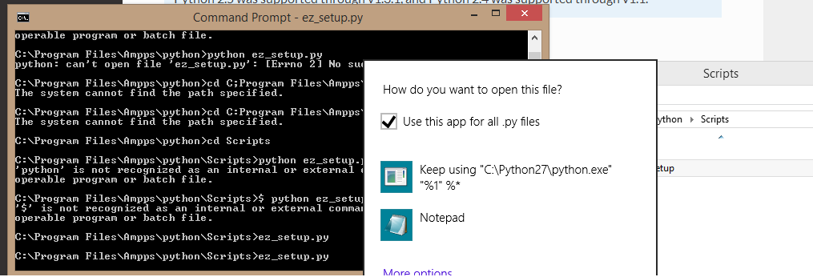
So I did 2) first, but now Windows keeps asking me if I want to open this with python, it just goes around in a circle even though I keep saying yes. This leads me to think I should be in the python shell, if I can remember/find how to do that.
I don’t the shell is the same as IDLE, but I don’t know that for sure.
I saw something on the documentation that suggests⁽¹⁾ IDLE included a shell, so I tried that:
Python 2.7.2 (default, Jun 12 2011, 15:08:59) [MSC v.1500 32 bit (Intel)] on win32
Type "copyright", "credits" or "license()" for more information.
>>> ez_setup

Traceback (most recent call last):
File "<pyshell#0>", line 1, in <module>
ez_setup
NameError: name 'ez_setup' is not defined
>>> ez_setup.py

Traceback (most recent call last):
File "<pyshell#1>", line 1, in <module>
ez_setup.py
NameError: name 'ez_setup' is not defined
>>>

(1) IDLE has the following features:
- coded in 100% pure Python, using the tkinter GUI toolkit
- cross-platform: works on Windows and Unix
- multi-window text editor with multiple undo, Python colorizing and many other features, e.g. smart indent and call tips
- Python shell window (a.k.a. interactive interpreter)
- debugger (not complete, but you can set breakpoints, view and step)
Obviously, that didn’t work, and my best guess is because it is looking for ez_setup to be a function. So maybe I’m remembering that there is such a thing as a python shell, but it isn’t what I thought it was, or at least isn’t like the windows shell.
Now what? Let’s back up. I think it is important to document what the hell is going on and how I got here. I started with trying to use django non-rel. See file, to rel, or not to rel.docx. Then I decided to go with “plain” django, but it said the “easiest” way to install was with pip. Pip, it seems, is a way to install all sorts of python related things, so it seemed like a good idea to get it. But then pip insisted I needed ez.setup. Note that this page also has a lot of not very encouraging security caveats, so I started to feel like I was on some kind of perverted and not very fun treasure hunt. That is how I got here.
Oh, btw, I should also mention, because I see it once again on the “regular” download instructions for django, that I also have the option to “clone” this from Git. I’d never heard of such a thing until a few hours ago when I was trying to get django non-rel. I did ‘clone’ those files, but that’s about as far as I got.
So now I see two different installation directions that appear to be applicable to me. Here’s the one I saw first:
https://docs.djangoproject.com/en/1.6/topics/install/ If you’re using Linux, Mac OS X or some other flavor of Unix, enter the command sudo python setup.py install at the shell prompt. If you’re using Windows, start a command shell with administrator privileges and run the command python setup.py install. This will install Django in your Python installation’s site-packages directory.
No, that’s not right. I was misinterpreting what I was reading. The “second” version is not an install, it is an import, which you can’t do before you install.
Well damn, I can’t win for losing. As I try to navigate to the site-packages directory to extract this tarball, I see there are TWO ‘scripts’ folders, so was I in the wrong one before?!
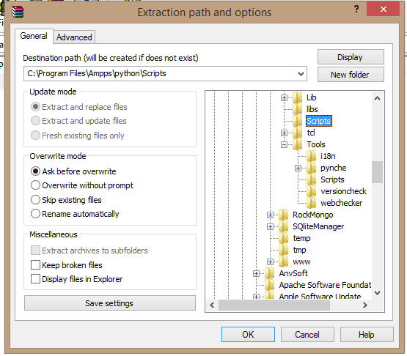
Well I don’t see it now, but somewhere on here I read that ez_setup had to be in the same folder as setup.py, or something like that. ⁽²⁾ Moving on…
So I have now extracted django to site-packages. It is 4:30am. I have been at this about an hour already.
Now it is time to see if this thing works or not:
Verifying¶
To verify that Django can be seen by Python, type python from your shell. Then at the Python prompt, try to import Django:
>>> import django
>>> print(django.get_version())
1.6
You may have another version of Django installed.
Note that these instructions do not specify what “shell” I am to use; the Windows command line? IDLE? Something else? Oft times these instructions assume Linux, and it becomes quickly evident that the writer is not familiar with windows, as in the instructions to include the $ first, above, which did not work.
So I decided to try IDLE:
Python 2.7.2 (default, Jun 12 2011, 15:08:59) [MSC v.1500 32 bit (Intel)] on win32
Type "copyright", "credits" or "license()" for more information.
>>> import django
>>> print(django.get_version())

Traceback (most recent call last):
File "<pyshell#0>", line 1, in <module>
import django
ImportError: No module named django
>>>
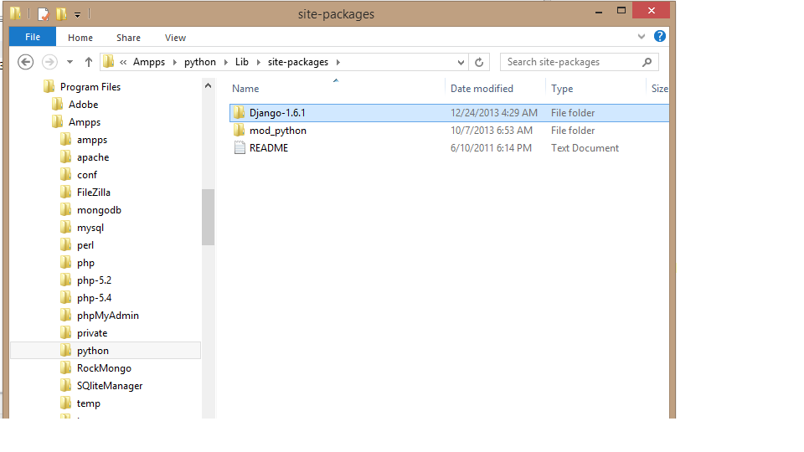
Well, error messages notwithstanding, you can see I do have django in site packages, so now what? The Windows command line, of course:

Microsoft Windows [Version 6.3.9600]
(c) 2013 Microsoft Corporation. All rights reserved.

C:\Users\...>python
'python' is not recognized as an internal or external command,
operable program or batch file.

C:\Users\...>cd C:\Program Files\Ampps\python

C:\Program Files\Ampps\python>python
Python 2.7.2 (default, Jun 12 2011, 15:08:59) [MSC v.1500 32 bit (Intel)] on win
32
Type "help", "copyright", "credits" or "license" for more information.
>>> import django
Traceback (most recent call last):
File "<stdin>", line 1, in <module>
ImportError: No module named django
>>> >>> print(django.get_version())
File "<stdin>", line 1
>>> print(django.get_version())
^
SyntaxError: invalid syntax
>>>

Now what?
Ok, I think I see what might be wrong. I have confused “untarring” with “installing”, so in essence I have skipped a step. But then where is the django 1.61 folder supposed to go, or does that matter?
Here’s another possible problem: Since I did not install pip, should I take out those two lines they told me to put into the top of setup.py before running this?

6:23am. I am back.

(2) C:\Program Files\Ampps\python\Tools\Scripts has setup.py in it, C:\Program Files\Ampps\python\Scripts is empty except for ez_setup, which I have now deleted. That was where I had read about ez_setup needing to be in the same folder as setup.py.

Notwithstanding, I am sticking with the current plan of skipping both pip and ez_setup, on the theory that if need be, I can always come back and besides, those are unlikely to be the only way to do this even if they are the so-called easiest.

Microsoft Windows [Version 6.3.9600]
(c) 2013 Microsoft Corporation. All rights reserved.

C:\Users\Administrator>python setup.py install
'python' is not recognized as an internal or external command,
operable program or batch file.

C:\Users\Administrator>setup.py install
'setup.py' is not recognized as an internal or external command,
operable program or batch file.

C:\Users\Administrator>cd C:\Program Files\Ampps\python

C:\Program Files\Ampps\python>setup.py install
'setup.py' is not recognized as an internal or external command,
operable program or batch file.

C:\Program Files\Ampps\python>python setup.py
python: can't open file 'setup.py': [Errno 2] No such file or directory

C:\Program Files\Ampps\python>cd C:\Program Files\Ampps\python\Tools\Scripts

C:\Program Files\Ampps\python\Tools\Scripts>python setup.py
'python' is not recognized as an internal or external command,
operable program or batch file.

C:\Program Files\Ampps\python\Tools\Scripts>python setup.py install
'python' is not recognized as an internal or external command,
operable program or batch file.

C:\Program Files\Ampps\python\Tools\Scripts>setup.py install
Access is denied.

C:\Program Files\Ampps\python\Tools\Scripts>
C:\Program Files\Ampps\python\Tools\Scripts>setup.py install

C:\Program Files\Ampps\python\Tools\Scripts>setup.py install

C:\Program Files\Ampps\python\Tools\Scripts>setup.py install
Traceback (most recent call last):
File "C:\Program Files\Ampps\python\Tools\Scripts\setup.py", line 2, in <modul
e>
setup(
NameError: name 'setup' is not defined

C:\Program Files\Ampps\python\Tools\Scripts>python setup.py
'python' is not recognized as an internal or external command,
operable program or batch file.

C:\Program Files\Ampps\python\Tools\Scripts>python setup.py install
'python' is not recognized as an internal or external command,
operable program or batch file.

C:\Program Files\Ampps\python\Tools\Scripts>

FUCK!!!!

Here is the content of my setup.py:

if __name__ == '__main__':
setup(
scripts=[
'byteyears.py',
'checkpyc.py',
'copytime.py',
'crlf.py',
'dutree.py',
'ftpmirror.py',
'h2py.py',
'lfcr.py',
'../i18n/pygettext.py',
'logmerge.py',
'../../Lib/tabnanny.py',
'../../Lib/timeit.py',
'untabify.py',
],
)

