I am using DialogFlow ES Slot Fulfillment. After the dialogflow calls webhook for slot fulfillment, and is going to prompt the user for next slot value, I want the next prompt to be the one I provide in the response. Here is the response I am sending. But DialogFlow picks the prompt that has been set in the Intent Design.

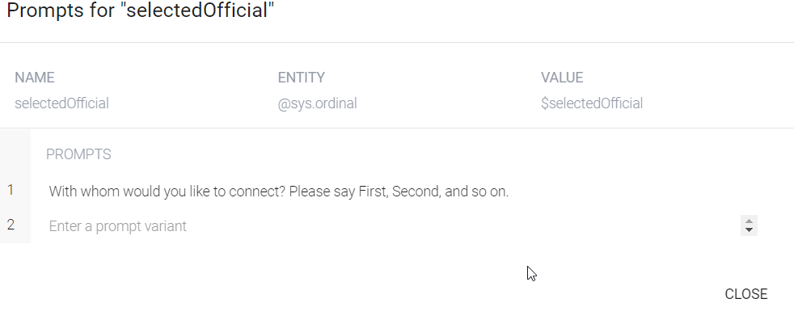
This is the response I am sending.

{
"fulfillmentText":" found ABC, CYZ, PQR. With whom would you like to connect? Please say First, Second, and so on.",
"fulfillmentMessages":[
{
"text":{
"text":[
"I found ABC, CYZ, PQR. With whom would you like to connect? Please say First, Second, and so on."
]
}
}
],
"source":null,
"payload":{
"google":{
"expectUserResponse":true,
"richResponse":{
"items":[
{
"simpleResponse":{
"textToSpeech":"I found ABC, XYZ, PQR. With whom would you like to connect? Please say First, Second, and so on."
}
}
]
}
},
"facebook":null,
"slack":null
},
"outputContexts":[
{
"name":"projects/targetsmartorchestration-ekit/agent/sessions/ABwppHE7AewnbLTSnjubsjXLmv_CC7PtIfeJs_IPt5WQwui6AeeM1AiM_K_KmoZfHY1P_gUrbiA3OiXjvYgVsiVtzAJaJiKod4_oUgc//session_vars",
"lifeSpanCount":50,
"parameters":{
"PhoneNumber":"XXXXXX",
"zipcode":"XXXXXX",
"selectedOfficial":"",
"Office":"",
"IssueTopic":""
}
}
],
"followupEventInput":{
"name":"selectedOfficial",
"languageCode":"en",
"parameters":null
}
}

This is the response in the conversation flow.
{
"conversationToken": "[\"0e19e67e-6b64-4be0-8a2c-ef83d65050cf_id_dialog_context\",\"connectofficialintent_dialog_context\",\"connectofficialintent_dialog_params_selectedofficial\",\"actions_capability_media_response_audio\",\"actions_capability_account_linking\",\"actions_capability_screen_output\",\"actions_capability_audio_output\",\"google_assistant_input_type_voice\",\"__system_counters__\"]",
"expectUserResponse": true,
"expectedInputs": [
{
"inputPrompt": {
"richInitialPrompt": {
"items": [
{
"simpleResponse": {
"textToSpeech": "With whom would you like to connect? Please say First, Second, and so on.",
"displayText": "With whom would you like to connect? Please say First, Second, and so on."
}
}
]
}
},
"possibleIntents": [
{
"intent": "assistant.intent.action.TEXT"
}
],
"speechBiasingHints": [
"$SchemaOrg_Number",
"$OfficeType",
"$IssueTopic",
"$ElectedOfficial"
]
}
],
"responseMetadata": {
"status": {
"message": "Success (200)"
},
"queryMatchInfo": {
"queryMatched": true,
"intent": "XXXXXXXXXXXXXX",
"parameterNames": [
"zipcode"
]
}
}
}

