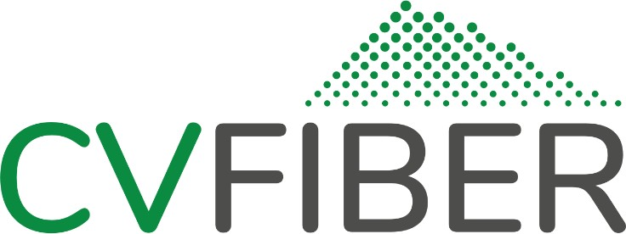

Agenda

April 11th, 2022 Special Executive Committee Meeting
Online Meeting Public Access:
https://cvfiber.net/mtg/executive
Or by phone:
(689) 206-9353 (access code 298-245-862#)

6:30pm

6:30 | Meeting call to order (start recording)
6:32 | Additions or changes to the agenda
6:35 | Public comment
6:40 | Construction Grant Eligibility Application | [no action expected]
6:50 | 2022/23 Construction Sequencing | [action expected]
7:20 | NRTC Contracting Update | [action expected]
7:45 | Adjourn

Times are advisory only. Agenda items may be discussed earlier or later than indicated.

802.552.3088 | info@cvfiber.net | https://facebook.com/CVFiber | http://cvfiber.net

Providing Central Vermont residents, businesses, and civic institutions with universal access to a reliable, secure, locally-owned and -governed communications network able to grow to meet future community needs.
Barre City • Barre Town • Berlin • Cabot • Calais • Duxbury • East Montpelier • Elmore • Marshfield • Middlesex
Montpelier • Moretown • Northfield • Orange • Plainfield • Roxbury • Washington • Waterbury • Williamstown • Woodbury • Worcester

