library('ctmm')
## Warning: package 'ctmm' was built under R version 4.0.1
Creating timestamp column in correct time zone for pilot data :
setwd('~/Box/GPS_data/Raw/Summer_pilot_collars_SFREC_06.05.2020')
gpsO8_p<- read.csv('cow632_collarO8_6.5.20.csv') #need to remove satellite row before import because it messes up the reading when from pure raw form.
gpsO8_p$timestamp <- as.POSIXct(paste(gpsO8_p$Date, gpsO8_p$Time), format="%Y/%m/%d %H:%M:%S", tz = 'Europe/London') #timestamp
attributes(gpsO8_p$timestamp)$tzone <- "America/Los_Angeles"
names(gpsO8_p)[15] <- 'HDOP' #renaming EHPE error column to HDOP
subsetting data into when cattle were in the two separate pastures:
gpsO8_pkoch <-subset(gpsO8_p, timestamp > "2020-06-05 00:00:00" & timestamp < "2020-07-16 24:00:00")
gpsO8_pcampb <- subset(gpsO8_p, timestamp > "2020-07-18 00:00:00" & timestamp < "2020-09-19 06:00:00")
gpsO8_pkoch$individual.local.identifier <- 'c632K'
gpsO8_pcampb$individual.local.identifier <- 'c632C'
Adding and cleaning calibration data (from 2 min calibration):
setwd('~/Box/GPS_data/Raw/Calibrate_GPS_data')
gpsO8_c <- read.csv('calibrate_2.4.21_gpsO8.csv') #need to remove satellite row before import because it messes up the reading when from pure raw form.
gpsO8_c$timestamp <- as.POSIXct(paste(gpsO8_c$Date, gpsO8_c$Time), format="%Y/%m/%d %H:%M:%S", tz = 'Europe/London') #timestamp
attributes(gpsO8_c$timestamp)$tzone <- "America/Los_Angeles"
names(gpsO8_c)[15] <- 'HDOP' #renaming EHPE error column to HDOP
gpsO8_c <-subset(gpsO8_c, timestamp > "2021-02-04 10:53:36" & timestamp < "2021-02-04 20:00:00") #Tina took units in at 8 pm on 2.4.21
gpsO8_c$individual.local.identifier <- 'calibO8'
List telemetry objects with calibration and pilot
gpsO8 <- rbind(gpsO8_c, gpsO8_pkoch) #this only worked with pkoch and not with pcampb, I don't know why
#gpsO8 <- rbind(gpsO8_c, gpsO8_pkoch, gps08_pcampb)
gpsO8 <- as.telemetry(gpsO8, timeformat="%m/%d/%Y %H:%M:%S", timezone="PST", projection=NULL, datum=NULL, timeout=Inf, na.rm="row",mark.rm=FALSE,keep=FALSE,drop=FALSE) #list of telemetry
## VDOP not found. HDOP used as an approximate VDOP.
## Minimum sampling interval of 9.7 minutes in c632K
## Minimum sampling interval of 1.92 minutes in calibO8
plot(gpsO8[2],col=rainbow(2))
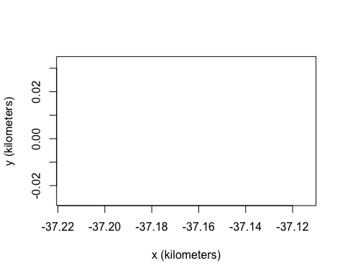
UERE <- uere.fit(gpsO8[2]) # only using calibration data
summary(UERE)
## , , horizontal
##
## low est high
## all 0.009612883 0.01021787 0.01082238
##
## , , vertical
##
## low est high
## all 0.008632825 0.009421618 0.01020955
##
## , , speed
##
## low est high
## all 0.6618991 0.7034753 0.7450185
uere(gpsO8) <- UERE
names(gpsO8[[1]]) # now the data are calibrated, as VAR is present
## [1] "timestamp" "longitude" "latitude" "t" "HDOP" "z"
## [7] "VDOP" "speed" "heading" "SDOP" "x" "y"
## [13] "vx" "vy" "VAR.xy" "VAR.z" "VAR.v"
plot(gpsO8[[1]],error=2) # plot with 95% error discs
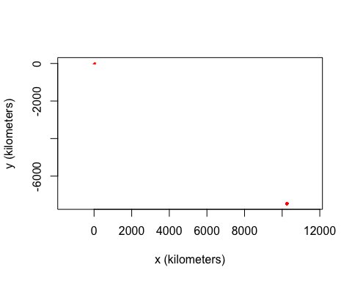
outlie(gpsO8[[1]])->OUT
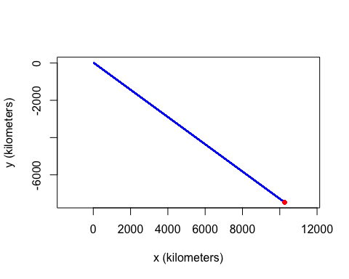
BAD <- which.max(OUT$speed)
gpsO8[[1]] <- gpsO8[[1]][-BAD,]
outlie(gpsO8[[1]]) -> OUT
