The Infinity Project

Learn2Be – Learning and Wellbeing Programme

------------------------------------------------------------------
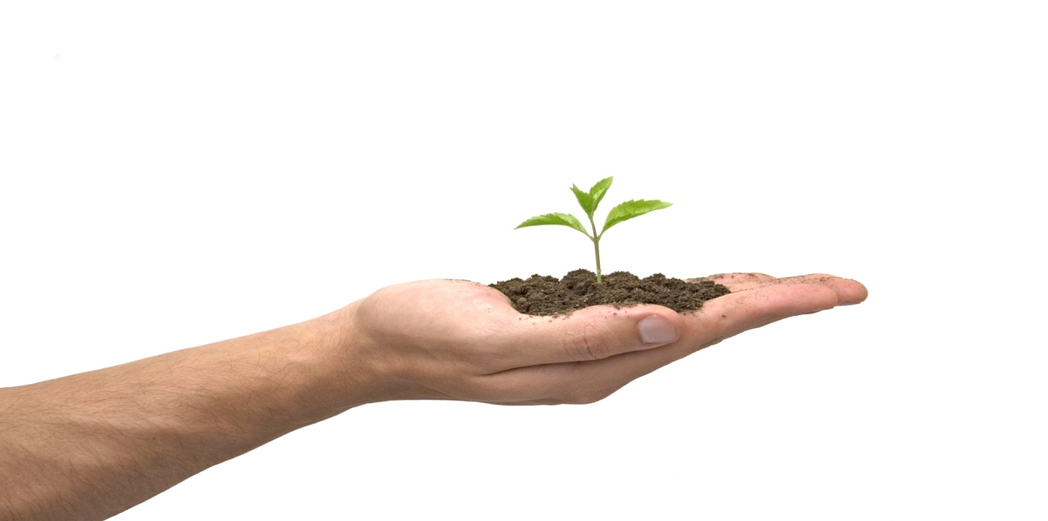

“as part of implementing a new paradigm we must take the next logical step in the development of the human psyche – the art of dialogue – which requires a new vocabulary and a new determination to meet our children in ways that will make it possible for us to discover who they are instead of defining who and what they should become” – Jesper Juul ‘Your Competent Child’

Learn2Be - overview
The personalised Infinity Project programme, Learn2Be, is an inspirational learning and wellbeing programme. It has been designed to specifically incorporate key components that we believe are fundamentally linked to gaining a greater understanding of who we are, what influences the choices we make and how they impact our lives and how we can choose to create a meaningful, productive and healthy life. The course in essence will promote the following:
- Raising self awareness and building self esteem, leading to personal responsibility
- Equipping young people with the knowledge, understanding, attitudes and practical skills to live healthy, safe, productive and fulfilled lives
- Supported transition to independent adulthood
- Healing of the physical/mental/emotional and spiritual selves
Although certain aspects of the programme will be compulsory, it is the young people who will decide on key elements of the programme that they will undertake. It is important that they take personal responsibility for their own journey on the programme and that they also understand the effect that the choices that they will make within it will have on their lives moving forward once they leave the programme.
Outdoor activity week
The Learn2Be programme begins with an outdoor survival week off-site. Based somewhere remote the young people will be encouraged to push themselves to the limit and to take on challenges way beyond the confines of their normal experience. On return to the programme they will use their newly developed leadership and team working skills to create the community in which they will now live. This common experience will bond both staff and young people together and will support the young people to develop a level of trust to begin to address the deeper issues underlying their addictive and destructive behaviours.
7 areas of the programme
There are 7 areas of the Learn2Be programme. Each young person’s participation in the following areas will vary depending on their own personalised needs and requirements:
- Life skills education
- developing life and social skills
- build a sustainable community – house building/maintenance/kitchen/housekeeping/finance/mechanics
- values/life mission and vision
- teamwork and leadership skills
- citizenship
- volunteering
- arts and creativity
- personal development and Identity/finding their “Element”
- Education and employability
- functional literacy and numeracy (up to GSCE where appropriate)
- nutrition
- first aid
- hygiene
- accredited short courses – National Open College Network
-work placements/CV creation/Self employment, etc
- Behavioural management
- safety and safe behaviours
- identify and modify self-defeating behaviours
- anger management
- Psycho Education modules
- learning about and understanding addiction and its impact upon self and others
- cognitive (thinking), affective (feelings), and behaviour aspects
- developing positive coping strategies
- Trauma work
- family constellation
- dynamic meditation
- psycho-drama
- neurotherapy
- body work
- art therapy
- nature therapy
- gestalt
- voice and sound work
- cognitive behavioural therapy
- Family focused work
- address relationships affected by addiction
- promote positive parenting and functional families
- learn new and effective ways of relating
- Family Lab intervention
- Health and nutrition
- Diet and exercise
- cookery skills
- grow organic food
- sport and exercise regime
- meditation
- yoga/tai chi

Daily sessions
Daily sessions will include community check-in groups, one-to-one sessions, group sessions, peer sessions and activity/fun sessions. All young people will be responsible along with staff for the running of the community and will have sessions each day with specific activities in departments such as the kitchen/maintenance/house-keeping/gardening and administration. As they progress through the 5 stages of the programme, they will be given additional responsibility within the running of the community. The timetable will vary dependent on the young person’s role within the community (those responsible for the kitchen, for example, will need extra time to set up/prepare)
One-to-One Sessions:
All participants will receive 2 hours of individual attention per week (2 x 1 hour sessions) with a therapist of their choice.
Group Sessions:
All participants will initially receive 2 hours of group work per week rising to 4 hours from the Insight stage and beyond. This will be led by highly experienced facilitators and will allow an exploration of hidden and painful memories and feelings and will allow a deeper level of trust to be built within the group. Only during the Insight stage and the stages beyond that, will young people be encouraged to explore the deeper core issues that underlie their addictive and destructive behaviours.
Group sessions will be dependent on the stage of the programme that the young person is currently at. Group sizes will therefore vary.
Peer Sessions:
All participants will receive 2 hours of peer support per week. This is an integral and vital aspect of this programme and will lead to the creation of a post programme support system. At the outset of the programme, all participants will be allocated in a random way, a one-on-one buddy, who will remain their course partner throughout programme. In addition, three pairs of buddies will join into groups of six, and will meet once a week to engage in peer support.
5 Stages of treatment
There are 5 Stages to the programme:
- Inclusion
- Integration
- Insight
- Identity
- Independence
Each stage will be taken at the pace of the individual. There will be no set expectations of time limits for each stage. Each person will progress to the next stage when both they and the rest of the community feel they are ready.
First stage – Inclusion
- Introduction to the community.
- Getting used to the surroundings.
- Getting to know other residents and staff
- What’s your story? Share life story and hear those of the staff/residents
- Setting intention for what they want to get out of the 6 months
- Settling in to the structure of the programme
- Reviewing the programme and what they would be interested in taking part in
- Peer mentored and buddy system introduced
- Beginning to trust the community and feel that they belong
Second stage - Integration
- Becoming an active member within the community
- Given more responsible role within the community
- Creating a personal vision for the programme and beyond
- Creating trusted relationships
Third stage - insight
- Feeling safe and trusting and belonging
- Opening up to the root cause of their addictive behaviours (at their own pace)
- Healing core wounds
- Given more responsibility within the community
Fourth stage - Identity
- Feeling empowered. Given more responsibility. Begin peer mentoring
- Looking at who they are and what they wish to be in life
- Creating a personal mission statement
- Exploring core values
- Finding their “Element” (Sir Ken Robinson)
- Given more responsibility within the community
Fifth stage - Independence
- Getting ready to move on from the programme
- Given key role within the running of the community
- Working with programme staff and external keyworkers to go into Education/employment or training
- Volunteering within the local community
- Access to internet for research and application purposes
- Working with their families where necessary to organise their return
- Organising supported housing where necessary
- Working with their external mentor to prepare for re-integration into society
A sample daily timetable
The Infinity Project - daily timetable (example outline)
Time | Activity
07:00 | Wake up
07:15 | Yoga/meditation/Tai Chi/jog/prepare breakfast
08:15 | Breakfast/clear up
09:30 | Community meeting - needs and feelings
10:00 | Activity session
11:30 | Prepare lunch
12:00 | Lunch/clear up
13:00 | Community Check In
13:15 | Creative session
15:00 | Tea break
15:15 | Community Check In
15:30 | Peer group or 1:2:1 session
16:30 | Prepare dinner
17:00 | Dinner/clear up
18:00 | Fun Group activity
19:00 | Community Check In
19:15 | Daily reflections/meditation
20:00 | Buddy 1:2:1s
20:30 | Free time
21:30 | Community Check In
21:45 | Tea break
22.15 | Community check in
22:30 | Bed time

