Adding Content for EM Digital Signage

Contents
An overview 1
Logging in 1
Adding content 2
Feeds 3

An overview
For most new users it is probably best to start by logging in and adding content (skip the overview and go straight to the logging in, if you do read it do not think about the concepts introduced too much, it is a complicated system to try to explain in a few paragraphs and if you are anything like me it is much easier to learn by doing).
If you want a little more background…
In Concerto we have screens which display templates.
There are some ready to go templates already in the system, they can be edited and new ones created (which is preferred) if your account has been enabled to allow this.
Templates can have different fields added to them (depending on what they display e.g. graphics, ticker, text, time). The template can have an overall background image and styles can also be applied to the fields (html / css style).
When you view a screen (in the admin console) if you hover over the wire frame a pop up will show what feeds the field in the screen subscribes to, if you click the “edit screen” button (in the top right) the template the screen will display can be chosen (as well as a number of other settings).
The fields in templates need feeds and feeds need contents.
More than one feed can be attached to a field and feeds can be attached to multiple fields – the same relationship exists for content and feeds.

Logging in
To access the admin console <at the url your concerto admin will have provided>
Your username is your email address the password for the system was sent to you on. The sign in link is in the top left of the main screen.
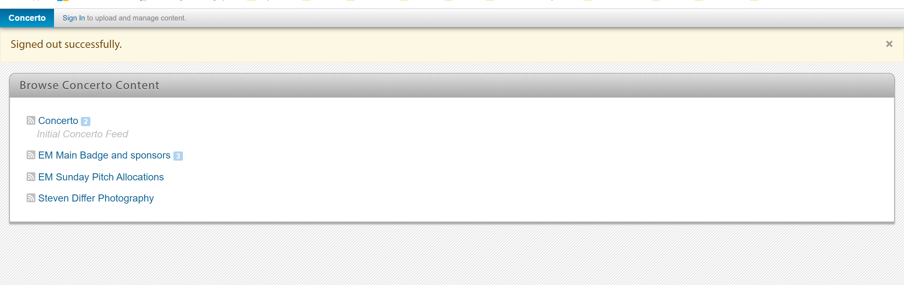

When you first log in to the admin console you will see feeds on the left and some information on the right highlighting the most recent activity on the admin console as well as some other background system information.
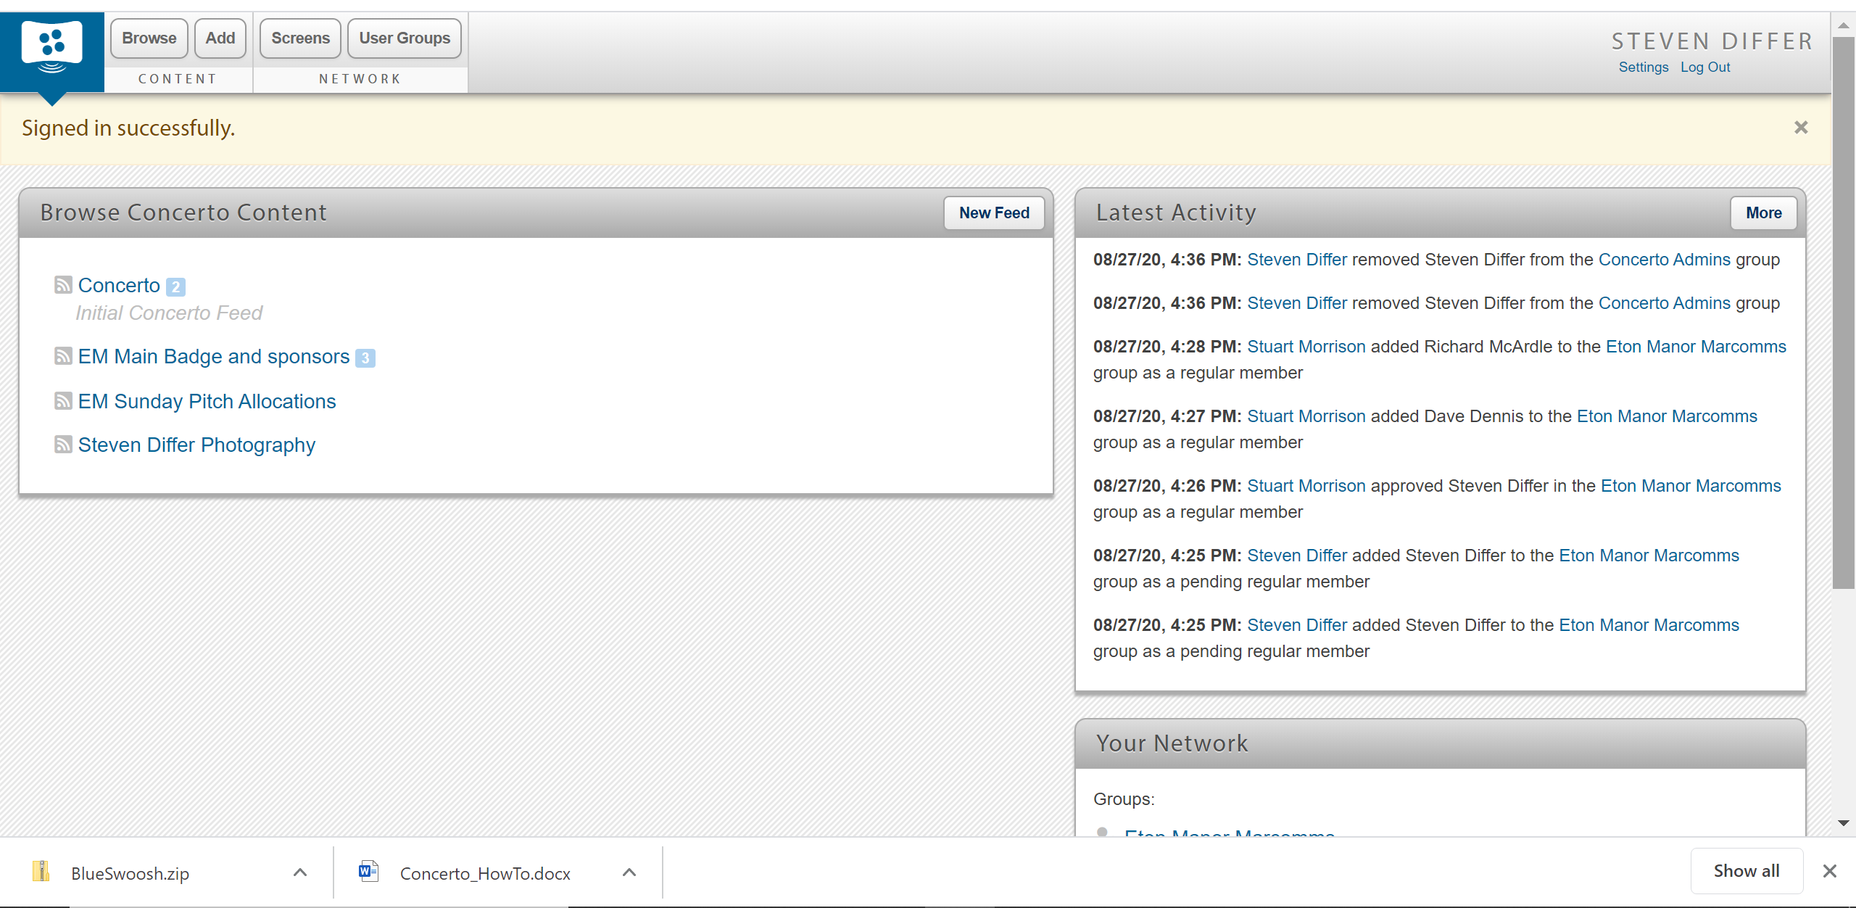

Adding content
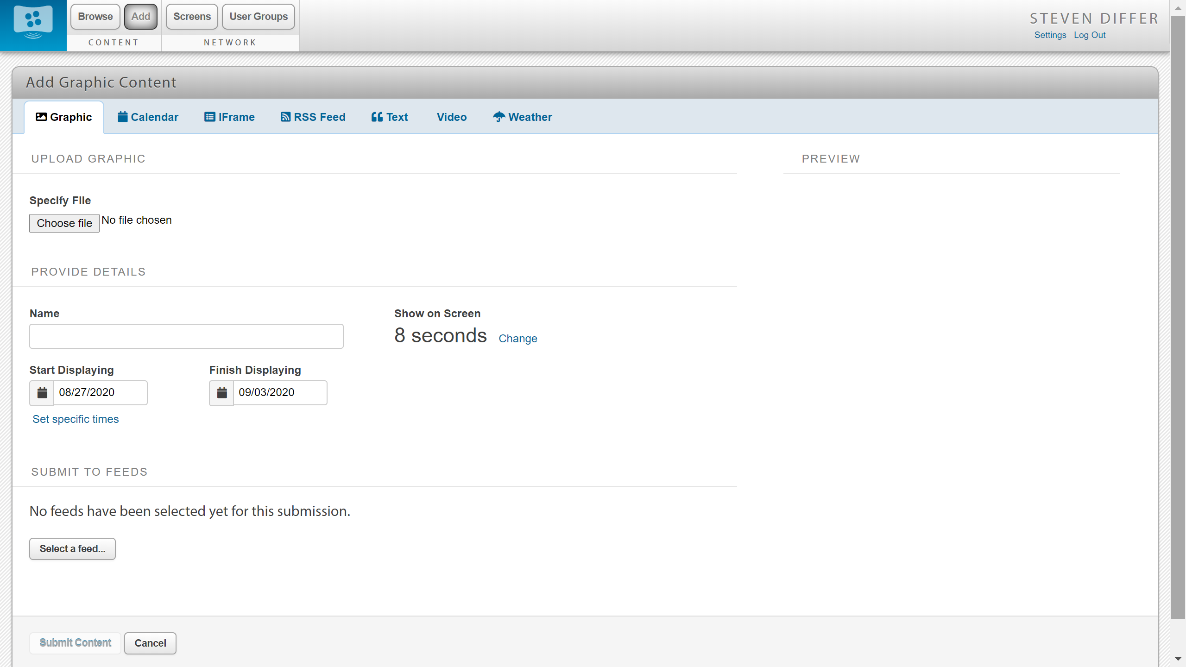
Click the “Add” button to see the screen above, it defaults to adding graphic content although the tabs at the top allow other content to be added.
Content must be given a name, start and stop times can be set specifically as well as the dates so that content can be preloaded to show at specific times in the future for a set amount of time – the default is to display for a week.
Before the content is displayed a feed must be specified – usually only one feed will be specified although it is possible to select more than one. An example of content ready to be submitted.
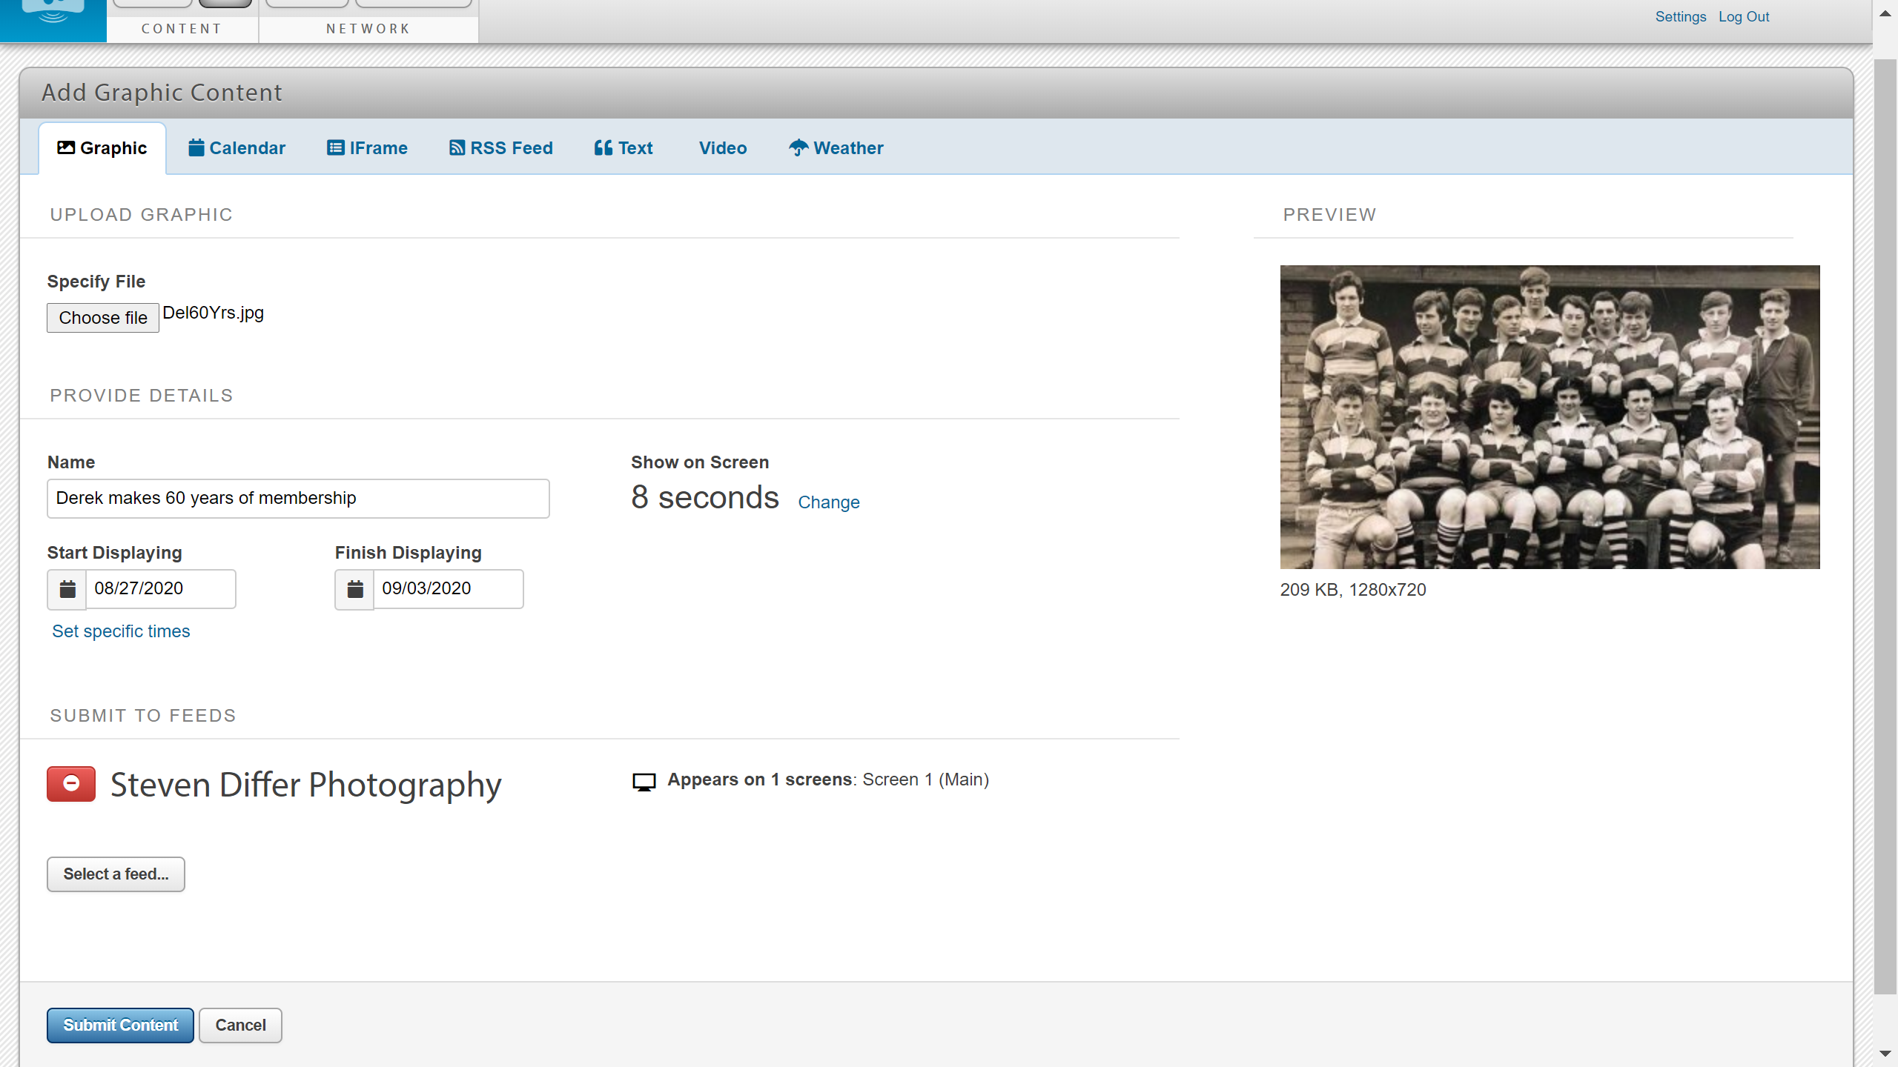
Once the content is submitted it can be previewed at <admin url>/frontend/1
Each screen gets a number – the first screen created is #1. Most beginners should be able to stop here – you are doing well if you are getting content out there!

Feeds
If you click on the feed you will be able to see what content is already used by that feed as well as the screens that use the feed.
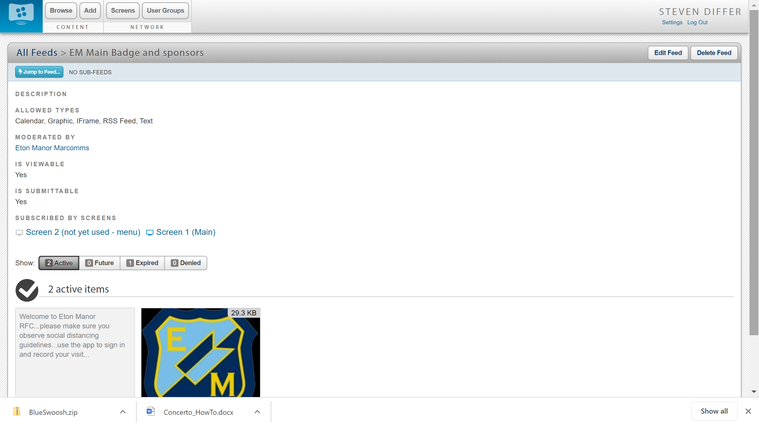
If there is no message to add content it may be that content has expired or is set to be shown in the future (or a moderator has denied it). The console does show how many items are in each category – in the screen shot above there are only two active items, one in the expired and zero in the future or denied categories.
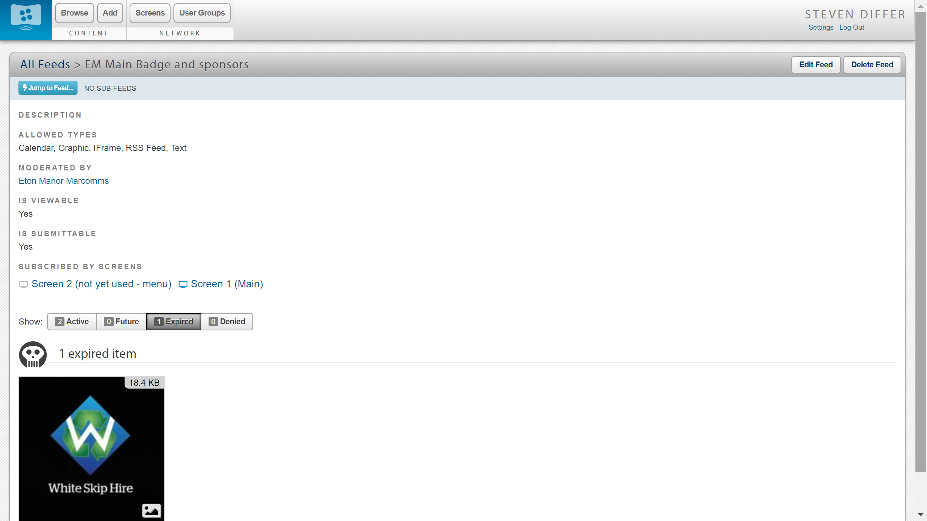
(viewing the expired content)

If there is no content in the feed it will invite you to add some content (this is the same as using the “add” button at the top of the page).
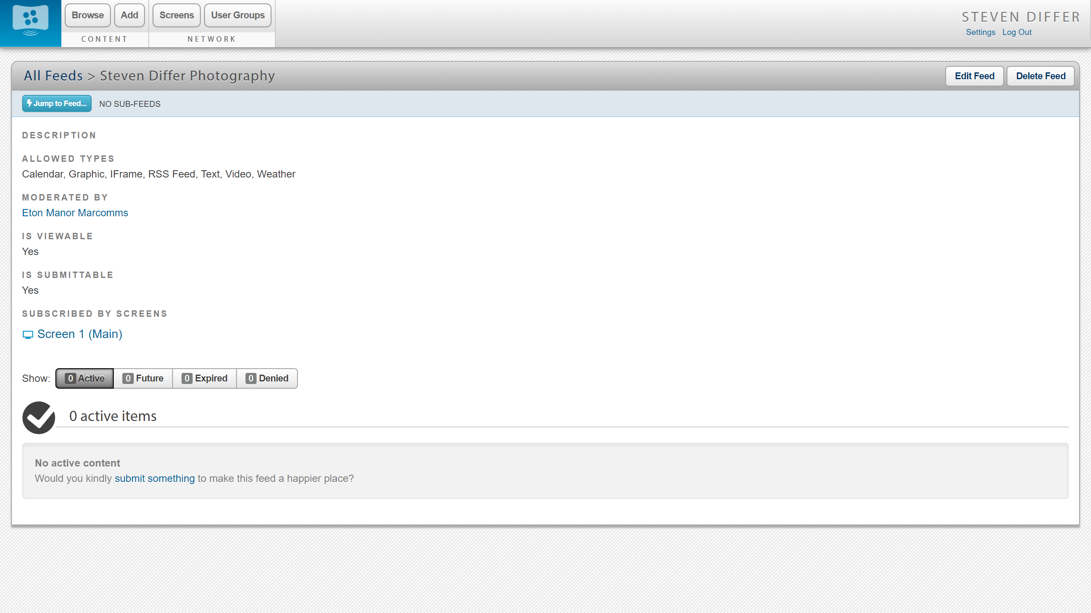
If you create a new feed you will need to make sure a screen subscribes to it for it to be displayed.

