Guerilla Running
presents
Backwards Mile

1 mile. 1 direction: backwards.

Saturday, January 23, 2010
3PM
Marathon Park
$10 (to benefit Olympia Action Network)

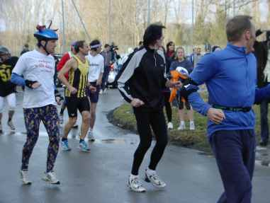

Backwards running offers many benefits:
- Builds stamina.
- Strengthens leg muscles.
- Improves quickness.
- Promotes balance.
- Enhances quality of life.
- Restores good posture.

Questions?: jamisongirls@hotmail.com

Stevenson, Dr. Robert S. “Backwards Running.” 1981.

