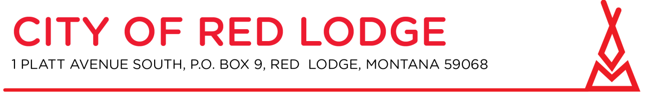
Please join my meeting from your computer, tablet or smartphone.
https://global.gotomeeting.com/join/605280837
You can also dial in using your phone.
United States: +1 (312) 757-3121 Access Code: 605-280-837

Planning Board and Zoning Commission
City Hall Council Chambers at 5:30 PM April 28, 2021

- Call to order

- Roll call

- New Business:
  - Public Hearing: Design Review for a neon sign in the Commercial Mixed Use (C-2) Zoning District
  - Zoning Regulation updates
    - 4.4.0 Standards for Specific Uses

- Written Correspondence
a. Staff Communication
b. Petitions and communications from the audience

- Other Business

In keeping with the State Constitution, the Planning Board will not now take final action on any matter raised under Other Business.

- Adjourn

