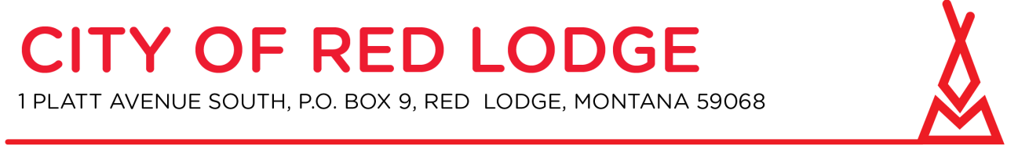
Wed, May 12, 2021 5:30 PM - 8:30 PM (MDT)
Please join my meeting from your computer, tablet or smartphone.
https://global.gotomeeting.com/join/822900605
You can also dial in using your phone.
United States: +1 (872) 240-3212 Access Code: 822-900-605

Planning Board and Zoning Commission
City Hall Council Chambers at 5:30 PM May 12, 2021

- Call to order

- Roll call

- Approval of Minutes: April 14, 2021 & April 28, 2021

- New Business:
a. Public Hearing: Design Review for a residential home in the C-2 Zoning District
a. 2nd Public Hearing: Conditional Use & Design Review for a commercial development in the C-3-N Zoning District – Colt Communications

- Written Correspondence
a. Staff Communication
b. Petitions and communications from the audience

- Other Business
In keeping with the State Constitution, the Planning Board will not now take final action on any matter raised under Other Business.

- Adjourn

