Red Lodge
Design Review
Staff Report RLDR-21-05

DATE: May 12, 2021
TO: Red Lodge Planning Board
Sandy Conlee, President

FROM: James Caniglia, Community Development Director

RE: S27, T07 S, R20 E, TR 7, BLK 85, Red Lodge Original Townsite
Bloom/Kessler - Design Review

Project Files DR 20-05

OWNER / APPLICANT: AUTHORIZED REPRESENTATIVE:
Erika Bloom/Ross Kessler Self-represented
5 Locust Street
Mattapoisett, MA 02739

PLANNING BOARD HEARING: May 12, 2021 @ 5:30 p.m.
CITY COUNCIL HEARING: Not Applicable

Property description:
The subject property may be described as S27, T07 S, R20 E, TR 7, BLK 85, Red
Lodge Original Townsite Carbon County, Montana. The property does not have a
physical address, but lies on the northeast corner of 3rd Street and Bonner Avenue.

Property size:
5,250 Square Feet (.121 Acres)

Notice provided:
Per the City of Red Lodge 2016 Zoning Regulations, notification was given at least (15) fifteen days prior to hearings via:
- Published in the April 21, 2021 edition of Carbon County News;
- Adjacent landowners received public notice via USPS;
- Notice posted at Post Office and City Hall

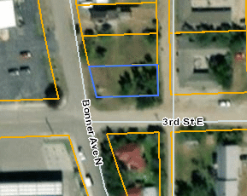
Executive Summary of Project
Bloom and Kessler are proposing the construction of a single-family structure within the C-2 (Commercial Mixed-Use Zoning) at the site. All new buildings within the C-2 are required to receive Design Review approval before construction.

The project will need approval by the Planning Board on the following Zoning Issues:

- Design Review in the Red Lodge C-2 for the construction of a new two-unit home.

Request:
A. To allow for the construction of a new home within the Red Lodge Commercial Mixed Use Zoning District.

Staff Recommendation / Suggested form of motion:

A. I move to adopt Staff Report DR 2021-05 as finding of fact.

B. I move to approve the Design Review Permit for RLDR 21-04 to allow for the construction of a new home located at Section 27, Township 07 South, Range 20 East, Track 7, Block 85, Red Lodge Original Townsite, Carbon County, Montana.

1. That the use, operation and development of the property be in accordance with the plans, specifications and documents submitted for review except as modified by these conditions.

2. That the developer shall obtain a building permit from the City of Red Lodge and comply with any/all requirements including obtaining a certificate of occupancy prior to opening or conducting any of the activities discussed in the application.

3. That all lighting associated with the project shall be installed at a 90º cutoff, shielded and directed downward onto the property. The use of Mercury Vapor Lamps for lighting is expressly prohibited. Lighting shall not create off-site glare.

4. The construction shall be compatible to the historic architecture of Red Lodge.

5. The applicant has one year after approval of Design Review to commence construction on the project.

6. If artifacts are uncovered during the excavation process the Carbon County Historic Preservation Officer is to be contacted.

7. A minimum of five understory trees or one overstory and one understory tree is required for the property. Acceptable tree species can be found in the 2018 Red Lodge Urban Forestry Management Plan. Trees shall be planted before a certificate of occupancy is given for the property.

8. Two paved parking spaces shall be installed.

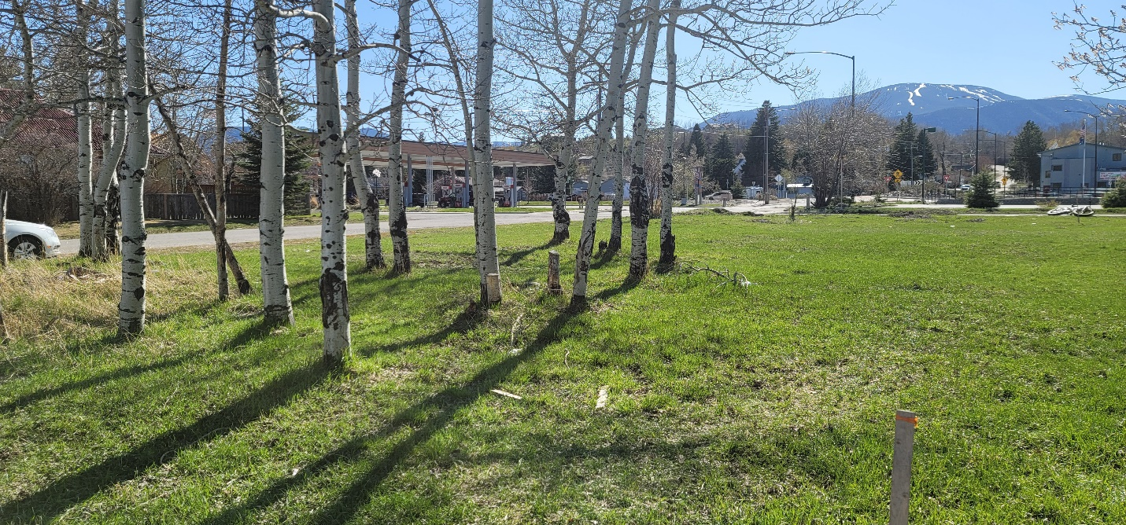
View looking west from the alley looking towards 3rd Street & Bonner Avenue. The property runs from the wooden property pin north to 3rd Street and west to Bonner Avenue.

Growth Policy
The Red Lodge Growth Policy seeks to increase housing options in a variety of Zoning districts and housing is contemplated in the C-2. The proposed use of the property fits within the general goals of the Growth Policy.

- Encourage ‘infill’ development.
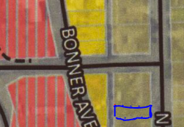
- Encourage new development where we currently have infrastructure.
- Off-street parking is required in the C-2.
- The Growth Policy also requires that we “protect residential neighborhoods from potential nuisances like excessive and persistent noise, excessive light, safety hazards and commercial impacts.” The design of the building is similar to other homes in the vicinity.

Zoning Regulations
Section 4.3.110
The purpose and intent of the C-2 Zoning District is to permit mixed-use developments containing a range of aesthetically compatible commercial and residential developments. This zoning district is intended to encourage residential and commercial uses in an urban context.

The proposal meets the intent of RLRZ 4.3.114, Residential Appearance.

Design Review Criteria: Standards of General Applicability (Chapter 4.5)

Section 4.5.20 Hillside Developments: The site is flat with slopes less than 8%. As such the Section of the Code is not applicable to this project §4.5.22.

Section 4.5.30 Environmental Regulations:

Sub-Section:
31 Wetlands. The property is not mapped as having regulated wetlands.
TABLE 4.3.112
Allowed Uses
C-2
Principal
Single Family | Day Care, Family, See 4.4.22 (B) |  |  |  | Professional Office, See 4.3.114. (B)
Short-Term Rental, See 4.4.33 | Public  Parks & Recreation |  |  |  | Day Care, Group, See 4.4.22 (B)
Retail, See 4.3.114. (B) | Group Home |  |  |  | 2-family/ Duplex
Medical Office, See 4.3.114. (B) | Long-Term Care Facility |  |  |  | Bed & Breakfast, See 4.4.22(A)
Accessory
Guest House, See 4.4.22(F) |  |  | Home Occupation, See 4.4.22 (C)
Storage/Garage |  |  | Building/Shed
Conditional
Light Industrial,  See 4.3.114(C) |  | Worship Facility |  |  |  | Multi-family >3 units
Vehicle Sales, Repair & Services |  | Drive- Through Facilities |  |  |  | Government Buildings & Facilities
School |  |  |  | Restaurant

32 Water Quality. As a single-family home with adequate setbacks, stormwater runoff from the home will not create stormwater runoff concerns.

33 Air Quality: The Zoning Regulations require the use of hard surfacing for all parking and driving surfaces, a driveway is being proposed along the eastern portion of the property off the alley. The application, as submitted, meets outdoor parking requirements.

34 Subsidence: The area is not in an area mapped as having the potential for mine subsidence.

35 Rock Creek, Floodplain: The property is not located in the Rock Creek Corridor and the Floodplain Map No. 30009C0692D does not indicate a Zone A (100-year floodplain) on the subject property.

Section 4.5.40 Parking and Loading Standards: The project is required to provide parking in accordance with Table 4.5.43. Per this table, the developer does need to add two parking spaces for a single-family residence in C-2. The developer shall have two concrete parking spaces via access from 3rd Street.

Section 4.5.50 Intersection Visibility:

Sub-Section:
53 The site is not located at an intersection.

Section 4.5.60 Landscaping.

The C-2 Zoning District requires landscaping; however, a landscaping plan is not required for a single-family home. A minimum of five understory trees or one overstory and one understory tree is required for the property. Acceptable tree species can be found in the 2018 Red Lodge Urban Forestry Management Plan. The applicant seeks to preserve existing aspen trees on the property which would provide more than the minimum amount of required landscaping.

Section 4.5.70 Lighting.

- This is proposed single-family home is in an area of the City in which single-family homes represent the majority of nearby development. As such, the issue of fugitive light from the development of the property should be limited to what is consistent with residential development. All lighting associated with the project shall be full cutoff, shielded and directed downward onto the structure or parking area. Lighting shall not create off-site glare.

Section 4.5.80 Infrastructure.

Sub-Section:

83 The project is located in an area that is served by City water and sewer. The Red Lodge Public Works Department will be extending sewer in the alley behind the property in the summer of 2021. The applicant may use the existing sewer line on 3rd Avenue, may opt to wait until sewer is available in the alley, which would prevent the need for re-paving a portion of 3rd Street.

84 The necessary private utilities already exist on the property.

85 The site has direct access to Bonner Avenue and an alley.

86 Sidewalks are not installed along any portion of the eastern side of Bonner Avenue and not required to be installed.

Section 4.5.90 Storm Water Management.

Sub-Section:

95 The City currently does not currently have stormwater collection in the vicinity. Stormwater runoff from the home will not result in elevated stormwater runoff as the home will be within approved setbacks and contain a limited amount of permeable surface.

Section 4.5.100 Operational Performance Standards.

Sub-Section:

104 The application references that the property will be used for a single-family home. The storage of hazardous or combustible materials beyond what is typically found in residential units is not expected. Further emissions of odors and gases should be typical of other residential uses.

105 Typically noise associated with a residential development is less than that associated with commercial development. The surrounding property is zoned C-3-N to the west, C-2 to the north and south and R-4 to the east. The noise generated by the development is equal to what would be expected in the neighborhood. Staff submits that there is insufficient cause to consider allowing elevated noise levels on the property beyond what is provided for in Table 4.5.106 given the exemption in §4.5.105 (B)(1) of the Zoning Regulations.

Unless specifically exempted by the Red Lodge Zoning §4.5.105, all noise measured at the property line generated by the use of the property as a Residential single-family development shall be limited to 75 dBA from 12:00 a.m. to 7:00 a.m. and 85 dBA at other hours.

Carbon County Historic Preservation
The project is not located within a recognized historic district. That said, the Carbon County Historic Preservation Office should be made aware of the project by the developer. Further, it is strongly recommended that the Historic Preservation Office be afforded the opportunity to evaluate the property both preconstruction and during construction should historical artifacts/concerns be identified.
Table 4.3.113
Dimensional Standards
C-2
Lot Standards
Lot Area, min. square feet | NA
Lot Frontage, min. feet | NA
Minimum Setbacks (feet)
Front | 10
Side | 6
Rear (when Not on an Alley or Row) | 10
Rear (when on an Alley or Row) | 0
Building Standards
Building Height | 35

Design of the Structure:

The materials and look of the facility are similar to those associated with the existing pattern of development in the C-2 when used for a residential purpose. Additionally, the development of the property is subject to the limitations imposed by Table 4.3.113 of the 2016 Red Lodge Zoning regulations. The design of the structure with conditions warrants approval.

