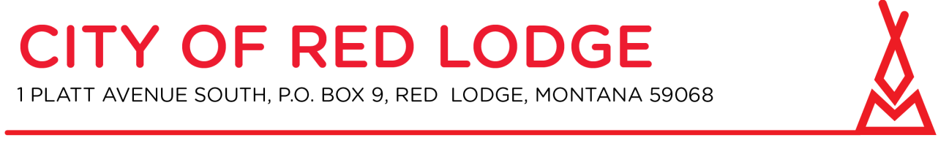
Resort Tax Review Committee
Please join my meeting from your computer, tablet or smartphone.
https://global.gotomeeting.com/join/240648285
You can also dial in using your phone.
United States: +1 (669) 224-3412 Access Code: 240-648-285
Resort Tax Review Committee
City Hall Council Chambers at 5:30 PM May 13, 2021

- Call to order

- Roll call
- Approval of Minutes: April 20, 2021

4. Discussion
a. Final Review of Taxable Items

5. Written Correspondence
a. Petitions and communications from the audience

6. Other Business

7. Adjourn

