[](http://www.ccctp.com/_vti_bin/shtml.exe/index.htm/map1)

Educational Workshop (Starting your own Small Business, Innovation as a Business Tool, and The Importance of Business Etiquette)

**Saturday, Nov. 2, 2019**

**From 2:00PM to 5:00PM**

**Where: 3000 Bayport Dr. Suite 1100—Tampa, Fl 33607 (Rocky Point—Office Building, in front of the Grand Hyatt). We will be on the 11th floor (the New York Life area). Park in the garage across from the Office Building. Call Eric Man (813-758-7582) if you get lost or have difficulties entering the building.**

**Free to Members---$5.00 for Non-Members.**

You don’t want to miss these game-changing sessions:

(2:00 PM to 2:05 PM) --Opening Remarks and Intro by our CCCTB President: Sunny Duann

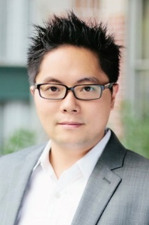

**(2: 05 PM to 2:55 PM, including Q’s & A’s) --John Huang will enlighten us on “Starting Your Own Business”. John is a successful entrepreneur and real estate investor who has grown a small retail store into a multimillion-dollar business. He will share how to operate a successful importing business (the benefits of importing from China,** the challenges and pitfalls to avoid, how to deal with the new tariff situation and how to find “joy” in business). **After graduation from the University of Connecticut with a degree in Electrical Engineering, John shadowed a friend’s business to learn the ins and outs of the cabinet industry before opening his own cabinet company, Innovation Cabinetry, in Clearwater, Florida. In the last decade, John has transformed Innovation Cabinetry into one of the largest cabinet wholesale distributors in the Tampa Bay Area. He recently opened his second location in Dallas,** Texas.

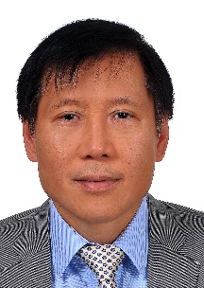

**(2:55 PM to 3:45 PM, including Q’s & A’s) --Hear Dr. Edward Lin share his ideas about Innovation**. Dr. Lin is the Founder and CEO of HealO Medical, LLC ([www.HealOMedical.com](https://linkprotect.cudasvc.com/url?a=http%3a%2f%2fwww.HealOMedical.com&c=E,1,ofbXXmh-bWCX0xPKmSs9ErC3LX8xNZJzwKsIKq7g-ei4-XP106fpSh80Nt_roHm72b1AkJmOjJfsDWTvSQwD1ImbjprygD50rsnj3dARNSg,&typo=1)) and Ingenious Technologies ([www.ingenious.com](https://linkprotect.cudasvc.com/url?a=http%3a%2f%2fwww.ingenious.com&c=E,1,1EB8AjpTbXBf5LgrWFestL2nLAOieJEkas5p3pDurhGZXAlruUXyNaDcLnP8rIhu_Kh1WOwNjiHWo6gdQHfB7-t9OPEZMeuDcvAtkQiPGiKuj6f5LdQeTdcAYg8,&typo=1)) with innovative technologies.

Dr. Lin was the Henry Woodburn Research Fellow at the renowned Roswell Park Cancer Institute, the highest honor bestowed by the State University of New York at Buffalo Graduate School of Biomedical Sciences. He is a board-certified anesthesiologist, trained at the Yale University School of Medicine.  During his years in clinical practice, Dr. Lin implemented innovative medical procedures that benefited many patients. He was Chairman of Anesthesiology at an Ohio hospital and Associate Professor of Anesthesiology at Ohio University.

Believing he can contribute even more to society by being an inventor, Dr. Lin left the practice of medicine at the peak of his medical career to pursue his dream and realize his vision. He is the holder of multiple US and international patents and other patent pending intellectual property, providing innovative solutions for diverse industries.

 Dr. Lin has won a $1.5 Million Leading Pioneer Award for his disruptive wound care technology named “O-ACE-Sys” and has R&D teams in Taipei and Shenzhen.  FDA clearance of this therapeutic platform is expected soon.

Dr. Lin is a firm believer in service beyond self.  He is an Asian American civil rights leader and has helped to gain equal opportunity and justice for 15.5 million Asian Americans at the federal level.

Break Time/Networking (3:45 PM to 4:05)

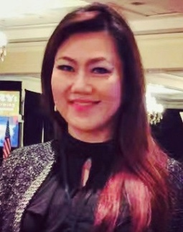

**(4:05 PM to 4:55 PM including Q’s & A’s)-- Anne-Marie Chuang, CMA, MBA, will share her dynamic ideas on the importance of “Etiquette in Business”, why business etiquette is important to everyone (not just for CEOs of Fortune 500 companies!), including the corporate employees, professionals in different field, and small business owners. Anne-Marie will outline the benefits of knowing and practicing good business etiquette, discuss how good etiquette can grow your business, and how you can learn better etiquette techniques.**

Anne-Marie earned her Master in Business Administration (MBA) degree from the University of South Florida. She also holds a BS degree in Civil Engineering and a BA degree in Finance. She has worked at several Fortune 500 companies in Boston and Tampa regions, including WR Grace, MorganStanley, at professional capacity of FP&A Analyst, Corporate Planning & Budgeting Manager, and Wealth Advisor. Currently Anne-Marie is a Real Estate investor and serves a consulting role for 24Invest, LLC. Anne-Marie has served on the board of CCCTB since 2013; formally as the president in leading the organization during its recovery years. Anne-Marie continues to contribute her time, business knowledge and skills to the local Chinese American Associations and helps grow businesses in our community.

(4:55 PM to 5:00): Summary and Concluding Remarks

Space is limited for this critical workshop, so you will need to register **by Thurs—Oct. 31 (5:00PM)**—you can register via e-mail (please **mark the Subject Heading as “CCCTB Workshop”** if you register via e-mail (Sunny [Duann—sduann@gmail.com](mailto:Duann—sduann@gmail.com) or call 727-656-9988) or (Sue [Xu— suetampa@gmail.com](mailto:Xu—%20suetampa@gmail.com) or 813-579-7379).

**See you at the CCCTB event on Sunday—Nov. 2, 2019 (2:00PM to 4:00PM)!**

***Be involved - Bring your cards - Bring your vision - Bring your enthusiasm!***

***CCCTB is your organization***