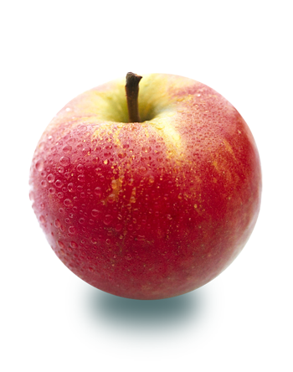

Healthy Eating Supermarket Tours
Chestnut Hill Plaza | 4 Seasons Plaza | Brandywine
10/22 @ 2pm | 11/5 @ 2pm | 11/12 @ 2pm
11/10 @ 6pm | 11/14 @ 6pm
11/19 @ 2pm | 11/30 @ 6pm
12/8 @ 6pm | 12/10 @ 2 pm
To Sign up Visit http://www.signupgenius.com/go/4090f4dacaa2fabf85-store
Or
Call Cassandra Umile, R.D. at 302.293.6351

ShopRite and University of Delaware are teaming up to help YOU eat healthier!

One participant will have a chance to win a $50 GIFT CARD!
It’s
FREE!
- Adding more fruits and veggies to your diet
- The difference between fresh, frozen, and canned
- Whole grains and how to find them
- Lean sources of protein
- Healthy eating on a budget
- And much more!

Learn about:

