Join us for…

NEW AMERICANS DEMOCRACY DAY

A national celebration of Immigrant Voting Power!

Join: Elected Officials from Illinois, including:
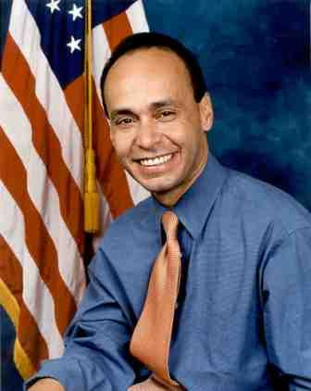
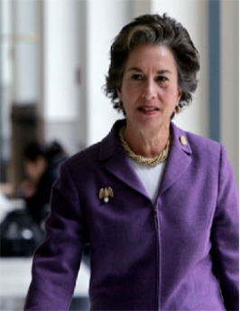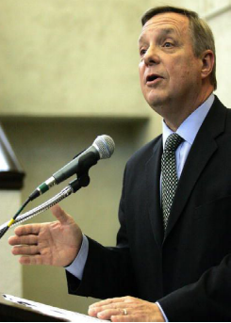

Senator Dick Durbin
Congressman Luis Gutierrez
Congresswoman Jan Schakowsky

And Leaders of the Immigrant Rights Movement:

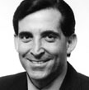
Ali Noorani, Executive Director, National Immigration Forum, Washington DC

Frank Sharry, Executive Director,
America’s Voice,
Washington DC
As well as Immigrant Justice Leaders from 17 states, coast to coast!

When: Saturday, June 28
10:30 AM until Noon

Where: Foreman High School
(3235 N. LeClaire Avenue in Chicago)

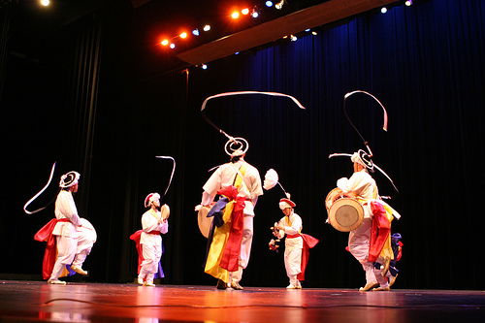
Entertainment by:
Il Kwa Nori , Korean Drumming Group
Organized by the Illinois Coalition for Immigrant and Refugee Rights alongside over 40 organizations in Illinois and across the country.

Info at www.icirr.org

