You can see the fuzziness in the vectors compared to the response image provided at the end…

It looks like cesium’s clipping the outside vectors – nice. But to get this vector field, EIGHT calls to the wms server were made for following rects – the black ones overlap the rectangle. The red ones do as well, but the calls are wasteful and ruin viewing in play mode:
0,-90,180,90
0,45,45,90
-180,-90,0,90
0,0,90,90
0,0,45,45
-45,45,0,90
-90,0,0,90
-45,0,0,45

My bet is that somewhere between the gross overlap and the clipping, the size and/or ratio of the images is/are violated, causing messed-up vectors. I’m at zero longitude, so I could understand two calls (even though -31 to 64 is contiguous), but there is no reason to split it into four calls. To be fair, I’ve been trying many different things to make this all better, so my setting this to 1024x1024 instead of something larger may have induced four tiles. However, there are two main points here:
- Something bad is happening to the imagery responses from the WMS server
- Tiling is bad for vector WMS overlays.

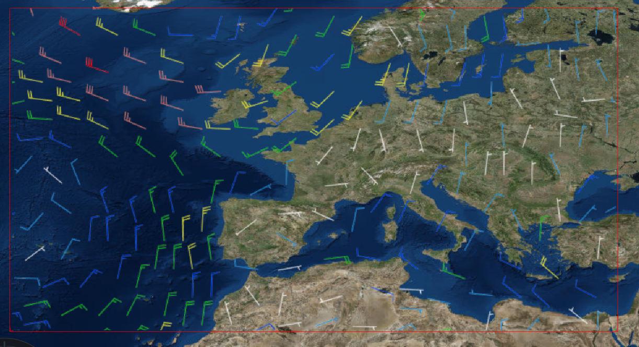
Figure 1 - rectangle’s about -31,29 to 34,64

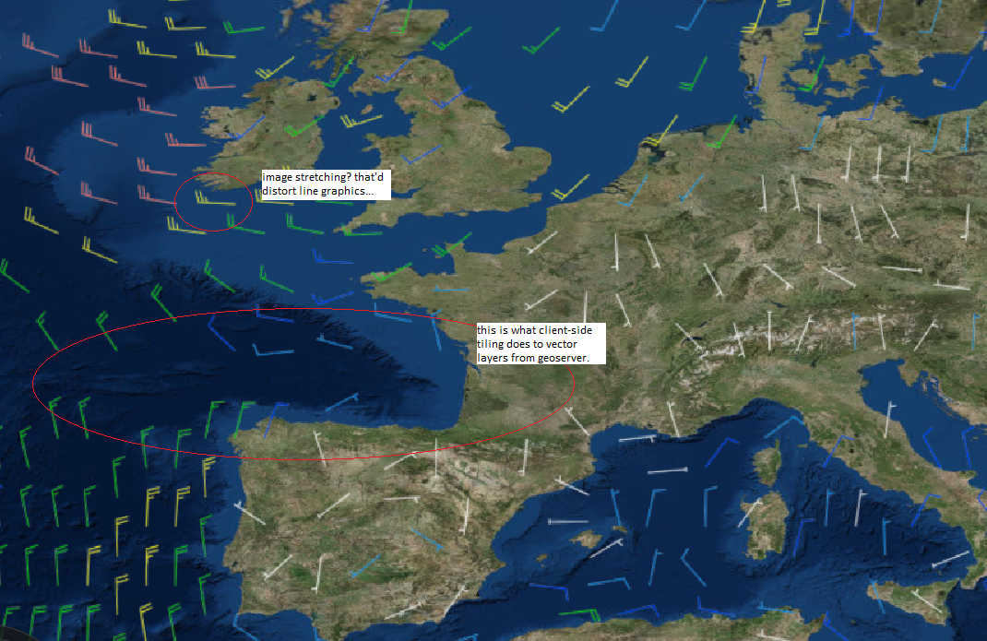
Figure 2 - zoomed-in, used rectangle for wmsimageryprovider, set tilesize to 1024x1024, STILL caused EIGHT downloads.
This version of tiling is client-side tiling. To the server, it just looks like a bunch of distinct calls. If the head or tail of a vector in an adjacent tile overlap your tile, the server’s not going to draw just that head or tail for your tile – the point doesn’t exist in your tile, and again, the server doesn’t think it IS a tile. Worse: geoserver and other WMS servers have density algorithms that determine how many points are to be skipped based on the bounding box, width and height of given data requests – when you make a bunch of tile calls, that algorithm is applied to each tile rather than to the entire field. This messes-up the amount of total vectors returned over the entire field.

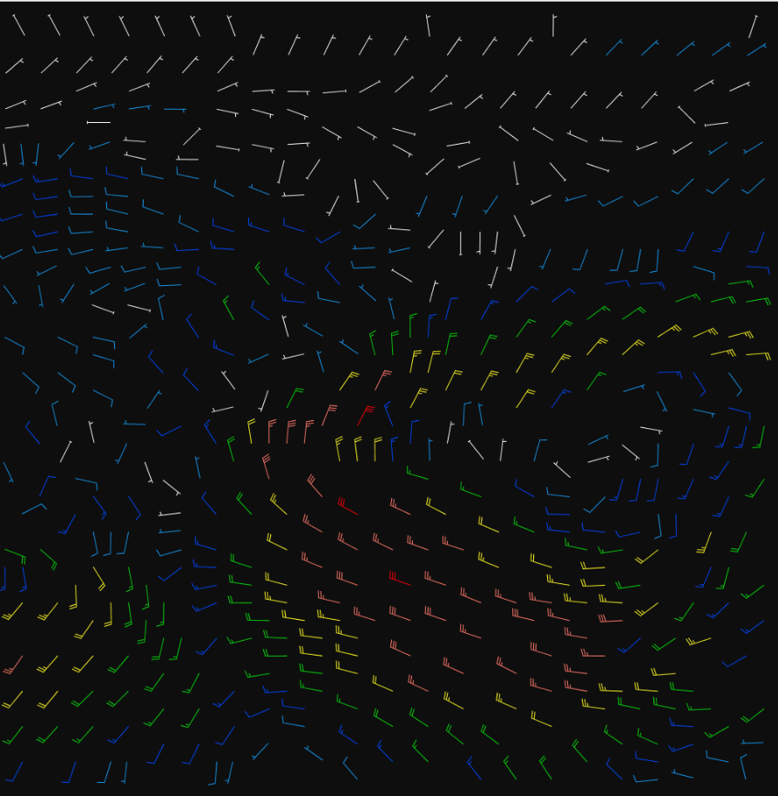
Figure 3 - -45,45,0,90 – a little weirdness with some lines may be seen – this is caused by squishing the pic into this doc.

