# What is the Purpose of our Life?

# The Hindu Doctrine of Four Purushārthas

**Table of Contents**

|  |  |  |
| --- | --- | --- |
| **No.** | **TOPIC** | **Page** |
| 1.0 | The Important Questions about Life | 2 |
| 2.0 | What do we want in our Lives? | 2 |
| 2.1 | The Four Aims of Human Life (Purushārthas): A Summary | 2 |
| 2.2 | Some Concepts related to the Four Purushārthas | 3 |
| 2.3 | Cornerstone of the Purushārtha Doctrine: Control the Pursuit of Artha and Kāma | 4 |
| 3.0 | The Artha Purushārtha – Meeting basic necessities of the Human Body | 5 |
| 3.1 | The Importance of Artha Purushārtha | 5 |
| 3.2 | The good and the bad Artha | 7 |
| 3.3 | Is Artha the Supreme Goal of Life? | 7 |
| 4.0 | The Kāma Purushārtha – Fulfilling the Desires of our Senses | 12 |
| 4.1 | Different types of Desires and their Fulfillment | 13 |
| 4.2 | The Bad Kāma – Ladder of Downfall | 13 |
| 4.3 | Is Kāma the Supreme Goal of our Life? | 14 |
| 5.0 | The Dharma Purushārtha | 18 |
| 5.1 | The Superiority of Dharma over Artha and Kāma |  |
| 5.2 | Is the fruit of Dharma the Supreme Goal of our Life? | 20 |
| 6.0 | Limitations of the first three Purushārthas | 22 |
| 6.1 | The three types of Sorrows | 23 |
| 7.0 | Moksha – Liberation from the Repeated Cycles of Birth and Death | 24 |
| 7.1 | Moksha as ‘Apavarga’ – what is absent in Moksha? | 26 |
| 7.2 | Moksha as the Final Goal of Life | 26 |
| 7.3 | Achieving Moksha | 27 |
| 8.0 | Relationship between the Four Purushārthas | 27 |
| 8.1 | Order of Listing the Purushārthas | 27 |
| 8.2 | Order of Importance of Purushārthas | 28 |
| 8.3 | School Education and the Purushārthas | 28 |
| 8.4 | Appropriate time in Life for pursuing the four Purushārthas | 28 |
| 9.0 | Living a True Life: The Way of Dharma and Moksha | 29 |
| 9.1 | Types of Individual Culture | 30 |
| 9.2 | Materialistic Versus Spiritual Cultures | 30 |
| 10.0 | The Human Body – Īshvara’s Valuable Gift to Us | 31 |
| 10.1 | How we waste our Human Birth | 33 |
| 11.0 | Getting Motivated towards Living with a Higher Purpose | 36 |
| 11.1 | The Path of Good versus the Path of the Pleasant | 38 |
| 11.2 | Not losing sight of our Final Goal of Life | 39 |
| 11.3 | Benefits of Living with a Higher Purpose | 41 |
| 12.0 | Confusion between Purushārthas – the importance of the Intent and the Goal | 42 |
| 13.0 | Conclusion | 43 |
|  | **Appendix 1**: Modern Theory (Maslow’s Pyramid) versus the Purushārtha Doctrine | 45 |
|  | **Appendix 2**: The framework of Purushārthas | 49 |
|  | **Appendix 3**: Can we blame India’s poverty on Hindu Dharma? | 50 |
|  | **Appendix 4:** Interfaith Perspectives on the Purushārtha Doctrine |  |
|  | **Bibliography** | 52 |
|  | **Class Exercise 1**: What do we desire in our Lives? | 53 |
|  | **Class Exercise 2:** Classification of different objects under the four Purushārthas | 54 |
|  | **Class Exercise 3:** How the same item can fall under different Purushārthas | 55 |

### 1.0 IMPORTANT QUESTIONS ABOUT LIFE: WHAT IS THE GOOD OF IT ALL?

At some point of the other in our lives, we all ask ourselves the following questions:

* What is the purpose of my life? What are the goals of my life? What is the aim of my life?
* What should I try to achieve in my life? Why do we live? What is the objective of my life?
* What will I gain if I study our scriptures, follow the teachings of our Sants, or be a good person?

These basic questions are the final questions, to which all questions lead. The answers to these questions lead to all answers and doubts in our mind, and help us understand who we are, why we are born and how we should live.

### 2.0 WHAT DO WE WANT IN OUR LIVES?

All human beings desire some or all of the following things in their minds –

1. Freedom from insecurity, overcoming all types fear, get adequate food, shelter, clothing, livelihood;
2. Attain joy and happiness, and prevent unhappiness or boredom in our daily lives;
3. Be virtuous and overcome the flaws of our character;
4. Do good to others, fulfill our duties;
5. Acquire knowledge and wisdom, and dispel ignorance;
6. Independence, and avoid being dependent on or under the command of others;
7. Perpetuate our existence and prevent death; become immortal.[1]

These desires take shape in the form of different things that we do in our life every day: taking medicines when sick, eating food, wearing clothes, watching sports or participating in them, listening to music, visiting Mandirs or doing Pujas in our homes, trying to understand Bhagavān, wear good clothes, give charity, help the needy, attend good schools and colleges, aspire to get a good job that pays a nice salary etc.

***2.1 What are the Four Purushārthas? A Summary of the Four Goals of our Life***

There is nothing wrong with pursuing the above desires, and acting accordingly. Therefore, Hindu Dharma advocates the doctrine of Purushārthas as a framework for our ‘life goals’ to overcome death, evil, ignorance, dependence, fears and sorrows. But there are certain rules associated with pursuing these four Purushārthas, so that we can lead a balanced life and put first things first.

Hindu Dharma teaches us that we can fulfill the first desire in the list above by pursuing ‘Artha’, the second by pursuing ‘Kāma’, the third and the fourth by pursuing the path of ‘Dharma’, and the remaining by making an attempt to achieve our final goal – ‘Moksha’, through spirituality.

***The First Purushārtha, Dharma*** means righteousness, good moral and ethical practices that are in accordance with the teachings of our holy scriptures (Shāstras). Dharma includes all our duties as an individual, as a member of a family, society, nation and the world/universe. It also includes following religious practices and examples established by the noble Rishis and Sants in ancient and modern times.

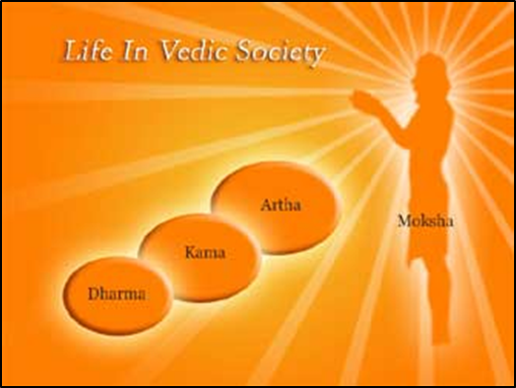E.g. of Dharma: Respecting elders and teachers; being a diligent student; kindness towards all life-forms; working to dispel world hunger and poverty.

***The Second Purushārtha, Artha*** means wealth or possessions; or our material well-being in general. All human beings must pursue this goal to sustain our body, our family and to ensure the prosperity of the society. We all need a house, clothing, food, transportation, money and other basic necessities in our life to survive. In fact, many of us go beyond the basic necessities and acquire more food, money, homes (palatial mansions), clothing (expensive brand clothing and jewelry), vehicles (expensive cars) etc. (e.g. electronic gadgets) than we need. All these fall under the Artha Purushārtha.

E.g. of Artha: Clothes, food, home, cars, college degree, employment (job).

***The Third Purushārtha, Kāma*** means fulfilling the desires of our five senses of perception (eyes, nose, ear, skin and tongue), the five organs of action (hands, feet, tongue, anus and genitals) and the mind. We need food to survive (Artha) but sometimes we want to eat specific dishes that please our tongue and mind. Eating delicious food for its taste is Kāma Purushārtha. Likewise, having power and authority over others sometimes pleases our mind, and falls under Kāma. Attraction towards others is also an example of Kāma. It is natural for human beings to pursue Kāma, because it is impossible to live without desires.

E.g. of Kāma: Jewelry, expensive clothing, delicious food, palatial mansion, world tour, pets, political power, aspiring a beautiful girlfriend/boyfriend, use of perfumes and beauty aids etc.

The first three Purushārthas (especially the second and third) are pursued by practically all human beings. They are collectively titled as ‘Trivarga’ (triad). These first three Purushārthas collectively help us overcome partially (not completely) our fears, death, ignorance, unhappiness, dependency, and all evils.

***The Fourth Purushārtha, Moksha*** means complete freedom (‘muchyate’, ‘mukti’) from fear, sorrows, death, ignorance, dependence and evil. This goal is the true goal of human life, and is in fact the final goal. Unfortunately, only a very small fraction of humans pursue this goal with any sincerity. Practices that are conducive for Moksha include Puja, Havan, Yajna, Japa, Yoga, or following one of the several spiritual paths taught in Hindu Shāstras.

An easy way to remember the four Purushārthas are: Love, Eat, Enjoy, Pray. Another tetrad of words is Virtue, Success, Pleasure and Liberation.[2]

**An Important Point regarding the Purushārtha Theory:** The four goals are not alternative goals that can be pursued individually. Hindu Dharma emphasizes that all the four goals must be pursued with certain rules in mind.[3] For example, Artha cannot be pursued if it is opposed to Dharma. Likewise, we cannot pursue Dharma alone at the cost of Artha or Kāma otherwise we will soon get frustrated when our basic needs are not met.

***2.2 Some Definitions related to the Four Purushārthas***

**DEFINITIONS:**

***Purushārtha*** = Purusha + Artha (Human + Desirable goal/object/end). Non desirable goals are called ‘anartha’ – such as violence, destruction, casualties etc.

***Chaturvarga***: All the four purushārthas are together called ‘chaturvarga’ (= tetrad). E.g., the ‘Chaturvarga Chintāmaṇi’ of Hemādri is a manual on means of achieving the four Purushārthas.

***Bhoga***: Dharma, Artha and Kama are collectively called ‘bhoga’ (enjoyment). The first two are to be pursued only if they conform to the tenets of Dharma. The fact that Hindu Dharma recognizes the role of artha and kāma in our lives negates the stereotype that it is a world denying ideology. Instead, Hindu Dharma accepts human life and endeavors in all their fullness, while grading them in relative orders of importance.

***Trivarga***: The three (Dharma, Artha, Kama) are then said to constitute a triad ‘trivarga’.

***‘Abhyudaya’*** (material or worldly good) is the good or happiness resulting from trivarga. Note that even Dharma is included in Abhyudaya because even if one is deeply immersed in Dharma, he will still get a finite good result and this happiness is related to the body/mind. Whereas the result of Moksha is related to the Soul alone and is *infinite* happiness (ānanda), knowledge (Jnāna), independence (svarājya) and security (abhaya).

***Apavarga:*** Moksha is called ‘Apavarga’ or the ‘higher category’ (compared to Dharma, Artha and Kāma).

***Nihshreyas***: The ‘spiritual power’ due to Moksha is called ‘Nihshreyasa’ (antonym of Abhyudaya) which means greatest good, or good beyond which there is no higher good.

***Pravritti Dharma:*** When Dharma is practiced in such a way so as to maximize Artha and Kāma, whether in the current human existence or in an after-life, it is called ‘Pravritti Dharma’ ( = ‘Dharma that attaches, or tends towards rebirth’).

***Nivritti Dharma:*** When Dharma is practiced such that Artha and Kama are not the primary goal or focus, and Moksha (or liberation) is the primary goal, it is called ‘Nivritti Dharma’ because it ‘delivers’ us or ‘detaches’ or ‘liberates’ us from the cycle of rebirth and death and leads to everlasting state of freedom in communion with God.

***2.3 Rules of the Purushārtha Doctrine: Controlling the Pursuit of Artha and Kāma***

Although Hindu Dharma allows us to pursue all the four goals in our life, it emphasizes that two of them (Artha and Kāma) can be pursued only in a controlled manner – they must obey the rules of Dharma. This basic ideology behind the doctrine of Purushārthas is explained by Professor Rambachan in the following words[4]:

“What is it about ourselves that Hinduism says we do not know? This question is best answered by looking first at what we seek in life. Hinduism affirms that we all naturally seek fullness and wish to avoid sorrow and unhappiness. We generally try to do this by increasing enjoyment through our senses and by multiplying our needs and possessions. We become selfish competitors with every other being in our private quest for happiness. Is our search for fullness, Hinduism asks, only through sense enjoyments and material passions valid? Can these ever fully satisfy us? Hinduism’s answer to both questions is negative. We will be disappointed and disillusioned if we make these ends with sole concerns of our lives.”

Hindu Dharma actually goes a step further to say that although Dharma should control the pursuit of Artha and Kāma, this itself is not sufficient. These three are goals ***in*** our life, but the true goal ***of*** our life is Moksha.

Hindus believe that only Brahman – the Supreme Being, is free of all the desires because It is immortal, full of infinite bliss and knowledge, almighty and unequalled, pure and without all evil, and the Ruler of the entire Universe. For this reason, Brahman is ‘Satchidānanda’ (True reality, Consciousness and Bliss) and has no use for Purushārthas.

**3.0 THE ARTHA PURUSHĀRTHA – MEETING BASIC NECESSITIES OF THE HUMAN BODY**

Artha in its broad sense means material wealth or material well-being. Therefore, this Purushārtha gives us a feeling of security. The following are included in the Artha Purushārtha:

* Fulfillment of basic needs – food, shelter, clothing.
* Acquiring power and success.
* Acquisition of material possessions beyond fulfilling basic needs.
* Security.

Sometimes, the following things are also included in the category of ‘wealth’:

* Good health
* Learning and wisdom
* Goodwill of others
* Spiritual wealth

***3.1 The Importance of Artha***

Inclusion of artha as a legitimate goal of human existence (or as one of the purposes of our life) recognizes the plain truth that all humans have certain material wants in the form of shelter, food, clothing and so on. If these wants are not met adequately, we cannot pursue other goals of our lives at all. Another reason why Artha is counted as a Purushārtha is that wealth is needed even to pursue Dharma. A wealthy man has to the ability to do several grand acts of piety, charity and so on. Conversely, poverty is considered the root of many evils and sins (Adharma).

Some people despise all sorts of wealth. Ironically, people who claim to be opposed to luxury are often the wealthiest of all! The fact is that money does play an important role in our lives. A scholar of Hindu Dharma argues –

“The pretense of despising material goods is a mere romantic dream. None can truly disengage himself from the temporal aspects of life. The worker does not despise his tools, not the scholar his intelligence and memory. Rather, they regret not having better instruments or keener intellectual faculties in order to improve their work. In this world of action, all means for amplifying action are important, and we must do our utmost to acquire and develop them…”[5]

Wealth is needed even for practicing Dharma and for progressing towards Moksha. Sant Thiruvalluvar said:

Compassion, which is the child of love, requires for its care the bountiful nurse called Wealth. Kural 757

Make money – that is the sharpest scalpel for paring down an enemy’s pride. Kural 759

A contemporary scholar also explains:

“Material goods are clearly not an end in themselves. If they are that for the ambitious man, it is at the cost of limiting his personality, as with the puritan, the man who sees duty, or the dissolute man, who only seeks pleasure. The mystic, who seeks liberation, can attain his goal only after adopting the conditions laid down by the other aims of life, which allow him to pursue his aim without ulterior motives. Wealth enables him to discharge his human debts, the essential prerequisite to spiritual liberation….

Even a poor man may inebriate himself with mysticism, but generally he is too busy warding off cold, hunger, or vermin to be able to dedicate himself fully to contemplation.”[6]

Some people argue that wealth is not important because ascetics live happily and in a state of spiritual advancement without relying much on material resources. However, a counter-argument below clarifies that it costs money to fund poverty -

“Virtue is a bourgeois luxury, requiring at the very least shelter from privation. The so-called monastic poverty of the Christian world is false poverty founded on important capital, which is often considerably more per person than would be necessary for material tranquility in secular life.

The vow of poverty of monks living in a community is merely the collectivization of wealth managed by the group, a little like a kibbutz. It is not, nor can it be, an absence or rejection of material goods. The resources of the monasteries give the monks the possibility of a life dedicated to the pursuit of spiritual experience.

The life of a sannyāsi, the wondering monk of India, is possible only because the whole of society is organized to support him. No Hindu family will start its meal without ascertaining there is no sannyāsi at the door, since he must be fed before anyone else.

All pleasures are based on riches. Houses, cars, comfortable homes, servants, musicians, women, delicate food – none of these may be obtained without “means”. Even the most fleeting and least onerous of pleasures of comforts – whether a hired car, a hotel room, …. – still requires a certain amount of money.

Property is the foundation of society, and the basis for all individual or collective realization, both human and transcendental.

Society exists for the purpose of creating favorable conditions for the acquisition of material goods, wealth, and power, in turn allowing science, culture, virtue, religious, pleasure, and spiritual pursuits to flourish. The basis of social organization is thus mainly economic….”[7]

A funny example is given in this regard- Sarojini Naidu, an outspoken Indian freedom fighter once joked to Mahatma Gandhi, who was known for his austere lifestyle, “Bapu, it costs India money to keep you in poverty!” Many Hindu scriptures therefore ask us to strike a balance. We must not reject wealth completely, but we must not give it more importance then it really has.

***3.2 The Good and the Bad Artha***

Artha that is earned through the means allowed by Dharma, and if used for promoting Dharma and making progress towards Moksha is good. On the other hand, any wealth that is earned through Adharmic means (e.g. stealing, swindling, forcible grabbing etc.), or is used to promote Adharma (e.g. investment in gambling) is bad wealth.

Examples:

1. In the Ramayana, Queen Kaikeyi conspires to have the crown prince Rama banished from Ayodhya so that her own son Bharata becomes the next king (Adharmic Artha). But Bharata, out of his devotion for his elder brother Rama, refuses to become the king and rules Ayodhya in the name of Rama till the latter returns from the forest.
2. In the Mahabharata, Duryodhana uses unfair means to deprive the Pandavas of their kingdom (Adharmic Artha).
3. Vidura, the Uncle of Duryodhana, does not want to enjoy the royal riches of his evil nephew. He decides to move out of the royal court and grow his own vegetables for food. (Dharmic Artha).

The following principles are a good guide to ensure that Artha or wealth is bound within the confines of Dharma:[8]

1. Wealth must be earned by honest and truthful means.
2. Wealth should be used for meeting one’s necessities. Surplus wealth should be used for the good of others.
3. Wealth must not be hoarded. Excess wealth should be given away for charity.
4. One must not become proud of his wealth or riches, nor should it lead to unjust behavior. A rich person should not consider himself above the law or superior to a poor man.
5. The owner should understand that all wealth is temporary; and that wealth acquired through foul means will lead to grief.

***3.3 Is Artha the greatest Purushārtha?***

Some people believe that earning wealth, living in palatial mansions, driving the latest cars, wearing the most expensive clothes, taking fabulous vacations etc., is the highest and the most important goal of life. They spend all their time, all their energy and all of their skills in hoarding more and more wealth. But does this make rich people happier than others?

Studies have shown that this is not necessarily true. After one’s basic needs of food, shelter, clothing etc., are met, more money does not always lead to more happiness. In fact, lots of extra money earned with little effort (e.g. winning a lottery) brings more grief than happiness.

The following parables from the Hindu tradition illustrate that Artha is just one of the goals of our life; and it is not the supreme goal of our life.

**Story: How a Miser became a great Saint**

This is a story of Purandara Dasa (1484-1564), who is traditionally considered the founder of Carnatic (S. Indian) music. Puranadara was born to a very kind trader and jeweler Varadappa Naik and his wife after the couple prayed to Lord Venkateshvara for a child. Varadappa was very wealthy, but he was also very kind towards the poor and needy. In his old age, he handed over his shop of gems and pawning to his son Sreenivasa and married him to a very pious wife Saraswati. Sreenivasa completely changed the nature of the business. He was a very business minded and a hard heated person. He cared only about maximizing his profits, and did not give anything from his income in charity to the poor and the needy. He stuck very hard bargains with poor and had no pity over their condition. As a result of his miserliness and his business acumen, the family business greatly prospered. Sarasvati, on the other hand, was a very kind hearted woman who liked to help the poor. But Sreenivasa forbade her to give anything in charity to anyone. Varadappa tried to make his son see the virtues of sharing and caring, but without success.

One day, Varadappa fell very sick. The physician suggested giving Varadappa the ash of some burned precious gems. But the miser son Sreenivasa simply rejected the idea of spending a lot of money to procure the gems. Saraswati tried to reason with her husband that his father’s life was more precious than any gem, but he merely said – “Father is very old and will die one day anyway. Why waste money on the gems for getting the medicinal ash?”

Varadappa soon died. Sreenivasa continued his old ways of being a merciless pawn shop and amassed so much wealth that people gave him the nickname ‘navakoti’ or “the owner of 90 million.”

One day, a poor Brahmana came to beg some money at Sreenivasa’s shop for performing the thread ceremony of his son. Sreenivasa was by now a notorious miser. So he was surprised that some had actually come to ask him for money! Instead of declining any help, he merely told the Brahmana to come the following day. When the Brahmana came the next day, Sreenivasa asked him to come later. This kept repeating day after day, but the miser Sreenivasa would just not relent.

One day, while cleaning his shop, Sreenivasa found a box of fake and worthless coins. When the Brahmana came the next time, he gave that box of coins to him say – “This should be enough money for you to perform the thread ceremony.”

The Brahmana of course found out that the coins were fake and worthless. He decided to be elsewhere and coincidentally, landed up at Sreenivasa’s home. Sreenivasa was away in his shop, and the Brahmana said to Saraswati (not knowing that she was his wife or that it was his home) – “I went for six months day after day to this miser and heartless merchant begging for a small amount of money which I needed to perform my son’s thread ceremony. Finally, the cheat gave me a box of fake coins which were worthless. Could you help me?”

Saraswati of course realized who the poor Brahmana was referring too. She felt really ashamed at her husband’s niggardliness. But she had been forbidden by Sreenivasa to give anything in charity. Suddenly, she realized that the diamond nose-ring that she wore was gifted by her own mother. Therefore, it was not the property of husband and she could gift it to the Brahmana.

The Brahmana thanked the gracious lady with tears in his eyes. Then, he went to Sreenivasa’s hop and asked him to pawn it and give him some money instead for his son’s ceremony. When Sreenivasa saw the expensive nose-ring, he was perplexed because it was identical to what his wife wore. So he told the Brahmana to come the following day, giving the excuse that he needed a day to evaluate its price before he could pawn it and give money in return. He locked the nose-ring in his shop and went home for dinner.

At home, he asked his wife to produce her nose-ring. Saraswati was terrified. She was already disgusted with her husband’s miserly behavior. Now she was worried that he might scold her for gifting away her expensive gold ring. Under the pretext of getting it from the bed-room, Saraswati went to the kitchen. She decided to commit suicide by grinding the diamonds of her bracelet and eating them with water. So she ground diamonds in a pestle-mortar and was mixed them with water in a glass. Just as she was about to drink the poison, she heard something fall from the ceiling into the glass. It was the nose-ring! She was overjoyed and bowed to the mūrti of Lord Vishnu for the miracle.

But when she took the nose-ring to Sreenivasa, it was his turn to get shocked. He thought that someone must have stolen it from the shop. He rushed to the shop and found that the nose-ring was missing from the safe. He returned home and asked Saraswati to tell the truth. She told him how she had gifted the ornament to a poor Brahmana who had been cheated with fake coins, and how she was about to commit suicide for the fear of her husband when a miracle saved her.

That night, Sreenivasa could not sleep. He concluded that it could have been only Lord Vishnu who had appeared as the Brahmana. The following morning, he said to his wife – “Saraswati, you have opened my eyes. I had been blinded by the love of wealth. This greed made me kill my own father. I also ill-treated Bhagawan Vishnu who came to my hut in the guise of a Brahmana. And then due to the same greed, I was going to lose you – my wonderful wife. What a sinner I am, whereas how blessed my wife is. She conducted herself so much more graciously and honorably than I!”

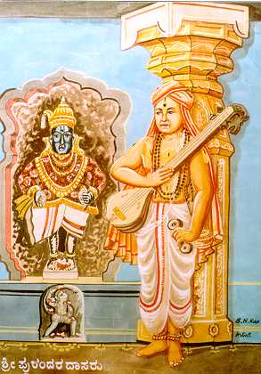From that day, Sreenivasa, who was 30 years of age then, had a change of heart. He decided to donate all his wealth to the poor and the needy. His wife was overjoyed. Together, the couple and their children decided to roam from one pilgrim center to another inside the Vijayanagara Empire in S India, singing the praises of God. Ten years later, during his travel, Sreenivasa met Saint Vyasatīrtha, a scholar who followed the philosophy of Saint Madhvacharya (13th cent. CE). Vyasatīrtha initiated Sreenivasa to Sannyāsa, giving him the name ‘Purandara Dāsa’.

Purandara Dasa composed thousands of soul-stirring and melodious songs in praise of Lord Vishnu and his various forms. Almost 1000 of these survive today. He systematized the method of teaching Carnatic music which is followed to this day. One of his disciples, Swami Haridasa, became a famous Hindustani classical musician, and was the guru of Tansen, the legendary musician of north India. So, Purandara Dasa influenced the musical tradition of the entire Indian subcontinent. His very first musical composition starts with the words of lament for having wasted his earlier years in material indulgences.

Sreenivasa Naik realized that true happiness can never result from pursuing wealth as the ultimate goal in our life. Doing this makes us so greedy and heartless that we lose all love and respect for even our near and dear ones. True happiness results only when we pursue God as our final goal in our life. This realization made the heartless miser a saint, and gave him the eternal peace that he was searching for.

It is said that he and his wife became so indifferent towards wealth that one day the king of the Vijayanagara Empire decided to test them. One morning, as the couple went around begging for the food, the king disguised himself as a commoner and poured in their vessel a mixture of rice and diamonds. Purandara Dāsa did not realize it at that time and took the donation home. The king followed them and waited at their door, hiding himself, to see how the couple would react after seeing the diamonds.

A while later, as the wife took the donation to sift the rice from the diamonds, she complained to her husband, “People have become very unethical these days. Look, how many of these worthless stones they have mixed in our rice.” Say this, she gathered the stones and threw them outside her hut. The king was humbled when he saw that a couple devoted to Bhagavān really have very little use for worldly riches.

**[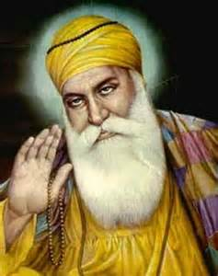](http://images.search.yahoo.com/images/view;_ylt=A0PDoS2ZDFhSIDYAH1.JzbkF;_ylu=X3oDMTFzdTRlOWF2BHNlYwNzcgRzbGsDaW1nBG9pZANiNzUyM2QxYzkyYWNkMzdiNTcyZGQwODk2NWZkYTIzMQRncG9zAzEyOQ--?back=http://images.search.yahoo.com/search/images?p%3Dguru%2Bnanak%26n%3D30%26ei%3Dutf-8%26y%3DSearch%26tab%3Dorganic%26ri%3D129&w=245&h=309&imgurl=chandrakantha.com/articles/indian_music/shabad_media/nanak.jpg&rurl=http://chandrakantha.com/articles/indian_music/shabad.html&size=16.2KB&name=%3cb%3eGuru+Nanak%3c/b%3e&p=guru+nanak&oid=b7523d1c92acd37b572dd08965fda231&fr2=&fr=&tt=%3cb%3eGuru+Nanak%3c/b%3e&b=121&ni=160&no=129&ts=&tab=organic&sigr=11qaaskb9&sigb=1335f1v26&sigi=11ujadg6n&.crumb=gNJkoZgTG/v&)Story: We cannot take our Money with us after Death**

Once when Guru Nanak was passing through the city of Lahore (now in Pakistan), a rich Hindu trader named Dhunichand invited the saint for a meal in his palatial mansion. Dhunichand was very proud of his wealth. Even while the Guru ate his meal, Dhunichand kept describing to him how rich he was, how much wealth he possessed and so on.

After Guru Nanak had finished his meal, he gave a sewing needle to Dhunichand and said, “Please keep this needle safely and take it to heaven after your death. When we meet there, I’d like to get it back from you.”

Dhunichand looked confused and he said, “But how can anyone take anything with us after we die? “ Guru Nanak smiled and said, “Exactly, you cannot carry even a small needle with you after you die. Then do you think you can carry all your wealth with you upon your death? If not, then what are you so proud of?”

Dhunichand understood the message that one must not be proud of what we wear, what we eat, where we live. All our worldly possessions are left behind when we die. Dhunichand now became a changed man, and he devoted his wealth for constructing Dharamshalas (community places for worship, satsang, wedding etc.) with his wealth.

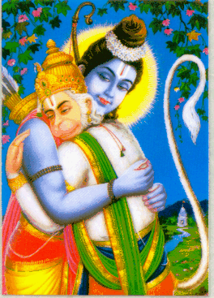**Story: For a Bhakta, Wealth is worthless compared to Bhagavān**

After the coronation ceremony of King Rama in Ayodhya was over, Shri Rama received a lot of expensive presents from other rulers of the world. He distributed this presents, which included precious pearls, diamonds, gems etc., to his friends – the Vanaras, King Vibhishana of Lanka and others who had helped him defeat Ravana.

Hanuman-ji was gifted a necklace of very rare and precious pearls. Everyone was overjoyed upon receiving their gifts. They started comparing their own gifts with those of others, and there was a lot of excitement in the air.

Suddenly, someone noticed that Hanuman was sitting in a corner. He was biting the pearls of the necklace, one by one, and then discarding the pieces in a heap of trash. When asked to explain his strange action of destroying the necklace of expensive pearls, he replied, “The only thing I value is my Lord Shri Rama. I do not find him inside these pearls. Therefore, they are worthless for me.”

**Story: Wealth can never give us Immortality**

Rishi Yajnavalkya decided to take Sannyāsa. He had a lot of property gifted to him by King Janak and others. He had two wives. Calling them, he said, “I wish to become a Sannyāsī. Let me do a division of my wealth between you two.”

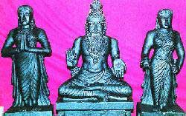Maitreyi asked the Rishi, “Will your wealth make me immortal?” Rishi Yajnavalkya replied, “No, my money will only get you a life that other rich people have. It will not give you immortality.” Maitreyi replied, “Then of what use is your wealth to me? Give me that wealth that will make me immortal.”

Rishi Yajnavalkya was very pleased with her. And then, he taught her the spiritual wisdom that can liberate a human from death and rebirth.

To conclude,

* Wealth can by a house, but not make a home
* Wealth can buy rich food, but it cannot give a good appetite
* Wealth can buy medicines, but not good health
* Wealth can buy companions but not necessarily good friends.

**4.0 THE KĀMA PURUSHĀRTHA – FULFILLING THE DESIRES OF OUR SENSES**

The literal meaning of the word ‘Kāma’ is desire. Therefore, this Purushārtha means fulfilling desires of the mind and body to be happy and joyous, or to derive pleasure. The inclusion of Kāma in the list of Purushārthas recognizes the natural human desire to enjoy pleasures of the sense organs. But Kāma stands not just for sensual pleasures; it encompasses pursuit of aesthetic pleasures too, in the form of indulgence in art, literature, poetry, drama, sculpture and so on. Kāma is also sometimes an extension of Artha. For e.g., obtaining food would be achieving artha, but obtaining delicious food would be an expression of fulfilling one’s desire, and not just a basic need. Thus, hankering after delicious food would be an attempt to pursue kāma.

This acceptance of Kama as a legitimate human aspiration explains why Hindu societies promoted and continued to promote several different forms of art and literature down the ages.

They who are ignorant in music, art and literature are like deformed animals that lack a tail or horns. Animals are fortunate that such humans do not eat fodder, or else such useless humans would not have left anything for animals to eat!

**Nitishataka of Bhartrihari Muni**

Another reason for inclusion of Kāma in the list is that after marriage, it leads to the birth of children. In Hindu Dharma, it is considered the duty or Dharma of a married couple to try and have children just as their own parents had given birth to them, so that the cycle of creation continues further. Therefore, a scholar explains,

“In order to reach the final aim of life, which is transcendental consciousness, life itself is necessary. The body is a set of faculties, constituting and depending on the “ego”, the instrument that allows the temporal being to approach timeless consciousness. The body is thus the basis of all realization. All its vital activities are based on desire, on a need to be satisfied, whether the need arises from hunger, thirst, fatigue, or sexual desire. The satisfaction of the need is indissolubly linked with pleasure; it is in itself a form of pleasure. Pleasure is thus one of the conditions of life. A man must keep his body happy and strong if he is to achieve his ultimate goal, which is a state of joy and permanent happiness. He must not forget, however, that his body is not himself but is only a vehicle, which he must look after with the same care and affection as a fine horse. If he ignores the body’s pleasures and neglects to satisfy them, his body will betray him somewhere along his path and he will not fulfill his destiny.”[9]

***4.1 Different Types of Desires and their Fulfillment:***

There are eight main forms of desires – one each for the 5 organs of perception, 2 related to our mind, and the 8th related to our body.

“1. **Words**: Words we hear and read. And sounds we hear (for example, music) give us pleasure; this is happiness through words.

2. **Touch:** Meeting friends and family, hot and cold, soft and hard touch gives us feeling of happiness through the sense of touch.

3. **Form:** Different forms of the world like beautiful buildings, oceans, mountains, forests, watching TV, movies, games etc., give us pleasure. Such joy is the pleasure through forms.

4. **Rasa**: Sweetness, hot, sour etc., tastes give us pleasure gained from tasting with tongue.

5. **Smell**: Beautiful fragrance of flowers, perfumes etc., give us the pleasure gained through our sense of smell.

6. **Māna** (exaggerated self-respect): When someone or in some place, respect is shown to us, it gives pleasure to our ego.

7. **Glory:** When we hear glory of our name, we feel happy; this is happiness arising from glory.

8. **Rest (being lazy):** We feel happy physically not doing anything, being lazy and just chilling.”[10]

However, there are also five organs of action. Corresponding to these, there are three other ways in which we can pursue Kāma. For example, a person who loves to talk with his tongue can talk endlessly and become happy hearing his own speech.

***4.2 The Bad Kāma: The Ladder of Downfall***

Over-indulgence in Kāma or pursuit of Kāma following Adharma quickly leads to one’s downfall. For example, it is acceptable to eat chocolate once in a while provided it is obtained by the proper means. But it is not acceptable to eat stolen chocolate. Likewise, over-eating chocolate can result in health issues like tooth cavities.

Another example is the need to sleep so that the body gets rest. Inadequate sleep can result in chronic tiredness and diseases like high blood pressure. On the other hand, excessive sleeping that is not due to any underlying medical condition makes one’s lazy and dull.

In the Bhagavad Gita, Bhagavan Krishna explains how uncontrolled pursuit of Kāma eventually leads to total self-destruction. He says,

In the case of a person who dwells on objects, there arises attachment for them. From attachment grows desire (kāma), and from desire springs anger. From Anger follows delusion; from delusion results failure of memory (an understanding of who I am); then loss of understanding; and finally from loss of understanding, he perishes. **Gita 2.62-63**

If we consider the worldly example of thought of a chocolate, here is how this ladder of downfall will appear:

|  |  |  |
| --- | --- | --- |
| *Step #* | ***Name of the step*** | ***Eg. A kid and chocolate*** |
| **1** | Thought | “I am thinking about chocolate” |
| **2** | Attachment | “I like chocolate” |
| **3** | Desire | “I want chocolate” |
| **4** | Anger | “I am angry that my mother is not giving me a chocolate.” |
| **5** | Delusion (losing touch with reality) | “If my mother really loved me, she would have given me the chocolate.” |
| **6** | Loss of Memory (forgetting who we are) | The boy starts abusing her mother because she would not give him chocolate, forgetting that he is supposed to respectful towards her. |
| **7** | Destruction of discrimination/understanding | “Mom, if you do not give me chocolate, I will hit you.” |
| **8** | He perishes | The kid attacks his mom, is arrested and lands up in a juvenile correction prison. |

Of course, most of us do not go down all the eight steps of the ladder, but we do hear cases now and then of people committing crimes for reasons that appear very trivial to us.

Hindu scriptures often try to define as to what the proper limits of indulgence in pleasures are. But really speaking, these limits vary from person to person. The key is to ensure that indulgences in these desires of our senses do not become an addiction. When a person is addicted to a particular pleasure, he keeps indulging in it repeatedly without realizing that he is ignoring other, more important things in his life. It is very easy to become addicted to different pleasures. One has to watch out for this constantly; and bear in mind that the main goals of one’s life are not pleasures, but Dharma and Moksha.

The following verses from the Hindu Shāstras are very useful in reminding the destructive power of indulging in the pleasures of our senses:

The deer, elephant, the moth, the honey bee and the fish - these five are destroyed due to addiction to their five sense organs. [deer - ear (listens to sweet music and gets caught by the hunter), elephant - touch (caught through she-elephants), moth - eyes (it is attracted by the flame and burnt), honey bee - smell (attracted by fragrance of lotus and caught within), fish - taste (nibbles at the bait and gets caught). Even one of the sense organs is destructive. Then how can a man addicted to all five senses escape destruction?] **Garuda Purāņa 2.12.18**

The field forced to produce too much grows barren. Seed no longer germinates there and whatever is sown dies. Similarly, whoever gives himself over to excessive pleasure ends by losing it entirely. The fire flares up when oil is poured on it drop by drop, but is extinguished if the flow is strong. **Bhāgavata Purāņa 7.11.33-34**

***4.3 Is Kāma the Supreme Goal of our Life?***

“We have just one life to live. So let us enjoy.” This is what we often hear from others. And believing this to be true, we try to be ‘happy’ and ‘high’ all the time by getting every latest electronic gizmo, drinking, and sometimes by even taking drugs! But do these things ever bring us lasting peace and happiness? In fact, taking drugs or cigarettes only fool us into thinking that we are ‘happy’, when in fact they are numbing our senses and are deluding our mind.

Mahatma Gandhi had once said, “*Mother Earth has enough for everyone’s needs, but not enough for a single man’s greed!*” Our desires are endless and we can never fulfill all of them. Forgetting this, we try to hoard things to please our eyes, nose, tongue etc., even if that means depriving others of their legitimate rights, and possessions. We run after evil people, and try our utmost to please them and earn favor with them because they are ‘cool’, ‘smart’, and ‘powerful’, even though we know that they are not good human beings.

All these actions can bring us temporary happiness or progress. But in the long run, what really brings us happiness is practicing Dharma, and seeking the knowledge and understanding of Bhagavān. In fact, if our senses come in the way of our meeting Bhagavān, then they are of no use.

**Story: No one ever gets satisfied with Kāma (from Matsya Purāṇa)**

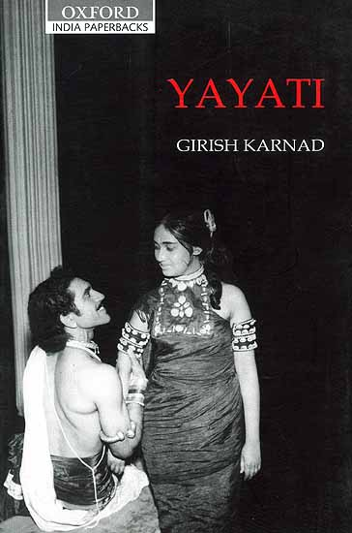Many people say – “There is only one life. So let us enjoy. Who knows if there will be a tomorrow.” Hindu scriptures narrate the story of Emperor Yayati who was devoted excessively to the pleasures of senses. Emperor Yayati had two wives and many sons. He loved to live a ‘good’ life, indulging in all kinds of pleasure. When he grew old, he was unable to indulge in such pleasures, but his mind still longed for them. So he asked his sons to exchange his youth for his father’s old age. The first three sons refused, and out of anger, he cursed them. The fourth son Puru was very obedient and he exchanged his youth for his father’s old age.

And then, Yayati lived through another youth and enjoyed pleasures of senses. When he grew old again, he realized that he was still not satisfied. Now Yayati felt very guilty that he had cursed his own sons, and deprived his own obedient son of his youth which had rightfully belonged to his son alone. And even after living a second youth, his desires for physical pleasures was not satisfied. He realized the folly of having deprived his own son of his youth, and narrated the following famous verses quoted in several Hindu scriptures (Brahma Purāņa 10.40-46):

*"He who withdraws within himself all pleasures like the tortoise that draws his limbs within itself is indeed a person who has attained the state of Yoga. Never does desire for pleasure subside by indulging in their enjoyment. Just as the fire blazes all the more when Ghee is poured into it, so also it increases at every indulgence.*

*If one were to possess all the grains of rice and barley on the earth, if one were to possess all the gold, if one were to become the master of all the cattle wealth on the earth or if one were to marry all women on the earth-- he will discover that even this is not sufficient to satiate his thirst.*

*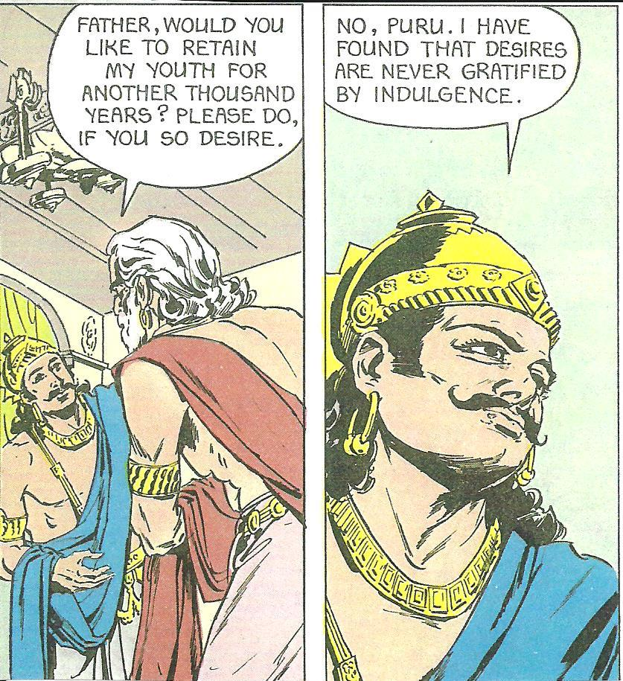That being so, one should not be deluded by these things. When one does not have any ill will towards any living being, whether in mind, in word, or in deed, then only does one attain Brahman.*

*When one is not afraid of others, when none is afraid of him, or when one does not like or dislike others too much, then alone one attains Brahman.*

*Happiness befalls a person who eschews greed and covetousness-- evils which can never be eschewed by the wicked, evils which do not become old even when one's own body becomes old and decrepit, evils which are like an ailment that comes to end only when the vital airs die out.*

*When a man becomes old, his hair become old, his teeth become old; but alas! The hope and greed for wealth and a prolonged life never grows old!*

*The happiness that supposedly arises from indulgence in pleasures and also the great happiness that one attains in heaven-- all these are not equal to even the 16th part of the happiness one attains when his greed is extinguished."*

Yayati then decided to devote the remainder of his life to worship God, practice Yoga and understand the nature of the truth. And when he died, he went to heaven. This story shows how a blind pursuit of pleasures of the senses (tongue, eyes, ears etc.) makes us so selfish that we forget the welfare of even our closest friends and family. Therefore, we should realize that there are more important things in life – Dharma and God. These alone should be our more important goals of life. Sure, we should pursue Kama and Artha, but with the understanding that Dharma and Moksha are more important than these two.

**Story: Dhanurdāsa sees the most beautiful eyes – There is nothing more pleasing than Bhagavān**

Shri Ramanujacharya once saw a strange incident – A man was walking backwards, while holding an umbrella over a prostitute. The saint asked the man the reason for his inappropriate behavior. The man replied, “I worship beauty. Even while walking with this woman, I do not want to waste a single moment by not seeing the beauty of her face.”

Ramanuja thought, “I wish that his infatuation for beauty were directed towards Vishnu, the most beautiful one! If that happens, this man would attain great spiritual heights.” And so, the saint replied, “If you really worship beauty, then come today evening to the Varadaraja Swami temple (in Kanchipuram) at the time of the Arati.”

The man was reluctant to go to the temple but his lady-love said, “Perhaps a misfortune would befall you if you do not obey the command of a holy man. So just go for today.”

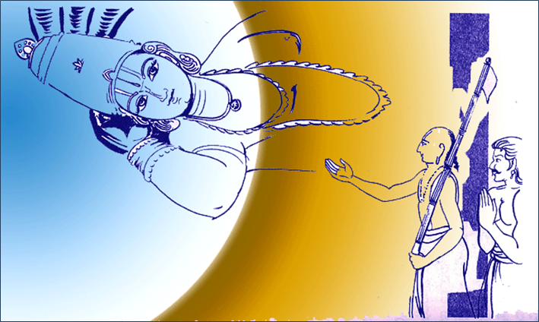The man showed up at the required time in the temple, and he was overwhelmed when he saw the beauty of the lamps being waved around the Deity. He was moved by the beauty of the prayers being chanted by the devotees, and by the faith in their eyes.

His transformation occurred there and then. He gave up his wrong ways and became a true devotee of Vishnu. His name is recorded as Dhanurdas in the tradition.[11] Shri Ramanujacharya asked Dhanurdāsa to marry his girlfriend. The couple decided to settle down in the temple town of Srirangam after the saint moved there.

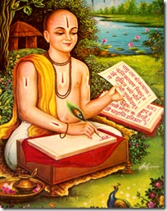**Story: Goswami Tulsi Das (1532-1623 CE) turns his desire towards Rāma**

Tulsidas had married a lady named Ratnāvalī. The couple settled down in the Hindu sacred city of Varanasi. For the first time in his life, he found someone who really loved him. Therefore, Tulsidas too loved his wife a lot and took very good care of her. One day, Tulsidas went to a Mandir to worship Lord Hanuman and in the meantime, Ratnāvalī got a message to visit her father’s home as soon as possible. When Tulsidas returned to his home, he found his wife missing. So, he decided to go to Ratnāvalī’s father’s home on the other side of the river. It was raining very heavily and there was a flood in the Ganga river, which flows through Varanasi. No boatman would take Tulsidas across the river because of the rain and floods. Tulsidas used a floating corpse on the river as a floater and crossed the river to go to the other bank. When he reached the home of Ratnāvalī’s father, he was in such a hurry that he did not want to take the stairs to her room upstairs. He saw a snake hanging from the window and thinking of it as a rope, he climbed up to her room.

When Ratnāvalī discovered the kind of risks her husband went through to meet her, she got very upset and said to him – “You are so much in love with me, and I am just a body made of bones and flesh. If you had loved Lord Rama even half as much as you love me, you would be a lot happier.”[12]

These words of Ratnāvalī shocked Tulsidas. Soon, he abandoned his family life, and took to the worship of Lord Rama and became a Sadhu. He called his wife his Guru for having awakened him from his sleep so that he could see the Lord. Tulsidas then started worshipping Bhagavān Rama and Hanuman with great devotion.

He wrote many holy books like the Ramacharitmanas and stotras like the Hanuman Chalisa. Impressed by his devotion, Hanuman as well as Bhagavān Rama and Lakshman appeared in front of him.

This story shows how we can overcome Kāma for worldly things and for other people by turning it towards Bhagavān. For example, if we are unable to control our tongue, we should use it to sing the praises of Bhagavān. If we like to watch beautiful things all the time, we should start focusing our sight towards spiritual objects.

**5.0 THE DHARMA PURUSHĀRTHA**

In a nutshell, Dharma[13] means to

* Follow a moral and a virtuous life (i.e., be truthful, honest, kind, charitable etc.),
* Fulfill all our duties relevant to our stage of life (childhood, adulthood, old age) and social class/profession,
* Fulfill our responsibilities towards our family, society, country and humanity,
* Worship Bhagavān and other Deities,
* Pursue Artha and Kāma in a way so that scriptural injunctions are not violated.

The word Dharma is derived from the Sanskrit root ‘Dhri’ which means to ‘uphold’, ‘adopt’ or ‘safeguard’ etc. Therefore, Dharma basically means something we must practice, adopt, uphold and life by, so that it safeguards us.[14] A scholar explains the term in the following words:

“The concept of dharma may have been derived from the Vedic concept of rita, which signifies the laws that govern the natural and moral order. No single English word can translate the word dharma, for it is a concept that has many connotations. The Sanskrit root of dharma is dhr, which means bearing, supporting, and upholding that which forms a foundation. Thus dharma means all meritorious actions of the body, mind, and speech that support the functioning of the universe. Dharma, generally translated as righteousness or duty, actually denotes much more than these translations convey. Dharma also denotes traditional duties (individual, social, religious), good moral and ethical practices, and adherence to righteousness and the laws of the land. Dharma provides moral and ethical guidance for accomplishing material and spiritual goals and for the growth of the individual and society. Dharma holds mankind together individually, socially, politically, culturally, and spiritually, and helps a person fulfill his individual needs and his obligations to society. Finally, dharma determines the social conduct of an individual, maintaining social stability.”[15]

Dharma involves conscious choices so that we can overcome our limitations and animalistic impulses, and elevate ourselves to become virtuous and spiritual. Most animals do not have a brain that is developed enough for them to overcome their natural limitations. Only human beings in general have that ability. Therefore, a human being who wastes his life and pursues only artha and kāma is actually worse than an animal.

Perhaps the most important of the four goals is Dharma, because it serves as the pivot around which the other three revolve. Dharma controls Kāma and Artha. Hindu scriptures state –

After we die, neither the father, mother, son, wife nor one’s clan is available for help. Only the Dharma that one has practiced in his lifetime before death is present to help us out. **Manusmriti 4.239**

When Dharma is destroyed, it destroys us. When Dharma is protected, it protects. Therefore, do not injure Dharma, lest the injured Dharma strikes us back. **Manusmriti 8.15**

Dharma ensures our welfare in this life and the next. As Paramacharya Chandrashekarendra Saraswati explained:

“If the Paramatman….is to draw us into Himself we must, without fail, perform our duties to Him as well as to the world. It is these duties that constitute what is called dharma. Dharma it is that serves us when we dwell in our body and when we must do that which would take us to a desirable state after we depart from it. We take an insurance policy so that our relatives will be able to take care of themselves when we are gone. But is it not far more important to ensure that we will be happy in our afterlife? Dharma is afterlife insurance. But in this life too, it is dharma that gives us peace and happiness.”[16]

It is Dharma that forms the foundation of Moksha. A person who transgresses Dharma can never aspire for Moksha. A saint of our times explains:

“The first step in this process of enlightenment is to make a man truly a man, by ensuring that he does not live on an animal level. The second step is to raise him to the heights of divinity. All religions have this goal. They may represent different systems of thought and philosophy. But their concern ought to be that man is not condemned as he is today to a life of desire and anger. All religions speak in one voice that man must be rendered good and that he must be invested with the qualities of love, humility, serenity, and the spirit of sacrifice.”[17]

Rambachan explains[18] the role of Dharma in Hindu Dharma very clearly:

“The pursuit of wealth and pleasure, however, does not make us unique as a species of living beings. Other forms of life also require certain basic physical necessities and are capable of varying degrees of sensual and mental pleasures. It is the third component of life termed, in Sanskrit, as *dharma*, which in the first instance, distinguishes us as human beings.

*Dharma* is a very rich and multi-faceted concept within the Hindu tradition and therefore, difficult to translate into the English language. The word is derived from a Sanskrit root meaning to support or maintain, and can be partly equated with virtue or righteousness. The human being is not only capable of pursuing wealth and pleasure, but is also capable of virtue as well. *Dharma* emphasizes the social context in which we aspire after wealth and pleasure. Through *dharma*, we are reminded that the selfish and uncontrolled pursuit of wealth and pleasure lead to social chaos and disharmony. *Dharma* demands that we broaden our perspective to incorporate the good and welfare of the society as a whole. The personal attainment of wealth and pleasure by inflicting pain and suffering on others, or by denying them the right to freely pursue these two ends is opposed to *dharma*.

*Dharma* is the principle in Hinduism which presupposes the unique human capacity for concern and responsiveness towards the needs and interests of others. It seeks to remind us that our rights as individuals are only possible and meaningful in a context where equal, if not greater, recognition is given to our duties and obligations. We are the only animal species with the capacity to make conscious moral choices in relation to our wealth and pleasure oriented activities. Being human requires that we continuously exercise this choice….

In the Hindu mythology, the symbol of *dharma* is the bull, whose four feet are truth (*satya*), purity (*sauca*), compassion (*daya*), and charity (*dana*). While there is no infallible way of determining *dharma*, a pure mind, intent on truth and blessed with compassion and charity is the most reliable guide in our quest for it.”

In a way, the notion of Dharma underlies most, if not all religious traditions,

“You must look upon this world as belonging to the Lord, and it is your duty to so conduct yourself as to conform to this belief. This constitutes the dharma….Acts dictated solely by selfish interests will push one into unrighteousness. A man must learn to be less and less selfish in his thoughts and actions; he must ever be conscious that He is the master of all this world. This view is the basis on which all religions have evolved.”[19]

However, Hindu Dharma certainly has several unique features that distinguish it from other faith traditions. Swami Sivananda gives one such list of the distinguishing features,

“He who has perfect faith in the Law of Karma, the law of reincarnation, *Avatara,* ancestor worship, *Varnashrama Dharma*, Vedas and existence of God, he who practices the instructions given in the Vedas with faith and earnestness, he who does *Sandhya*, *Shraadha*, *Pitri Tarpana* and the *Pancha-Maha-Yajnas*, he who follows the Varnashrama Dharmas, he who worships the Avataras and studies the Vedas is a Hindu.”[20]

**Good and Bad Dharma:** Dharma in itself is good because it prepares the human being for Moksha. However, Dharma can be sometimes bad if it is not practiced correctly. Many types of practical advice are given in the Hindu scriptures regarding the wise practice of Dharma. For example, giving charity is Dharma, but giving it to a person who will misuse is Adharma.

***5.1 The Superiority of Dharma over Artha and Kāma***

Practically all human beings spend more than 95% of their energy and time in pursuing the first two Purushārthas. In fact, they measure their ‘success’ and ‘happiness’ in terms of how much they possess and what they possess (clothing, house, vehicles, electronic gadgets, jewelry etc.) and how much they have indulged in activities like vacations, parties, shopping sprees, sports etc. But all these can result only in temporary happiness. They can never result in ever-lasting happiness. Pursuing them as the ultimate goal of life is like drinking water at the mirage. Swami Vivekananda gives a very beautiful illustration of how a person who pursues only Artha and Kāma is merely chasing a chimera:

“In some oil mills in India, bullocks are used that go round and round to grind the oil-seed. There is a yoke on the bullock’s neck. They have a piece of wood protruding from the yoke, and on that is fastened a wisp of straw. The bullock is blindfolded in such a way that it can only look forward, and so it stretches its neck to get at the straw; and in doing so, it pushes the piece of wood out a little further; and it makes another attempt with the same result, and yet another, and so on. It never catches the straw, but goes round and round in the hope of getting it, and in so doing, grinds out the oil.

In the same way, you and I, who are born slaves to nature, money and wealth, wives and children, are always chasing a wisp of straw, a mere chimera, and are going through an innumerable round of lives without obtaining what we seek.”[21]

Very often, we see that even after hoarding a lot of wealth and indulging in pleasure pastimes to the fullest, our heart feels a vacuum within it. We hear of life stories where a millionaire gave all his wealth in charity and obtained more joy in giving it than he had obtained in accumulating it. Likewise, many examples can be given of people who were permanent fixtures at parties and sought joy in them, but suddenly transformed their lifestyles and sought true peace and bliss through Dharma and Moksha.

The Brihadaranyaka Upanishad has a beautiful story on how true peace and joy come from self-restrain, charity and compassion – all of which are values of Dharma:

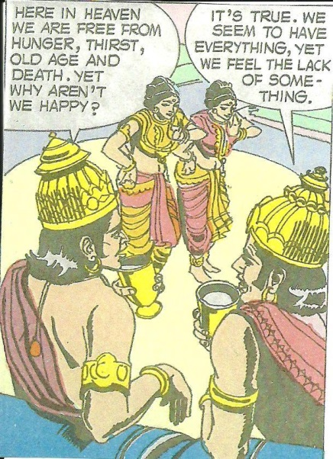**Story: Bhagavān Brahmā’s Teaching – Da Da Da**

Once, the residents of all the three worlds had whatever they wanted in plenty. The Devas in heaven desired for pleasures of food, drink and dance and they got plenty of all their objects of desire (Kāma). On earth, human beings desired bountiful crops, comfortable dwellings, good clothing and money (Artha) and their wishes were also fulfilled. The evil Asuras aspired for power which they obtained through their military conquests. Therefore, the Asuras too enjoyed their taste for power and lordship over others (Kāma).

But all these three beings felt that there was still something lacking in their leaves. They were not really happy. Their hearts still yearned for inner peace and joy. However, they could not figure out how they could obtain that inner joy.

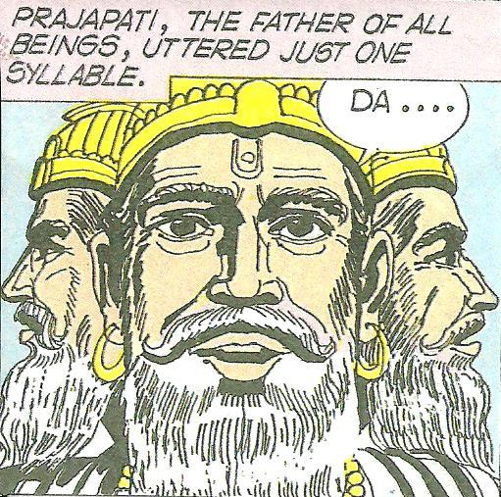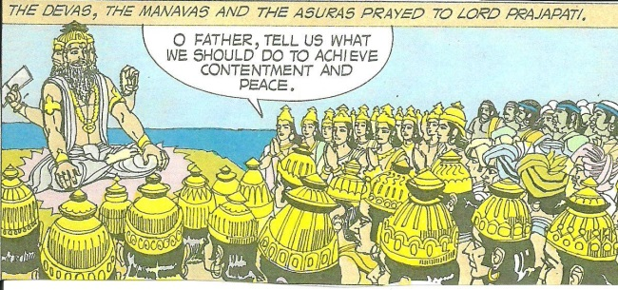Therefore, all the three- the Devas, Asuras and Humans approached Bhagavan Brahmā and prayed to him for inner peace in their hearts. To their surprise, Brahmā merely uttered one syllable ‘Da’. None could figure out what it meant, and therefore they all returned to their abodes.

The Devas went back to their orgies of pleasure – drinking, eating and dancing. They tried to drown their inner sense of hollowness in these activities. Suddenly one of them got up and shouted in a loud voice – “I know what father Brahmā had meant when he uttered ‘Da’. He had meant ‘damyatā’ or control over our senses. Perhaps, we should restrict our food, drink, dancing etc., and lead more disciplined lives.” The Devas tried it out, and they discovered that inner peace and joy in their heart that they had been seeking. They realized that true happiness is not in indulging excessively in pleasures of the senses, but in restraining them and doing more purposeful activities.

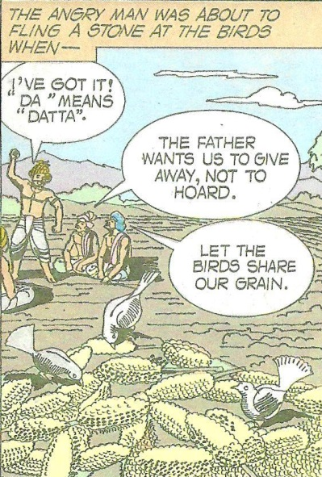Meanwhile on earth, a group of men were admiring their bountiful harvest when they saw a flock of hungry birds descend to eat the grain. One of them got up to shoo the birds away, but stopped suddenly. He said, “I think our father Brahmā had expected us to practice ‘datta’ or charity when he had uttered ‘Da.’” The farmers thought that their friend sounded reasonable and let the birds continue eating. When they saw how satisfied the birds felt and how joyously they chirped, they laughed and felt really happy. The humans then understood what Bhagavan Brahmā had wanted to teach them – That true joy is not in hoarding wealth, but in sharing it with others.

The Asuras, as usual, were on one of their military rampages, killing and beating others. As one of them saw their victim beg for forgiveness, one of the Asuras stepped forward and said, ‘Stop! I think our father meant ‘Dayadhvam’ when he uttered ‘Da’. Let us therefore show him compassion.” The victim whose life got saved thanked them profusely, and for the first time, the Asuras experienced the peace in their hearts that they had never felt before. The Asuras too realized that true peace is not in suppressing and over-powering others through violence, but in living a life of love and compassion.

And indeed, true contentment, peace and happiness are obtained not by accumulating riches, power or indulgences in sense pleasures, but through the values of Dharma like sharing, compassion/love and self-restrain.

***5.2 Is Dharma the Final Goal of our Life?***

When we pursue Dharma, we accumulate a lot of ‘merit’. As a result, we are either blessed with happiness in this life, or in the next life. Or after our current life, we take birth in a rich or in a spiritual family. Or we may be reborn in heaven.

In Abrahamic religions (Judaism, Christianity and Islam), everlasting heaven is said to be the reward of being a believer. Hindu scriptures however deny that there can be a permanent heaven. The argument is that the result of our actions is always finite and therefore our good actions can result only in a temporary stay for us in heaven. Moreover, the pleasures of heaven are similar to those on the earth, although they are much better than earthly pleasures. Once the fruit of our good actions are exhausted, we have to leave heaven and have to take birth again on this earth.[22] Hindu scriptures liken heaven to a temporary jail, and going to heaven can never result in ever-lasting happiness or freedom. Moreover, in heaven, one can get arrogant and proud because of the good environment that he is in, and can be sent back to earth. Only when we reach the state of God do we never return to mortal existence. We become immortal and eternally happy and free upon reaching God.[23]

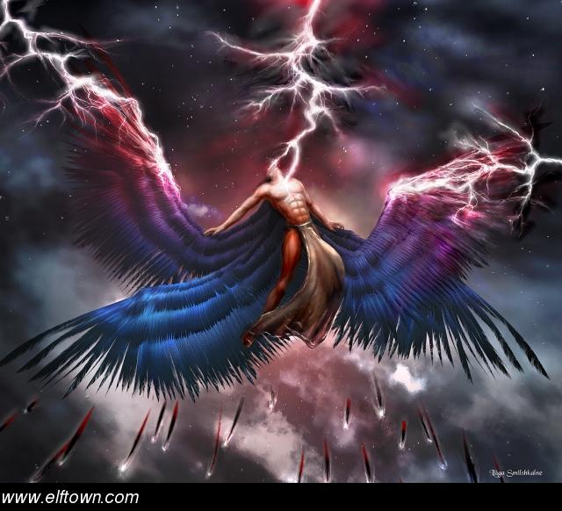**Story: Yayāti falls from heaven back to earth (source: Matsya Purāṇa)**

When Yayati realized how his unquenchable thirst for pleasure had made him deprive his own son of his youth, he felt very sad. He prays and is successful in getting Puru regain his youth. Now Yayati decides to abandon his kingdom in favor of Puru, and retire to the forest.

So Puru was crowned as the king, and Yayati goes to the forest to do austerities (tapasya) and meditation. As a result of his tapasya, Yayati ascends to the heaven. While he is ascending heaven, many great sages offer respects to him in reverence.

In heaven, Indra who is the king of heaven asks Yayati – “What great austerities did you do that even the great sages offered you respects while you were on your way to heaven? After all, even the great sages are always engaged in tapasya. So you must have done something wonderful to earn their respect.”

Now, Yayati got a little puffed with pride. He said – “You are correct Indra. None of the sages did the type of austerities that I performed in the forest. Mine were the best. And that is why they saluted me.”

Indra got upset with Yayati’s pride. He said – “King, even if you had performed some unique austerities and meditations, it was not proper to belittle the spiritual qualities and austerities of the sages. Because of your arrogance, I think that your good karma that brought you to heaven just ran out. And so, I will have to send you back to earth.”

Yayati requested – “Truly, I have realized that even in heaven, a man need not be completely free of evil qualities of the character. I regret that I got carried away and belittled the sages, who may have saluted me just out of courtesy and humility. But I request you not to throw me back to the earth altogether. Please suspend me above a place which is full of holy men. By listening to them and conversing with them, my mind will get purified of all evil traits of character. But if I land back on earth, I will have to mix with both good and evil people and it will take me longer time to regain my merit of good deeds that brought me to heaven in the first place.”

Indra granted his wish, and suspended Yayati above a place called ‘Satbhuvanam’ (abode of the virtuous) where Yayati conversed with the holy men residing there. He explained to them how he came to be suspended in mid-air, and emphasized that no one should have excessive pride or ego or harshness of character. Even a small bad deed can have catastrophic consequences.

In the course of time, Yayati and holy men both benefited from each other’s company and they ascended to heaven together.

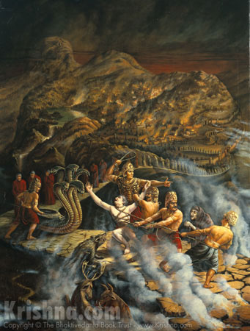**King Vipaschit Rejects the Pleasures of Svarga (Mārkandeya Purāṇa):** Once, there ruled a virtuous king named Vipaschit. He ruled justly and every one in his kingdom followed Dharma. Those who did not follow Dharma by indulging in stealing, killing etc. were jailed and kept under control. All the citizens of the kingdom were happy, prosperous and contended. They all prayed for the long life of their King, and thanked Bhagavān for having given them a noble ruler like him.

When King Vipaschit died, he was taken to heaven. There, he enjoyed the pleasures of heaven for a while. But soon, a thought came to his mind, “I had treated all of my citizens as my own children. I wonder where they are. I can see some of my noble citizens who had died before me, also in heaven. But what happened to my citizens who sometimes disobeyed Dharma? Where did they go?” He put this question to Indra.

Indra, the King of heaven said, “King Vipaschit, your citizens who had done evil were taken to hell.” King Vipaschit replied, “Whatever they might have done, they were like my own children because it is the duty of a King to take care of all of his citizens. Therefore, please take me to Hell, where I can see them, at least for some time.” Indra agreed, and the two went to Hell. In Hell, King Vipaschit was deeply pained to see that his evil citizens were suffering in various ways. He wept at their suffering, and asked that he be taken back to Heaven.

But as he was leaving, one of his citizens cried out, “Please do not leave my King. I know that I am suffering due to my own bad Karma, but your presence here is making me feel more comfortable.” Another voice said, “You were like our father. How can you leave us here alone. Please do not go away. Even the wind that touches your body and blows towards us carries the coolness of your virtue, and makes it easier for us to bear the pain of our burning bodies.”

Hearing these voices, King Vipaschit was moved greatly. He said to Indra, “Of what use is my stay in heaven if I cannot give any relief and happiness to my former subjects. There is nothing superior to compassion and love. So please leave me behind here in hell. If my presence gives happiness to anyone here and reduces their pain, then I am willing to stay behind in hell, even though it may be the most unpleasant and painful place.”

But Indra refused, and said, “Every creature has to bear the fruit of his or her own karma. If they did bad karma, they must suffer in hell. But you were a virtuous king, and had good karma due to which you deserve to stay in heaven and not in hell.” King Vipaschit replied, “I did not do good karma with the intent of going to heaven alone. Of what use is good karma if it does not fill one’s heart with love and compassion? Desire for heaven and other fruit of karma can make one a hard hearted and an arrogant person. I want to donate the fruit of all my good karma to these suffering residents of the hell, so that they can return to earth and get one more chance to be good. Or at least, my good karma will reduce the length of their stay here in hell.”

Indra replied, “Any act of charity is also good karma. If you are giving away the fruit of your good karma, then you are earning even more good karma. Therefore, all the more reason for you to come to heaven and stay there even longer than you were supposed to!” King Vipaschit replied, “I want to donate all the fruit of my good karma, whether these karmas were performed in the past or whether they will be done in the future. I have no desire to live in heaven. All I want is that everyone should be happy.”

When King Vipaschit had said these words, Bhagavān Vishnu appeared in front of them on Garuda. He said to the king, “Truly, a person who has no desire for any fruit of good karma, even if it be heaven – that great person becomes fit for Moksha. So I will take you with me and you will get everlasting Moksha. Your good karma will be given to your well-wishers.” The soul of Vipaschit then attained Moksha, and he resided in the company of Bhagawan Vishnu forever thereafter.

His good Karma were transferred to the residents of hell which shortened their stay in hell, and then they were reborn on this earth.

**6.0 LIMITATIONS OF THE FIRST THREE PURUSHĀRTHAS**

As seen in section 2.0 above, all human beings have some basic desires. But can Dharma, Artha and Kāma lead to a complete fulfillment of these desires?

First, we want happiness (*sukha*) and fullness in our lives. Life is not always happy. It is a mixture of both happiness and sorrows. Moreover, something that gives us joy leads to sorrow the next day and vice versa. Sometimes, we mistake sorrows for joys and it is too late before we realize our mistake. Others can snatch the wealth that we earn. Can we attain happiness that is infinite, permanent and unadulterated with sorrows by obtaining all the riches of this world, or by pursuing all our other physical, emotional and mental desires and fulfilling them? The answer is no.

### Second, we desire to know the world around us (*jnāna)*. But, can we know everything through wealth or through our senses of smell, taste, sight, touch and hearing? The answer is again negative.

Third, we desire security (*abhaya*). We want to remove our fears arising from inevitable death, or potential pain caused by other creatures, by natural calamities, sickness and so on.

Fourth, we are always subservient or dependent on someone or the other and cannot always act with freedom (*svarājya*) without inviting serious repercussions.

Fifth, most human beings also want to be good humans by doing good deeds, speaking virtuous speech and have noble thoughts. But quite often we note that even the best of our actions has some element of evil attached to it. For example giving a lot of charity is a very Dharmic Karma, but there are others in the world that could have benefitted more from the charity than the person we gave it to. Also, a person who practices Dharma and aspires for a good rebirth or a slot in heaven can get egotistic about his having done good deeds.

Finally, we all dread death and desire to live an eternal life. But no one, even the most Dharmic person, has dodged death. Yoga and other medical aids can prolong our lives, but cannot make us immortal.

This lack of complete fullness or happiness, virtue, immortality, complete knowledge or awareness, security or fearlessness and independence results in three types of sorrows.

***6.1 THE THREE TYPES OF SORROWS (‘Trividha-Taapa/Dukha’):***

Hindu scriptures divide sorrows, frustrations, insecurity and the like into three major categories depending on their cause, and the triple repetition of the word ‘*shaanti*’ at the end of each prayer signifies removal of these three categories of sorrows. The following table lists the three types of sorrows:

|  |  |  |  |
| --- | --- | --- | --- |
|  | **Adhidaivika** | **Adhibhautika** | **Adhyaatmika** |
| **Definition** | Related to or caused by natural or divine powers | Related to or caused by other living creatures | Related to or caused by mental problems, physical illness, and delusion (lack of spiritual enlightenment) |
| **Examples** | Floods, earthquakes, volcanic eruptions, Tsunamis, hurricanes, lightning strikes, tornados, famines, unnatural death caused by these events etc. | Theft, murder, beatings, abuse, calumny and slander, attacks and injury by animals (e.g., snakebite), unnatural death caused by other living creatures. | Depression, hysteria, diabetes, cardiac disease, ignorance, anxiety due to uncertainty, old age, death, Parkinson’s disease etc. |

How should we live so as to maximize our happiness and minimize our sorrows?

How do we live our leaves so that eventually we attain a state of complete and perfect happiness, knowledge, freedom and security?

Is such a state even possible?

Hindu Dharma responds in affirmative. This state is called Moksha.

**7.0 MOKSHA – LIBERATION FROM REPEATED BIRTHS AND DEATHS**

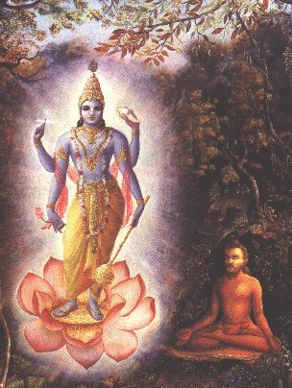For most people, the entire life can be summarized in the following few words, “He (or she) was born, went to school, married, had children, worked a job, grew old and then died.” But is this all that there is to life? Most people would answer, “Yes, that is all that there is to life.”

Yet, there are some intelligent and wise individuals who are not satisfied with this explanation. Such a life, in their opinion, is no better than that of animals. In fact, it is perhaps better to be an animal rather than a human being, because we humans have to put in much more effort to procure the basic necessities of life than animals. We all know that all these stages of life involve a mixture of pain and pleasure, ignorance and wisdom, dependence or independence etc. These few intelligent people ask, “Does there exist a state in which there is no misery, ignorance, death, dependence etc.?” Hindu Rishis have answered that there is such a state, and it is called Moksha. In fact, Moksha is not just one of the goals in our life, it is the goal of our life.

Unfortunately, the number of these wise individuals is very little. Most of us continue to live our lives as dumb animals, and keep running the rat-race of acquiring material possessions and enjoying physical pleasures. In the Gita, Bhagavān Krishna says,

Among thousands of humans, only a rare one strives for perfection. Even among the perfected ones, who are diligent, it is rare for someone to truly know Me. **Gita 7.3**

Attaining moksha is an extraordinary goal, which only some people specifically seek. Moksha is the ultimate aim of human life, a complete liberation from sorrow and desire, and attainment of the union with the Ultimate Reality. Rambachan expounds[24] upon the Hindu concept of Moksa in the following words:

“… In spite of the high value placed upon dharma and the necessity and difficulty of living up to its demands, it is not, along with wealth and pleasure, considered to be the highest end of human life. In other words, a life which consisted of the search for wealth and pleasure within the framework of the moral obligations of dharma does not exhaust the highest possibilities of the human being. The Sanskrit term moksha, which means freedom, describes the highest end of life.

We do not, however, come to this goal of life very easily. The urge for wealth and pleasure is quite common; the appreciation of the value of dharma is less commonly found. The desire for moksha is the rarest after desire for wealth and pleasure, we feel a deep want and lack within us which ever remains unfulfilled. It comes when we somehow feel that as important as our material wants are, satisfying these cannot be the ultimate purpose of our lives. At that moment when we feel the need to know whether there is any deeper significance to life, the quest for moksha really begins.”

The intent of Moksha is described very well in this beautiful prayer from Hindu scriptures:

Lead me from the unreal to the Real.

Lead me from darkness to Light.

Lead me from death to Immortality.

**Brihadaranyaka Upanishad 1.3.28**

What exactly then, is this state of moksha? Rambachan explains[25]:

“[In the state of Moksha] Hinduism conceives of a life where human beings can live out of the fullness and joy of the Atman. Existence can become a celebration in its most profound sense. Instead of searching through acquisitions of every imaginable kind for a fullness which ever evades us, we are called upon to discover and live from a fullness with which we are already blessed. Moksha is not a selfish concern with oneself. In fact, it is the exact opposite. Because it tells us of a truth about ourselves which informs is of a unity we share with all beings, it draws out of the isolated perception of ourselves. Moksha celebrates the oneness and unity of existence, and provides a profound basis for a life of unselfish activity and giving….”

In other words, Moksha is that state in which the three types of sorrows are completely adulterated. Indeed, Hindu scriptures are very clear that it is only by knowing the Divine that we overcome all sorrows, and there is no other way to achieve that goal.

There is indeed one Inner-Controller, the indwelling Soul of all creatures, Who creates this world of variety from the one source. Only the wise, who see this Soul within their own soul obtain Eternal Happiness, and none others. ***Katha Upanishad 5-12***

To conclude therefore,

“Moksha is the desire to abide in deep and lasting peace, to know the Eternal; it is the aspiration to experience a boundless state, one that is beyond the reach of the other three desires.”[26]

***7.1 Moksha as Apavarga***

Another term for Moksha is ‘Apavarga’ which literally means ‘one less than five’ because it is the fourth of the Purushārthas. However, our Hindu Sages explain the word Apavarga in a very interesting way as ‘that which is free of ‘pavarga’’, where the latter stands for five letter series (pa, pha, ba, bha and ma) of the Sanskrit alphabet.

These five letters respectively mean: pāpam (evil), phalam (fruit of karma), bandhanam (bondage, constraints, rebirth in samsaara), bhayam (fear) and maraṇam (death).

Moksha is free of all these five things, and therefore, it is referred to as ‘Apavarga.’ To explain in detail-

* In Moksha, the ātmā is completely free of evil and sin, because it is as pure and as Paramātman. A soul that is in the state of Moksha does not seek to do any evil because it is perfect. Therefore, Moksha is free of pāpam.
* All of our Karma produce good and bad fruit in the form of joy and sorrow. But in the state of Moksha, the Karmas do not produce any joy or sorrow. Instead, we are perpetually in a state of bliss because of constant companionship with the Lord. Therefore, a soul in the state of Moksha is free of phalam.
* In our lives, we do not have complete freedom. We are dependent on others for our livelihood, for happiness and security and so on. Also, our own capabilities and what we can influence is limited. On the other hand, in the state of Moksha, we enjoy complete freedom and have infinite wisdom and knowledge like Bhagavān. The only constraint on us is that we cannot interfere in the activities of Bhagavān (e.g. destroy the Universe that He creates). Therefore, we say that the ātmā is free of bandhanam in Moksha, and instead enjoys svarājyam (freedom).
* The liberated soul in Moksha has no fear of death, poverty, violence, sickness, old-age etc., because all these affect only the body. The liberated soul is on the contrary free of any physical body and therefore free of fear.
* Death affects only the body, not the soul. In the state of Moksha, the soul is free of a physical body and therefore it does not undergo the process of death and rebirth.

***7.2 Moksha as the Final Goal of Life:***

The first three Purushārthas are the goals **in** our life, whereas Moksha is the goal **of** our life. Once Moksha is attained, there is nothing left to attain. It is eternal, and full of joy, peace, contentment, wisdom, knowledge in the company of Bhagavān. In the Hindu tradition, there are numerous stories from the lives of Sants who got a glimpse of the Lord, and then they were interested in nothing else after that.

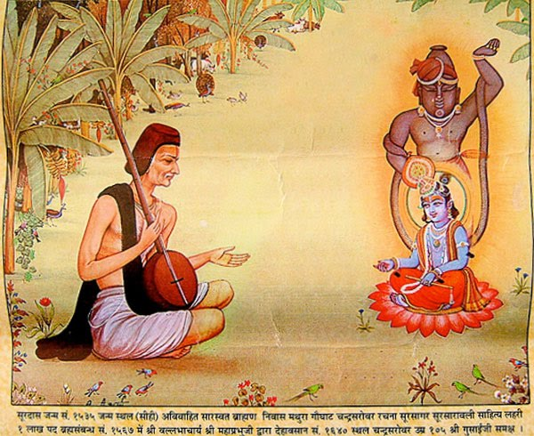**Story: Surdas asks Lord Krishna to make him Blind**

Sant Surdas lived in the Indian state of Uttar Pradesh in the 15-16th cent CE. It is believed that he was born blind. Surdas was greatly devoted to Bhagawan Krishna. Every day, he composed hymns in praise of Krishna, and sang them melodiously. One day, he fell into a well. He sang out to Krishna. Miraculously, a couple appeared soon and pulled him out of the well.

Surdas realized that the couple were none other than Radha and Krishna. Moved by the devotion of Surdas, Radha comes back to see Surdas, who immediately catches her feet to get her blessings. Radha was able to get away, but in the process, her anklets fell off. She asked Surdas to return them, but he insisted, “How do I know they are yours because I cannot see.”

Radha restored his vision, and at once, he saw none other than Bhagawan Krishna and Radha in front of him. Krishna requested Surdas to ask for some boons because He was very pleased with the devotion of the saint. But Surdas asked for only one thing – “Please make me blind again. I have seen my Lord with my own eyes. And now I do not wish to see anything else.” Krishna insisted that this would be unfair to Surdas. He could keep his vision and also ask for something else. But Surdas insisted – “No, please make me blind again. But give me the boon that I always remain devoted to you as your servant.”

**Parable: Sage Jaigishavya evaluates the Bliss of Moksha**

**[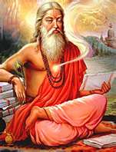](http://images.search.yahoo.com/images/view;_ylt=A0PDoX0DNrRPx1sAxEeJzbkF;_ylu=X3oDMTBlMTQ4cGxyBHNlYwNzcgRzbGsDaW1n?back=http://images.search.yahoo.com/search/images?p%3Dhindu%2Bsage%26fr%3Dyfp-t-701%26fr2%3Dpiv-web%26tab%3Dorganic%26ri%3D10&w=229&h=300&imgurl=www.indianetzone.com/photos_gallery/3/agastya_14550.jpg&rurl=http://www.indianetzone.com/30/dahragni_indian_sage_agastya.htm&size=30.9+KB&name=...+renowned+sage+Agastya.+Dahragni+is+an+ancient+Hindu+sage+of+India&p=hindu+sage&oid=3c30031ad367242a11d09e2b0627c16c&fr2=piv-web&fr=yfp-t-701&tt=...%2Brenowned%2Bsage%2BAgastya.%2BDahragni%2Bis%2Ban%2Bancient%2BHindu%2Bsage%2Bof%2BIndia&b=0&ni=21&no=10&ts=&tab=organic&sigr=11v27pgrs&sigb=134t0nghr&sigi=11nh0inf5&.crumb=6NPxxKDtbr7)**Through intense meditation, Sage Jaigishavya came to see all of his past lives, across billions of years. He saw that in some lives, he was human, in others, he was animal, and yet in others, he lived in heaven. But, nothing seemed permanent. He discovered that he had lived in multiple universes and had been born again, and had died millions of times. Sometimes, he had been happy, at other times, he was sad. But none of these states was permanent. However, his soul stayed the same in all these lives. Therefore, he realized that there was not much gain in getting excited over little things, or in getting upset over temporary setbacks. Instead, one must continue to make progress in their entire life despite temporary setbacks.

Another Sage named Avātya asked him, “So what will you consider the greatest source of happiness in all your lives?” Jaigishavya replied – “True happiness results not from indulging in all kinds of temporary pleasures, but by being a balanced person and being contented. And even greater happiness is being one with Brahman, because that alone brings complete and eternal joy.”[27]

***7.3 Achieving Moksha***

One cannot take short cuts in the path of Moksha. Typically, one must life to its fullest (enjoying the fruit of Artha, Kāma and Dharma) before achieving Moksha. Sometimes, we find children who are spiritually gifted and attain Moksha even without pursuing Kāma and Artha. In their case, we assume that they have enjoyed the Trivarga in their past lives. One should also not believe that the first three goals are opposed to achieving Moksha. In fact, when practiced correctly, they are conducive to take us to Moksha. The Mahābhārata rightly remarks:

Bheeshma said –

Desire for the fruits of one’s actions is the defect of Dharma. Hoarding is the defect of Artha. Excessive indulgence is the defect of Kāma. But when these three (Dharma, Artha and Kāma) are free of their respective defects, they become conducive to one’s welfare. **Mahābhārata 12.123.10**

Hindu scriptures describe four main, overlapping ways of achieving Moksha – Karmayoga (the path of selfless action dedicated to Īshvara), Dhyānayoga (the path of meditation on Īshvara), Jnānayoga (the path of spiritual wisdom) and Bhakti yoga (the path of loving devotion for and surrender to Bhagavān). A detailed discussion of these four paths is beyond the scope of this lesson.

**8.0 RELATIONSHIP BETWEEN THE FOUR PURUSHAARTHAS:**

***8.1 Order of listing the Purushārthas:*** Dharma is always placed first, followed by Artha, Kama and Moksha in that order. The intent behind this order is that Dharma must regulate Artha and Kama. In other words, pursuit of wealth and physical pleasures must be governed by Dharma or ethical norms. Artha appears second in the list of Purushārthas to indicate that material wealth is essential for the well-being, survival and prosperity of a healthy human society. Artha and Kāma that result from violation of Dharma are not counted as Purushārthas because they do not lead to happiness. Hindu scriptures declare:

*“Those men who are Adhaarmic, whose wealth is earned through falsehoods, and who are always engaged in hurting others – such persons will never get happiness in this life or the next.”* **Manusmriti 4.170**

*“Lifting my arms I keep declaring, but no pays attention to fact that one can attain Kama, Artha as well as Moksha by practicing Dharma. Then why don’t people serve Dharma?”* **Veda Vyasa in Mahabharata 18.5.49**

Dharma is the foundation or pre-requisite for spiritual liberation or Moksha. The greatness of Dharma is extolled in the Upanishads in the following words –

Dharma is the support of the whole Universe. All people draw near a person who is fully devoted to Dharma. Through Dharma, a person chases away sin. All are supported by Dharma. Therefore, they say that Dharma is Supreme. **Taittiriya Aranyaka 10.79.7 (Andhra recension) = Mahanarayana Upanishad 79.7**

***No one who is Adharmic can attain Moksha***. This is another reason why Dharma is placed first in the list.

8.2 Order of Importance of Purushārthas: Kāma is considered the least important Purushārthas. Artha is more important than Kāma, and Dharma more important than these two. Moksha is the most important (parama-purushaartha) or the final (atyanta-purushaartha) one. Hindu scriptures state –

*“A wise man tries to obtain Dharma, Artha as well as Kāma. But if he cannot obtain all the three, only two, he goes after Dharma and Artha; or after Dharma if he can obtain only one of the three. An enlightened prefers Dharma over the other two, a mid-level human prefers Artha over the other two, whereas the lowest type of human beings pursue only Kāma.”*

**Mahabharata 5.122.32-33**

8.3 School Education and the Purushārthas: Modern secular schools teach us mainly about Artha i.e. impart skills and knowledge which will enable us to earn our livelihood when we become adults. They teach a few aspects of Dharma (e.g. our duties as a citizen) and Kāma (e.g. fine arts like painting, music, sculpture) but they hardly teach anything about Moksha.

The Weekend Dharma schools however focus their teaching on Dharma and Moksha. For this reason, it is very important to attend these schools too.

8.4 Appropriate Time to Pursue these Purushārthas: Another important point to note is that all these four goals must be pursued at all times, but with varying degrees of emphasis on one over the others depending on what state of life one is in.

* The student needs to prepare himself to earn a living and support his family when he becomes an adult. Therefore, he has to focus on those sciences that will help him achieve Artha. But, he must also love how to live his life ethically and morally later, and therefore, he should also focus on Dharma. At the same time, a student who wastes his time pursuing Kāma or pleasures (e.g. Video Games) will not be able to master the sciences of Artha and Dharma. Therefore, the student is told to avoid Kāma.
* For example, a householder must pursue Artha to support his family, and Kāma to produce progeny. At the same time, he must also pay attention to Dharma and Moksha.
* On the other hand, a Sannyāsi is not supposed to devote too much effort towards achieving Artha or Kāma, but he must devote all his energies towards Dharma, and Moksha. The relationship between the four goals may be explained with an analogy:

**Example on Relationship between the four Purushārthas:**

Suppose a man named Ram needs to travel to a sacred shrine at the top of a mountain. The mountain is several hundred miles away. Therefore, Ram rents a chariot temporarily. The chariot has two horses, but can be pulled easily with one too. He also gets a charioteer who knows the way to the base of the mountain, and can also control the two horses to steer them to the base of the mountain. This charioteer can also assist the man in his ascent from the base to the shrine at the summit of the mountain by giving him tips on the easiest path that he should take while climbing the mountain. At the base of the mountain, the man, who wished to reach the mountain, gets off the chariot and bids goodbye to the chariot, the horses and the charioteer – who gives directions to the man on reaching the top of the mountain. He then climbs the mountain with the charioteer, and finally reaches the shrine, where he has a darshana of God.

In this analogy, Ram, who reaches the shrine is the soul. The chariot that he rents permanently is the body. The two horses, associated with the chariot are Kāma and Artha. The charioteer, who controls the two horses, steers them to the right direction towards the summit of the mountain, and then guides Ram towards the top of the mountain is Dharma. Ram’s climbing the mountain represents his spiritual journey, assisted by the knowledge of the chariot (Dharma). The shrine at the top of the mountain, where Ram has a darshana of the Lord represents Moksha.

Thus, the Hindu World View acknowledges that all aspects of human existence – pleasure, wealth, piety and spirituality are valid in their own spheres. They are not opposed to each other, and one should try to seek a balance between these depending on one’s social status, position, temperament etc.

Hinduism accepts all four Purushārthas as valid goals of human endeavor. Hindu Dharma does not say that we should ignore Artha or Kama completely or look down upon them. Rather, we should regulate them through Dharma, and practice them in moderation. Eventually, we should transcend Artha and Kama and seek the help of Dharma and spiritual knowledge to proceed towards the final goal of Moksha.

**Transcending Artha and Kāma: Analogy**

A child is naturally inclined towards playing toys and not much more. In fact, a world where children do not have toys would be a sad world. However, when children grow up, they should overcome their fascination with toys because a world in which adults are still obsessed with toys only would be sadder indeed!

Similarly, human beings cannot ignore Artha and Kāma in general. But as we grow in wisdom and spiritual knowledge, these two become less relevant to us, and Dharma and Moksha become more important.

**Source**: Smith, Huston. 1991. ***The World’s Religions***. Harper: San Francisco, Chapter 2 (on Hinduism)

### 9.0 LIVING A TRUE LIFE: THE WAY OF DHARMA AND MOKSHA[28]

***What is Culture:*** When a group of people live together for a long time in a particular area, living certain values, the special individuality or fragrance that emanates from that group is said to be their culture. If the individuals are spread out – one living here, another living there – or if they are constantly roaming about with no values in common, then you will not find any recognizable culture emerging from them. This special mark or characteristic that develops under the above circumstance is called culture, which is not the characteristic of only one individual but of the group as a whole.

***Culture and Individual:*** When a certain individual behaves in a particular way, we generally say, “This is his nature.” But when a community responds to different situations in a particular way, we say it is its culture. The difference is that with respect to one person’s mode of behavior we all it nature, and with respect to a community, we call it culture. They influence each other because each individual influences his society, and the society influences who we are.

***What is Individual Culture or Nature (Svabhaava or Samskaara):*** In a family with 3 or 4 children, though each is born into the same culture, we find that each individual behaves differently. Then we ask: If they are born in the same family, the same culture, and in the same country, then why does each person behave differently? We answer that it is his nature (samskaara, svabhaava); and his actions are in accordance with those particular tendencies. When it comes to a group, however, we say that the group’s mode of behavior and response is its culture.

#### *9.1 Types of Individual Culture:*

Samskriti: In Sanskrit, the word for culture is Samskriti. Kritam means “that which is done,” sam means “very well”; samskriti means “that which is very well made, very well refined.” Therefore, even the Sanskrit language itself is that which is a well-refined, purified language. In terms of behavior, when we say that an individual is “cultured,” his behavior is “cultured,” although he may not necessarily be an educated person. Many times, in fact, an educated man may be a brute because being truly cultured is different from merely being formally educated.

Prakriti: The inherent nature or tendency of a thing is called its Prakriti. For example, animals as well as human beings have urges such as hunger, thirst, feelings of fear and insecurity, and the need for sleep, and they live according to these desires or urges. This is defined as their nature.

Vikriti: When an urge or desire grows out of proportion and we transgress the control and limits of Prakriti, it is Vikriti, perversion; no longer Prakriti.

E.g., I feel hungry and go to eat food. This is an example of Prakriti, because we all naturally feel hungry and have to eat food to sustain our bodies. Now, if I eat like a glutton, or if I spend $500 to eat an unhealthy and excessively rich lunch while three are so many people in front of my dying of hunger, it is Vikriti. But if I eat only a healthy amount of nutritious food, and share my food with others who need it, it is Samskriti.

#### *9.2 Materialistic and Spiritual Cultures:*

There are many communities and nations and each one has its own culture or traditions. Nevertheless, we can divide or classify these cultures into two main groups – Spiritual culture (Adhyaatmika Samskriti), and Materialistic Cultures (Bhautika Samskriti, from bhuuta = element). People raised in the former find the latter very petty and superficial. People raised in the latter think that people from the former are very primitive and are losers. This is because, people from materialistic cultures have a very narrow mindset that is perhaps just a little more developed than animals. They are unable to comprehend and appreciate the values of a spiritual culture, which give a great importance to Dharma and Moksha.

##### What is a Materialistic Culture?

The philosophy of materialistic culture gives the most reality to that which is solid, gross, tangible, and perceivable by the senses. In Hindu scriptures, the Asuras are the representatives of this kind of culture. Materialistic cultures emphasize further investigation onto the nature of matter, along with the application of that knowledge to make our lives more comfortable. Materialists are satisfied with the understanding of the material Universe. Even if he recognizes that something else exists beyond what we can see with our senses, he does not exert any significant effort to understand the supra-sensuous. He is interested only in what he can see with his eyes, through microscopes, telescopes, spectroscopes, stethoscopes and so on. In its extreme case, the materialistic culture considers that the sole purpose of creation is its enjoyment by humans. In such a culture, humans make attempts to dominate and modify their environment, but do not spend much effort in trying to understand the nature of the soul which makes this Universe come alive. In other words, people belonging to materialistic cultures focus a lot of energies towards Artha and Kāma but largely ignore Dharma and Moksha.

##### What is a Spiritual Culture?

Such a culture does not deny the importance or existence of the material world. Rather it teaches that beyond this Universe that we can experience through our senses, there is a greater, deeper underlying Reality. Such cultures want to live in harmony with nature and finally go beyond it. People in such a culture believe that the purpose of this entire creation is to help us in understanding that underlying Truth or Reality. In a spiritual culture, the Universe is considered subservient to this Reality, called God in most religions. It teaches that we should live our lives purposefully and meaningfully rather than just being infatuated with ‘things’ such as good clothes, shoes, tasty food, electronic gadgets, music and dance and so on. In other words, people belonging to Spiritual Cultures divert a lot of their efforts and energies towards Dharma and Moksha, and try to minimize their involvement with Artha and Kāma.

Most people do not want to pursue anything beyond what they can easily see, hear, taste, smell, feel and think. Rare is that human who seeks that which cannot be seen, heard, tasted, smelled, felt or rationalized intellectually. Within even spiritual cultures, it is sometimes rare to find people who are truly spiritual – people who do not care much about materialistic pleasures.

**Story: Swami Vivekananda Contrasts the Materialistic Western Culture with the Spiritual Hindu Culture**

During his visit to the United States, Swami Vivekananda was once walking on a street. Clad in saffron clothes, he presented a strange sight to the Americans, who had never seen a Hindu Sadhu. They started jeering at him, as if he were a madman.

Swami Vivekananda stunned them by turning towards them and saying in chaste English, “It appears that in your country, the worth of a man is estimated by the richness of his clothing. But in my country, the worth of a man is estimated by the goodness of his character.”

The onlookers who jeered at him bowed their head in shame. The person they had thought to be a mad man turned out to be a very learned man.

##### Can the study of this Material Universe lead to spirituality?

Yes. Several schools of Hindu philosophy devote a great deal of their content to understand the nature of matter and energy. But this is done with intent to distinguish it from the underlying Soul, or with the purpose of showing how this Universe is merely subservient to the Soul. Study of this Universe in Hindu philosophy is not pursued for its own sake (as is the case in a Materialistic Culture), but for the sake of understanding the final Truth – that we as humans are much more than this body and mind, that we are in fact related to or a part of that Underlying Reality.

### 10. Human Body – A Unique Gift:

Eating, drinking, sleeping, shelter, sex, excretion, security, desire to live, progeny – these are common between humans and animals. All living creatures have their own nature or Prakriti. All living beings have natural urges, as long as they live within their limits it is not a perversion; it is simple prakriti. In the case of animals, their behavior is regulated by nature itself, and rarely, they show signs of Vikriti or Samskriti. Animals are literally trapped within the bounds of their Prakriti. For example, a monkey will never read a book, but at the same time is incapable of indulging of consciously poisoning the children of other monkeys. A cow will always be a vegetarian. A lion will always eat meat.

But in the case of human beings, there is a difference. Human beings, unlike animals, can rise above Prakriti to the level of Samskriti (e.g., Saints and Sages), or can lapse considerably down to the level of extreme Vikriti (e.g. Hitler). This is because humans are blessed with the ability to think to a much more sophisticated extent than animals, and this allows us a lot of freedom and power. And what is this power or freedom? I can either destruct or construct myself; both are possible. Thus, this faculty is a blessing if we use it rightly. If we do not know how to use it properly, it can become a curse. Our Prakriti or nature, can become an obsession or an abnormality.

The word ‘manushya’ (used for ‘human being’) means a creature who can think because the word ‘mananam’ in Sanskrit means ‘thought’ or ‘thinking’. So, a human being is a creature who can consider the consequences of his actions, good or bad, and make a choice as to what he would like do. A human being is not a passive creature like a ‘Pashu’ or an animal (from ‘pashyati’ meaning ‘seeing’ in Sanskrit) who is a passive onlooker and is driven purely by his inherent nature in acting, and not by a rational choice.

Hindu scriptures state that there are 8.4 million different life forms. Humans are said to the only life form that has the ability to reflect and choose between good and bad, and make progress towards Moksha[29]. In the Mahabharata, Sage Paraashara says to King Janaka:

*“A human being should not degrade himself to be reborn into a lower species by indulging in sensual pleasures alone, because the human body, even if that of a chandaala (an uncultured and barbarian person) is very difficult to obtain. The Human form is the best that one can hope to obtain because in this form, the soul can deliver itself by performance of pious deeds.”* **Mahabharata 12.286.31-32**

## “*This human body is the source of all auspicious fruits. It is easily gained by those who are devoted to virtuous deeds, but exceptionally difficult to men of depraved conduct. It is like a strong boat to cross the sea of rebirth; the moment he is sought, the Guru (Preceptor) becomes its pilot, and I (Bhagavān), when remembered, push it on towards the goal like a favorable wind. Notwithstanding these facilities, he who does not cross the sea of Samsāra through this body, is truly killing himself by himself*.” Shrimad Bhāgavata Purāna 11.20.17

The person who uses his human body, obtained as a result of a hundred virtuous deeds, for pursuing pleasures of sensual organs instead of using it to pursue the path of Moksha, is like one who burns (the fragrant and precious sandal tree wood) hurriedly (i.e., without thinking) for obtaining ash. **Narasimha Purāṇa 9.7**

In terms of the doctrine of Purushārthas, what distinguishes humans from animals is that our minds are much more well developed and allow us to -

1. Pursue artha and kāma to a much greater extent than animals
2. Pursue the third goal of Dharma to regulate artha and kāma, which animals cannot
3. Go beyond the third goal and pursue the final goal of Moksha, which leads to infinite and endless life, happiness and knowledge.

Hindu scriptures therefore declare,

Food, sleep, fear and sex are the common features of man and animal. Dharma alone is the specific characteristic that distinguishes man from animal. Those men who have no Dharma are just like animals. **Hitopadesha 25**

Sleep, fear, sex and food are equal for all creatures. A human is one who possesses knowledge whereas an animal is one who is ignorant. **Garuda Purāņa 2.49.53**

One is guilty of self-deception if he does not strive to gain either heaven (through Dharma) or Moksha after being born as a human, whereby he could gain either. **Garuda Purāņa 2.12.13**

Animals cannot even aspire to pursue Dharma and Moksha. A human being has a natural capability (unlike animals) to pursue Dharma and Moksha. In other words, it is a human’s Prakriti to aspire for things beyond just shelter, clothing, food, progeny, fame and so on. And therefore, humans are held to a much higher standard than animals (and plants).

How can we human beings make the best use of our lives, so that we don’t just waste our lives as animals. What we need to do is to control, discipline, and refine our behavior. In order to refine the person, to prevent Prakriti from turning into Vikriti, what we need is Samskriti, or culture. Mere education or rising to higher positions (artha), gaining more money and power (artha), indulgence in sensual pleasures such as from dance, song, perfumes, jewelry, cigarettes etc. (kāma) will not make necessarily a cultured person. One’s mind may yet remain animalistic. Such an animalistic human mind is like a vulture that soars high up in the sky. But as soon as it sees a carcass, it plunges to devour that reeking carcass[30].

The svabhaava or samskaara (individual nature) of the human being who does not rise beyond these physical desires (Artha and Kāma) to pursue Dharma and Moksha is in fact Vikriti, and not just Prakriti. This is because such a human being is perverting or wasting his life, his inner or natural strengths and capabilities by living the life or an animal. But a human being who reflects upon and practices Dharma and works towards Moksha – his svabhaava or samskaara is that of ‘samskriti’ or it is refined.

Swami Rama had said,

“Rebirth in a human form is the necessary condition for gaining experience by which the consciousness of the Self may expand into the full awareness of its essential unity with God. Through the operation of the universal law of karma, the Self is born into those conditions which enable it to gain the necessary experience and to complete the work left undone in previous lives.”

***10.1 How most of us Waste our Human Birth:***

Whenever a group of people are asked as to what they desire out of life, what they want and long for, a the responses (see Class Exercise 1) when compiled show that the wants in the columns of Artha and Kāma are the maximum in number. Some people have wants in the ‘Dharma’ category. And the items in the ‘Moksha’ column are either very few, or are totally absent.

This exercise indicates that we as individuals spend most of our life pursuing material objects, or physical pleasures. We do not pay much attention to Dharma, and often totally ignore Moksha. This defeats the very purpose of human birth, because even animals aspire for Artha and Kāma. Hindu scriptures and Rishis therefore emphasize that a human being who does not devote himself to Dharma and Moksha degrades himself and insults Bhagavān by wasting his life. A modern Hindu saint gives the following example to illustrate this point-

[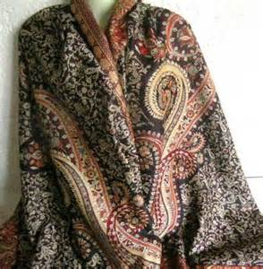](http://images.search.yahoo.com/images/view;_ylt=A0PDoKiZzVhSVBUARvWJzbkF;_ylu=X3oDMTFxMGM5aG8zBHNlYwNzcgRzbGsDaW1nBG9pZAM3M2ZmZmY2ODI2OGI4ZDQ2MTA2Zjc3NzEyZGQ4M2QxOARncG9zAzg-?back=http://images.search.yahoo.com/search/images?p%3Dkashmiri%2Bshawl%26n%3D30%26ei%3Dutf-8%26y%3DSearch%26fr%3Dyfp-t-900%26tab%3Dorganic%26ri%3D8&w=393&h=400&imgurl=www.muglooandsons.co.in/full-images/kashmiri-woolen-shawl-755321.jpg&rurl=http://www.muglooandsons.co.in/kashmiri-woolen-shawl.htm&size=39.9KB&name=%3cb%3eKashmiri+%3c/b%3eWoolen+%3cb%3eShawl%3c/b%3e,Cashmere+%3cb%3eShawl%3c/b%3e,Cashmere+Wool+%3cb%3eShawl+%3c/b%3eManufacturers+...&p=kashmiri+shawl&oid=73ffff68268b8d46106f77712dd83d18&fr2=&fr=yfp-t-900&tt=%3cb%3eKashmiri+%3c/b%3eWoolen+%3cb%3eShawl%3c/b%3e,Cashmere+%3cb%3eShawl%3c/b%3e,Cashmere+Wool+%3cb%3eShawl+%3c/b%3eManufacturers+...&b=0&ni=160&no=8&ts=&tab=organic&sigr=11oq3o1rj&sigb=13ij871ij&sigi=1242l5qd7&.crumb=DoSLDIa.hSd&fr=yfp-t-900)

“A Raja presented a rich Kashmiri shawl to a foolish Pandit. The Pandit had no idea of the value of the shawl. He at once wiped his nose and feet with the shawl. Irate at such stupidity, the Raja ordered that the shawl be taken away from the Pandit who did not know how to use it. And his peon snatched it away from the Pandit.

Similarly, this precious human birth has been bestowed upon us as a great gift by God. But the foolish man wastes it on woman, gold and fame. Death soon comes and snatches away this gift of God, grossly misused by man.

O man, utilize this precious human birth in Japa, study of scriptures, selfless service and meditation. Realize the Self and be free.”[31]

Some people argue that we should spend our childhood and youth in enjoyments and in earning money, because pursuit of Dharma and Moksha can always be postponed to the old age. Although one has a different focus in different stages of life, we must never ignore Dharma and Moksha completely. Time is precious, and not even millions can bring back a moment that has gone into the past.

Even when we pursue Artha and Kāma, we should set aside some time and effort for the higher goals of our life without fail. The fact is that Artha and Kāma cannot bring us the bring us the inner peace and happiness that we all seek.

**Story: Wasting a Precious Opportunity**

[](http://images.search.yahoo.com/images/view;_ylt=A0PDoKjXzVhSHEYA8QmJzbkF;_ylu=X3oDMTJhMTZ1aHBiBHNlYwNkZC1pbWctc3VtLTEEc2xrA2hxaW1nBG9pZAM0ZDE2ODRmMC1lYzdlLTMzOWEtYjc0NC1kNWI0N2IzYWM4MGQEZ3BvcwMz?back=http://images.search.yahoo.com/search/images?p%3Dthrowing%2Bstones%2Binto%2Bwater%26n%3D30%26ei%3Dutf-8%26y%3DSearch%26fr%3Dyfp-t-900%26ri%3D3%26tab%3Dorganic&w=1530&h=1024&imgurl=d4.yimg.com/sr/img/1/4d1684f0-ec7e-339a-b744-d5b47b3ac80d&rurl=http://images.search.yahoo.com&size=212KB&name=Little+Boy+Throwing+Big+Stone+Into+Lake&p=throwing+stones+into+water&oid=4d1684f0-ec7e-339a-b744-d5b47b3ac80d&fr2=&fr=yfp-t-900&tt=Little+Boy+Throwing+Big+Stone+Into+Lake&b=0&ni=160&no=3&ts=&c=0,0,198,198&s=0&imgs=yahoohq&prtnr=Getty&sigr=10u1vb470&sigb=13ubq3kk5&sigi=11pod8qq6&.crumb=DoSLDIa.hSd&fr=yfp-t-900)Once, a fisherman was taking a walk on the beach late in the night. He saw a bunch of debris from the last tide on the sand. One of the items looked like a pouch. He thought that the pouch must have been washed ashore from a ship. When he opened a pouch, he found that it was full of stones.

The fisherman sat on the beach, and started throwing the stones at leisure into the waves. He enjoyed the ‘plup’ sound as the stone crashed into the water. Soon, it was sunrise, and there was light. As the fisherman put his hand into the pouch to pluck out one of the last stones, he realized that the stones were in fact large diamonds.

Apparently, he had wasted most of the diamonds by throwing them into the water. Most of us are like the fisherman. We do not realize, in the darkness of our ignorance, that we are wasting our precious assets like good health and young age to enjoy trivial pleasures like that plup sound. Only if we had the light of wisdom, we would not waste even a moment in spending our life wisely, and in taking care of our assets.[32]

**Story: The Well of Life (Source: Mahābhārata, Shanti Parva)**

This story[33] was narrated by Vidura to his half-brother King Dhritarāshtra to explain to him how the pleasures of this world are really transient, and life itself always ends in death. Yet, people continue to chase the mirage of these temporary pleasures even till their death. But the wise man sees the true nature of life in this world (samsāra) and abandons ephemeral Artha and Kāma in favor of Dharma and Moksha, which are more permanent.

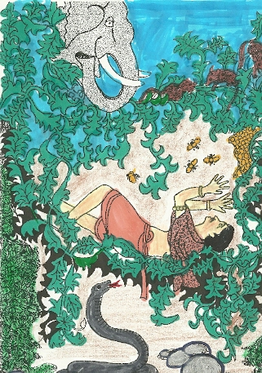“Vidura said to Dhritarashtra, “Once, a certain Brahmin was caught in a vast thick forest which was inhabited by wild beasts like lions and tigers. He became perturbed and frightened and ran in circles to find a place of refuge. But, he did not succeed. He found the forest enclosed in a net, that was held by a terrible witch standing with her hands outstretched. Many five headed snakes also lived in that forest. There was a pit in that forest, and its mouth was covered by trees, creepers and herbs. In his wanderings, the Brahmin fell into the pit. But before he could fall to the ground, he was held midway by the branches of the tree and the creepers. He was hanging head down and feet up.

In this position, he saw a big venomous snake at the bottom of the pit. He also saw a huge six-faced, twelve footed elephant slowly approaching the pit. Several black and white mice were above the Brahmin, chewing at the creepers and branches from which the Brahmin was hanging. On one of the branches above his head, there was a beehive. Numerous bees were hovering around the hive. Honey started trickling drop by drop down to his head. The Brahmin turned his head a bit and started drinking the honey to quench his thirst. But the more he drank the honey, the more thirsty and dissatisfied he felt. But even then, he was not discontented with life and kept clinging to the branches. With the elephant above him, the serpent below him, bees hovering around his head and the rats gnawing at the creepers that held him, the Brahmin, even in that hopeless situation, continued to sip the drops of honey!

Dhritarashtra then asked Vidura, “Please explain me the meaning of this story. What is meant by your example of the snake, the elephant, forest, honey etc.”

Vidura replied, “The wilderness is the mysterious universe. The forest is the limited sphere of one’s own life. The woman who holds a net over the forest is the aging process, which takes youth and vigor from the body. The pit is this physical body. The beasts of the forest are the diseases which threaten every life, and the serpent at the bottom of the well is Time, the destroyer of all living beings. The creeping vines are the desires that entangle every person. The six-faced elephant and his twelve feet represent the six seasons and 12 months of the year, and the white and black rats symbolize the days and nights. The honey represents the pleasures of life.

The story that I have told you shows how humans keep clinging to life’s pleasures even in the face of numerous dangers and imminent death. The tragedy of life is that people continue to chase these transient pleasures even till their death. They are like the old dog that has no teeth left in its mouth, but will not let go the bone which it cannot chew! Rishis however understand the true nature of this life. They do not get attached to the transient pleasures of life and instead pursue Moksha by acquiring knowledge, wisdom and spiritual progress.”

### 11. Getting Motivated towards Living with a Higher Purpose

How can one get motivated towards Dharma and Moksha, and get detached from Artha and Kāma? There are three main factors that can individually or collectively make us attracted towards the higher goals of life.

1. ***The Role of a Guru:*** Sometimes, it takes a spiritually enlightened Guru to teach us the truth that there is much more to life than pursuit of Artha and Kāma. The story below is one such example:

**Story: Swami Vivekananda teaches the true value of Wealth to a Student**[34]

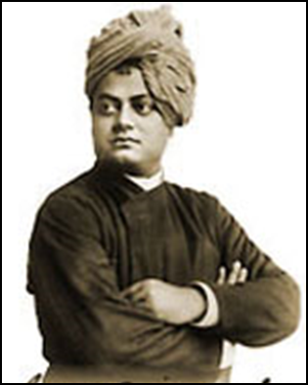Swami Vivekananda was sailing to America for the second time. He met an Indian student in the ship who was going to America for higher studies. He looked very sophisticated and behaved arrogantly, as very few people went abroad those days. Swami Vivekananda thought that this would be the right time to give him proper values in life. So one evening, when they met on the deck, Swamiji asked the student, “Son, what are you going to America for?”

“I am going for higher studies, Sir. It will take four to five years.”

“Then what will happen?”

“I will return to India. I am sure to get a very good job and earn a lot of money.”

“Then?”

“Then?” The student was surprised. Was the Swami so ignorant that he did not know the value of money? ‘Then Sir, I shall be the most fortunate person. All the fathers of marriageable girls will come to me with proposals. I will be in a position to dictate my own terms and marry the girl of my choice. They will give a substantial dowry too!”

“Then?”

The student felt irritated by these questions, but he did not show it. However, he answered impatiently, “Then Sir, we will live together, and have children. I shall be a big officer, with a huge bungalow to live in and a car too. My children will get the best education, and all opportunities to do well in life. The daughters will make good matches and the sons may even go abroad like me for higher studies and get good jobs.”

“Then?”

Now the student was certain that the Swami was mocking him. He looked at his face to see his expression, but the Swami’s face was dead-pan. So suppressing his mounting irritation, the student replied, ‘Sir, by the time my children are settled in life, I shall be nearing the age of retirement. So I will build a small house in my village, and live there after retirement. I will get a good pension and manage to live quite comfortably.

“Then?”

The student angrily lost control over himself this time. He retorted angrily, “Then? What sort of questions do you ask, Sir! What more is there to say? Then one day I will die.”

The Swami smiled calmly and said, “If it is only to earn, eat, produce children and then one day die, what is human life worth? Are not the animals doing the same without foreign education? Are not the birds doing the same without schooling? Are not the fish doing the same thing without high salaries and bungalows? Birth and death are common to all beings.

No doubt one should live a decent life, but one should always have high ideals. It is fine to have money and position but they are only worthwhile if used in the service of others.”

The student felt duly ashamed and that day onwards resolved to lead a purposeful life in the service of the society.

1. ***The Role of Life-Changing Events:*** In the case of many individuals, a life-changing event jolts them out of ignorance, and makes them inclined towards Dharma and Moksha. These events can include: death of a near and dear one; surviving a life-threatening incident (e.g. a plane crash); loss of one’s possessions; recovery from a life-threatening disease like cancer etc. These incidents or events make the person realize the triviality of all the things that he had been pursuing so far in comparison to the larger goals of Dharma and Moksha. Sometimes, these incidents are seemingly ordinary- e.g. encounter with a spiritual book, or listening to the sermon of a Sadhu. Below is an example of how a medical professional had a life changing experience that transformed him to a great Hindu saint:

**The Transformation of Swami Shivananda (known as Dr Kuppuswami in his earlier life, 1887 - 1963):** “Once, Dr Kuppuswami had come to India. He had to cross Tamraparni river. He was ferrying through the river in a small boat, with a group of people. They were about to be dragged into a whirlpool and all the inmates of the boat were in the grip of fear of death. One of the passengers – an employee in a jewelry shop, suddenly jumped out and stood upon a projecting granite stone along with [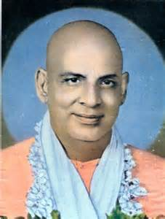](http://images.search.yahoo.com/images/view;_ylt=A0PDoX4gylhSG20AK6KJzbkF;_ylu=X3oDMTFxaTJtcmpwBHNlYwNzcgRzbGsDaW1nBG9pZANjOGNkNzhiNDQ5MTcyM2Q1OGUwMjFiZmU4OWY0Y2FiOARncG9zAzM-?back=http://images.search.yahoo.com/search/images?p%3Dswami%2Bsivananda%26fr%3Dyfp-t-900%26fr2%3Dpiv-web%26tab%3Dorganic%26ri%3D3&w=673&h=886&imgurl=3.bp.blogspot.com/-glvVNA9kx-0/TfOV3UfiFhI/AAAAAAAABJk/HSA_Q8WBDrE/s1600/Swami_Sivananda.jpg&rurl=http://www.hindudevotionalpower.com/2011/06/swami-sivananda.html&size=86.2KB&name=%3cb%3eSwami+Sivananda%3c/b%3e&p=swami+sivananda&oid=c8cd78b4491723d58e021bfe89f4cab8&fr2=piv-web&fr=yfp-t-900&tt=%3cb%3eSwami+Sivananda%3c/b%3e&b=0&ni=160&no=3&ts=&tab=organic&sigr=1204nqf0i&sigb=138rmoreq&sigi=12spdr5br&.crumb=DoSLDIa.hSd&fr=yfp-t-900)a rope tied to the boat. With all his physical power at his command, he pulled the boat towards him! How he did this against the water current and when fourteen people were sitting in the boat was really a miracle. This grim situation which put him face to face with imminent death developed in him full renunciation and with simultaneous unshakeable faith in God and love for him. This incident endangered a colossal change in him and in his attitude to life.”[35]

1. ***The Samskāras (mental impressions) of Prior Lives:*** We often come across individuals who have been inclined towards Dharma and Moksha from their childhood. In their case, no apparent cause is seen that made them less attracted towards Artha and Kāma. Our Rishis have said that these individuals must have pursued Dharma and Moksha in their previous lives, and their present life preferences are just a continuation of what they had gotten used to earlier. Examples are those of Adi Shankaracharya, Sant Jnaneshvara and several other saints who were spiritual right from their childhood.

***11.1 The Path of Good versus the Path of the Pleasant***

To get motivated towards Dharma and Moksha, we should also understand the difference between that which is pleasing (Kāma, Artha) and that which is Good (Dharma and Moksha). That which is pleasing is not necessarily the same as what is good for us! For example, some people like to get ‘high’ on drugs, but drugs are not good for them because they eventually suffer a lot.

The distinction between Shreyas (the Path of the Good) and Preyas (the Path of the Pleasant) as discussed in the Katha and Chhāndogya Upanishads is explained in the following table by Swami Chinmayananda (reproduced verbatim):[36]

|  |  |
| --- | --- |
| ***The Path of the Pleasant*** | ***The Path of the Good*** |
| * Guided by demands of the sense organs | * Guided by the subtle intellect |
| * Temporary joy in the beginning, but sorrow later | * Unpleasant in the beginning, but provides permanent happiness later. |
| * More alluring; caters to the extroverted mind | * Has a hidden beauty, perceived by the introverted mind only |
| * The path of devolution | * The path of evolution |
| * The path for the majority of people | * The path followed by only a few people |
| * Based on sense gratification | * Based on sound knowledge |
| * Denounced by all religions | * Recommended by all religions |

Bhagavān Krishna also explains the three different kinds of pleasure, and how true pleasure is that which leads us towards Moksha, whereas false pleasures are those which take us away from Dharma and Moksha.

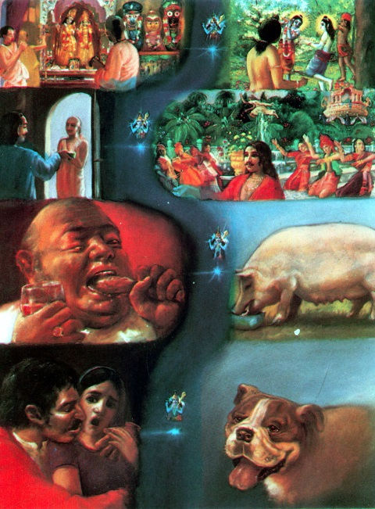The Sāttvik (best) happiness is that which is like a poison in the beginning, but becomes like the nectar of immortality at the end, because it arises from a clear understanding of the soul. **Gita 18.37**

The Rājasic (mid-level) happiness is like the nectar of immortality in the beginning but becomes like a poison at the end, because it is based solely on indulging in the pleasures of the senses. **Gita 18.38**

The Tāmasic happiness arises from a love for sleep, laziness and indifference (“I do not care”) and is nothing but self-delusion. **Gita 18.39**

These verses are very useful even in achieving worldly success. For example, a student who suffers long periods of hard work will eventually succeed in his exams; whereas a student who loves to sleep, watch cartoons, play video games, spend time on Facebook or in texting will eventually fail in his school grades.

***11.2 Never lose sight of your Final Goal of Life***

Once we have realized that the true goals of our life are Dharma and especially Moksha, we must never forget this fact. We must continue to work towards these goals every day. The person who keeps in mind his final goal always, and continues to work towards it diligently every day succeeds. Whereas he who loses sight of his goal and is indifferent towards it never reaches the goal. This is illustrated by the following story:

“There was a kingdom where the constitution required the ruler to rule for five years. During the five years that he ruled, he could rule in any manner completely unrestrained. There was no impeachment, no coup, and no voting. One of the kings believed that if he had unrestrained absolute power for five years, he would eat, drink, and be merry. Just enjoy! Soon, five years were over and the king was thrown into a forest, which was infested with wild animals on the other side of the river.

Then another king was installed who knew the fate of the first king. This ruler was so scared that he could not enjoy anything or do anything. He was afraid all the time. At the end of this five years he had a heart attack on the way to the forest.

The next king first decided to enjoy for some time and then to take care of the kingdom. After three years, he did not know what to do, because his faculty of thinking or reasoning had never been used. Clueless, he was miserable for the last year and a half. And the same fate befell him as had befallen the others.

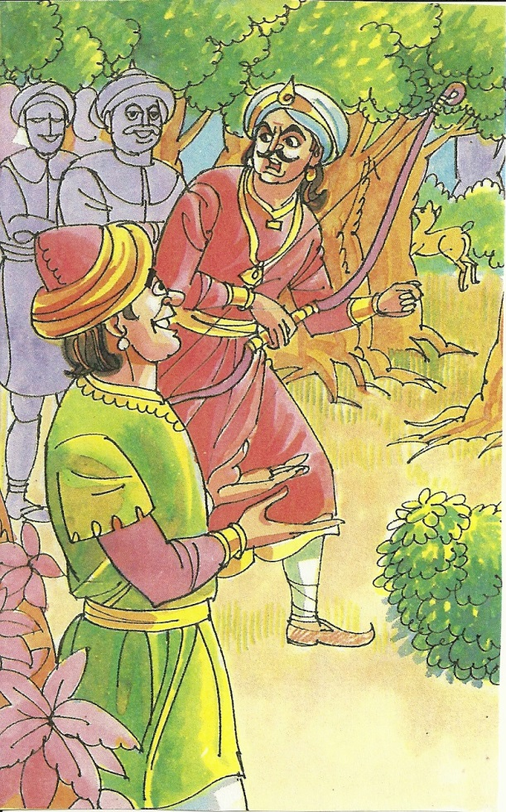Then when the succeeding king was installed, he examined all that had happened to the previous kings. This king was bright and brilliant. He ruled justly and also enjoyed the royal comforts. Everyone fell in love with him. After five years, the subjects did not want him to leave. But he was fair, followed the constitution and left happily. He ordered the boat carrying him to be decorated. The boatman was surprised and asked, “Oh king why are you so happy? All the others whom I took before you were so miserable! Do you know what horror awaits you on the other side the river?” The king answered that during his tenure as king, he had planned and established a forest department. The forest had been cleaned and a new kingdom was established on the other side where people were waiting for him to rule. The boatman then decided to accompany the clever king. On reaching the other side of the river, they found a beautiful city filled with people eager to welcome the far-sighted king!

Similar to a king with a restricted tenure, all of us have a limited time to live. We have to choose what we make of this time. Some live to eat, drink and be merry, and do not bother to think deeply. Such people are afraid of serious thinking [like the first king]….Though serious thinking is a difficult process, we have to face the “realities” of life and cannot escape them. Most people, from lack of thinking deeply, do not know what to do when facing difficult situations. They go into depression or commit suicide.

….In addition to people who avoid serious thinking, there are also pessimistic people. Even when they are happy, they worry that sorrow may befall them. They cannot enjoy any of life. [Like the second king]…

The third category of people believe – first *bhoga* (enjoyment) then *yoga*. This view is that one can remember God after retirement, when there will be nothing else to do; enjoyment comes first. But after putting enjoyment first, we find that the mind does not work! We want *bhoga*, and then *yoga*. But after *bhoga* (enjoyment) comes *roga* (disease); and then *bhoga* always ends in *viyoga* (sadness).

The fourth type of person is the wise man. From the beginning, he knows that since he is born, his life is finite and any moment can be the last. He knows that he should live his life happily and productively. That is the best way of living. Such living becomes a blessing for him as well as for others. Someone may ask, “Why should I remember that I have to die?” Well, there are deadlines in business contracts, aren’t there? A person who remembers that he has to finish before the deadline remains focused and has clear priorities. He does what is most important and does not get distracted by secondary or meaningless activity. If we lack clarity of mind, then we lose sight of the purpose of life.”[37]’

***11.3 Benefits of Living with a Higher Purpose***

When our lives are focused towards Dharma and Moksha, and we keep these goals always in our minds, there are several benefits that result.

1. **Overall social harmony:** Most of the problems of law and order, of social discord and hatreds result because humans are motivated by greed, pride etc, - feelings that fall under Artha and Kāma. If only people were more focused on Dharma and Moksha, they will see the triviality of the causes of these disputes.
2. **We are able to achieve more in our life.** Dharma and Moksha require a certain discipline and focus – two values that help in worldly success as well. These two higher goals make us a more balanced person, versus a frivolous and a shallow person who is addicted to material wealth and physical pleasures. The higher the goal we set in our life, the more we achieve. Conversely, if our goals are low, we do not achieve much. Therefore, we should have high goals like Dharma and Moksha, and success and excellence will follow us easily.
3. **We live a more balanced life** instead of getting distracted towards wasteful and harmful indulgences. It helps us chose the correct priorities in our lives.
4. **Live Longer:** Many premature deaths result when people lose their will to live, or have no great purpose in their lives. But if one has a higher purpose and goal in his life, his will to live through the night into the next day is stronger.
5. **Living with a purpose prevents depressions and suicides.** We are more happy, contended and fulfilled. The benefits of pursuing Artha and Kāma can be lost or be snatched from us very easily. But the benefits of Dharma and Moksha, which reside in our mind and soul, cannot be taken away from us. Therefore, a person who revolves his life around Dharma and Moksha is more centered, balanced and ‘solid’ and is not easily disheartened or driven to suicide even when he faces great losses of wealth or means of pleasures. Conversely, people who link their entire self-worth to objects of Artha (mansion, bank balance) and Kāma (beautiful girlfriend, diamonds) are driven to despair when they lose these objects.
6. **Saves us from evil.** Most of our temptations to do evil deeds results from our addiction to Kāma or greed for Artha. But realizing that material wealth and pleasures are not that important keeps us away from evil acts and keeps us focused on the right path.

### 12. CONFUSION BETWEEN PURUSHĀRTHAS

There is no strict line of distinction between the four Purushārthas. See Exercise 3 to understand how the same object can fall within a different Purushārtha, or even under Adharma depending on what our intent and purpose is. For example, charity can be given because it is the command of scripture to give to the needy (Dharma), or to please a rich man and expect a future reward (Artha), or just as a sense of duty (Moksha). Sometimes, a lavish charity is given just so that the members of the society do not criticize the donor for being stingy. In this case, this charity falls under ‘kāma’ because it brings fame (something that pleases his mind) to the donor. In fact, an expensive gift may be given with the intent to ruin the receiver. For example, in olden days, the King of Thailand would gift a white elephant (considered sacred animals) to a person he wanted to ruin. The recipient could not re-gift it to anyone else because that would be considered an insult to the King, or kill it (because it was a sacred animal). He landed up spending all his wealth towards feeding the animal and soon came to ruin.

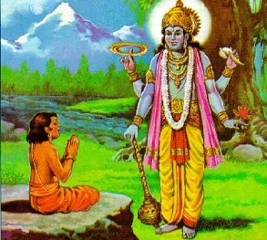The following story illustrates how a Bhakta was not granted Moksha despite getting a darshana of Bhagavān, because his spiritual pursuits were motivated by his anger towards his own father. Had the boy practiced Bhakti out of love for Bhagavān, the result would have been different.

**Story: Dhurva rejects the Kingdom for a Place at the feet of Lord Vishnu, but is sent to the Sky**

Thousands of years ago, there ruled a king named Uttaanpaada. He had two queens, Suruchi and Suniti. Suruchi was his favorite queen. Suniti had a son named Dhruva.

One day, Dhruva came running to his father, and sat on his lap. Suruchi, his step mother, scolded Dhruva and said – “You have no right to sit on your father’s lap. Only my own son can sit on his lap.”

Dhruva became very upset and asked his mother – “Mom, how can I become my Dad’s favorite. How can I become more powerful than my Dad? How can I become the king of his country?” But his mother asked him not to be upset with his father. Instead, he should only worship Bhagavān Vishnu, who is God and therefore more powerful and rich than anyone else.

Dhruva left the palace and went to a forest to worship Bhagavān Vishnu. Sage Narada appeared before him and tried to convince Dhruva not to leave his home to worship Vishnu. But Dhruva did not agree. Then Narada told Dhruva that he should chant the prayer “*Om Namo Bhagavate Vaasudevaaya*” constantly if he wanted to please Bhagavān Vishnu.

Dhruva meditated and prayed to Vishnu chanting that prayer for six months. After some time, he stopped eating food. His prayer was so powerful that when he gave up food, all creatures on the earth became hungry. Then, he gave up water, and all creatures became thirsty. And at last, Dhruva even stopped breathing in air. All creatures then started feeling suffocated.

Pleased with the prayers of Dhruva, Bhagavān Vishnu descended from Heaven and appeared before Dhruva. He said – “My child, ask me what you want. And I will give it to you.” Then, Dhruva replied – “Dear God, I had come to ask you for a lot of power and money so that I become more powerful and richer king than my father. But now I do not want all that. I have seen how beautiful you are. And I feel very happy now. I do not want anything more. Just give me one thing – I want that I should never forget my Bhagavān Vishnu, and always dwell at Your feet.”

Bhagavān Vishnu was very pleased with Dhruva. He said – “Dhruva, go back to your father’s palace. He is waiting for you and he will make you the king. And after you have been the king for a very long time, I will make you the Pole Star in the sky. Just like you did not move for six months while worshipping me, the Pole Star never leaves its position in the sky.[38] However, you had worshipped me because you were angry with your father. Therefore, I cannot grant you Moksha.”

### 13. CONCLUSION: LIVING A BALANCED AND A PURPOSEFUL LIFE

Everyone has daily mundane needs of food, clothing and shelter (Artha), and other desires such as sensual pleasures (Kāma). Hindu Dharma teaches us that it is OK to pursue material wealth (artha) and physical pleasures (kāma) but this should not be the sole focus of our life. Human birth is very rare and valuable and we must not waste our life by constantly running after material goods and physical pleasures alone. We must regulate our pursuit of wealth and physical happiness with the help of Dharma.

Dharma means that we should try to cultivate virtues such as truth, honesty, ahimsa, compassion, contentment, self-control, purity, charity, simple living etc., and avoid evils such as jealousy, violence, hatred, anger, greed, lust, arrogance, pride and lies. Dharma also means that we should never neglect our duties towards our parents, the society, towards our friends, towards our nation and towards the entire world. We should give greater importance to cheerful performance of our duties than to pursuing material and physical pleasures.

However, even if these needs and desires get fulfilled by following Dharma, there comes a moment when we feel a vacuum inside us, a sense of hollowness and despair. Even beyond pursuit of physical pleasures, material possessions and Dharma, we have a final supreme goal that we must strive to achieve. This goal is Moksha, or spiritual liberation that leads to a permanent union with God.

Each of these four goals or desires has an important role to play in our lives. As a practitioner of Yoga remarks:

“According to the Vedic tradition, the four desires are inherent aspects of your soul or essence; your soul uses them for the purpose of fulfilling its unique potential. Learning to honor the four desires allows you to thrive at every level and leads you to a complete and balanced life. It’s important to understand that while these four desires are always present, at various times in your life, as your life’s conditions change. One of the four will predominate. In other words, at any given time one of the four desires will become the most essential for you to fulfill.”[39]

We should strive to align all our activities in our daily lives so that they are in harmony with Dharma and Moksha. Every day, we should make some progress in the paths of Dharma and Moksha. This higher goal is above and beyond things like becoming a rich man, owning a palatial mansion, wearing good clothes, eating in expensive restaurants, listening to the latest rock band albums, becoming famous and so on. Every day, we should take some action to proceed closer to that higher goal even if we get engrossed in our day to day activities. Even if our life gets depressing and intolerable at times, we should still continue to work towards that higher purpose so that at the end of the day, we have a sense of achievement, and a reason to get out of the bed the following day.

This is called living life with a higher purpose, and it can manifest in many different ways – fundraising for cancer research, teaching scriptures and meditation to others, not hankering after the latest electronic gadgets just because your neighbor has them and so on. In other words, our goal should be ‘Simple Living, and High Thinking.’

We should try to shape our lives gradually in such a way that our lower goals (everyday mundane activities and desires), do not obstruct these higher goals. When we live a life in which all our mundane needs and desires are aligned in harmony with our higher goals, we attain an inner peace and sense of fullness that cannot be had even if all the wealth of the world were laid at our feet. When we lead such a purposeful life, we truly justify our human birth. We tend to live longer, healthier, happier, more contended and our life appears more meaningful.

# Appendix I: MODERN PSYCHOLOGICAL THEORIES ABOUT HEIRARCHY OF HUMAN NEEDS

Source: <http://en.wikipedia.org/wiki/Maslow's_hierarchy_of_needs>

**Maslow's hierarchy of needs** is a theory in [psychology](http://en.wikipedia.org/wiki/Psychology), proposed by [Abraham Maslow](http://en.wikipedia.org/wiki/Abraham_Maslow) in his 1943 paper *A Theory of Human Motivation*,[[1]](http://en.wikipedia.org/wiki/Maslow's_hierarchy_of_needs#cite_note-multiple-0) which he subsequently extended to include his observations of humans' innate curiosity.

Maslow studied, what he called, exemplary people such as [Albert Einstein](http://en.wikipedia.org/wiki/Albert_Einstein), [Jane Addams](http://en.wikipedia.org/wiki/Jane_Addams), [Eleanor Roosevelt](http://en.wikipedia.org/wiki/Eleanor_Roosevelt), and [Frederick Douglass](http://en.wikipedia.org/wiki/Frederick_Douglass) rather than [mentally ill](http://en.wikipedia.org/wiki/Mentally_ill) or [neurotic](http://en.wikipedia.org/wiki/Neurotic) people, writing that "the study of crippled, stunted, immature, and unhealthy specimens can yield only a cripple psychology and a cripple philosophy."[[2]](http://en.wikipedia.org/wiki/Maslow's_hierarchy_of_needs#cite_note-1) Maslow also studied the healthiest one percent of the college student population. In his book, *The Human Nature*, Maslow writes, "By ordinary standards of this kind of laboratory research... this simply was not research at all. My generalizations grew out of my selection of certain kinds of people. Obviously, other judges are needed."[[3]](http://en.wikipedia.org/wiki/Maslow's_hierarchy_of_needs#cite_note-2)

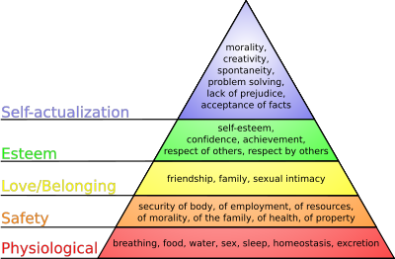

**Representations**

This diagram shows Maslow's hierarchy of needs, represented as a pyramid with the more primitive needs at the bottom.[[4]](http://en.wikipedia.org/wiki/Maslow's_hierarchy_of_needs#cite_note-3)

Maslow's hierarchy of needs is often depicted as a pyramid consisting of five levels: the four lower levels are grouped together as being associated with Physiological needs, while the top level is termed growth needs associated with psychological needs. Deficiency needs must be met first. Once these are met, seeking to satisfy growth needs drives personal growth. The higher needs in this hierarchy only come into focus when the lower needs in the pyramid are satisfied. Once an individual has moved upwards to the next level, needs in the lower level will no longer be prioritized. If a lower set of needs is no longer being met, the individual will temporarily re-prioritize those needs by focusing attention on the unfulfilled needs, but will not permanently regress to the lower level. For instance, a businessman at the esteem level who is diagnosed with cancer will spend a great deal of time concentrating on his health (physiological needs), but will continue to value his work performance (esteem needs) and will likely return to work during periods of remission.

## Deficiency needs

The first four layers of the pyramid are what Maslow called "deficiency needs" or "D-needs": if they are not met, the body gives no indication of it physically, but the individual feels anxious and tense. The deficiency needs are: survival needs, safety and security, love and belonging, and esteem.

#### Physiological needs

These are the basic human needs for such things as sex, warmth, water, and other bodily needs. If a person is hungry or thirsty or their body is chemically unbalanced, all of their energies turn toward remedying these deficiencies and other needs remain inactive. Maslow explains that "Anyone who attempts to make an emergency picture into a typical one and who will measure all of man's goals and desires by his[her] behavior during extreme physiological deprivation, is certainly blind to many things. It is quite true that man lives by bread alone — when there is no bread".[[1]](http://en.wikipedia.org/wiki/Maslow's_hierarchy_of_needs#cite_note-multiple-0)

The physiological needs of the [organism](http://en.wikipedia.org/wiki/Organism) (those enabling [homeostasis](http://en.wikipedia.org/wiki/Homeostasis)) take first precedence. These consist mainly of (in order of importance):

* Breathing
* Drinking
* Eating
* Excretion
* Sleep
* Sex

If some needs are not fulfilled, a person's physiological needs take the highest priority. Physiological needs can control thoughts and behaviors and can cause people to feel sickness, pain, and discomfort.

#### Safety needs

With their physical needs relatively satisfied, the individual's safety needs take over and dominate their behavior. These needs have to do with people's yearning for a predictable, orderly world in which injustice and inconsistency are under control, the familiar frequent and the unfamiliar rare. In the world of work, these safety needs manifest themselves in such things as a preference for job security, grievance procedures for protecting the individual from unilateral authority, savings accounts, insurance policies, and the like.

For the most part, physiological and safety needs are reasonably well satisfied in the "First World". The obvious exceptions, of course, are people outside the mainstream — the poor and the disadvantaged. If frustration has not led to apathy and weakness, such people still struggle to satisfy the basic physiological and safety needs. They are primarily concerned with survival: obtaining adequate food, clothing, shelter, and seeking justice from the dominant societal groups.

Safety and Security needs include:

* Personal security from [crime](http://en.wikipedia.org/wiki/Crime)
* Financial security
* Health and well-being
* Safety net against accidents/illness and the adverse impacts

#### Social needs (love, belonging)

After physiological and safety needs are fulfilled, the third layer of human needs is social. This psychological aspect of Maslow's hierarchy involves emotionally-based relationships in general, such as:

* [friendship](http://en.wikipedia.org/wiki/Friendship)
* [intimacy](http://en.wikipedia.org/wiki/Intimacy)
* having a supportive and communicative [family](http://en.wikipedia.org/wiki/Family)

Humans need to feel a sense of belonging and acceptance, whether it comes from a large social group, such as clubs, office culture, [religious groups](http://en.wikipedia.org/wiki/Religion), professional organizations, sports teams, [gangs](http://en.wikipedia.org/wiki/Gangs) ("[Safety in numbers](http://en.wikipedia.org/wiki/Safety_in_numbers)"), or small social connections (family members, intimate partners, mentors, close colleagues, confidants). They need to love and be loved (sexually and non-sexually) by others. In the absence of these elements, many people become susceptible to [loneliness](http://en.wikipedia.org/wiki/Loneliness), [social anxiety](http://en.wikipedia.org/wiki/Social_anxiety), and [Clinical depression](http://en.wikipedia.org/wiki/Clinical_depression). This need for belonging can often overcome the physiological and security needs, depending on the strength of the peer pressure; an anorexic, for example, ignores the need to eat and the security of health for a feeling of control and belonging.

#### Esteem needs

All humans have a need to be respected, to have self-esteem, self-respect, and to respect others. People need to engage themselves to gain recognition and have an activity or activities that give the person a sense of contribution, to feel accepted and self-valued, be it in a profession or hobby. Imbalances at this level can result in low self-esteem or inferiority complexes. People with low self-esteem need respect from others. They may seek fame or glory, which again depends on others. It may be noted, however, that many people with low self-esteem will not be able to improve their view of themselves simply by receiving fame, respect, and glory externally, but must first accept themselves internally. Psychological imbalances such as depression can also prevent one from obtaining self-esteem on both levels.

## Growth needs

Though the deficiency needs may be seen as "basic", and can be met and neutralized (i.e. they stop being motivators in one's life), self-actualization and transcendence are "being" or "growth" needs (also termed "B-needs"); i.e. they are enduring motivations or drivers of behavior.

## Aesthetic needs

Based on Maslow's beliefs, it is stated in the hierarchy humans need beautiful imagery or something new and aesthetically pleasing to continue towards Self-Actualization. Humans need to refresh themselves in the presence and beauty of nature while carefully absorbing and observing their surroundings to extract the beauty the world has to offer.

## Criticisms

While Maslow's theory was regarded as an improvement over previous theories of [personality](http://en.wikipedia.org/wiki/Personality_psychology) and [motivation](http://en.wikipedia.org/wiki/Motivation), it had its detractors. For example, in their extensive review of research which is dependent on Maslow's theory, Wahba and Bridgewell[[5]](http://en.wikipedia.org/wiki/Maslow's_hierarchy_of_needs#cite_note-4) found little evidence for the ranking of needs Maslow described, or even for the existence of a definite hierarchy at all. Conducted in 2002, a recent study forwards this line of thought, claiming that "the hierarchy of needs is nothing more than a fool's daydream; there is no possible way to classify ever-changing needs as society changes"[[6]](http://en.wikipedia.org/wiki/Maslow's_hierarchy_of_needs#cite_note-5).[[*unreliable source?*](http://en.wikipedia.org/wiki/Wikipedia:RS)]Chilean economist and philosopher [Manfred Max Neef](http://en.wikipedia.org/wiki/Manfred_Max_Neef) has also argued [fundamental human needs](http://en.wikipedia.org/wiki/Fundamental_human_needs) are non-hierarchical, and are [ontologically](http://en.wikipedia.org/wiki/Ontology) universal and invariant in nature - part of the condition of being human; [poverty](http://en.wikipedia.org/wiki/Poverty), he argues, is the result of any one of these needs being frustrated, denied or unfulfilled.

## References

1. ^ [***a***](http://en.wikipedia.org/wiki/Maslow's_hierarchy_of_needs#cite_ref-multiple_0-0) [***b***](http://en.wikipedia.org/wiki/Maslow's_hierarchy_of_needs#cite_ref-multiple_0-1) A.H. Maslow, [*A Theory of Human Motivation*](http://psychclassics.yorku.ca/Maslow/motivation.htm), Psychological Review 50 (1943):370-96.
2. [**^**](http://en.wikipedia.org/wiki/Maslow's_hierarchy_of_needs#cite_ref-1) Maslow, Abraham (1954). *Motivation and Personality*. New York:. Harper. p. 236.
3. [**^**](http://en.wikipedia.org/wiki/Maslow's_hierarchy_of_needs#cite_ref-2) Maslow, A.H. (1971). The farther reaches of human nature. New York: Penguin Compass. Chpt 3, "Self-actualizing and beyond", p. 41.
4. [**^**](http://en.wikipedia.org/wiki/Maslow's_hierarchy_of_needs#cite_ref-3) [Maslow's Hierarchy of Needs](http://honolulu.hawaii.edu/intranet/committees/FacDevCom/guidebk/teachtip/maslow.htm)
5. [**^**](http://en.wikipedia.org/wiki/Maslow's_hierarchy_of_needs#cite_ref-4) Wahba, A; Bridgewell, L (1976). "Maslow reconsidered: A review of research on the need hierarchy theory". *Organizational Behavior and Human Performance* (15): 212–240.
6. [**^**](http://en.wikipedia.org/wiki/Maslow's_hierarchy_of_needs#cite_ref-5) Lim, Cwisfa; Khruschev, Vesh (2002). "Maslow's Pyramid - a necessity?" (12): 15-17.

**DISCUSSION:** Evaluate Maslow’s theory with the help of the Hindu doctrine of Purushārthas.

**Appendix II: The Framework of Purushārthas (A Summary)**

|  |  |  |  |  |
| --- | --- | --- | --- | --- |
| **Purushārthas=** | **Dharma** | **Artha** | **Kāma** | **Moksha** |
| ***Order*** | 1 | 2 (or 3) | 3 (or 2) | 4 |
| ***Meaning*** | Duty | Wealth | Pleasure | Spirituality |
| ***Description*** | Piety, virtue, discharging one’s duties, righteous living | Pursuit of material possessions, acquiring wealth | Pursuit of physical pleasures, gratification of our senses | Attainment of spiritual liberation |
| ***Categorization 1*** | trivarga (Triad) | | | apavarga |
| ***Categorization 2*** | bhoga | | |
| ***Goal*** | abhyudaya (material good) | | | nihshreyasa (greatest good, beyond which there is no greater good) |
| ***Related Scriptures or books that teach about this Purushārthas*** | Vedas, Smritis, Gita, Puranas, Mahabharata, Ramayana, Agamas etc. | Arthashastra, 64 arts or skills (kalaa) | Gaandharva Veda (Music), Dhanurveda (Military science), Kalaas (64 arts or skills), Shilpashastra (architecture), Kamashastra (erotics) | Upanishads, Gita, Darshana Shastras (6 schools of philosophy), spiritual portions of Vedas and other scriptures, portions of Agamas |
| ***Relationship of this Purushārthas to joy and sorrow*** | Leads to a finite mixture of joy and sorrow | | | Leads to pure and infinite bliss |
| ***Major means of learning about this Purushārthas*** | Vedic/Scriptural, Supra-sensuous knowledge | laukika (Worldly) | | Vedic/Scriptural, Supra-sensuous knowlede |
| ***Relationship to three gunas*** | Sattva | Rajas | Tamas | Beyond three gunas |
| ***What type of individual personality typically focuses on this Purushārthas?*** | samskrita, praakrita | vikrita, praakrita | vikrita, praakrita | samskrita |
| ***What type of culture focuses on this Purushārthas?*** | Spiritual culture | Materialistic Culture | Materialistic Culture | Spiritual Culture |

**Appendix III**

###### If Hindu Dharma recognizes Artha (or pursuit of material possessions) as one of the legitimate pursuits for humans, then why is poverty so rampant in India?

**Ans:** Hinduism has a history stretching over the last five thousand years and the question assumes that Hindu society has always been marked by extreme poverty. In reality, widespread poverty in the Indian subcontinent that has been profoundly influenced by Hindu thought and culture, is a relatively recent phenomenon. For a greater part of history, Hindu societies have been amongst the most prosperous in the entire world. Travelers from China, Greece and the Middle East visiting India in ancient and medieval times marveled at the overall prosperity of Hindus compared to their own societies back home.

Indian traders dominated large segments of oceanic and overland trade east of the Mediterranean. This is the reason why the Indian Ocean was so named. In fact, India is the only country after which an ocean is named! It was precisely the fabled prosperity of Hindus that attracted numerous invaders from west of the Indian subcontinent in search of loot and a better life than their own homelands could give to them.

As late as the 1700’s, Indian economy was the second largest in the whole world. This is quite clear from the chart below:



***Table 1: Proportion of American, Chinese, Indian and UK’s Economy in Global Economy from 0-1950 AD[40]***

Many of these invasions had a devastating effect on the economy, culture and civilization of Hindus. Some invaders, such as Nadir Shah (who invaded from Iran in 1738 CE) and Muhammad Ghori (who invaded and looted parts of India more than 15 times in the 12th cent. C.E.) and carried vast amounts of wealth to their native homelands in Central Asia and the Middle East. Many Muslim rulers treated Hindus as lowly infidels and were very hard upon them. Hindu traders often had to pay more taxes than Muslims, and Hindus often also paid a crippling tax called the Jaziya to prevent from being molested further by the rulers. Numerous Hindu institutions, religious and otherwise, were destroyed. Moreover, these rulers did not always have a modern outlook. They also ignored the importance of oceanic trade, leaving the doors wide open to Europeans who soon came to dominate oceanic trade.

Coming initially as traders, European powers, notably the British, soon came to dominate Indian politically as well. India became a ‘colony’ that primarily supplied cheap raw materials to fuel the Industrial revolution in the west. The economic policies of the British rulers crippled the Indian economy and further impoverished the Indian masses. And Indian Nationalist Dadabhai Naoroji explained this as drain of Indian capital to England. In today’s worth, the amount of wealth transferred from India to UK due to economic exploitation would translate to trillions of dollars!

Another effect of alien domination on the Hindu society was that it made the caste system more rigid, and almost fossilized. This made it extremely difficult for several Hindu communities to change their hereditary occupations and for individuals to exercise their full potential in contributing to the betterment of the society as a whole. In our own times, the caste barriers are evaporating rapidly, and members of hitherto underprivileged and oppressed social classes are making a lot of progress, in turn contributing immensely to the Indian society as a whole.

With the attainment of independence from foreign rule however, Indian society, which is predominantly Hindu, is fast emerging as a global industrial and economic powerhouse. India already boasts one of the largest middle classes in the world, and despite the mixed legacy of its government’s socialist policies and mismanagement, its economy is booming by leaps and bounds. It is a matter of time before India will once again be one of the largest economies of the world, and mass poverty will become a thing of the past. It is said that the 19th century belonged economically to Europe, the 20th to the United States and the 21st century will belong to Asia again.

On the other hand, when we look historically at the economic situation of societies in the Middle East and the West, we find that their current prosperity is in sharp contrast to their relatively impoverished status in much of the ancient and medieval periods. For example, much of the Arab world lived in abject poverty till the discovery of vast oil deposits in the last few decades. This example further shows how it is false to equate religious beliefs of Hindus to their poverty.

Another fact that should cause us to reject the supposed connection between Hinduism and Indian poverty is that the golden age of Hinduism (under the Gupta Empire) also coincided with the greatest prosperity and flowering of art and science seen in India. In contrast, the golden age of Christianity in Europe coincided with the Dark Ages in Europe. Europeans became prosperous and scientifically advanced only when they overthrew the yoke of oppression of the Church in their own countries.

Before castigating Hindu beliefs as the cause of poverty in India, one should also consider the fact that the current wasteful and extravagant lifestyle of several western countries is not just unsustainable, it is also contrary to the tenets of Dharma which asks us to respect Mother Nature and live in harmony with her, instead of trying to abuse, dominate and suppress her.

**Appendix IV: Interfaith Perspectives on the Purushārtha Doctrine**

Buddhism: Within the Buddhist tradition, there is an excessive emphasis on Nirvana (as the Buddhists prefer to call Moksha) and therefore an exaltation of the monastic life. Of course, most Buddhists are householders and it is considered a great Dharmic act for them to make donations to Buddhist monasteries. Unfortunately, that has historically led to accumulation of great wealth in these Buddhist institutions. The opulent lifestyle of some Buddhist monks has invited criticism from opponents of Buddhism, and this is said to have been one of the factors that lead to the decline of this faith in the Indian subcontinent. In general however, the systematic Hindu articulation of the Purushārtha doctrine is not present in Buddhism.

Jainism: Jains share the overall doctrine of the four Purushārthas with the larger Hindu community of which they are a part. However, due to their great emphasis on Ahimsā (not harming other creatures), many professions that involve injury to other living beings, such as farming, and military services, are discouraged or even disallowed. Consequently, Jains have taken in large numbers to other pursuits of Artha, like trade and commerce, in very large numbers. In many parts of India, Jains have opened charitable hospitals for treating animals, as a part of their Dharmic beliefs. For Jains, Moksha does not mean reaching the Divine, because Jainism is an atheistic tradition.

Sikhism: The Sikh religion de-emphasizes the monastic and ascetic traditions that are prevalent in the other Dharmic traditions. Their Gurus believed that Moksha can be achieved only through a pursuit of Dharma and Moksha while being involved in the matters of the world through a householder’s life. Sikh Sadhus exist of course, but they do not have as important a role as in Hindu Dharma. In fact, several types of Sikh Sadhus (e.g. Udāsīs) actually consider themselves as Hindu-Sikhs.

Abrahamic Religions: Within the Abrahamic traditions, the Hindu doctrine of the four Purushārthas has no good parallel. In the New Testament, Artha and Kāma are uniformly treated as evil, but that is not how most Christians live. In medieval ages, some Christians did not even bathe regularly because exposing the body to even oneself was regarded as a sin! And Christian monks who taught poverty to others themselves lived in great style. Even today, the Vatican is known to have assets of several billion dollars (if not trillions). In Islam, simplicity of lifestyle is considered a virtue but acquisition of wealth (Artha) by taxing non-Muslims or in religious wars is considered acceptable. By modern standards and the beliefs of Hindu Dharma however, this is immoral. Secondly, Islam does not seek to keep Kāma in control and for that reason, monasticism and asceticism is strongly discouraged. Their Prophet Muhammad is reported to have said that the best person in his community is one who has the maximum number of children. This is incompatible with the modern situation of overpopulation on our planet. The higher population growth among Muslim communities is a world-wide phenomenon and is resented by many non-Muslims.

**In summary**, it is only Hindu Dharma which gives a very balanced view of life by allowing all the four pursuits in human life. And not only that, Hindu Dharma also puts them in their correct perspective and relative hierarchy.

**Bibliography:**

In addition to the Hindu Scriptures (Mahabharata, Shatakatraya of Bhartihari, Manusmriti etc.) in original or translation, the following secondary works were considered-

Acharya, Shriram Sharma. 2010. *Prajna-Purana* (4 vols). Yug Nirman Yojana Vistaar Trust: Mathura

Aiyar, R. Krishnaswami. 1965. *The Eternal Law, a Brief Outline of the Basic Principles of Sanatana Dharma.* Ganesh & Co. (Madras) Private Ltd.: Madras

Amore, Roy C and Larry D Shinn. 1981. *Lustful Maidens and Ascetic Kings*. Oxford University Press: New York

Chakrabarti, Samiran Chandra. 2000. *The Concept of Purusārthas*. Maharshi Sandipani Rashtriya Ved Vidya Pratishthan: Ujjain

Danielou, Alain. 1993. *Virtue, Success, Pleasure and Liberation – The Four Aims of Life in the Tradition of India*. Inner Traditions International. Rochester (Vermont, USA)

Kane, P. V. 1997. *History of Dharmasastra* (Vol. II, Part 1). Bhandarkar Oriental Research Institute: Pune

Krishnamani, M N. 1998. *Godly Men and their Golden Words*. Rashtriya Sanskrit Sansthan: New Delhi

Maddison, Angus. 2001. *The World Economy – A Millennial Perspective*. Development Centre of the Organisation for Economic Co-operation and Development: Paris (p. 127)

Mehta, J. M. 2006. *Four Objectives of Human Life*. Pustak Mahal: Delhi

Pandit, Bansi. 2004. *The Hindu Mind.* New Age Books: New Delhi

Prasad, Rajendra. 2008. A *Conceptual-Analytic Study of Classical Indian Philosophy of Morals*. Center for Studies in Civilizations (Concept Publishing Company): New Delhi

Rambachan, Anantanand. 1992. *The Hindu Vision*. Motilal Banarsidass: Delhi

Sharma, Arvind. *Hinduism***:** from: <http://encarta.msn.com/encyclopedia_761555715/Hinduism.html>

______. 1990. *Classical Hindu Thought*. Oxford University Press:: Delhi

Shome, Alo. 2015. *Bankim Chandra Chattopadhyaya, Many Threads of Hinduism*. Harper Element: Noida (India)

Smith, Huston. 1991. *The World’s Religions*. Harper: San Francisco, Chapter 2 (on Hinduism)

Sri Chandrasekharendra Saraswati Swamigal, Fitzgerald, Michael Oren (ed.). 2008. *Introduction to Hindu Dharma*. World Wisdom: Bloomington (Indiana, USA)

Stryker, Rod. 2011. *The Four Desires*. Delacorte Press: New York

Swami Akhandanand Saraswati. 1970. *Karmayoga*. Satsahitya Prakashan Trust. Bombay (India)

Swami Chinmayananda, “The Two Paths,” pages 26-28 in *Values in the Workplace*. 2008. Chinmaya Mission West. Piercy (California)

Swami Chinmayananda and Swamini Sharada Priyananda. 1990. *Chinmaya Vidyalaya, Tarangini Seven*. Central Chinmaya Mission Trust (Mumbai).

Swami Mukhyananda. 2000. *Hinduism the Eternal Dharma*. Center for Reshaping our Worldview: Calcutta

Swami Rama. 1977. *Freedom from Bondage of Karma*. Himalayan International Institute of Yoga Science & Philosophy of USA. Honesdale, PA (USA).

Swami Sivananda. 1993. *All About Hinduism*. The Divine Life Society. Tehri-Garhwal (Uttarakhand), India

Swami Sivananda. 2004. *Parables of Swami Sivananda*. The Divine Life Society. Tehri-Garhwal (Uttaranchal), India

____. 2000. *Stories from the Mahabharata.* The Divine Life Society: Shivanandanagar (Dist Tehri Garhwal, Uttarakhand).

Swami Tejomayananda. 2009. *“Life is a Gift, Living is an Art”* Chinmaya Mission West (Piercy, California)

_______. 1994. *Hindu Culture*. Central Chinmaya Mission Trust: Mumbai

Swami Vivekananda. The Complete Works of Swami Vivekananda. Available online in 9 volumes at <http://www.ramakrishnavivekananda.info/vivekananda/complete_works.htm> <last accessed on 1st January 2014>

Tripathi, Premvallabh. *Purushārtha-Chatushtaya*. Anandakaanana Press: Varanasi (in Hindi and Sanskrit)

**Class Exercise 1 – Ask yourself the following questions-**

What things do I want in my life? What are the goals of my life? What do I want to achieve in live? What should be the purpose of our lives?

|  |  |  |  |
| --- | --- | --- | --- |
| 1.___Dharma_______ | 2. ______Artha_____ | 3. ___Kama_________ | 4.____Moksha_________ |
| People should remember me for my good deeds | Good education x2 | World Tour X2 | Eternal peace |
| Help Others x2 | Good job (doctor) x 13 | Happiness, Fun job | Reaching God |
| Family- spread education | Start business | Athlete | Total freedom |
| Simple life | Good house/neighbor | Actor X 2 |  |
| Help blind see | Nice life X 3 | Music |  |
| Cure cancer | Money X 5 | Have an airplane |  |
| Empathy | Software development business | Video Game designer |  |
| Equality | Food | Singer |  |
| World peace | Clothing | Pet x 5 |  |
| Feed my starving children camp | Study abroad | Nice Car |  |
| Rebuild demolished temples | Take over the world | Nice clothes |  |
| Make parents happy and proud |  | Become famous X 3 |  |
|  |  | Iphone |  |
| TOTAL ITEMS = 13 | TOTAL ITEMS = 30 | TOTAL ITEMS = 22 | TOTAL ITEMS = 3 |

**Observations:**

1. An overwhelming majority of our desires fall within Artha and Kāma. Few in Dharma and hardly any in Moksha 🡪 Most people are not interested in Moksha, and some have an interest in Dharma.
2. All the wants of animals will fall within Artha and Kāma 🡪 We should try to be better than animals by aspiring for Dharma and Moksha.
3. A little kid will not think much of Dharma or Moksha.
4. A poor man will not think much of Dharma and Moksha 🡪 It is important to fulfill Artha and Kāma in life too.
5. It is possible to get Kāma and Artha by disobeying Dharma 🡪 Use Dharma to control Artha and Kāma.

**Note to the teacher:** While doing this exercise in the class, do not label the columns and ask students to list their desires randomly and without much thought. Every student must participate.

**Class Exercise 2 – Classify the following as Dharma, Artha, Kāma or Moksha or as Adharma**

* Perfumes
* brand clothing
* eating Gulab Jamun
* sharing one’s food with the hungry
* donating money to earn fame
* killing a terrorist; taking a world trip
* respecting parents
* petting one’s dog
* volunteering in social activities
* earning money
* buying a second home
* upgrading one’s car to a Rolls Royce
* practicing Yoga Āsana for good health
* practicing meditation to be closer to Bhagavān
* doing one’s duties as a citizen
* taking an umbrella while going out in the rain
* using air-conditioner
* paying our taxes
* doing a favor upon someone with the intent of getting a counter-favor later
* giving money to someone to humiliate him
* robbing a bank
* looting rich to help the poor
* killing a cockroach
* eating healthy food

**CLASS EXERCISE 3: LIVING WITH A HIGHER PURPOSE IN MIND (PRAVRITTI vs. NIVRITTI)**

## Give examples of how you can perform the acts listed in column 1 so as to result in the 4 different Purusharthas

## (or in Adharma = Purusha-Anartha). A POSSIBLE SOLUTION IS GIVEN FOR ‘CHARITY’ as an ILLUSTRATION.

|  |  |  |  |  |  |  |
| --- | --- | --- | --- | --- | --- | --- |
| 1 | 2 | 3 | 4 | 5 | 6 | |
| ACT PERFORMED | CONFORMS TO | | | | | |
| **DHARMA** | **ARTHA** | **KAMA** | **MOKSHA** | | **ADHARMA** |
| CHARITY | Give charity to fulfill someone’s genuine need; give charity to reduce one’s own bad karma; give charity to get a reward from God. | Give charity with the intent to get something back in return from the beneficiary. | Give charity to derive mental happiness, or to get rid of a guilty conscience (‘I should have helped him but I did not’). | Give charity to a needy person with faith and respect and, as an offering to God, and with no expectation of reward from the beneficiary, from the society or from God. | | Give a harmful or a useless item in charity, or insult the person while giving charity etc. |
| EDUCATE OTHERS |  |  |  |  | |  |
| WORK TO EARN A SALARY |  |  |  |  | |  |
| READ A BOOK |  |  |  |  | |  |
| PRAY TO GOD |  |  |  |  | |  |
| FIGHT A WAR |  |  |  |  | |  |

1. Aiyer, p. 3; Tripathi, p. 370
2. Danielou (1993)
3. Prasad, p. 226
4. Rambachan, p. 17
5. Danielou, p. 100
6. Danielou, p. 101
7. Danielou, p. 102
8. Mehta, p. 39
9. Danielou, pp. 109-110
10. Hindu Culture. *Grade 9 Bala Vihar Teachers’ Handbook*. 2011. Chinmaya Mission West. Piercy (California), Lesson 30
11. Swami Akhanandand Saraswati (1970), p. 281
12. *asthi charmamaya deha mum, taamey aisi preeti* | *taisi hon sri raam mein, hotii na tava bhava bheeti* ||
13. “The concept of Dharma has a varied and comprehensive connotation. The word s derived from the root ‘Dhri’ – to uphold – and stands for the Supreme Principle which upholds and sustains the whole universe and the activities of all beings in it. It also means: (1) the essential property of an entity which makes it what it is; (2) the chief innate characteristic of an entity or being; (3) Virtue, religious conduct; (4) the principles which hold a society together (*Dharmo dhārayate prajāh*); (5) Law, justice, ethics and morals; (6) the duties pertaining to persons, individually and collectively, in the different social conditions, status, and stages of life; etc. So the word ‘*Dharma*’ is used in different cognate senses at different levels and in different contexts. Only in a secondary sense it is used to represent God-centered religion as understood in the West.” (Swami Mukhyananda, p. 61)

    According to Bankim Chandra Chattopadhyaya, a 19th century scholar of Hindu Dharma, the word Dharma has the following six meanings in practical usage (Shome, pp. 48-49):

    1. Religion, as in Hindu Dharma, Christian Dharma.
    2. Morality or practical application of morality. E.g., ‘what this noble politician is doing is Dharma.’
    3. Virtue, goodness, piety
    4. Opposite of sin (papa), i.e., puṇya
    5. Intrinsic nature or property of an entity. E.g., the Dharma of fire is to burn.
    6. Convention or social norm, e.g. the ‘Dharma of the Agarwal community.’

   
14. Mehta, p. 16
15. Bansi Pandit, p. 280
16. Sri Chandrasekharendra Saraswati Swamigal (2008), p. 1
17. Sri Chandrasekharendra Saraswati Swamigal (2008), p. 6
18. Rambachan, pp. 17-18
19. Sri Chandrasekharendra Saraswati Swamigal (2008), p. 1
20. Swami Sivananda (1993), p. 8
21. Swami Vivekananda, *Complete Works of Swami Vivekananda*, vol. 1, p. 408
22. See Gita 9.20-21
23. See Gita 8.15-16
24. Rambachan, Anantanand. 1992. *The Hindu Vision*. Motilal Banarsidass: Delhi; pp. 22-23
25. Rambachan, Anantanand. 1992. *The Hindu Vision*. Motilal Banarsidass: Delhi; pp. 24-25
26. Stryker, pp. xiv-xv
27. Narrated in the Vyāsabhāshya on Patanjali’s Yogasutras.
28. This section is extracted from chapters 1-2 of ***Hindu Culture*** (1994), by Swami Tejomayananda, Chinmaya Mission Central Trust (Mumbai). Sentences quoted verbatim or with slight modifications have not been placed within quotation marks.
29. There are life forms higher than humans such as Devatas, Vidyaadharas but they are typically not visible to us and therefore are being ignored in this discussion.
30. This example is given by Swami Ramakrishna Paramahamsa.
31. Swami Sivananda, p. 28
32. Parable of Swami Atmashraddhananda, “Life is Precious,” in *“Life is a Gift, Living is an Art”* Chinmaya Mission West (Piercy, California), 2009
33. Quoted from Swami Sivananda (2000), pp. 23-24 & Amore et al. pp. 166-168, with slight abridgement and changes.
34. Swami Chinmayananda and Swamini Sharada Priyananda, pp. 3-5
35. Krishnamani, pp. 674-675
36. Swami Chinmayananda (2008), pp. 26-28
37. Swami Tejomayananda (2009)
38. This is why the Pole Star is called ‘Dhruva’ by Hindus.
39. Stryker, p. xii
40. Derived from statistics given in Maddison, Angus. 2001. T*he World Economy – A Millennial Perspective*. Development Centre of the Organisation for Economic Co-operation and Development: Paris (p. 127)