A 14.070 MHz BPSK31 Portable Amateur Radio Station
With Spring and Summer 2017 on the way the Binary Phase Shift Key 31 (BPSK31) operator may be considering portable operation in the great outdoors. This article describes a 14.070 MHz BPSK31 portable amateur radio station that worked flawlessly for me in 50 National Parks on the Air (NPOTA) activations in 2016. Over 800 QSOs were worked around the CONUS from north central New Mexico. BPSK31 QSOs with Washington, Nevada, Mississippi, Kansas, Texas, Montana, Illinois, California, Missouri, South Dakota, Idaho, Arizona, Iowa, Alabama, Arkansas, Connecticut, Wisconsin, Tennessee, Ohio, North Carolina, Indiana, Virginia, Florida, Louisiana, Maryland, Iowa, Minnesota, New York, Oregon, Pennsylvania, Michigan, Georgia, Kentucky, New Hampshire, Maine, New Jersey, Delaware, North Dakota, Wyoming, West Virginia, South Carolina, Oklahoma, New Mexico, Rhode Island, Utah, Colorado, and Hawaii were conducted on 20 – 25 watts of RF power delivered to the antenna. In addition, many QSOs were also conducted with BPSK31 operators in Canada. This portable station is housed on a pickup truck shown in Figures 1 and 2. The key component that made this BPSK31 portable station successful was the antenna system which a majority of this article describes.
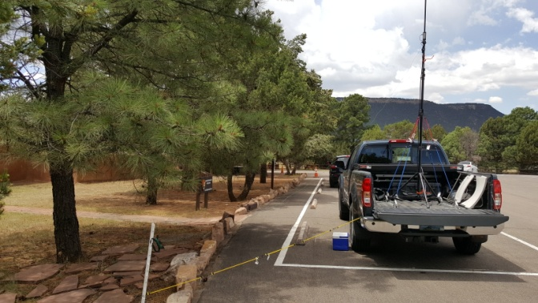
Figure 1 - 14.070 MHz BPSK31 Portable Station

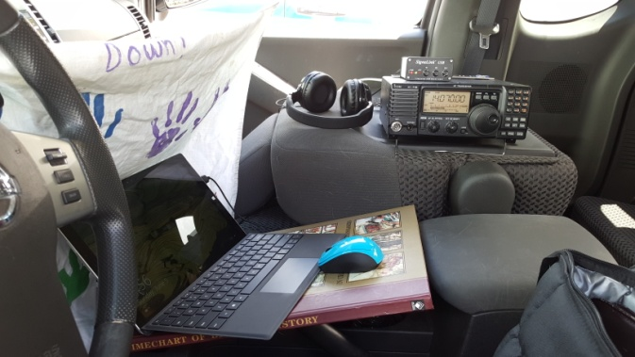
Figure 2 – Inside the cab

What I need to know to put the BPSK31 portable station together
Figure 3 shows a block diagram of the components that make up the portable amateur radio station.
Buddipole Antenna in the raised vertical configuration with 9.5 foot whip
8 pin radio cable
SLCAB13I
ICOM 718
Transceiver
SignaLink USB
Interface
25 foot antenna coax
12 VDC power cable
USB cable with RF chokes
lenovo
Notebook

32Ah Gel Cell Battery

17 foot counterpoise
38 inch plastic fence stake

Figure 3 – BPSK31 Portable Station Components
Description of Block Diagram Components
Buddipole Antenna
The Buddipole Antenna is in the raised vertical ground plane configuration and the tripod stand is set up on the bed of the pickup truck with bungee cords securing the antenna assembly to the truck bed, Figure 4. The radiating elements consist of one 9.5 foot whip with all 6 sections fully extended and one 22 inch antenna arm. The total height of the combined radiating elements is approximately 11 ft 2 in. The antenna feed point (Buddipole Versatee) is approximately 6 feet above pickup truck bed and the truck bed is 30 in above ground. Hence, the feed point height above ground is approximately 8.5 feet. The Blue and Black Loading Coil is tapped on the Black Paint (6 turns in from the whip end), Figure 5. I used a 25 foot, RG-8/U low loss 50 ohm antenna coax cable run through the back window of the pickup truck. Finally, the 17 foot counterpoise, which is part of the antenna system, should be at least 2 feet above the ground. I used the Buddipole Wire Assembly (32 feet of insulated wire) and a Lowe’s 38 inch plastic fence stake as my counterpoise system, Figure 6. Using an antenna analyzer, I tuned the antenna system to 14.070 MHz resonance by adjusting the length of the counterpoise and getting as close as I could to a voltage standing wave ratio (VSWR) of 1.0:1. Tuning the antenna system to a VSWR 1.1:1 in the field was easily achieved. See Figure 7.
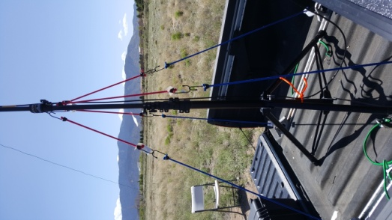
Figure 4 – Antenna tripod is mounted on the pickup truck bed.
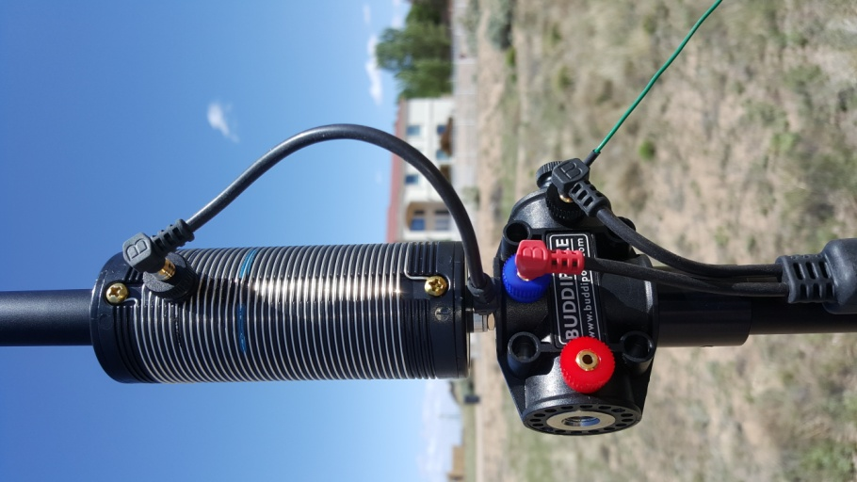
Figure 5 - The Blue and Black Loading Coil is tapped on the Black Paint (6 turns in from the whip end)

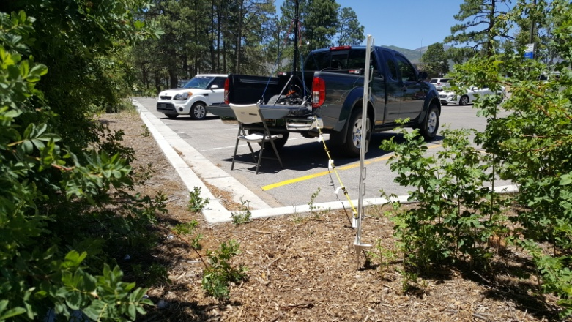
Figure 6 - The counterpoise is supported by a 38 inch plastic fence post with short metal stake on the bottom

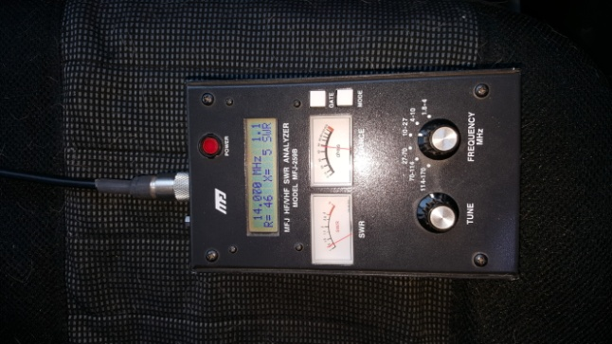

Figure 7 – A near resonant antenna can be achieved at VSWR = 1.1:1

Radio System
I used my ICOM 718 Transceiver for all my activations. The ICOM 718 requires 12 Amps to support a transmit power of 25 watts. The SignaLink Radio 8 pin SLCAB13I cable connects to the ICOM 718 ACC Accessory Port. The SignaLink connects to the PC via USB cable. Because of the close proximity of the PC to the antenna the USB cable should have RF chokes on both ends to prevent the BPSK31 software execution from latching up. See Figure 8.
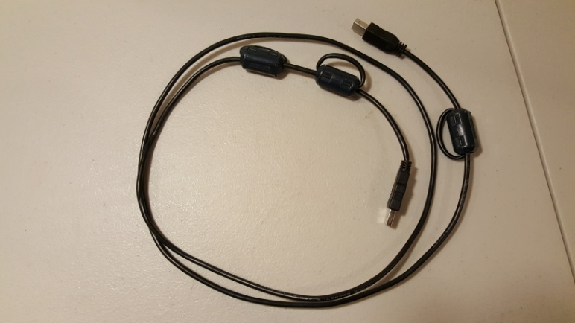
Figure 8 – SignaLink USB Cable with RF Chokes
Personal Computer
The lenovo ThinkPad Notebook PC hosts Digipan Software. It is a military specification (MILSPEC) rugged Notebook that can handle the rigor of frequent portable operations. In the beginning, I used the Microsoft Surface Pro 3 and it fell apart. The PC battery generally holds up for at least 3 hours at full display brightness. If the PC battery does not hold up for a typical 4 hour activation, I plugged in an external MOBILE POWER, Model: MP-32000-B, unit to finish off the day.

Power Supply
The 32 Amp-Hour Gel Cell Battery provides 3 to 4 hours of operation at an average transmit power level of 23 watts and 50% operational duty cycle (during a BPSK31 portable operation I am transmitting half the time and receiving the other half). Since the ICOM 718 draws 12 Amps during transmissions, a 24 Amp-Hour (12A x 4 hr operation time x 0.5 duty cycle) battery is required. The 32 Ah battery more than met my NPOTA day time activation needs. The battery is a Delco Dominator, Part Number 8GU1, East Penn Manufacturing Co., Inc. The battery is toted around and operated in a U1 Battery Buddy DC-to-GO Box with RIGrunner 4005 fuses and Anderson PowerPole connectors. At home, I kept the Gell Cell Battery charged with the Battery MINDer Model 128CEC1 12 volt Battery Maintainer-Desulfator. The ICOM 718 12 VDC power cable has an Anderson Power Pole connector on one end. See Figures 9 and 10.
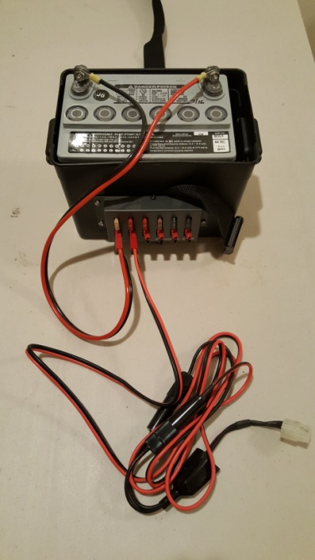
Figure 9 – Portable 32Ah battery for transceiver power

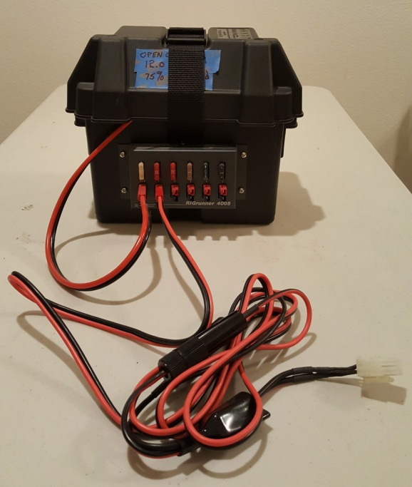
Figure 10 - Portable 32Ah battery in box

Reasons for installing the Buddipole Antenna on pickup truck bed
- Minimized the number of stakes driven into ground to stabilize tripod in wind; only one stake was needed to support the counterpoise. The New Mexico national monuments/historical parks biggest hang-up was stakes driven into the ground and the potential for destroying unexcavated Native American artifacts, like pottery shards.
- Antenna on pickup truck bed functioned as an informal sanctioned area that guaranteed separation of the antenna from national park visitors, and contributed to spectator safety.
- Provided some security from theft. Easily strung bike lock cable through tri-pod and equipment case and locked the tailgate. Although these provisions helped prevent a quick heist, it should be said that I never felt station equipment security was a threat during any of my national park activations.
- The 25 foot RG-8/U, 50 ohm coax, which minimized line loss to the antenna was run through the back window of cab.
- The consolidated system minimized National Park Ranger concerns about proximity of high frequency radiation to visitors.
- I did not have to look for available ground space. The pickup truck based installation accommodated parking lot operation on asphalt and concrete that bordered grassy soil areas for installing the counterpoise fence post.
- The truck bed configuration contributed to minimizing setup time and ensured no ground loss interaction because the counterpoise functioned as an artificial electrical ground. The antenna feed point height 6 feet above truck bed also ensured the counterpoise wire would be more than 2 feet above the ground. The counterpoise strung out from the Versatee ground side connection to a plastic fence pole 17 feet away always provided more than adequate distance above ground. The plastic fence pole was 38 inches above the ground.
Reasons for operation inside truck cab

The electromagnetic interference (EMI) problem that frequently latched-up the PC in early outside-the- cab activations solidified the decision to move all BPSK31 operations inside the cab to obtain some level of Faraday Cage protection. When I nailed down the truck bed hosted raised vertical antenna configuration, trial and error experimentation made it evident that only one counterpoise strung out in a direction away from the cab, e.g., out the back tailgate, maximized the mitigation of EMI effects. Second, by mid April 2016, outside operation with high angle sunlight was inhibited by computer screen washout. The truck cab was needed to minimize display wash out, further aided by using windshield visor and stringing the an apron up to block the sun. It also resulted in reducing display brightness, hence extending the PC battery life. The downside to this operational mode is it may have impeded visitation from park visitors and getting the opportunity to demonstrate ham radio. Even still, I did get occasional visits and took the opportunity to provide a dissertation on why I was there and what I was doing during lunch breaks.

But what if I don’t own a Pickup Truck?
Buddipole operation on the ground will work fine. But I recommend using a 50 foot 50 ohm coax cable to separate your operations from the immediate proximity of the antenna. To prevent EMI induced latch-up of BPSK31 operations, I suggest a separation of at least 30 feet away from the radiating antenna. I experimented with on-the-ground outside-the-cab operations in early 2016 activations but did not pursue that operational mode for the following reasons:
- The 30 feet or more separation away from the antenna made me nervous with park visitors milling around. It also gave the impression that the amount of RF energy coming off the antenna made close proximity of operations unsafe. Of course that was not the case, but when you are representing the National Park Service in celebration of their 100th anniversary perception becomes important.
- By mid April the higher angle position of the sun made operations practically intolerable due to display wash out. One would have to find some shaded cover in a picnic area or bring it with you. My daytime activations were relatively short events (5 to 6 hrs) so I didn’t want to spend time setting up a canopy; especially since my activations were all conducted by me alone and no one else was brought along for canopy raising.
- The Buddipole will have to be staked down or the wind will blow it over. As mentioned above, the biggest pet peeve National Park Rangers had was the number of stacks going into the ground and the size of the stakes. To avoid that issue inside cab operation made everyone happy.

Figure 11 is a picture of an early activation outside the truck cab. Notice the creative idea of using a music stand to hold the tablet PC.

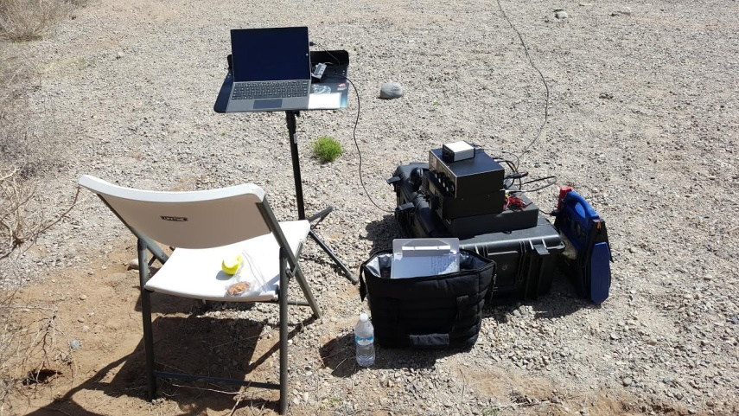
Figure 11 – NPOTA BPSK31 on the ground activation

Station Performance
Typical BPSK31 Signal-to-Noise Ratios (SNRs) Reported by NPOTA Chasers were in the range of 12 dB to 33 dB. A minimum 12 dB SNR is needed to produce a perfect text message print out on your display regardless of BPSK31 software application used. Reference How does BPSK31 stack up against CW in a Noisy Channel, BPSK31.com/articles/BPSK31-vs-cw/.
Station Setup Sequence
The sequence of steps I used to activate my portable BPSK31 HF amateur radio station are listed below.
- Upon arrival, coordinate station location on national park unit with park ranger
- Setup the ICOM 718 first on the passenger seat
- Erect the Buddipole Antenna and coax cable connection
- Connect the 17 foot counterpoise
- Tune the antenna to resonance with antenna analyzer by adjusting the length of the counterpoise until I got at least a 1.1:1 Voltage Standing Wave Ratio
- Install bicycle lock and cable on the equipment transport case in the back of the truck
- Connect coax to ICOM 718 transceiver
- Connect the Notebook PC
- Activate DIGIPAN BPSK31 application
- Verify transceiver indicates a good VSWR
- Set the desired transmit power level for BPSK31 operation
- Go operational

Activation Equipment List
  - Radio Gear: headphones, ICOM 718, antenna tuner (but never used), SignaLink box, Radio cable, 2 - BNC Male to UHF Female adapters, 2 - 50 foot coax cables, 1 - 25 foot coax cable, Buddipole Antenna, 2 - short 50 ohm coax cables, extra batteries, Antenna Analyzer
  - Computer Gear (Lenovo notebook, wireless mouse, SignaLink USB cable, thin flat surface for mouse operation)
  - 32 Ah - 12 VDC Gel Cell Battery
  - Extra 12 VDC power supply cables
  - Batteries charged
  - Food and water
  - Tool Bag (including my Leatherman, extra counterpoise wire, etc.)
  - Clipboard, pen, paper tablet, ARRL WAS Map, NP Unit Maps
  - Cell phone car charger
  - Warm clothes
  - Coat and hat
  - Sun screen
  - Money
  - Jump and Carry (2) – backup 12 VDC portable battery sources
  - Chair
  - Digital Multi-meter
  - Bicycle cable and lock
  - Windshield visor and apron for sun blockage

The Devil is in the Details
How to Derive Power Supply Requirements for Your Portable BPSK31 Station
To derive power supply requirements, the BPSK31 portable operator must answer the following questions:
- What is the desired transmit power level and much 12 VDC current (amperes) is required to achieve it?
- How long do I want to sustain that transmit power level?
- What is the operational duty factor for that portable event?
- What are the most practical power supply sources that can sustain me over that portable operations event?
The method I’ll use to answer these questions is to apply my own National Parks on the Air portable operations experience.
What is the desired Transmit Power Level? 25 watts. The ICOM 718 demands about 12 amps of current to transmit 25 watts.
How long do I want to sustain that transmit power level? 4 hours. In my NPOTA activations my fun meter was pegged after 3 to 4 hours of sustained operations. My activations were usually day trips that might have entailed 1.5 hrs to get to the site (3 hour round trip), 1 hour for set up and 1 hour to tear down at a leisurely pace, a total 1 hour break for touching base with the park ranger, visiting, getting out of the truck to stretch or walk and lunch, and a 4 hour on-the-air activation gave me a fun filled 10 hour day.
What is the operational duty factor for that 4 hour on-the-air time? 50%. Note, this duty factor is not the electrical duty factor for a typical transmission. We know the electrical duty factor for a BPSK31 transmission is 100%. The operational duty factor is a reasonable best guess of the percentage of time I will actually be transmitting during an activation. My guest was I would be transmitting half the time and receiving half the time, therefore, a 50% operational duty factor.
With these first three questions answered we can now derive the 12 VDC power supply demands for a portable station in terms of Amp-hour (Ah) requirements from a power source.
12 VDC Power Requirement (Ah) = 12 Amps x 4 hrs of activation x 0.5 duty factor = 24 Ah battery source
I chose a 32 Ah Gel Cell battery because it provided me the flexibility to extend my on-the-air activation time, allow for greater than 50% operational duty factor in the event I had to call CQ more than normal, to provide some extra transmit power to help mitigate signal fading during a QSO, or to make that rare QSO with a NPOTA Chaser in Maine.
It is important to note a battery that is not being constantly charged will drop its voltage over time. My 12 VDC Gel Cell battery that started out with 13 volts when I began an activation will be close to 12 volts at the end. The ICOM 718 begins to cut out during transmissions when the battery drops to about 11.8 volts. In fact, in order not to totally drain the battery I defined my activation stop point when the Gel Cell battery was 75% discharged. My battery had 25% of its charge remaining when the no load battery voltage (open circuit battery voltage) measured 12.00 volts. As the battery discharged, the average RF power reduced to approximately 22 or 23 watts over a major portion of the activation period, and then comes down to approximately 20 watts by the time the battery is 75% discharged.
What are the most practical power supply sources that can sustain me over that portable operations event? In my case, it simply was a standalone 12 VDC Gel Cell battery. Using the truck’s 12 VDC battery was not a viable option for me because I did not want to risk pulling the battery down to the point the truck wouldn’t start in the middle of Valles Caldera National Preserve in the Jemez Mountains. And, the national parks I visited would not permit vehicle engine idling. Further, the use of a power generator in the New Mexico national monuments and historical parks I activated from was prohibited.

How to Nail Down the Right Antenna Configuration for BPSK31 Portable Operations
The process of nailing down the right antenna configuration for BPSK31 portable operations starts by answering the following 3 questions:
- What frequency band will I use for my portable BPSK31 digital communications ?
- Who do I want to communicate with? More specifically, where do I want to direct my RF energy?
- How efficiently must the antenna radiate the RF power delivered to it?
What frequency band will I use for my portable BPSK31 digital communications ? Operations were always during the day when the national park unit was open for visitation, so the 20 meter band maximized the probability for CONUS QSOs. The national park units I activated were open from 9 AM to 4 PM before Memorial Day and after Labor Day. In the summer tourist season they opened at 8 AM and went to 6 PM. So it was a no brainer as to the frequency band that would give me the highest probability for making CONUS contacts. The 20 meter band won hands down, and more specifically for my BPSK31 operations, 14.070 MHz.
Who was I directing my RF energy to during a NPOTA activation? The ARRL NPOTA activation rule was at least 10 QSOs must be completed for a NPOTA Activation to count. To maximize the probability of establishing at lease 10 BPSK31 QSOs during a 3 or 4 hour activation I directed my RF energy to major populated areas of the United States, the Midwest, southeast, northeast, east coast, and west coast. Hence, the probability of finding a NPOTA Signal Chaser hungry to log a QSO with a New Mexico national monument or historical park would be higher than directing my energy directly north, south, or to an area 300 to 400 miles away in the adjacent states. It worked, most activations resulted in 2 to 3 times the minimum QSO requirement.
The Buddipole 14.070 MHz raised vertical antenna with one counterpoise produces an azimuth radiation pattern shown in Figure 12 and a elevation pattern shown in Figure 13. Figures 12 and 13, as well as, the three dimensional antenna radiation pattern in Figure 14, were produced with an antenna modeling tool called EZNEC.

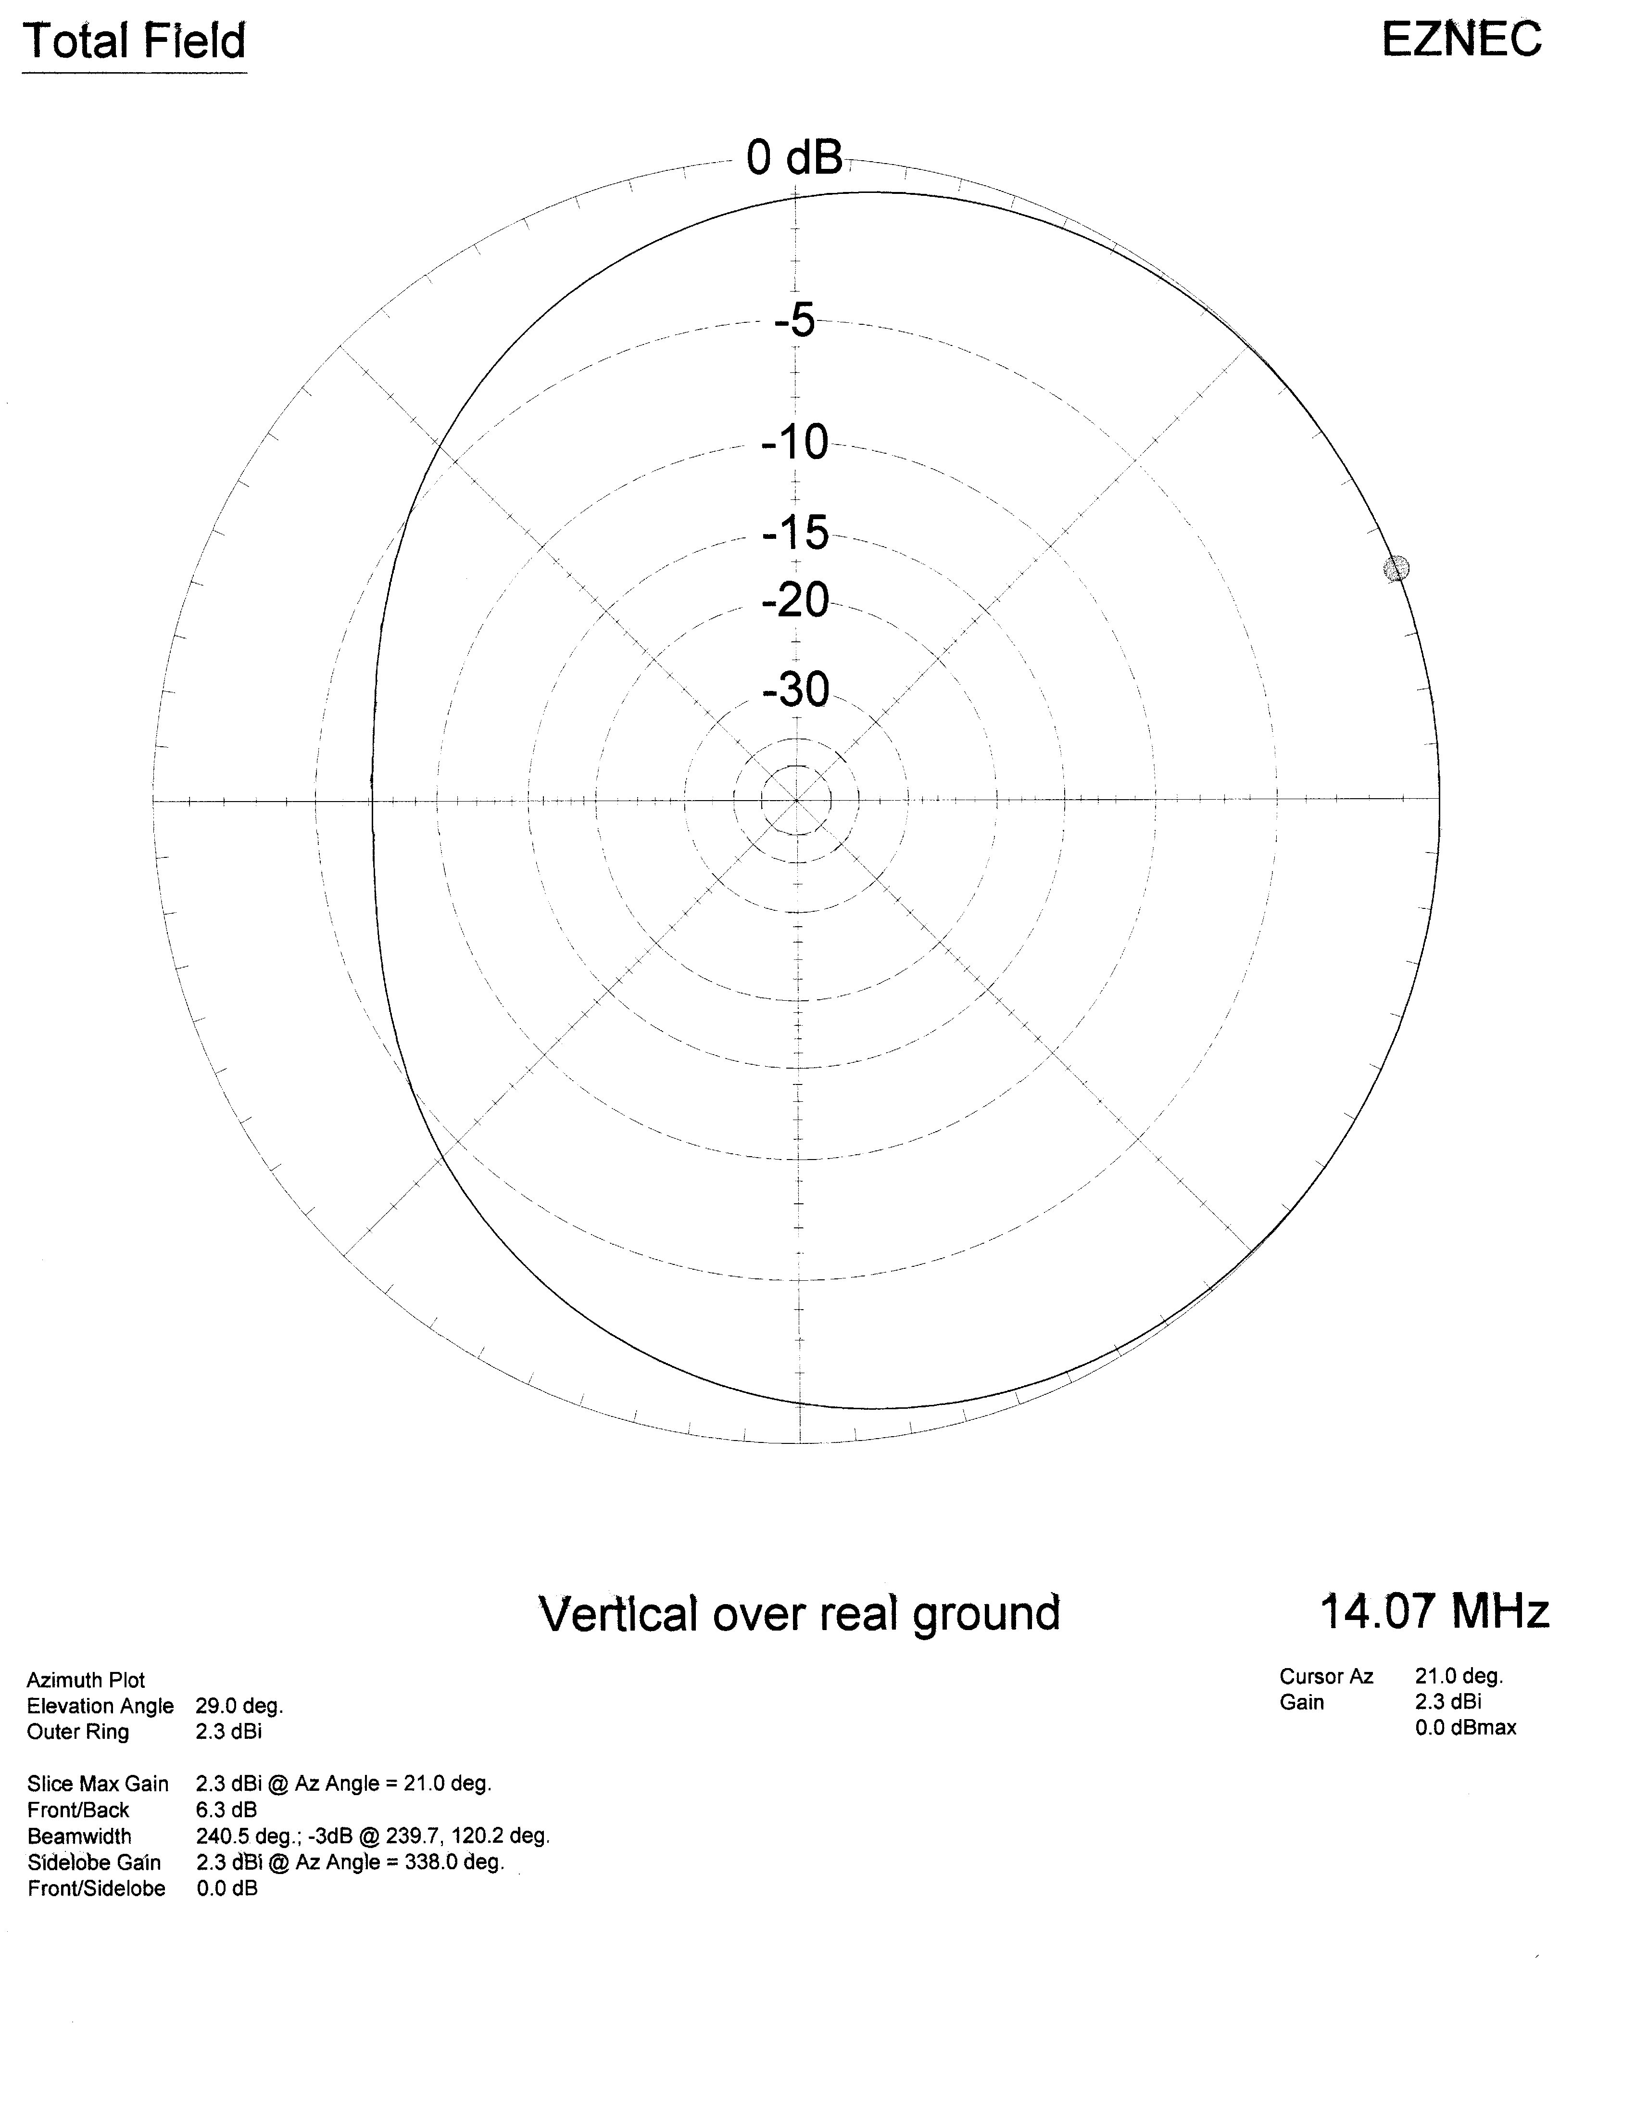
Figure 12 – 14.070 MHz Buddipole raised vertical antenna azimuth radiation pattern with one counterpoise

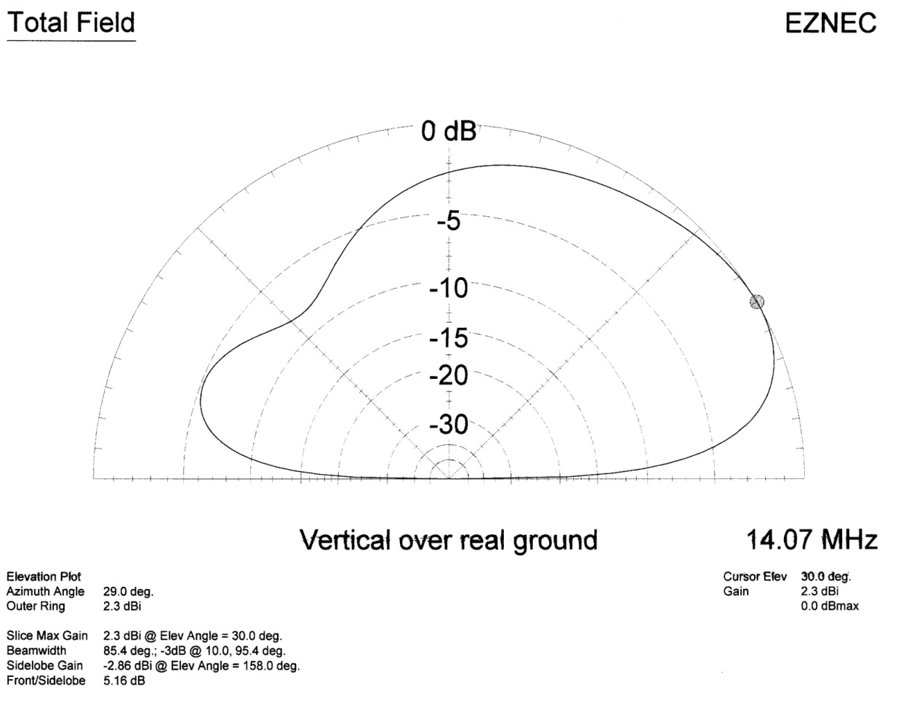
Figure 13 - 14.070 MHz Buddipole raised vertical antenna elevation radiation pattern with one counterpoise

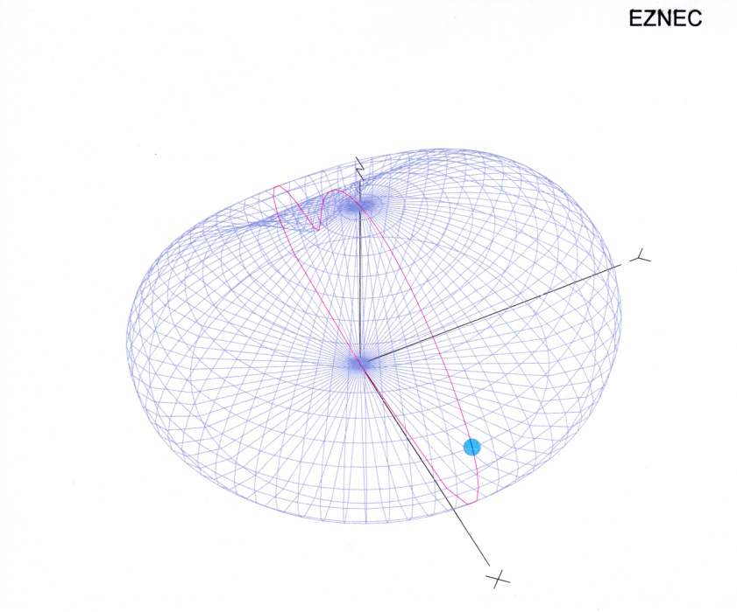
Figure 14 - 14.070 MHz Buddipole raised vertical antenna 3D radiation pattern with one counterpoise

The highest antenna gain for this Buddipole raised vertical antenna always occurs in the direction of the counterpoise. When my truck was positioned such that the cab was heading west and the counterpoise was extended 180 degrees in the opposite direction, east, the highest antenna gain is achieved over a geographical magnetic heading range of approximately 58 through 122 degrees. To correlate the EZNEC azimuth position shown in Figure 12 with geographical magnetic heading, think of the EZNEC 0 degree direction in Figure 12 as the geographical East, or 90 degree, magnetic heading. In this figure the maximum antenna gain of 2.3 dB occurs at EZNEC azimuth 21 degrees (69 degree magnetic heading), and at an elevation angle of 29 degrees above the horizon. Also note that the smallest antenna gain occurs in the opposite direction, west, or at the 270 deg magnetic heading.
Figure 13 illustrates the antenna’s elevation radiation characteristics. Here you can see the greatest antenna gain occurs for this 14.070 MHz raised vertical antenna at an elevation angle 30 degrees above the horizon; one degree off from the model calculation in Figure 12 but still in the ballpark. Figure 13 also shows the minimum antenna elevation gain occurs at an angle 49 degrees above the horizon in the opposite azimuth direction.
Illustrations of the 14.070 MHz raised vertical Buddipole Antenna radiation patterns wouldn’t be complete without the three dimensional view in Figure 14.
How efficiently must the antenna radiate the RF power delivered to it?
My activation criteria was to achieve a 98% or higher Radiation Efficiency, I wanted every watt of power delivered to the antenna (minus some unavoidable line loss, of course) to be radiated off that antenna and not dissipated as wasted power resulting from ground losses or antenna load impedance reactance loss. It is not difficult to achieve a Radiation Efficiency close to 100% with the 14.070 MHz Portable Raised Vertical Buddipole Antenna. I was able to achieve 98% or better Radiation Efficiency by tuning this antenna to resonance; simply by adjusting the counterpoise length until I achieved a 1.1: 1 Voltage Standing Wave Ratio.
If you construct this raised vertical Buddipole as described above with the Black/Blue Coil tapped on the Black paint, the task of tuning to resonance, using an antenna analyzer, can be achieved by adjusting the length of the counterpoise, sometimes by inches, to get as close to a 1.0: 1 VSWR as you possibly can. A 1.0:1 or 1.1:1 VSWR was easily achieved in all of my activations with this antenna. The procedure for tuning the antenna to resonance can be observed on the Vertical Buddipole You Tube Video https://www.youtube.com/watch?v=Ujp_N0ljFAo. If you don’t own an antenna analyzer, an alternative method that will get you close to resonance is demonstrated in the video.
This paper will not go into the theory of Radiation Efficiency , but I do provide an example below on how I maximize Radiation Efficiency in the field.
After the vertical antenna has been correctly erected with the fully extended 9.5 foot whip, which is screwed into 1 – 22” antenna arm, and that whole assembly screwed into the loading coil (tapped 6 turns down from the whip end) the remaining task is to extend the counterpoise out approximately 17 feet to the plastic fence post. I marked the 17 foot point on the counterpoise with electrical tape. The counterpoise support pole should never be made of electrical conducting material, it should be either plastic or wood.
Tuning to resonance entails adjusting the length of the counterpoise, shorter or longer than 17 feet, until the Antenna Analyzer measures a VSWR of 1.1 or better. The objective, of course, is to achieve the lowest possible VSWR at 14.070 MHz. When you make your first VSWR measurement with the Antenna Analyzer, change the analyzer’s frequency until a 1.0:1 VSWR is indicated. This will provide a starting point on whether the counterpoise needs to be lengthened or shortened. If the resonant frequency is below 14.070 MHz, the counterpoise is too long and needs to be shortened to achieve a 1.0:1 VSWR at 14.070 MHz. Similarly, if the resonant frequency is above 14.070 MHz, the counterpoise is too short and must be lengthened.
Reference Figure 7 again. A resonant antenna state occurs when the antenna load impedance is a pure resistance. This one is close with a 46 ohm resistance and just 5 ohms of reactance, (46+j5).
The overall antenna system impedance = SQRT ( 46² + 5²) = 46.27 ohms

Hence, for this specific antenna configuration, where ground losses do not factor into the equation because an artificial ground counterpoise is employed and the ohmic loss associated with the radiated element is 0.1 ohms as measured with a digital multi-meter,
Radiation Efficiency = Radiation Resistance / (Radiation Resistance + Reactance Loss + Ohmic loss ) = 46/(46.27 +0.1) = 99.2 %

Portable 7.070 MHz 40 meter Buddipole Raised Vertical Antenna System
With the solar minimum coming our way one might be interested in the 40 meter, 7.070 MHz, version of this raised vertical Buddipole Antenna. Although I did not conduct NPOTA activations with this antenna, I did practice setting it up at home in case I wound up doing some evening activations. I was able to achieve a 1.3:1 VSWR, Radiation Efficiency = 97% at 7.070 MHz, with the following Raised Vertical Buddipole construction:
- 9.5 foot whip
- 4 – 22” antenna arms
- Red/Green Coil, tapped at 17 windings down from the whip end (7 windings down from the Green Paint)
- Counterpoise: approximately 30 feet long
- Other aspects of the 7.07 MHz BPSK31 Amateur station configuration is the same as described above.

Summary
In summary, this article emphasizes the design of your portable BPSK31 amateur station is based upon your own operational requirements: location, the constraints of the portable event itself, the frequency band you want to operate at, where the QSOs are to be directed, the amount of transmit power you want to communicate with and how long you want to sustain it. The operational performance requirements of the portable BPSK31 amateur station drives the antenna type, size, electrical characteristics and power supply demands. I encourage you to try BPSK31 portable operations. You’ll learn some new skills as I did in 2016 and it will give you an excuse to enjoy the outdoors at the same time you pursue your favorite hobby.

