Pielke article response

1. He assumes that global energy demand continues to increase at a constant rate through to 2030. Using BP data as a source for energy demand projections is absurd. BP will always overstate future energy consumption. It’s in their interest to do so.

2. He conflates coal and natural gas as having the same emissions, whereas natural gas is much cleaner than coal—which is why US emissions have been falling over the last decade.

3. He seems to assume that the only source of clean energy is from nuclear. He writes: “the magnitude of the of the net zero challenge is equivalent to the deployment of a new nuclear plant every day for the next 30 years.” No it isn’t. Nuclear is on the way out. It is much more expensive than solar and wind, the costs of which are still falling.

4. He states: “There is simply no evidence that the world is or is on the brink of making rapid far-reaching and unprecedented changes.” This is nonsense: there is plenty of evidence from many countries around the world including the European Union (globally, the 3rd biggest emitter of GHGs) which has set a target of 80% reduction in emissions by 2050 as is strongly committed to meeting it. The UK recently generated more power from wind than coal for an extended period of time. I would say that qualifies as unprecedented change.

5. From 2010 to 2018, the EU reduced emissions by 12.8% and the US by 7.1 %. Globally, increases in emissions are being driven by India and China. Yet both those countries have committed to reducing their emissions and both have huge renewable energy programs, particularly China, which is a world leader in wind and solar, including electric vehicles. At the same time the consumption of coal is increasing in these countries, but the execrable air pollution has sparked massive protests and both countries (1st and 4th in terms of global emissions) are making forceful moves to transition away from coal. The problem is that several countries: including China, India, Australia and Poland, have large reserves of very cheap coal. It is going to require a huge social mobilisation to force those governments to leave that coal in the ground. But that movement has already started.

6. He also states wrongly: “If the ultimate goal is net-zero carbon dioxide, then eventually all energy consumption will have to be carbon free”. This is not true. There are natural carbon sinks which, like the world’s forests, can be greatly expanded. The oceans are also a massive carbon sink (although acidification is obviously a concern). A recent scientific article has explored the positive impact of 1 trillion trees to draw down atmospheric levels of carbon dioxide. All these factors are ignored by Pielke.

7. Extrapolating from present global trends to 2030 and beyond is essential forecasting a business-as-usual scenario. But we know that business will never again be usual. The constant drumbeat of protests in the streets of countries around the world is testament to the mounting pressure on governments. California residents know that business is very unusual indeed.

8. One important metric is the number of countries that have reduced emissions to the point where they are now declining. This is called peaking. 57 countries including China have committed to peaking before 2030. This graphic is from the World Resources Institute.

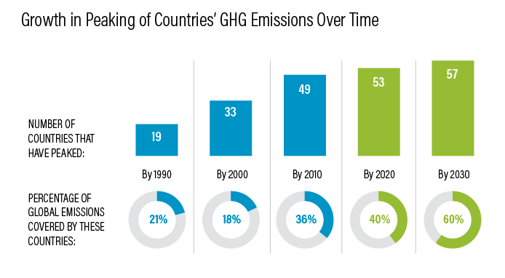

India isn’t mentioned but I have seen reports that India is fully committed to meeting its 2015 Paris Agreement targets.

9. Pielke is generally considered to be a subtle climate denier. He doesn’t deny that climate change is real, but he denies that we can do much about it and disparages all and every effort to solve the problem. He discounts the huge and growing importance of renewable sources of energy. This plays into the hands of the oil and gas conglomerates because their playbook is based on the notion that carbon capture technologies will allow them to continue to extract and process petroleum to supply what they hope is a constantly increasing global energy demand. Note that the words “solar”, “wind” or even “renewable” do not appear in the article. How can you write about managing the climate crisis without once mentioning renewable energy?

10. With reference to Mark Jacobsen and the proposal to transition to 100% renewables, it’s still considered to be a technically feasible scenario. I’ve seen a rebuttal of his scientific paper but what was interesting was that the academics who disputed some of Jacobsen’s data did not dispute the central thesis that 100% renewable is feasible. They only contested some of the numbers and the timeframe. The problem here is solidly political and the enormous blocking influence of the petrochemical companies and their capture of the regulatory agencies in the US, and to some extent also in Canada.

I could write a lot more about this. Anyone interested could take a look at my book: Climate change and renewable energy: How to solve the climate crisis. Hot off the press. Check it out here: https://www.palgrave.com/us/book/9783030154233

Martin Bush 31.10.2019

