Contact - Title
Business
Address

January 14, 2022

Dear [Name or Title],

For almost 148 years Incarnate Word Academy, Houston’s oldest Catholic high school, has provided an exemplary Catholic education to young women, regardless of their financial need. Because of strong relationships with businesses like yours, IWA can give our 310 students an outstanding education grounded in academics, values and spirituality.

Can you help us this year by donating to our 2022 IWA Gala and Auction?

Our auction is only as good as our auction items, and your donation would contribute significantly to our success this year! The proceeds for this year’s gala will go toward:

- Aids in keeping tuition as low as possible
- Maintaining quality faculty and academic excellence
- Continuing state of the art technology upgrades
- Support of our one-of-a-kind Young Leaders Program

Our team is happy to pick up the donation item and Donation Form, or you may mail, fax or drop off your donation at the Academy. Our 2022 IWA Gala and Auction “An Evening in Dublin,” will be held on Friday, April 22, 2022, so we would like to receive your donation no later than March 2, 2022. Your contribution is tax deductible and you will be recognized in the IWA 2022 Gala and Auction program, as well as in our Annual Report that is mailed to over 4,000 IWA supporters.

With your help, IWA can continue the mission we started in downtown Houston so many years ago by offering young women an exemplary Catholic college preparatory education. Thank you in advance for giving our request your consideration.

Please contact Lauren Schneider, IWA Special Events Coordinator, at 713-227-3637, Ext. 144 or lschneider@incarnateword.org with any questions or to schedule a donation pick-up.

Sincerely,
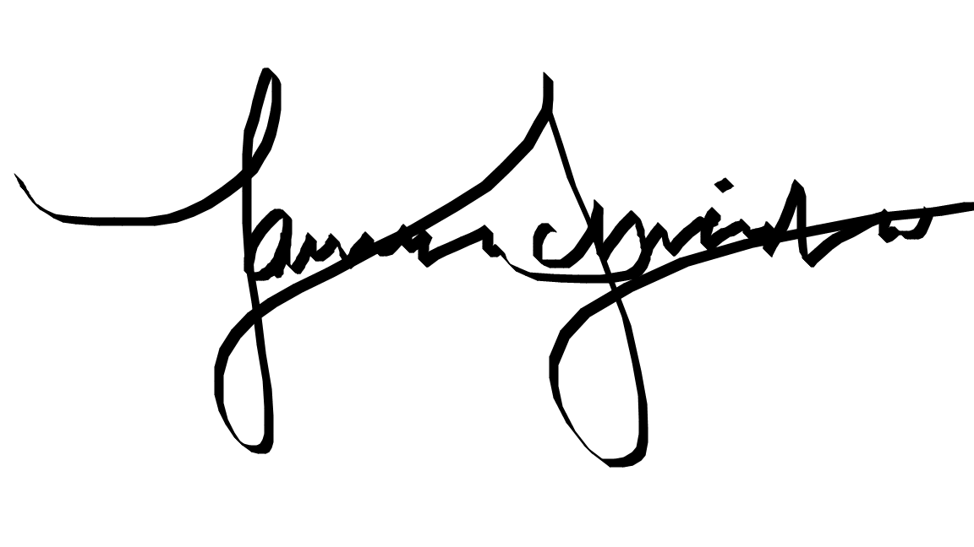

Lauren Schneider
IWA Special Events and Volunteer Coordinator

