How to set up timed lights using Google Home, IFTTT and Apilio.

Configuration
You will need to have IFTTT linked to your Google Home account, then create an account with the website, https://apilio.herokuapp.com/.

Apilio.io
Once you have created an account with Apilio, you will need to create the following:

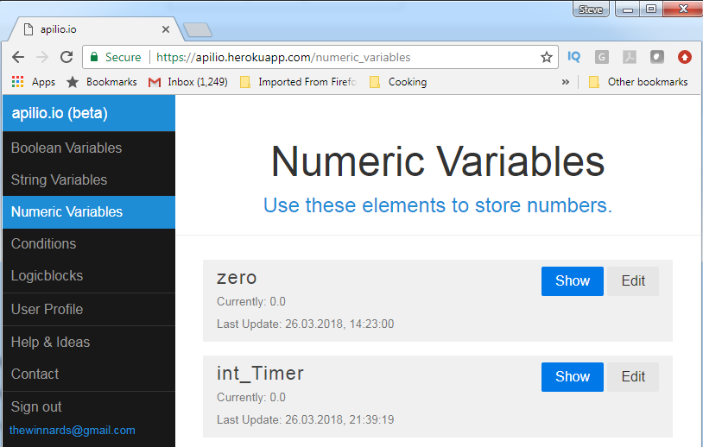
Two numeric values
- The first one needs to be called ‘zero’.
- Set the value to 0.
- The second one is called ‘int_Timer’.
- This can be set to be 0 initally.
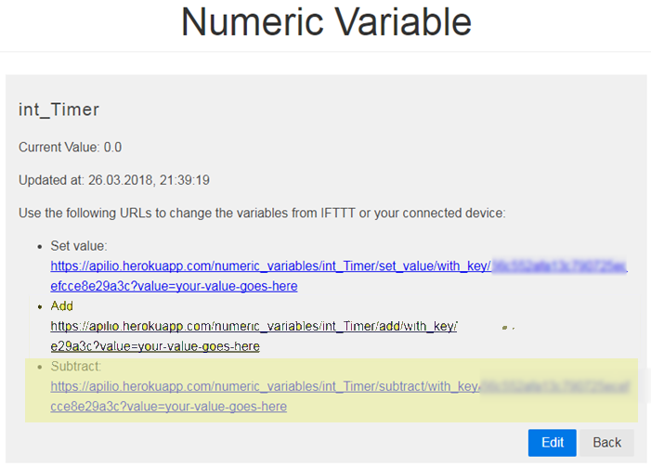
- When you save the variable, copy the URL to the Subtract URL.
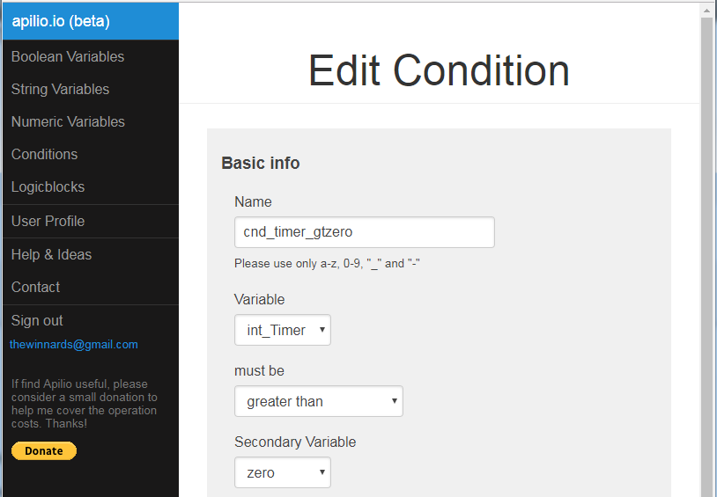
Figure 1

A Condition
- First condition is called ‘cnd_timer_gtzero’.
Figure 2
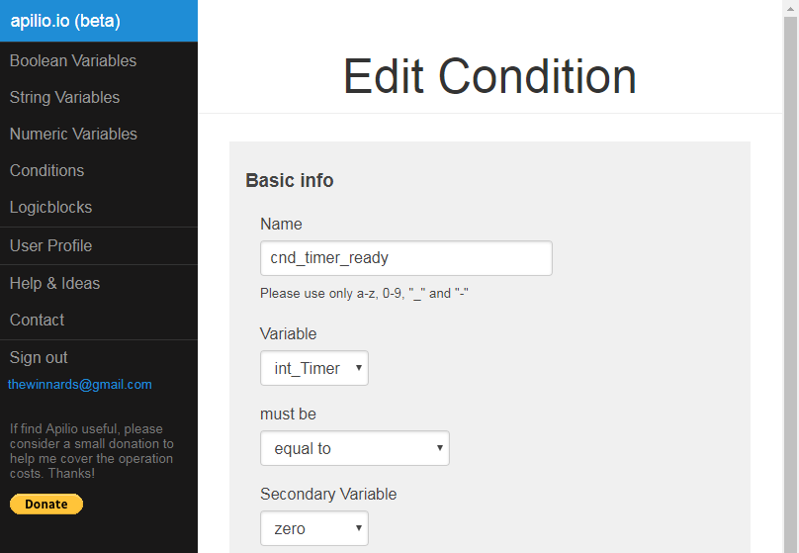
- Variable ‘int_Timer’.
- Must be ‘greater than’
- Secondary Variable ‘zero’.

Figure 3

A LogicBlock
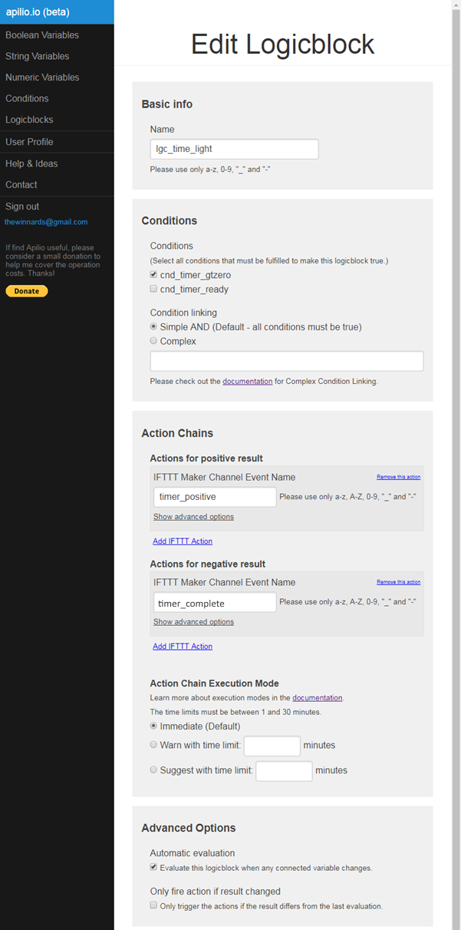
- The LB is called ‘lgc_time_light’.
- Select ‘cnd_timer_gtzero’ as the condition to test.
- Create an Action called ‘timer_positive’ for a positive result. In the advanced options set the timeout to 60 seconds.
- Create an action called “timer_complete” for negative result.
- Set the LB to Automatic evaluation.

IFTTT
In IFTTT you will need to create three applets, one to trigger the timer, another to make the timer countdown, and the last to receive the notification from Apilio.io once the evaluation timeout has expired.

Applet 1
- For the THIS filter, choose the Google Assistant / Say A Phrase With A Number.
- Enter the text you want to trigger this applet – remember to put a hash mark where you want to say the number in your sentence. For example, “Time the bedroom lights for # minutes”
- For the THAT filter, choose WebHooks / Make A Web Request.
- Paste the URL from the ‘int_Timer’ ‘Set Value’ URL above.
- Remove the text after “value=” the click the Add ingredient button. Choose NumberField form the list. The last part of the text should now read ‘value=NumberField’.
- Set the Content Type to ‘text/plain’.
- Leave the Body blank.

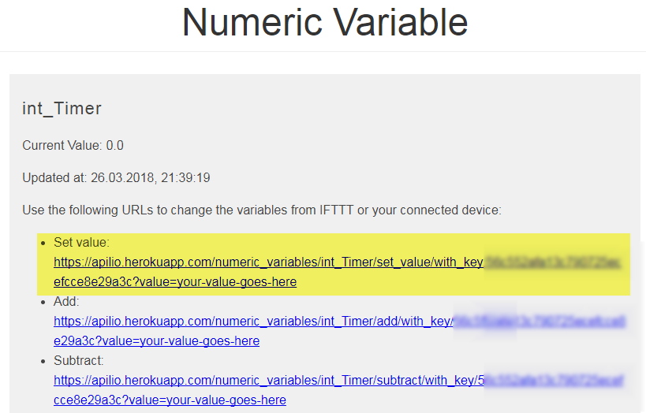

Applet 2
- For the THIS filter, choose WebHooks / Receive A Web Request.
- In the Event Name box, enter ‘timer_positive’ as configured above.
- In the THAT filter, in the URL box, paste the ADD URL for the ‘int_Timer’ variable you created above.

Applet 3
- For the THIS filter, choose WebHooks / Receive a web request.
- In the Event Name box, enter ‘timer_complete’.
- For the THAT filter, create and configure the filter that suits your lights.

