How to set up timed lights using Google Home, IFTTT and Apilio.

Configuration
You will need to have IFTTT linked to your Google Home account, then create an account with the website, https://apilio.herokuapp.com/.

Apilio.io
Once you have created an account with Apilio, you will need to create the following:
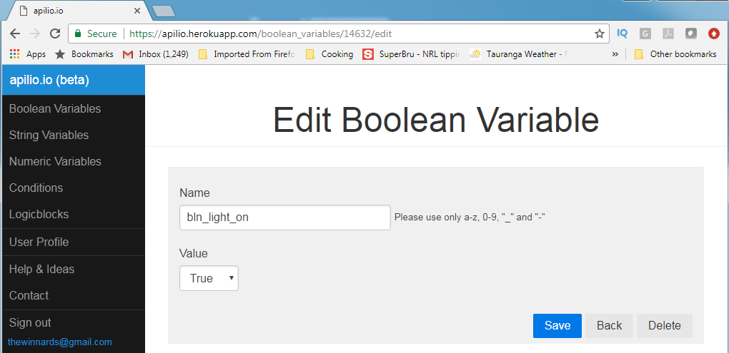
A Boolean value
- Give the value a name.
- Set the value to TRUE.

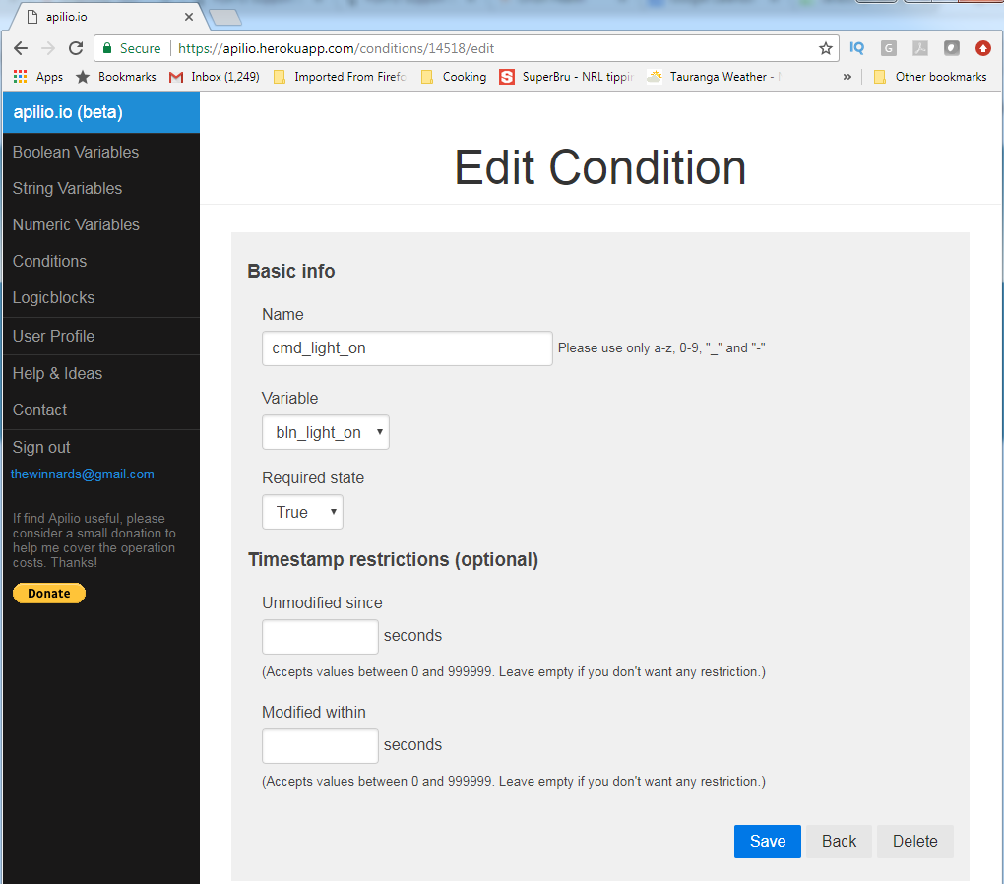
A Condition
- Give the condition a name.
- Choose the variable that the condition is testing.
- Select the Required State the variable must be set to.

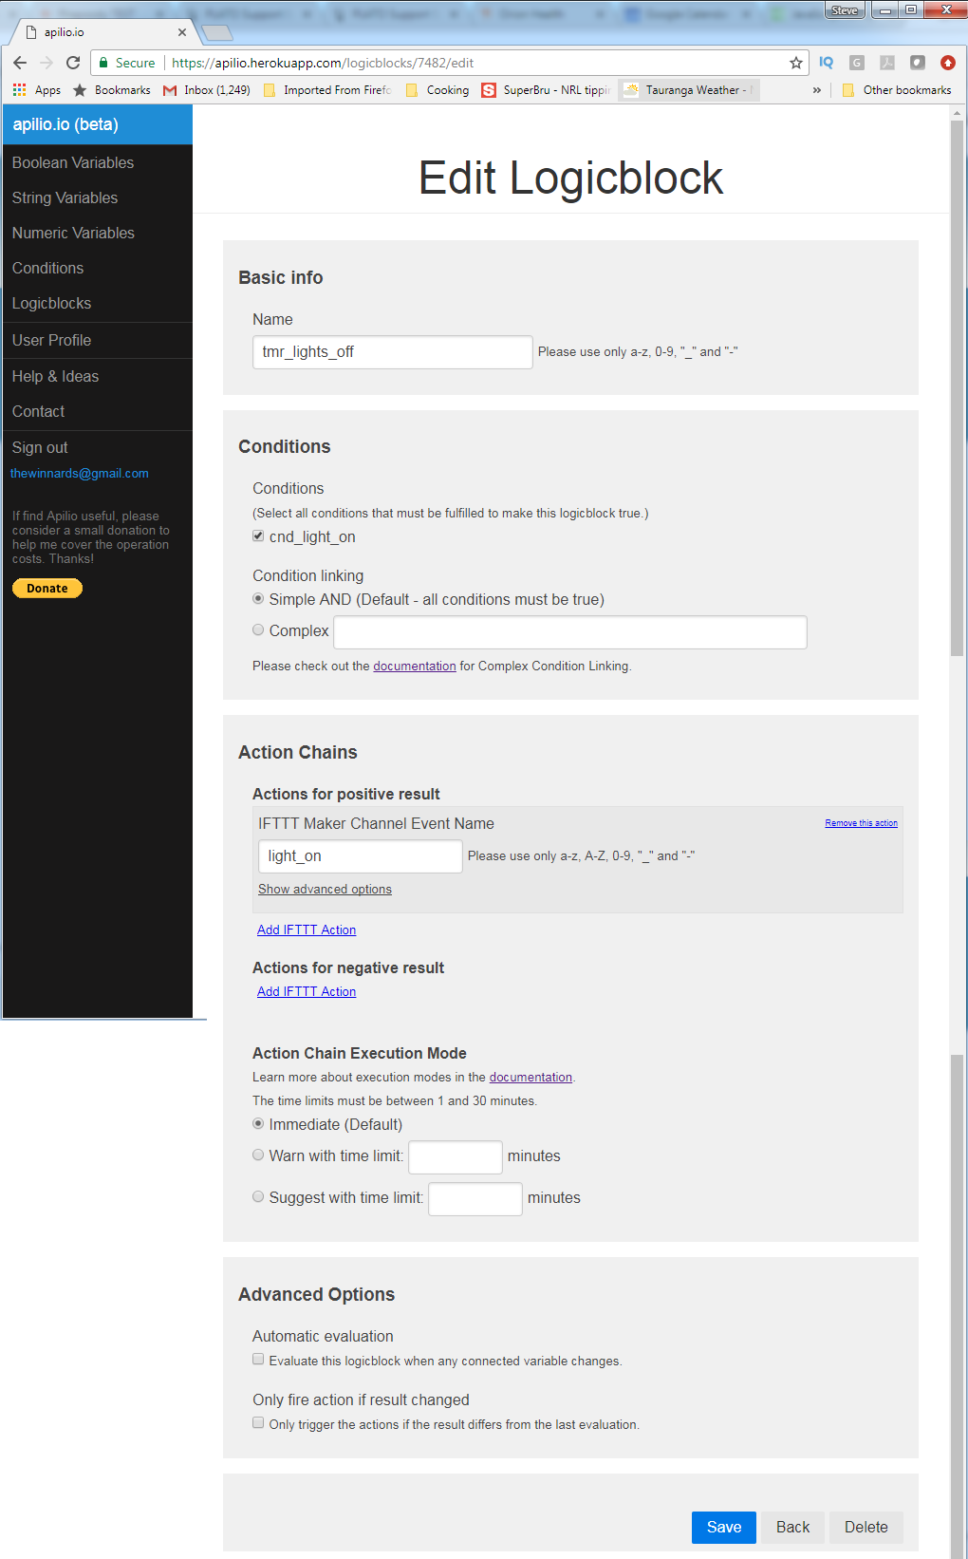
A LogicBlock
- Give the Logicblock a name.
- Select the Condition that this LogicBlock will test.
- Create an Action for a positive result:
Give the action a name ‘light_on’.
In the advanced options for the action, set the timeout you wish to expire before evaluating the condition.
- When you save the Logicblock, you will be shown a list of of URLs to use in your IFTTT applets. From this list copy the URL for the Evaluation Trigger.
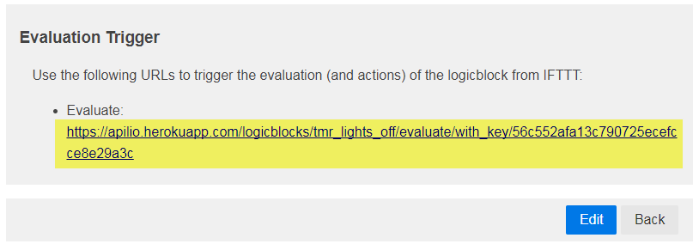

IFTTT
In IFTTT you will need to create two applets, one to cause the evaluation to be made, and the second to receive the notification from Apilio.io once the evaluation timeout has occurred.

Applet 1
- For the THIS filter, choose the Google Assistant / Say A Simple Phrase.
- Enter the text you want to trigger this applet.
- For the THAT filter, choose WebHooks / Make A Web Request.
- Paste the URL from the Logicblock Evaluation Trigger into the URL box.
- Set the Content Type to ‘text/plain’.
- Leave the Body blank.
- Click the Create Action button.

Applet 2
- For the THIS filter, choose Webhooks / Receive a Web Request.
- In the Event Name box, enter the name of the IFTTT Maker Channel Event Name from the Action Chains section, you entered when you created the Logicblock. In this example is it ‘light_on’.
- In the THAT filter, choose the filter to activate / deactivate your lights.

