Support Notes

DEVELOPMENT PROVISIONING PROFILE
A development provisioning profile allows your app to launch on devices and use certain app services during development. For an individual, a development provisioning profile allows apps signed by you to run on your registered devices. For an organization, a development provisioning profile allows apps developed by a team to be signed by any member of the team and installed on their devices.
The development provisioning profile contains:
- A wildcard App ID that matches all your team’s apps or an explicit App ID that matches a single app
- Specified devices associated with the team
- Specified development certificates associated with the team

APP STORE CONNECT
App Store Connect is a web app for developers to submit and manage their apps for sale on the App Store, distribute builds to testers using TestFlight Beta Testing, complete legal and tax documents, and view sales, usage, and earnings information.
Initially, only the Account Holder (the person who joins the Apple Developer Program) has access to App Store Connect and is assigned the Legal role. Later, the Account Holder can create additional users in App Store Connect and assign specific roles to users.
For more information on App Store Connect roles, go to Role permissions.
For all App Store Connect workflows, choose Help > App Store Connect Help (or go to App Store Connect Help).
To sign in to App Store Connect, go to App Store Connect.

APPLE DEVELOPER PROGRAM
https://developer.apple.com/programs/
The Apple Developer Program is a membership-based service for organizations, individuals, and sole proprietors/single person businesses interested in creating apps for distribution on the App Store for iPhone, iPad, Mac, Apple Watch, and Apple TV. Membership includes access to beta operating system releases, advanced app capabilities, and tools to develop, test, and distribute apps and Safari extensions.
Learn more about the Apple Developer Program.

REGISTER MULTIPLE DEVICES
If you have many test devices, you can create a file containing the device names, device IDs, and platform, and upload the entire file to your developer account. Your developer account supports these two file formats: a property list file with a .deviceids file extension and a plain text file. The file format you choose depends on whether you have access to the devices you want to register.

Required role: Account Holder or Admin.

Create a property list devices file
If you have access to the testing devices, you can use Apple Configurator 2 to create a property list file that contains all your device names and device IDs. Download Apple Configurator 2 from the Mac App Store.

- In Apple Configurator 2, choose Actions > Export > Info.
- Select List of Device Identifiers for Developer Portal, then click Export.

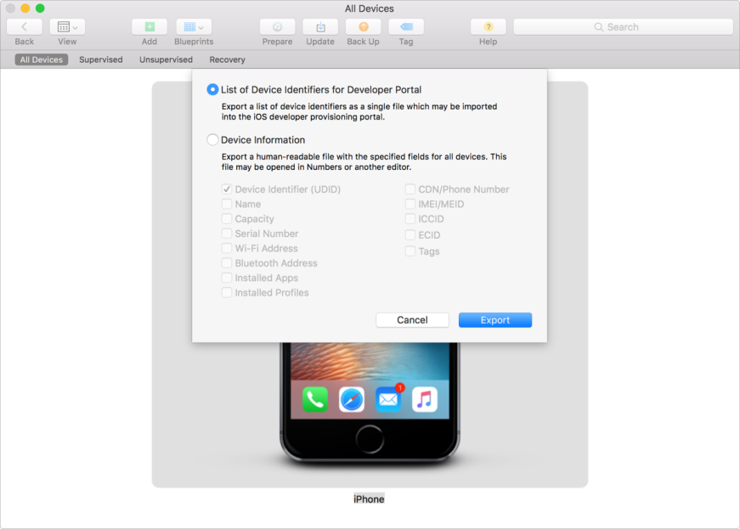

- Choose a file name and location, then click Save. The file has a .deviceids extension.

Create a plain text devices file
If you don’t have access to the testing devices, you can create a .txt file containing the device names and device IDs you collect using another method.
- Create a tab-delimited file with one device ID, one device name, and one platform name in each row. You can use the first row for your headers, because that row is ignored when parsed.

Upload a devices file
- In Certificates, Identifiers & Profiles, click Devices in the sidebar, then click the add button (+) on the top left.
- Under Register Multiple Devices, click Choose File.
- Select the file you want to upload, then click Choose. Select either the .deviceids or .txt file you created earlier.

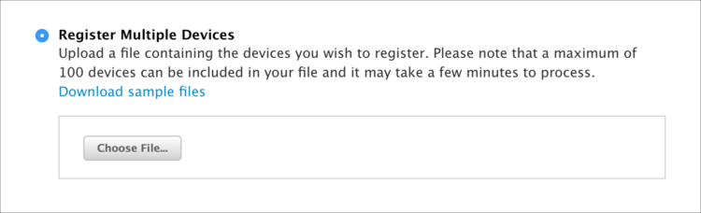

- Click Continue.
- Review the registration information, then click Submit.

DEVICE ID

A device ID is a UDID that uniquely identifies an Apple device including a Mac computer.

DEVELOPER ACCOUNT

A developer account is created for you on the Apple Developer website (developer.apple.com/account) after you accept the Apple Developer Agreement. You’ll use your developer account to download beta software and tools, visit forums, and report bugs. If you join a paid program, you’ll see additional membership-related options in your account, such as your team information, access to Certificates, Identifiers & Profiles, code-level support, and more.

To learn about these programs, go to Apple Developer Program and Apple Developer Enterprise Program. For developer account documentation, choose Help > Developer Account Help (or go to Developer Account Help).

APP STORE CONNECT
App Store Connect is a web app for developers to submit and manage their apps for sale on the App Store, distribute builds to testers using TestFlight Beta Testing, complete legal and tax documents, and view sales, usage, and earnings information.
Initially, only the Account Holder (the person who joins the Apple Developer Program) has access to App Store Connect and is assigned the Legal role. Later, the Account Holder can create additional users in App Store Connect and assign specific roles to users.
For more information on App Store Connect roles, go to Role permissions.
For all App Store Connect workflows, choose Help > App Store Connect Help (or go to App Store Connect Help).
To sign in to App Store Connect, go to App Store Connect.

