HOLIDAY
WREATH DECORATING

BCYF/Jackson Mann Community Center
500 Cambridge Street, Allston, MA. 02134

Classes will be held on Wednesday December 7th
Session 1, 6 – 7pm,
Session 2, 7 – 8pm,
Session 3, 8 – 9pm
Refreshments will be served
Class space is limited, pre-register by dec. 5th 2016
Class Fee: $25 per wreath
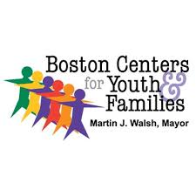
For more info call 617-635-5153
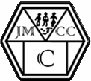
Sponsored by stop and shop, Allston, Mass.

