Queer Oz Folk
An Interventions series
info@interventions.org.au
PO Box 24132
Melbourne VIC 3001

The Mystery of the Handsome Man: The Double Life of John Lempriere Irvine
Author Wayne Murdoch in conversation with Christos Tsiolkas
Thursday 2 September, 6pm via zoom
The event is free, but you will need to register with one of the following:
Zoom: https://www.eventbrite.com.au/e/mystery-of-the-handsome-man-tickets-168044225803
Facebook Events: https://www.facebook.com/events/1081351435729389/
The link to the event will arrive a day or two before September 2
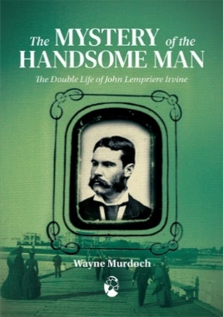
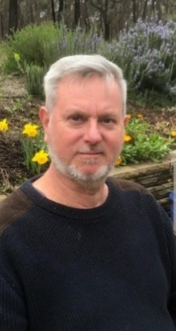
Wayne Murdoch lives near Bendigo in Central Victoria and often drinks in the wine bar at the Union Bank where J.L. Irvine once worked. He is the author of Kamp Melbourne in the 1920s and 30s: Trade, Queans and Inverts (Cambridge Scholars Publishing, 2017).
Christos Tsiolkas is the acclaimed Melbourne-based author of six novels including Loaded, which was made into the feature film Head-On, The Jesus Man, Dead Europe and Damascus. He is also a playwright, essayist and screen writer. (Photo: Zoe Ali)
The Mystery of the Handsome Man
When John Lempriere Irvine approached 19-year old Ernest Smith in Grattan Street one night in September 1897 with a cheery ‘Hallo, are you working?’ he set off a chain of events that ended with his life in ruins within a week. Banker, champion sportsman and bon vivant, Irvine was also a man with a secret. In this deeply researched and lively biography, Wayne Murdoch follows the rise and fall of a life of success and scandal.
About Queer Oz Folk
Queer Oz Folk has been set up to publish Australian queer history in well-produced, affordable and appealing editions. It is an imprint of Interventions www.interventions.org.au
Celebrate with us
If you would lie a little something with which to toast and celebrate our authors, you might like to order some wine from Goodwill Wines, who share profits from this page with the Australian Queer Archives: https://goodwillwine.com.au/pages/australian-queer-archives

