Sylvain

Wikicolor English

You have done a remarkable job on this. I think the change in size of the words has real potential and makes a graphic image that represents the major feature of English pronunciation pretty well.

What the size representation does is help the reader become aware of a) where to make the breath push and also, more subliminally show that the stressed syllables are longer (and clearer) and the other syllables are shorter (and rather indistinct).
Also by drawing attention to the colour of the stressed vowel – its large and obvious – students can give their attention to the quality of those stressed vowels which is exactly what they need to do.

And as we have said before, supporting students practice when their teachers aren’t around is really good. And as a tool that teachers can use to supplement their teaching and expand the range of vocabulary for students to practice this is also really good. So, thank you!

Here are a few reactions for how it could be even better … (sorry, you should know by now I’m always going to be pushing you for more!).

- Could the scale of the sounds be shown at syllable level rather than at vowel level. Like this:
acceptable

Rather than like this:
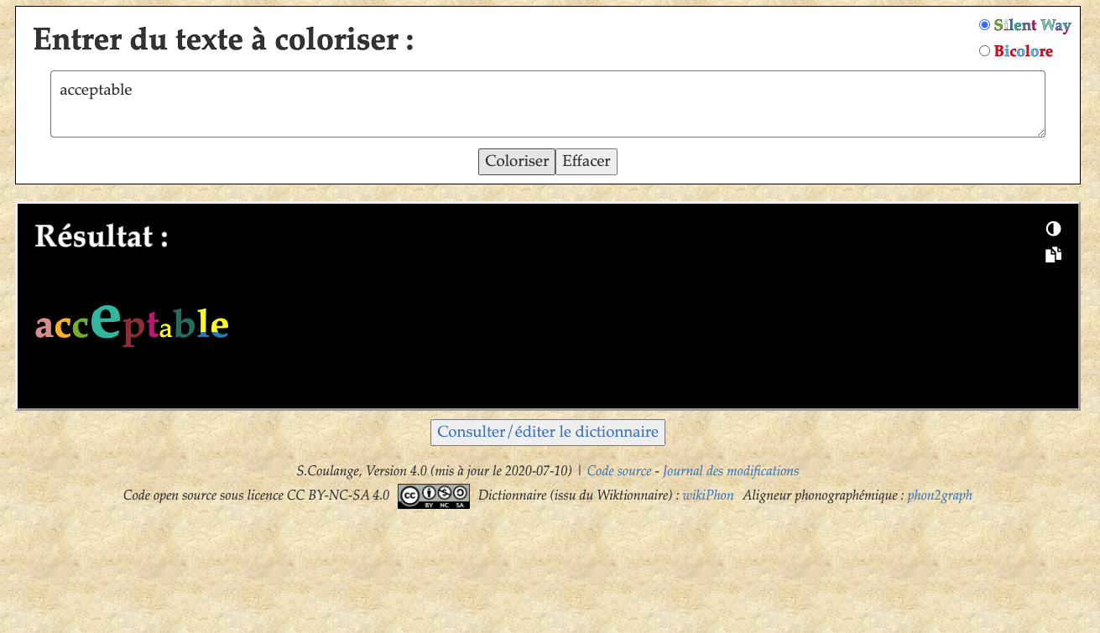
I think it’s more realistic for the syllable as a whole rather than just its constituent vowel that should be thought of as taking the weight or weakness.

- For the purposes of pronunciation also I would have everything shown in lower case. So, for example if the user types in ‘Acceptable’ wikicolor should read it as ‘acceptable’. The reason is as you see below.

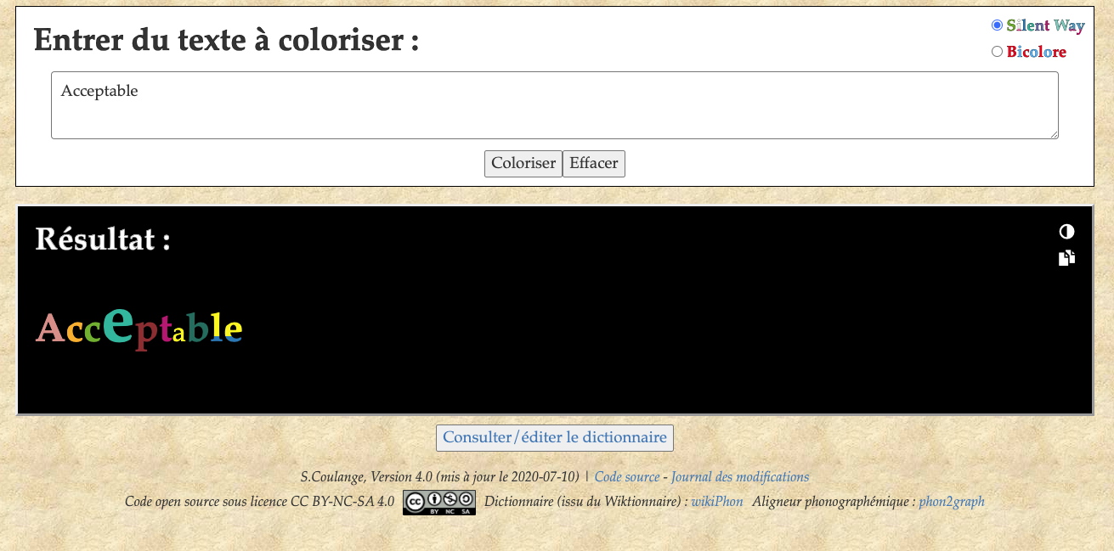

‘Acceptable’ with a capital letter gives an impression of weight on the beginning of the word which we don’t want.

- For pedagogical purposes we really need four levels of stress in English – stressed, unstressed, schwa/i/u and open transition. Four levels is enough to teach students to sound English but three is not (and it is remarkable how different English sounds with the open transitions). So ideally this word would come out something like:

accept.ble or possibly accept.ble

It is an interesting question why I feel the open transition between t and b should be shown bigger than the le – I think it is the experience of the curve of the breath since ‘t.ble’ is said on the remnants of the breath from the syllable cep. What this also reveals is that the last two syllables of this word are very, very different from the word ‘table’! Anyway, this is probably not a practical option but nevertheless it is how English works.

- We briefly discussed whether there was a way of distinguishing from the wikitionary whether a reduced syllable should be a schwa or an open transition.

- I think it is probably true to say that if a syllable has a consonant or consonants on either side of a schwa/i/u then it is a) permissible for a speaker to make it an open transition in all but the slowest speech b) that native speakers would normally do so in conversation.

- I think it is also true pedagogically that if at all possible teachers should train students to always use an open transition in these places. This is because the English habit of syllables effectively without any vowel sounds is such a strange phenomenon that students need all the practice they can get in saying and hearing these.

- In practice, English speakers make a graded series of reductions in what they actually say depending on speed and formality of the occasion. So, in the case of ‘acceptable’ it could be said as four syllables with a schwa: ac cep tab le, for emphasis or in slow speech. Or as four syllables with an open transition: ac cep t.b le or with two open transitions ac cep t.b.l which is probably the most normal form you would hear. You could even say it as three syllables: ac cep t.bl – I would use this if it was in a sentence or phrase like ‘It’s acceptable to say XXX” in which case across the word boundary between acceptable and to there would be another open transiton.

- So, what should we teach students? I think if I were working at the level of an individual word, then I would probably teach “ac cep t.b le” (with a schwa in the last syllable). Which, conveniently, if my algorithm in 4 is accurate would give you an algorithm you could design?

- So, here’s a proposition: why don’t we examine a random sample of multisyllabic words from Wiktionary to see where the open transitions have to be and therefore test whether this algorithm is sufficiently accurate – I don’t mind doing that as a contribution to the project if you would like! (provided the list of words is not too long! You’ll need to tell me how many we would need for statistical validity … If this rule proves not to be accurate this kind of examination might suggest a refinement to the rule.

- Finally, in terms of connected speech I think the results are pretty good, but I’m not really convinced – it’s the same issue. The minute you string together several words in English, in normal speech the number of open transitions and schwa’s multiply and multiply. As you already note there is a serious error in the below. It would be possible, but the speaker would have a very bizarre intention for them to stress the word ‘the’ and use the vowel i: before ‘park’ in the sentences below. In any normal context it would be an open transition.

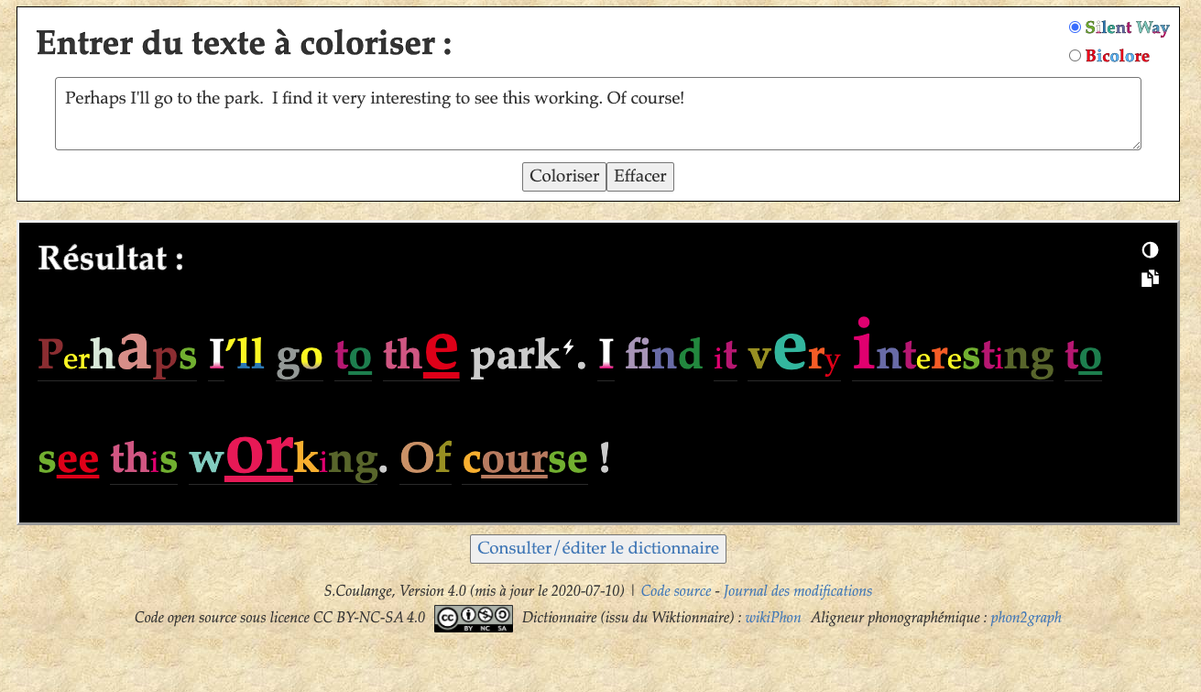

In fact this sentence would probably be “prap sI’ll gət.th.PARK” … one syllable for ‘perhaps’, a liaison from the s to I’ll and three open transitions for the following three function words. All this confirms the difficulties of connected speech … But then … I know you like a challenge.
Laurence

