Task: Exercise will be to take up a mnemonic and test a product. Submit a report on how you applied the mnemonic.
Date: 26/01/2015
SYNOPSIS
MNEMONIC
- SFDIPOT (San Francisco Depot)
PRODUCT
- CALCULATOR (Version: 6.1 Build: 7601)
APPLYING MNEMONIC
REFERENCE

MNEMONIC
"A mnemonic device is a mind memory and/or learning aid. Mnemonics rely on associations between easy-to-remember constructs which can be related back to the data that is to be remembered." Source- Wikipedia.
SFDIPOT (San Francisco Depot)
Test Strategy Heuristics by James Bach
Structure, Function, Data, Integrations, Platform, Operations, Time
- Structure (what the product is):
What files does it have?
Do I know anything about how it was built?
Is it one program or many?
What physical material comes with it?
Can I test it module by module?
- Function (what the product does):
What are its functions?
What kind of error handling does it do?
What kind of user interface does it have?
Does it do anything that is not visible to the user?
How does it interface with the operating system?
- Data (what it processes):
What kinds of input does it process?
What does its output look like?
What kinds of modes or states can it be in?
Does it come packaged with preset data?
Is any of its input sensitive to timing or sequencing?
- Platform (what it depends upon):
What operating systems does it run on?
Does the environment have to be configured in any special way?
Does it depend on third-party components?
- Operations (how it will be used):
Who will use it?
Where and how will they use it?
What will they use it for?
Are there certain things that users are more likely to do?
Is there user data we could get to help make the tests more realistic?

PRODUCT

CALCULATOR (Version: 6.1 Build: 7601)
You can use Calculator to perform simple calculations such as addition, subtraction, multiplication, and division. Calculator also offers the advanced capabilities of a programming, scientific, and statistical calculator. You can perform calculations by clicking the calculator buttons, or you can type calculations by using your keyboard. You can also use the numeric keypad to type numbers and operators by pressing Num Lock.
Opening of Calculator window:
- Click to open Calculator.
- Click the View menu, and then click the mode that you want. When you switch modes, the current calculation is cleared. Calculation history and numbers stored by the memory keys are retained.
- Click the calculator keys to perform the calculation you want.
- Below are the lists of calculation that can be performed:
- Using Scientific mode

- Using Programmer mode

- Using Statistics mode
- Using calculation history

- Convert values from one unit of measurement to another

- Calculate dates

- Calculate fuel economy, lease, or mortgage payments

I have considered Statistics mode for the performing this exercise
APPLYING MNEMONIC

- Structure:
It does not have any file
No idea how it was built
It has many programs
It has display window
It can be tested module by module

- Function:
Statistics mode: When you use Statistics mode, you can enter the data that you want to calculate statistics for and then perform the calculations. When you enter the data, it's displayed in the history area and the number of values you have entered is displayed in the calculation area.
- Click the View menu, and then click Statistics.
- Type or click your first piece of data, and then click Add to add the data to the dataset.
- Click the button for the statistical calculation you want to perform
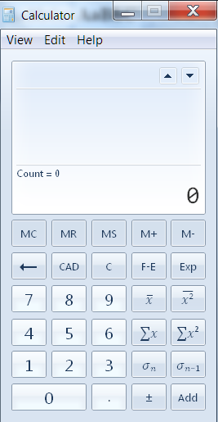
It is visible to the user. It has user friendly interface
- Data:
Numerical data input is processed
Output will be in numeric form
No preset data was available
- Platform :
It runs on windows 7 ultimate operating system in my machine
No it does not depend on third-party components?
- Operations :
Any user can use it.
It can be used at any point of time when a person is using the system.
They use it for making Statistical calculation.
For example: Finding the average of the values
100,123,557,887
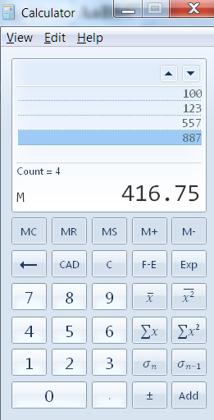
REFERENCE:
http://www.satisfice.com/articles/sfdpo.shtml

