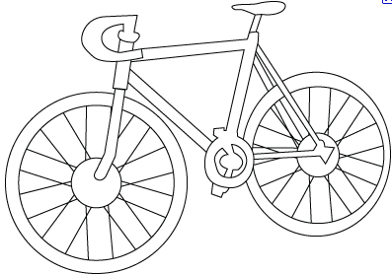 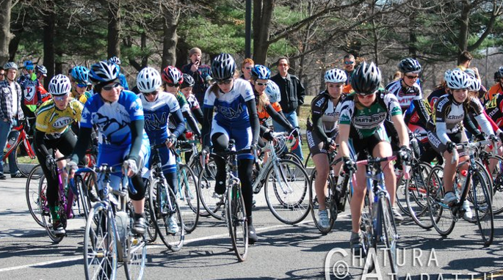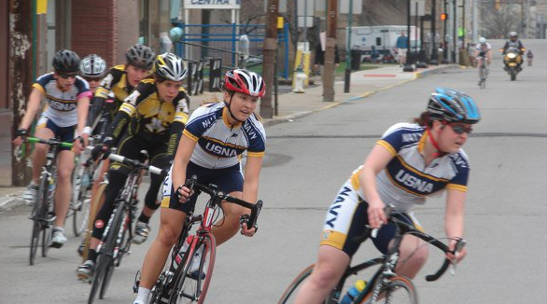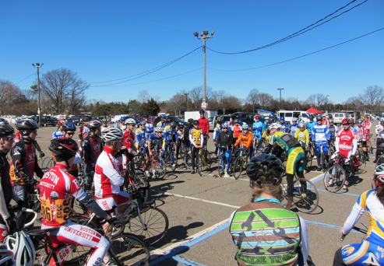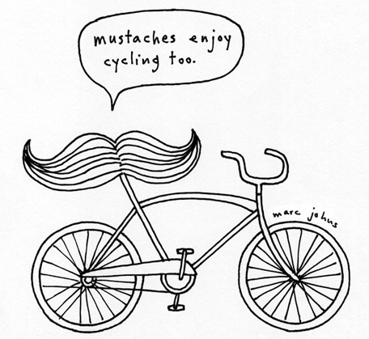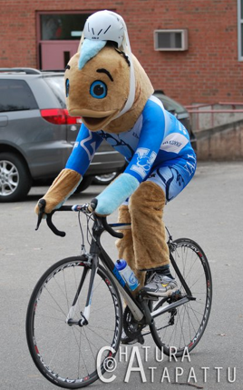

How to attract the ladies and keep ‘em coming back for more...

* ACCC Women’s Cycling 2011

# Mission Statement

Check out all those ladies in spandex! This is just a portion of the women’s C field at the Philly Phlyer in 2011.

Let’s be honest: the women racing in the ACCC deserve better. Novice and elite women alike should be able to expect adequate field sizes, a friendly atmosphere, and fun competition. These are hallmarks of the collegiate cycling experience and the conference – racers, teams, promoters, and officials – need to keep an eye on protecting and encouraging this tradition.

It’s time for the ACCC to become a leader in the cultivation and development of women’s collegiate cycling. This kind of change is not easy. It requires us to accept that what we are doing is not working. It requires us to explore new, uncomfortable, and different approaches. Women’s cycling needs to become a priority for the conference, and one that we all take very seriously.

There are two things we need to do better: recruitment and development. We need team leaders to help us in improving both. It’s important to remember that a healthy women’s program isn’t just good for the conference, it’s good for your team as well. Don’t fool yourselves, guys, a good group of fast ladies is what will get you to nationals and will help you succeed there.

Let’s make a deal. We’ll help you find new ways to get women to come to the races. We’ll help you deal with any problems you might encounter along the way. In return, we need you to be open to change. We need you to make a good faith effort to implement new recruiting tactics. Together we can increase both the size and quality of women’s fields in the ACCC.

ACCC women tearing up the Duke crit course in 2010!

**I should have thought of that...**

* Make sure you’re advertising collegiate cycling as a co-ed sport. Posters, web sites, Twitter, Facebook. Seriously.
* Speaking of Facebook. You need a web presence. People Google everything.
* Make sure you’re advertising the sport as beginner friendly. No experience necessary. No spandex required.
* If you’re putting up posters, find places that women are likely to see them.
* Be shameless. Try poaching riders from other sports at your school. Triathletes, runners, rowers. These people all **love suffering**. Let them do it on two wheels.

**Advanced tactics**

* You **need** a women’s captain. It doesn’t matter if you only have one woman on your team. Advertise her on your web site, through club sports, on flyers. Women need someone relatable to answer their questions.
* Team up with local bike shops, club teams, or advocacy groups. Try to get a weekly women-only ride started or to tag collegiate riders onto an existing ride.
* Social events. People don’t want to spend a romantic weekend in a hotel room with 15 stinky strangers they barely know. Pot lucks, parties and the like a great way to get to know one another. Pro tip: opt for a weekday night.

# **Recruitment: What you can do**

Every weekend, all season long, we’ll be running an hour-long clinic before women’s racing begins. The clinic will be staffed by A riders, men and women alike, and will teach basic race techniques. We’ll cover everything from getting clipped in to braking, cornering, pace lining, and more.

# Intro Clinics

# Remember, cyclists don’t exclude anyone!

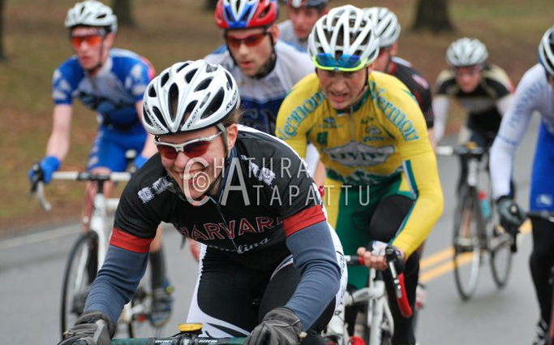

##### Contact: ACCCWomen@gmail.com

Yes...that is a Woman, kicking some major butt in a Men’s B race. Don’t support the women and they will make you suffer for it!

Women’s cycling is not a joke or a side show, and to treat or even think of it like anything but an equal half of collegiate cycling is to seal your team’s fate as a men’s only club.

Words of wisdom from USA Cycling...