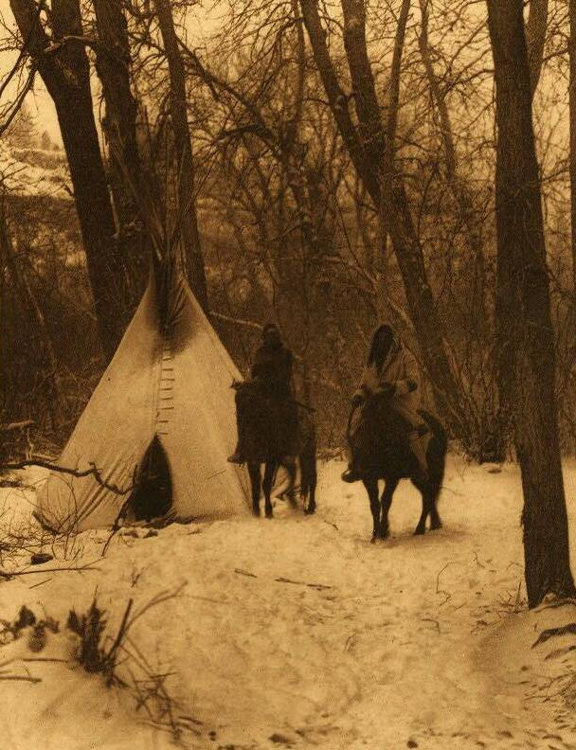

**Wandering Spirit**

**2nd Memorial Round Dance**

**Saturday, November 28th, 2009**

**At Enoch Recreation Centre**

**Enoch, Alberta**

* **6 p.m. Feast**

|  |  |
| --- | --- |
|  |  |
|  |  |
|  |  |
|  |  |

**This Round Dance is being held to honour 240 Ancestors who fled Canada (November 1886) and whose descendents now reside in Rocky Boy, Montana USA.**

**For more information call Lillian at 1-780-758-5716 or** [**lilyshirtcreations@hotmail.com**](mailto:lilyshirtcreations@hotmail.com)**.**

**Photo Credit: http://www.firstpeople.us/**