The 24th Annual Washington State Governor's Employer Awards Program

The Governor's Employer Awards Program recognizes:
- Public, Private and Non-Profit Employers for their efforts to recruit, hire, and promote individuals with disabilities.
- Employers supporting youth with disabilities through employment preparation and job
skills training.
- An individual with a disability who has significantly enhanced the empowerment of people with disabilities through employment, public service, advocacy, and other avenues.

NEW CATEGORY FOR 2016
- Employment Support Award for an individual who has made significant achievements in the successful employment of persons with disabilities.

- The nomination deadline is August 31, 2016
- Electronic applications should be submitted to http://tinyurl.com/2016-gov
- Nominees and Award recipients will be recognized in a ceremony on
October 7th at the Microsoft Conference Center in Redmond, WA

About the GCDE: The Governor's Committee on Disability Issues and Employment administers the Governor's Employer Awards Program and other activities, provides statewide advocacy and leadership to empower the disability community to obtain equality of opportunity and maximum independence.

For more information on the GCDE and the Governor's Employer Awards Program, contact Conrad Reynoldson via phone (206) 855-3134 or email: conrad3445@gmail.com.

To request an application in alternate formats, please contact Melinda Johnson, via phone (509) 482-3854 or email: GCDEawards@esd.wa.gov.

Page 1 of 12

2016 Governor's Employer Nomination Instructions

Requirements:

All employers considered for these awards must employ workers with disabilities that are paid at least the Washington State minimum wage of $9.47 per hour or higher and eligible to receive employee benefits as other similarly situated employees.

Award nominators are responsible for submitting accurate and complete information.

- The nomination packet must include all of the requested information to be considered a completed application. Incomplete nomination packets will not be considered for judging. The nomination deadline is August 31, 2016.
- Nominators must submit 1-3 photos and a signed release form (see page 11) giving us permission to use the photos in our program and marketing materials. Photos and signed releases should be emailed to GCDEawards@esd.wa.gov.
- Please do not disclose confidential or personal information about the nominees, especially details about medical conditions that must remain private to comply with regulations (e.g. the Health Insurance Portability and Accountability Act - HIPA).
- Nominations can be submitted Online at: http://tinyurl.com/2016-gov
OR
- Mailed to: GCDE - Governor's Employer Awards Program
PO Box 9046
Olympia, WA 98507-9046
- Mailed nominations must be typed or printed legibly to be considered

If you need assistance in filling out these forms, please contact Emily Heike via phone
(360) 902-9440 or email: eheike@esd.wa.gov.

2016 Governor's Employer Nomination Instructions

Successful Tips for Award Nominations:
  - Discuss and review your nomination with the employer to ensure you are including all of the information that supports your nomination.
  - Send/email the attached letter to your nominee to assist you in gathering more detailed information about their hiring practices (see page 10).
  - Have your materials prepared and saved in a Word document and available on your desktop to complete the online application. Please Note: The online application cannot be saved. You will need to submit a completed application in a single attempt.
  - Testimonials from employees or customers with disabilities are encouraged.

Awards Nomination Process:
An individual, business, agency or organization may submit nominations for themselves or others. Nominations should include specific detailed information about the nominee answering the outlined criteria. Judging is conducted solely on the information provided in the nomination packet. Note: videos will not be accepted as part of the nomination materials.

Selection Process:
A distinguished panel of professionals consisting of Governor's Committee Members, previous award winners and business representatives will select the award recipients.

Category Definitions:

Private Employers generate revenues from the services and products they provide.
Non-Profit Employers are registered with the state and maintain 501(c)(3) certification.
Public Employers are federal or governmental entities (city, county, state or municipality) whose revenues are derived from public support, i.e. taxes.
Youth Employers are any private, non-profit or public employers that sponsors programs or events that promote employment preparation and job skills training for youth with disabilities.
Governor's Trophy in Memory of Carolyn Blair Brown for an individual with a disability who has significantly enhanced the empowerment of individuals with disabilities in the community and/or workforce.
NEW CATERGORY FOR 2016
Employment Support Award for an individual who has made significant achievements in the successful employment of persons with disabilities.

2015 Governor's Award Winners

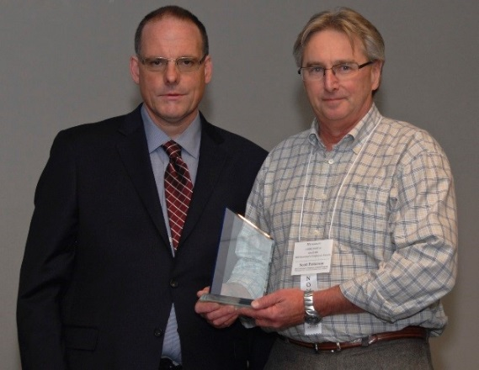
Governor's 2015 Medium Private Employer of the Year Electronetics LLC (A Northwest Center Co.)
Chris Carnell (Left) with Scott Patterson & the award

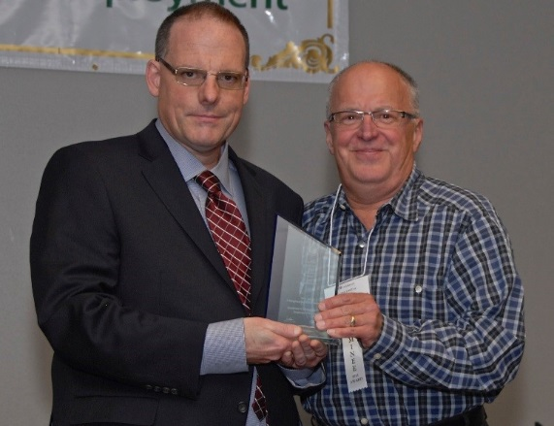
Governor's 2015 Large Private Employer of the Year Hop Jack's: A Neighborhood Gathering Place
Chris Carnell (Left) with Mark Schaefer & the award

Governor's 2015 Federal Employer of the Year JBLM Army & Air Force Exchange
Chris Carnell (Left) with Tiffany Evans & the award

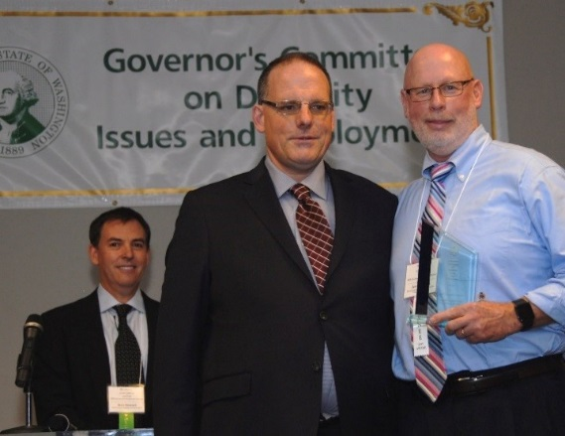
Governor's 2015 Youth Employer of the Year Client Assistance Program
Chris Carnell (Left) with Jerry Johnsen & the award

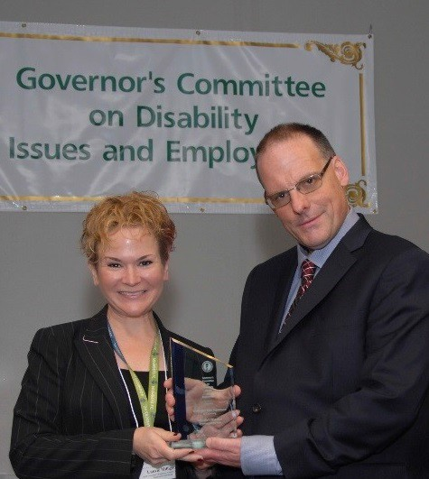
Governor's 2015 State Employer of the Year WA State Department of Licensing
Chris Carnell (Left) with Laurie Milligan & the award

Governor's 2015 Large Non-Profit Employer of the Year Pioneer Human Services
Karen Lee with award at podium

Governor's 2015 Small Employer of the Year South Perry Pizza
South Perry Pizza Sign

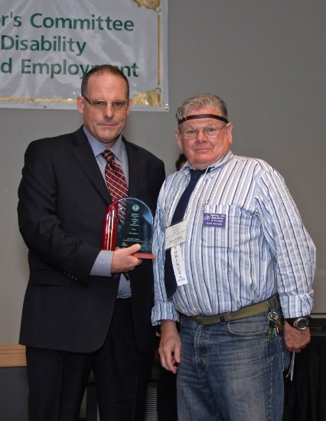
Governor's Trophy In Memory of Carolyn Blair Brown Bruce Rafford
Chris Carnell (Left) with Bruce & his award

2016 Governor's Employer Awards Program Nomination Form

Please select only ONE from the nominee categories below:
Private Employer:
Small (25 or less employees) Medium (26-249 employees)
Large (over 250 employees)
Non-Profit Employer:
Small (25 or less employees) Medium (26-249 employees)
Large (over 250 employees)
Public Employer:
Federal State
Local
Professional Award:
Employment Support Award Professional Award
Youth Employer:
Youth Employer Award
Governor's Trophy:
Governor's Trophy in Memory of Carolyn Blair Brown

Award Nominee Information:

Name of Business or Individual Total Number of Staff
Name of Contact Person
Contact Person's Phone Number Contact Person's Email Address
Nominee's Mailing Address
Number of staff with disabilities

Nominator Information: Nomination Submitted by Nominator's Organization Relationship to Nominee
Nominator's Phone Number Nominator's Email Address

By submitting this nomination I attest that all of the information I am providing is accurate and complete. I have obtained the necessary permission and releases for the information and photos being submitted. I also understand the information I am providing may be used for local, state or national publicity.

Signature Date
Page 6 of 12

Governor's Employer Awards Employer Criteria:
All questions must be answered in order for the application to be complete. The nomination narrative may not exceed six pages. The packet may include letters of endorsement or other supporting documentation. We understand there may be overlap in the responses provided below.
NOTE: All employers considered for these awards must employ workers with disabilities that are paid at least the Washington State minimum wage of $9.47 per hour or higher and eligible to receive employee benefits as other similarly situated employees.

For the Governor's Employer Awards Nomination; please provide a narrative or bulleted list for the following:

- Explain how the organization has been creative in their activities building successful practices to recruit people with disabilities.

- Describe the nominee's practices to retain and advance individuals with disabilities in their workforce and in their management teams, such as regular pay increases, additional work hours, increased work responsibilities and promotional opportunities.

- Describe the organization's practices to involve employees with disabilities in the informal/ social aspects of workplace culture fostering natural supports and creating an inclusive environment.

- Describe the nominee's efforts and practices to make workplace accommodations for customers or employees with disabilities. Some examples include: acquisition of adaptive technology or equipment, facility modifications, job sharing, providing alternate or extra supervision, special training, or collaboration with job coaches or service organizations.

- Feel free to add any information about other programs, procedures, processes, practices, attitudes or any other information about the employer that you feel is relevant to your nomination for the Governor's Employer Award.

The Nomination Deadline is August 31, 2016
Electronic applications should be submitted to http://tinyulr.com/2016-gov

Page 7 of 12

NEW CATEGORY FOR 2016

Employment Support Professional Criteria
All questions must be answered in order for the application to be complete. The nomination narrative may not exceed six pages. The packet may include letters of endorsement or other supporting documentation. We understand there may be overlap in the responses provided below.

For the Governor's Employment Support Professional Award Nomination; please provide a narrative or bulleted list for the following:

- Please provide the nominee's title/ position and the length of time in the position or field.

- Describe the characteristics that make this nominee outstanding in his/her position. Provide detailed examples of this nominee is exceptional, this may include work habits, attitudes, interpersonal/communication skills or other abilities.

- What specific achievements or contributions has the nominee made in supporting persons with disabilities find and or succeed in the workplace? Provide specific details that may include; building natural supports, advancing career opportunities, creative problem solving, and affecting positive changes in the workplace etc.

- We encourage you to include additional documentation to support your nomination. This may include photographs, letters of recommendation, statements, etc.

The Nomination Deadline is August 31, 2016
Electronic applications should be submitted to http://tinyulr.com/2016-gov

Page 8 of 12

Governor's Employer Awards Youth Employer Criteria:
All questions must be answered in order for the application to be complete. The nomination narrative may not exceed six pages. The packet may include letters of endorsement or other supporting documentation. We understand there may be overlap in the responses provided below.

For the Governor's Youth Employer Award Nomination; please provide a narrative or bulleted list for the following:

- Describe the nominee's efforts and practices to sponsor programs or events and supporting activities that promote the employment preparation and job skill training for youth with disabilities.

- Describe the nominee's efforts to provide opportunities for work experience, internships, student transition programs, mentoring events and job shadowing for youth with disabilities.

- If applicable, describe the employer's success in hiring youth with disabilities in competitive employment. Please include as many specific examples as you can.

- Feel free to add any information about other programs, procedures, processes, practices, attitudes or any other information about the employer you feel is relevant to the nomination for the Governor's Youth Employer Award.

The Nomination Deadline is August 31, 2016
Electronic applications should be submitted to http://tinyulr.com/2016-gov

Governor's Trophy Award Criteria:
Governor's Trophy Award in Memory of Carolyn Blair Brown is for a Washington resident with a disability who has significantly enhanced the empowerment of individuals with disabilities in the community and workforce.
All questions must be answered for the application to be complete. The nomination narrative may not exceed six pages. The packet may include letters of endorsement or other supporting documentation. We understand there may be overlap in the responses provided below.

For the Governor's Trophy Award Nomination; please provide a narrative or bulleted list for the following:
- Please provide an overview summary of why the individual deserves to be nominated for the Governor's Trophy in Memory of Carolyn Blair Brown.

- Describe the nominee's volunteer/community service including length of service and an estimated number of hours of service.

- List any recognition this individual has received from other disability organizations with the specific award name, date and the reason they received the recognition.

- Describe the nominee's dedication, activities or actions that address disability related issues. These activities or actions need to go beyond their paid work experience. For example, if the person you are honoring is employed in the disability industry, you must describe activities or actions that go beyond the scope of their paid position.

- Explain how this individual has made positive changes in the disability community at local, state and/or national levels.

The Nomination Deadline is August 31, 2016
Electronic applications should be submitted to http://tinyulr.com/2016-gov

Congratulations

You have been nominated for the Washington State Employer Governor's Award

Please fill out this form so we can complete the nomination:

Private Employer:
Small (25 or less employees) Medium (26-249 employees) Large (over 250 employees)

Non-Profit Employer:
Small (25 or less employees) Medium (26-249 employees) Large (over 250 employees)

Public Employer:
Federal State Local

Organization/Business Name Contact Person Name
Contact Person's Phone Number Contact Person's Email Address Mailing Address
Total Number of Staff How Many Individuals with Disabilities Currently on Staff

Any Specific Strategies for Hiring or Recruiting Individuals with Disabilities

Story of a Great Hire of a Person with a Disability

Nominated by

The person above will contact you to schedule a time to come to your place of business to take some photos for the award

Governor's Committee on Disability Issues and Employment
Publication, video and website consent and release agreement

The agency seeks permission to use your photo, name, voice, statement, written work and/or art

Release agreement

Please sign here

Governor's Committee on Disability Issues and Employment (GCDE) employees and members of the public are occasionally asked to be a part of GCDE's publicity, publications, and/or public relations activities, which may include representation in the media.

This signed form indicates agreement that the subject's name, picture, art, written work, voice, verbal statements and/or portraits (video or still) may appear in the department's publications, videos and/or website, or in print, social or broadcast media. These images may or may not personally identify the subject. The subject also agrees that:
No money shall be paid.
Consent and release have been given willingly.
The name, picture, art, written work, voice, verbal statements, portraits (video or still) may be used in the future.
Governor's Committee on Disability Issues and Employment, agrees that the subject's name, picture, art, written work, voice, verbal statements and/or portraits (video or still) shall be used only for public relations, public information, event or project promotion, publicity and instruction.

If the subject or, in the case of a minor child, parent or guardian wish to rescind this agreement, he or she may do so at any time with written notice.

Agreement
I authorize the Governor's Committee on Disability Issues and Employment to use my name, voice, verbal statements, and/or any photographs, film, digital recording or videotape that may contain my likeness, for publicity or informational purposes. This includes the editing, duplication, reproduction, copyright, representation in the media, exhibition, broadcast, posting on GCDE's website, and/or other non-profit use and distribution of such photographs for purposes deemed suitable by GCDE, unless I make my wishes to the contrary known. I understand that my image or information that I provide may be used without my review.

Subject (print name) Signature of

subject Date

Phone Number

If subject is a minor child (less than 18 years old), complete the following section.

Please complete this section for minors
Guardian (print name) Signature of Guardian

Minor (print name)

Date Phone Number
Page 12 of 12

