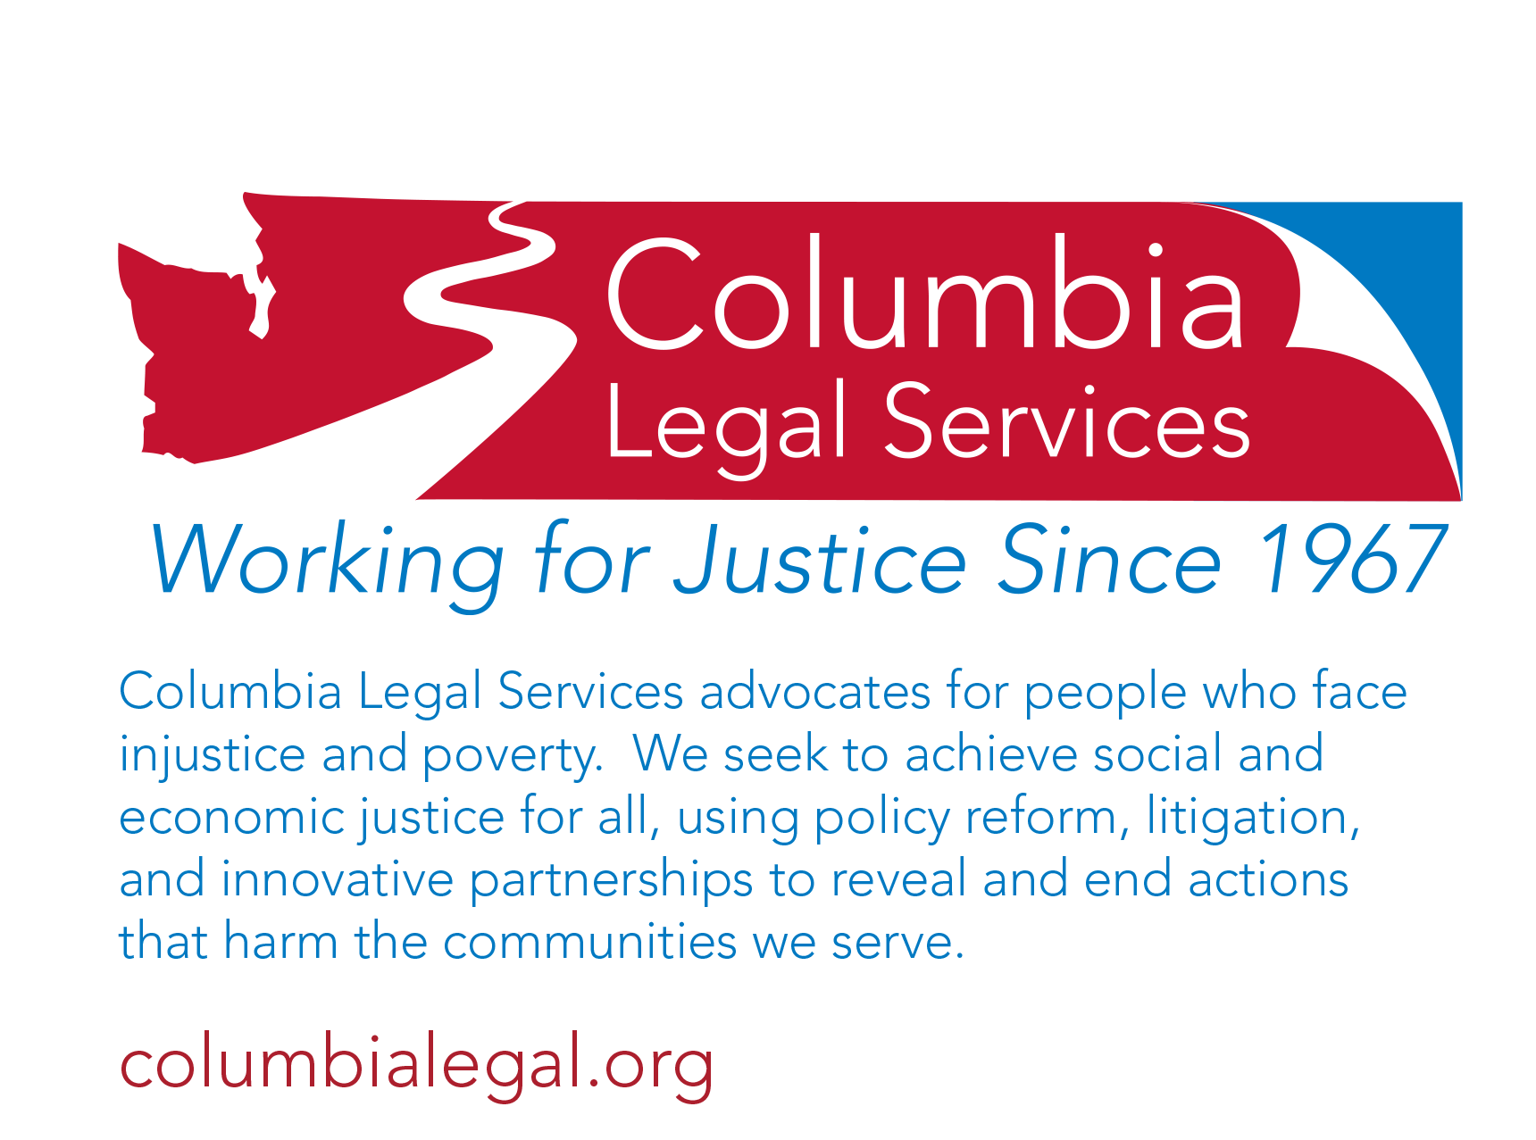Program Description

## Staff Attorney

## Working Families Project

## Seattle, WA

# Employment Opportunity

For many years, Columbia Legal Services has represented some of the most marginalized people in our community. We use every legal tool available on their behalf. Our role to serve people and use advocacy that might otherwise not be available makes our work an integral part of the [Washington Alliance for Equal Justice](http://allianceforequaljustice.org/). Our vision of justice is when people have the necessary tools and opportunity to achieve social and economic justice, a more equitable and inclusive society is possible. Through large-scale litigation, policy reform, and innovative partnerships, our lawyers and other staff work in furtherance of our mission. The ideal candidate for any position at Columbia Legal Services will be able to articulate their role in the achievement of that vision.

Position

Columbia Legal Services seeks a full-time Staff Attorney to work in our Working Families Project. This position will provide systemic, multi-forum legal advocacy to advance a broad range of legal issues affecting farm and other low-wage workers and their families in Washington. This position will focus primarily on employment, as well as related civil rights matters and access to equal opportunities in our communities.

Responsibilities

* Work with a team of attorneys and legal workers on complex trial and appellate litigation, class actions, and legislative advocacy.
* Creatively investigate and pursue new opportunities and identify practices and laws that adversely affect the rights and diminish the benefits of low-wage workers, and devise creative strategies for addressing these problems.
* Assist with the development of campaigns and strategies to advance the goals of the project team.
* Coordinate with other advocacy groups, legal services organizations, and the private bar to identify opportunities and execute strategies to advance the law for low-income populations.
* Be available to travel occasionally around the state and work flexible hours. May include travel to Olympia during the legislative session.

Qualifications

* Bilingual skills in Spanish/English are required.
* Minimum of 5 years of litigation experience. Judicial clerkships, fellowships, or externships may be counted as up to one year of litigation experience.
* Demonstrated commitment to racial, social, and economic justice.
* Ability to analyze complex problems and develop creative, practical systemic solutions.
* Excellent written and oral communication, research, negotiation, and analytical skills; superior attention to detail.
* Willingness to work well independently and on a team, prioritize responsibilities, and meet deadlines on time-sensitive projects.
* Experience in impact litigation, particularly in public interest and civil rights law.
* Cultural competence and experience working with low-income client communities, particularly immigrant and indigenous populations.
* Washington State Bar member or willingness to seek admission as soon as possible upon hiring.

**This job description is not designed to cover or contain a comprehensive listing of activities, duties or responsibilities that are required of the employee.**

Compensation

CLS offers a competitive and comprehensive compensation package including generous holiday and paid time off, and excellent health care benefits. Salary is commensurate with experience.

Applications

Applications will be considered by August 31, 2016. Please note that due to the volume of applications received, CLS is unable to respond to every application. CLS will contact you if we decide to pursue your application. **If you apply by e-mail, please make Seattle Staff Attorney - WFP your subject line.**  **Please send your letter of interest, resume, three professional references, and a 5-10 page writing sample to:**

Trisa Kern, Director of Program Administration

Columbia Legal Services

101 Yesler Way Suite 300

Seattle, Washington, 98104

[jobs@columbialegal.org](mailto:%20jobs@columbialegal.org)

Program Policy

Columbia Legal Services is committed to a policy of pluralism and equal opportunity in an environment free of barriers and discriminatory practices for its client communities, Board and staff. Pluralism refers to the active promotion of mutual respect, acceptance, teamwork and productivity among people who are diverse in work background, experience, education, race, color, national origin, sex, age, religious preference, marital status, sexual orientation, sensory, mental and physical abilities, veteran status, or any other perceived differences. The resulting diversity is both a source of program strength and a matter of fundamental human fairness. If you need a reasonable accommodation for the application process, contact Sharon Nyland at 206-464-1122 or jobs@columbialegal.org.