Vero Memory Channel Excel Spreadsheet – Instructions for Vero N7500 & Revetis RT99 for Andriod App users.
I have had several requests on how to complete the form and do alterations for different countries.
Corrected spreadsheet
Imbedded Excel Memory Channel program.
Open Excel spreadsheet and fill up to 16 memory channels (it will only take 16)
- Fill in the names and frequencies with off sets and tones for your requirements in the red box only.
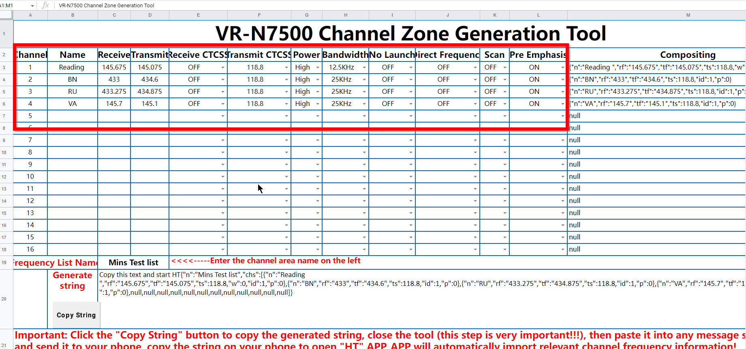

- CTCSS Tone settings. Use the drop down for the tones you need… if they are not suitable go to step 2A.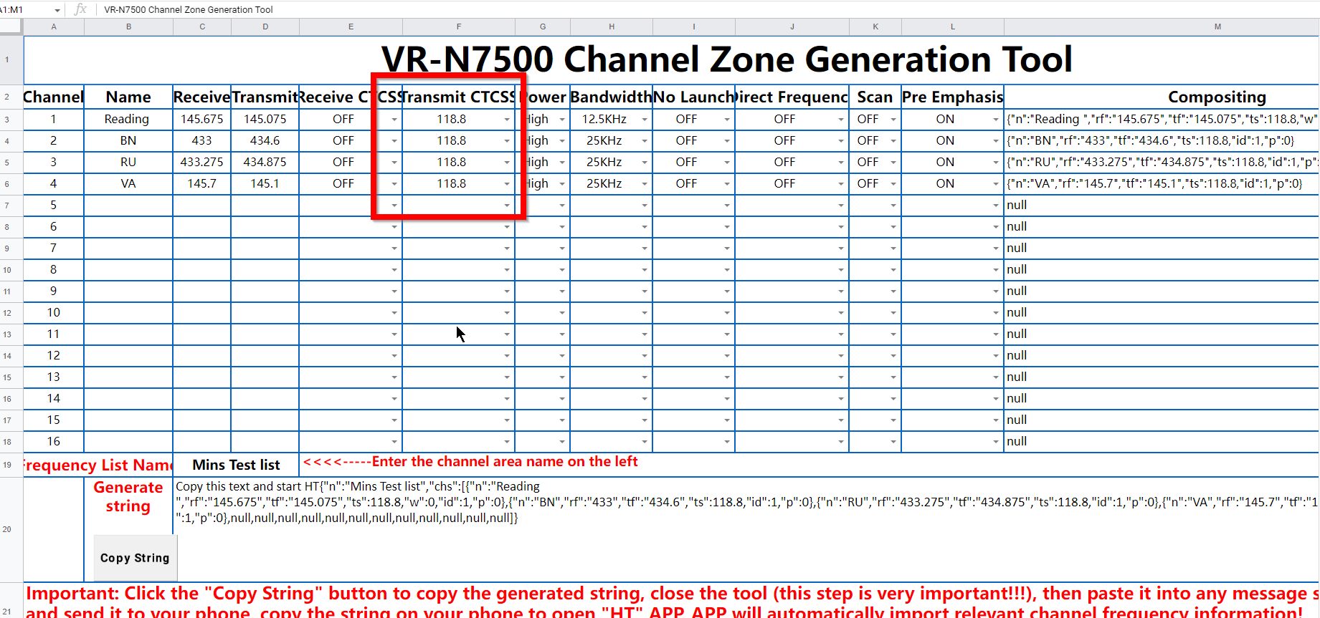
2A. Open the 2nd Page of the Editor
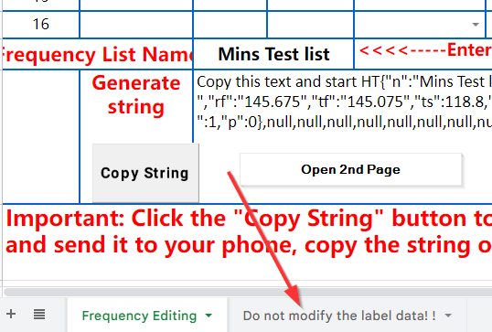

Only change the CTSS Data to your local requirements, save the file under different names for yourself.
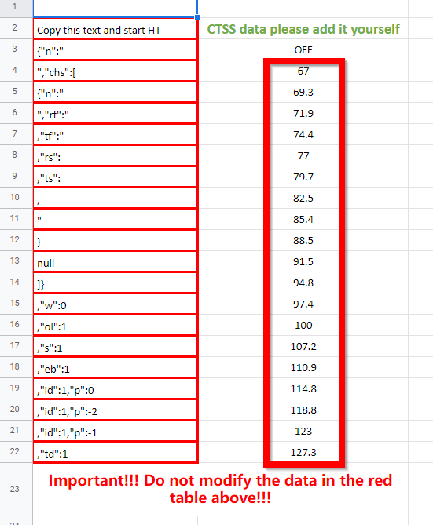

Return to part 2 of the first page and change the tones to your requirements the go to section 3.
Section 3
- Give the Memory Block a Name and save it to your files.
- Then click on copy string.
- Then close the excel program, saving any changes. (Important)
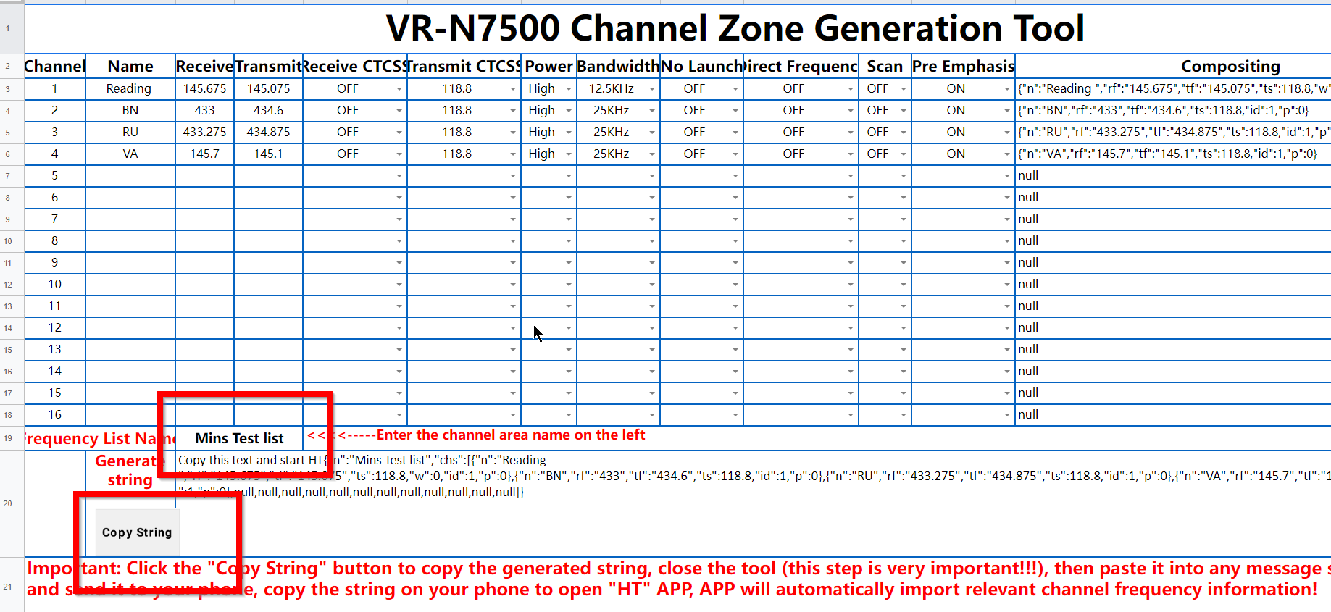

4 Open Email and send it to yourself. It will create an email like this when you have pasted it in.
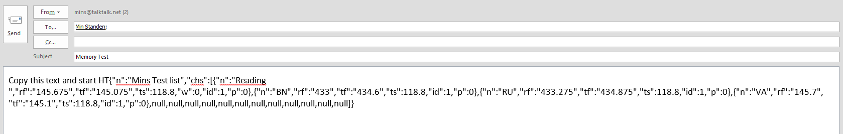

Send email and with the app closed on the phone app.
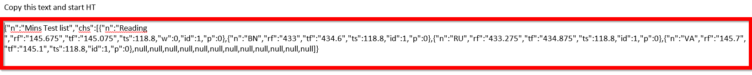
Open the email and copy the data shown below then open the APP. This will open a new Channel Group for your 16 memories with the name you put into the program. Save the file on the app with that same or new name.
You can have up to 12 groups of memories of 16 channels. Total 192 memories within the app.
The radio stores the last memory group of 16 for when you start the radio.
Note should you have a problem of disappearing channels it is a corrupt memory groups and best options is to delete that memory group.

What an imported list looks like and it can be save under a different name if need be.
You can share this memory block with other is so desired.
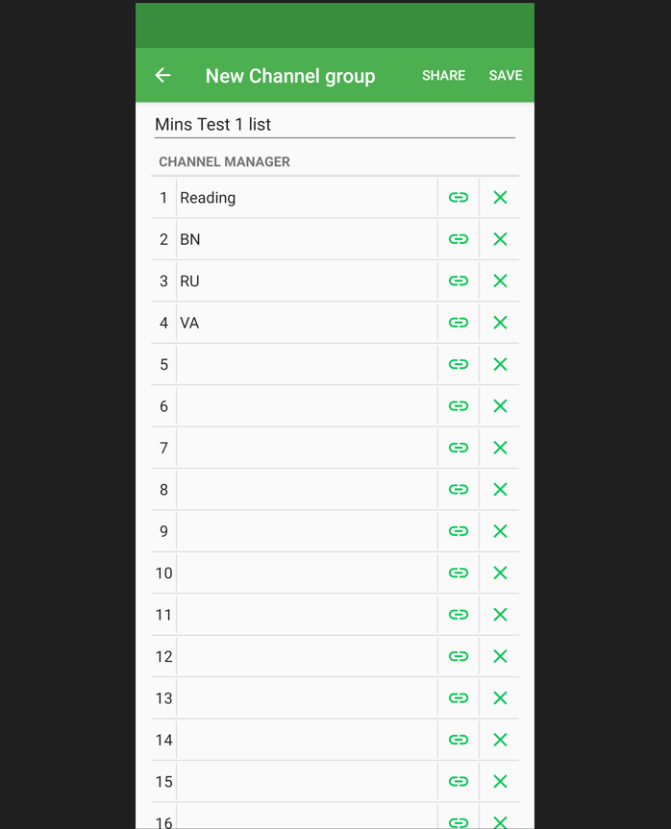

This is an easy way to copy and paste the various configurations you may have for different blocks and areas.
Min Standen G0JMS October 2022

