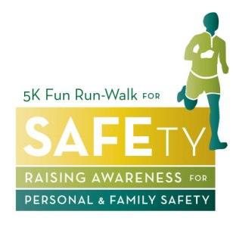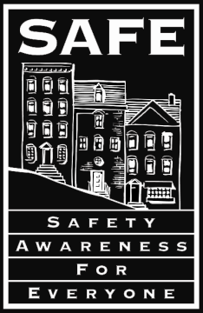5K Fun Run/Walk for SAFEty

Join us to Raise Awareness of Personal
& Family Safety!

Save the date!! San Francisco SAFE is gearing up to host its 3rd annual 5K Fun Run/Walk for SAFEty event designed to promote awareness of personal and family safety, while raising funds for all of our important crime prevention services. Join SAFE, Chief Greg Suhr, members of the SFPD, and the community as we build stronger, safer neighborhoods.

- Sunday, October 30, 2011
- Peacock Meadow in Golden Gate Park
- Race starts at 11:00 a.m.
- BBQ and after-party immediately following race
- Prizes for the top 3 male & female finishers, and for the best costume
- Registration and information at www.sfsafe5k.dojiggy.com

You can run or walk the 5K – as an individual or as a team! Wear a costume and have a chance to win some great prizes. Get your fellow officers together to form a team. Show everyone that your team is the best! Bring your whole family and enjoy a fun day in Golden Gate Park!

SAFE needs your support to increase our public safety efforts. We believe that through simple and practical crime prevention techniques everyone can avoid being a victim. In 2010 SAFE staff gave over 100 presentations on personal and child safety, observing and reporting suspicious and criminal activities and created at least 10 different neighborhood advisories in a variety of languages for the affected areas. We have created numerous neighborhood watch groups in various neighborhoods across the city. Help SAFE to continue to provide these free services to the community.

All proceeds from the 5K Fun Run/Walk will go to SAFE to support its mission – building safer, stronger communities through crime prevention education and public safety services. This event is designed to bring communities, Neighborhood Watch groups and the Police together to show their support for a safer City.

Registration is $20 per person. Children under 10 are free. All participants are encouraged to raise a minimum of $100. If you decide you don’t want to run or walk, you can sponsor another runner or register to volunteer and still be a part of a great cause, and help make our event a success. For more information and to register please visit our website at www.sfsafe5k.dojiggy.com or call (415) 553-1984.

