Russian Anchorage Presents
Russian Poetry and Culture Celebration
To honor 222 birthday of Russia’s greatest poet, playwright and novelist Alexander Pushkin.

When: Saturday, July 10, 11 am – 3 pm
Where: Valley of the Moon Park, 610W. 17th Avenue, Anchorage
Admission: FREE
Donations are appreciated and support 501C3 nonprofit Russian Anchorage, Center for Russian American Friendship and Trade (CRAFT)
Program Includes:
- Poetry competition results and awards; poetry recitals
- Violin prima Elena Lukina
- Folk dance numbers, including ensemble Sudarushka
- Games for the children and the whole family
- Complementary refreshments
- More info: https://www.facebook.com/events/1447069715640272/

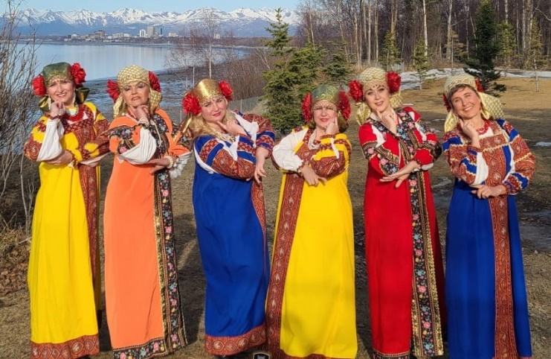 | 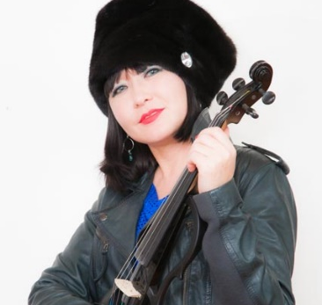
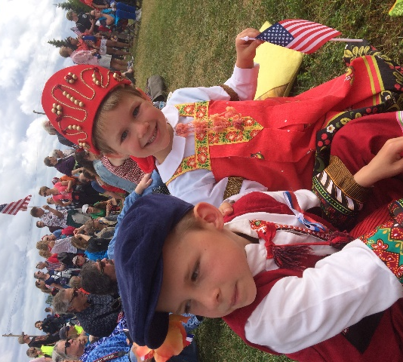 | 