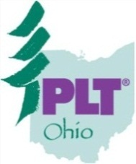
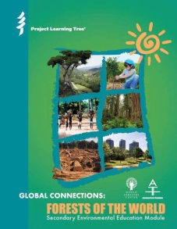
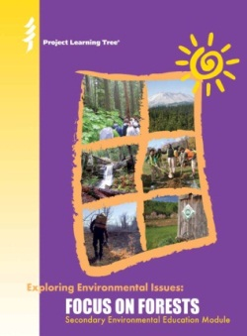
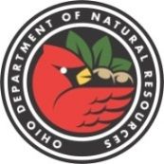
Have Can

Don’t miss this exciting opportunity to get a unique look at Ohio’s forest issues!

Come participate in hands-on, fun activities from PLT, all while discovering the wonders of Ohio’s public and private forests from topic experts.

Participants will receive award winning PLT curricula, which meet state and national education standards including NGSS & Common CORE.

Qualifying attendees can take Ashland graduate course if attending two or more workshops in the series (1-2 credits possible). Separate course fees apply.

PD Contact hours are offered for each workshop for ALL attending.

Be sure to check out www.plt.org

Project Learning Tree PreK-12 Professional Development:
2013 Regional Forestry Workshop Series
Public Benefits from Ohio’s Forests

Where: Caesar Creek State Park (Waynesville, Ohio)

When: October 12, 2013

Topics: Economic Opportunities, Social Benefits, Ecological Services, Forest Products, Urban Forestry, Conservation
Conservation of Soil and Water Resources

Where: Miller Conservation Farm (Tiffin, Ohio)

When: November 2, 2013

Topics: Windbreaks, Soil Retention, Riparian Buffer Strips, Water Issues, Forest Land Protection, GIS, Tour of farming conservation practices in Seneca County
Forest Fragmentation and Land Use Conversion

Where: Cleveland Museum of Natural History (Cleveland, Ohio)

When: September 14, 2013

Topics: Urban Development and Sprawl, Fragmentation, Parcelization, Forest Health Threats, Population Growth
Sustainable Forest Management on All Forest Lands

Where: Ross Co. Educational Service Center (Chillicothe, Ohio)

When: August 1, 2013

Topics: Service Forestry, Tree Species, Sustainable Multiple Uses, Healthy Forests, Future Generations, Biological Diversity

Health and Vitality of Ohio’s Forests

Where: Muskingum Valley Park District (Zanesville, Ohio)

When: August 8, 2013

Topics: Drought, Wildfire, Invasive Plants and Animals, and more!
Tour of 200+ conifer species at the Mission Oaks Conifer Grove

Each workshop has a $10 registration fee, except Cleveland (Sept. 14) has a $15 registration fee.

All workshops are 8:30am-4pm (lunch provided)

To register, please contact 614.265.6701 or 614.265. 6657, or email plt@dnr.state.oh.us

Payment by check only to “Project Learning Tree “

Invasive Plants & Insects

2013 PLT Ohio Regional Forestry Workshop Series Registration Form
Please Email (plt@dnr.state.oh), Fax (614-447-9231), or Mail to:
PLT-Ohio
2045 Morse Rd. Bldg. H-1
Columbus, OH 43229
Attn: Sue Wintering

Name: _______________________________________________

Affiliation/Position:_______________________________________________________________________

Phone Number:_________________________________________

Email Address:______________________________________________________________________________

Mailing Address:________________________________________________________________________________

Which workshop(s) are you attending?
___ Sustainable Forest Management on All Forest Lands (Chillicothe, OH) – August 1, 2013
___ Public Benefits of Ohio’s Forests (Waynesville, OH) – October 12, 2013
___ Conservation of Soil & Water Resources (Tiffin, OH) - November 2, 2013
___ Health & Vitality of Ohio’s Forests (Zanesville, OH) – August 8, 2013
___ Forest Fragmentation & Land Use Conversion (Cleveland, OH) – September 14, 2013 (***please register at link on flyer)
If you have any special dietary (allergies, etc.) or mobility requirements, please list below:

Are you interested in graduate credit? (Remember you must attend 2 or more workshops to get credit):

***Please send check/money order to address at the top of the page***

