Academic Freedom Coalition of Nebraska
2022 Annual Membership Meeting

The Legacy of Meyer v. Nebraska
for Academic Freedom and Parental Rights

Co-sponsored by ACLU Nebraska
and by the American Constitution Society (UNL Law Chapter)

Saturday, October 22
10:00 a.m. to Noon
via Zoom
free and open to all

Keynote Speaker: Randy Moody
Meyer v. Nebraska
Expanding the Meaning of “Liberty” in the Fourteenth Amendment

Following the keynote, Mindy Rush Chipman, Legal Director of ACLU Nebraska, and Harrison Rosenthal, litigation fellow at the Foundation for Individual Rights and Expression (FIRE) will elaborate on the legacy of Meyer, focusing especially on parental rights, after which there will be questions from the audience and open discussion.

In addition, President Vicki Wood will present Academic Freedom Awards to the Nebraska School Librarians Association and the Nebraska Library Association for their ongoing work supporting and protecting intellectual freedom, and specifically for working to defeat LB1213 in the last legislative session.

See page 2 for more about Meyer v. Nebraska and subsequent constitutional history.

Register Here

Participants in the program speak only for themselves unless they indicate otherwise. AFCON (a) supports intellectual freedom in academic contexts regardless of what constitutional protections may apply; (b) supports parental authority with regard to their own minor children in matters of education; (c) takes no position on other issues such as rights to marital choice, contraception, or abortion; and (d) supports the right to teach, learn, read, think, and do research about all of these topics.

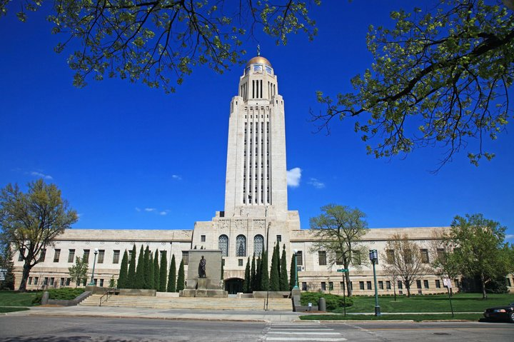

Meyer v. Nebraska
A Very Brief Constitutional History

In 1919, during an upsurge of anti-German sentiment throughout the United States, Nebraska passed a law specifying that

[n]o person, individually or as a teacher, shall, in any private, denominational, parochial, or public school, teach any subject to any person in any language [other] than the English language…. Languages, other than the English language, may be taught as languages only after a pupil shall have attained and successfully passed the eighth grade….

In June 1923 the U.S. Supreme Court found the Nebraska law inconsistent with the 14th Amendment’s general guarantee of liberty. Without invoking the First Amendment, the Court ruled in Meyer v. Nebraska (1923) that the law was an unconstitutional attempt “to interfere with the calling of modern language teachers, with the opportunities of pupils to acquire knowledge, and with the power of parents to control the education of their own.”

About the same time, the Ku Klux Klan attempted to eliminate Catholic schools in Oregon by persuading the state to pass a law requiring that all children attend public schools. In Pierce v. Society of Sisters (1925), again without reference to the First Amendment, the U.S. Supreme Court found this law unconstitutional:

The fundamental theory of liberty upon which all governments in this Union repose excludes any general power of the State to standardize its children by forcing them to accept instruction from public teachers only. The child is not the mere creature of the State; those who nurture him and direct his destiny have the right, coupled with the high duty, to recognize and prepare him for additional obligations.

In the decades after Meyer and Pierce, subsequent decisions established fundamental rights to liberty and autonomy in personal and family matters, including marital choice, reproductive freedom, and freedom to raise one’s own children.

In June of this year, 99 years after Meyer, the U.S. Supreme Court ruled in Dobbs v. Jackson that the 14th Amendment guarantee of liberty does not include a right to abortion, thus raising questions about other rights protected by the 14th Amendment guarantee of liberty as interpreted in Meyer, Pierce, and cases since. These include not only matters of contraception and marital choice, which have been much in the news, but also the right of parents to raise and direct the education of their own children.

As we approach the centennial of Meyer v. Nebraska and consider the implications of Dobbs v. Jackson, AFCON is devoting its annual meeting to the legacy of Meyer, focusing especially on parental rights in relation to education and intellectual freedom. Join us on October 22! See page 1 for further information.

AFCON
www.academicfreedomnebraska.org

The Academic Freedom Coalition of Nebraska was founded in 1988 to promote intellectual freedom in Nebraska education and research, including freedoms of belief and expression and access to information and ideas.

